TAGRA Acute MLC Subgroup
Health Inequalities Impact Assessment for the Acute MLC review
Briefing for Health Inequalities Impact Assessment Discussion, 14th August 2015

This paper summarises progress to date in embedding the principle of equity in the TAGRA Acute MLC review and the process for facilitating Health Inequalities Impact Assessment in advance of a workshop discussion with the Subgroup at their meeting on 14th August 2015.

Background

The TAGRA Acute MLC Subgroup was keen to ensure that a Health Inequalities Impact Assessment (HIIA) was undertaken during its work. Recognising good practice indicates that HIIA should be considered from the outset, a presentation about HIIA was given at an early meeting of the committee and a representative from NHS Health Scotland was invited to join the Subgroup.

HIIA is an integrated approach to impact assessment that brings together consideration of equality, social determinants of health and human rights to achieve effective policy making and service development. The purpose of HIIA is to provide a systematic method to identify and reduce barriers to equitable implementation of the service or policy at a stage in planning where changes can be made.

Equally Well (Scottish Government, 2008) was the first strategy in Scotland to recommend using an integrated approach to impact assessment. There are many versions of integrated impact assessments in use but the Equally Well HIIA approach draws on methodology from Health Impact Assessment, Equality Impact Assessment and Human Rights Impact Assessment. It is constructed so that it meets but goes further than the Public Sector Equality Duty for assessing impact in relation to legally protected characteristics and incorporates exploration of impact relating to the right to health and determinants of health inequalities. The Quality Strategy proposed that all new health policies should be subject to an HIIA to ensure that they are person centred as well as meet with the requirements of the Equality Act (Scottish Government, 2010, p24). The HIIA tool was piloted with local and national NHS Boards and with Scottish Government before being formally launched in 2011. It has since been applied to policy, strategy and service developments in Scottish Government, local and national Health Boards and some third sector agencies. The principles and support materials have been developed in a way that enables adaptation of the process if required to suit different circumstances.

The HIIA process

The process we are taking with the Acute MLC Subgroup goes beyond a one-off HIIA as we are embedding equity considerations throughout all our work. NHS Health Scotland has produced guidance documents and facilitators’ notes to support groups through the HIIA process from initial preparation to taking action. We have devised a process for the Acute MLC Subgroup comprising three components of regular, informal assessment at Subgroup meetings and two focussed HIIA workshop discussions at the interim and final points in the review. Each of the three components is informed by the core HIIA process as summarised in Figure 1 below:

Figure 1. The HIIA Process
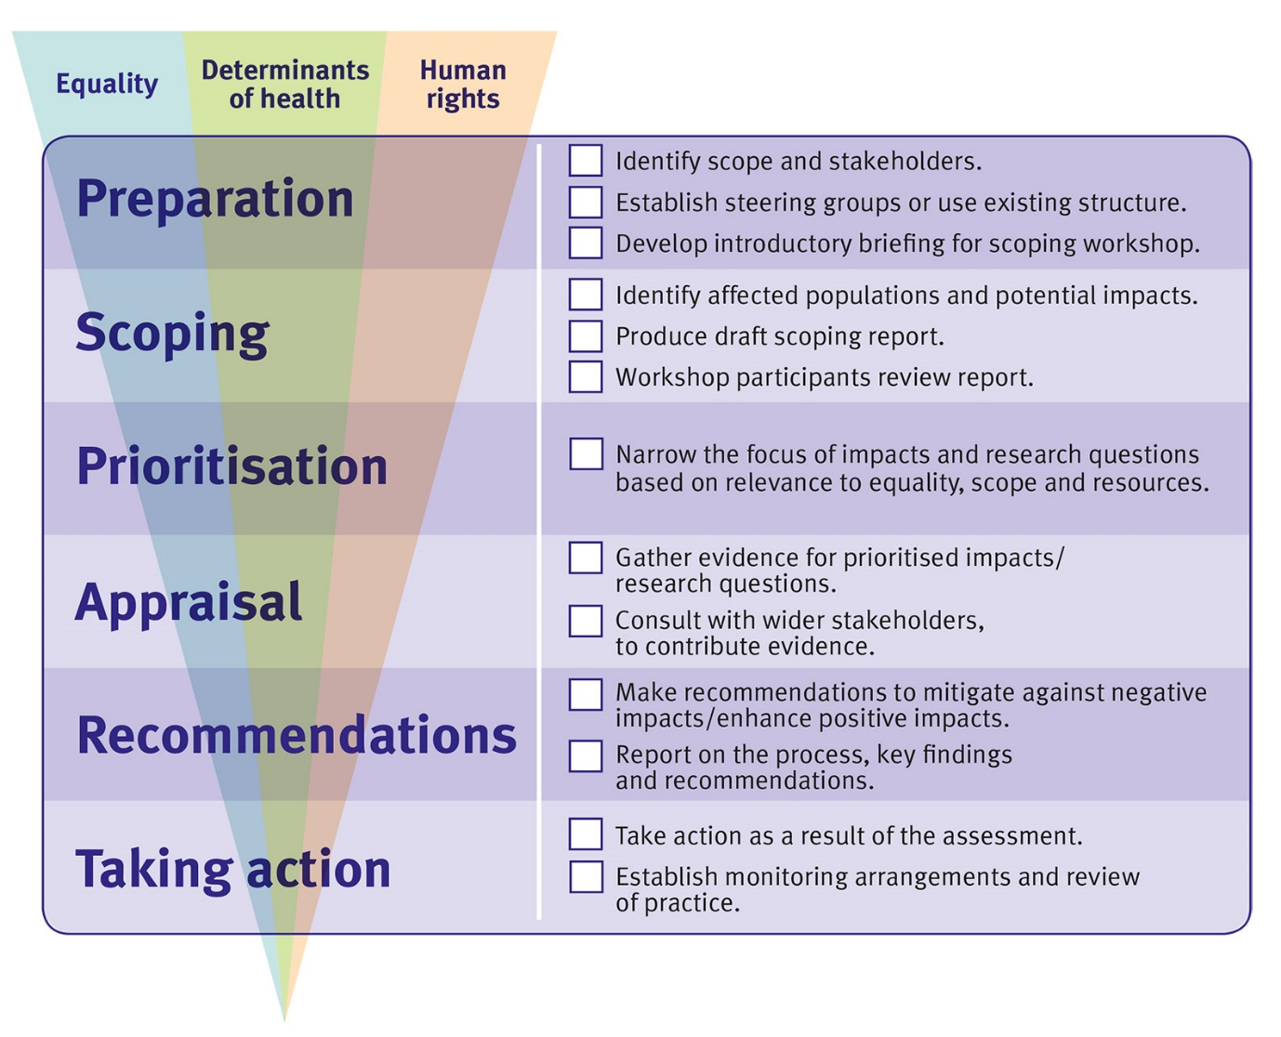

The three components for the Acute MLC review can be described as follows. First, the NHS Health Scotland representative has an ongoing role in the Subgroup throughout the review for supporting the exploration of all three dimensions of equity, that is, legally protected characteristics, social determinants of health inequalities and the right to health. The second component is to hold a workshop discussion with the group at an interim stage approximately half way through the review about potential impacts of the formula on equality, inequality and human rights. The workshop discussion will involve additional equality advisers to review progress to date on equity and to enable exploration of further issues or data at a point where any omissions or negative impact can be remedied. The third component will be to carry out a further HIIA workshop discussion towards the end of the process scheduled for December 2016.

Progress on HIIA to date
The first component began with a presentation to the group on HIIA from NHS Health Scotland and an invitation to join the group. An early change made in the committee was to amend the NRAC core criteria to expand the definition of equity to specifically mention variation in need across population groups. Later, potential additional inequality indicators were explored with public health data analysts including Child Poverty, Child Pedestrian Casualties, numbers of asylum seekers and refugees, Roma community, DNA rates, life expectancy, and the gender gap in life expectancy. A number of suggestions were explored and some rejected due to double counting, low impact on acute MLC, or that data were unavailable. The result of this exploration is that DNA rates and life expectancy are being followed up as potential indicators for the formula. The potential impact on inequality was also taken into account in the groups’ decision making on the level of geography (data zones or intermediate zones) with data zones favoured for reasons of responsiveness to deprivation, equality and transparency. The ongoing, informal assessment will continue throughout the review to its conclusion.

Interim HIIA workshop discussion, 14th August 2015
The interim HIIA workshop discussion will follow the systematic process as would normally be applied to any HIIA scoping workshop with some adaptations made to reflect the nature of the task, such as the work already done with the group and the distance of the formula from frontline impact. The discussion will take place as part of a routine meeting of the Subgroup to which additional participants have been invited to bring specific experience of research, data and practice relating to equality, inequality and human rights. NHS Health Scotland staff will facilitate the discussion using the published HIIA materials which offer a systematic set of questions and prompts relating to a broad range of factors and population groups known to be associated with barriers to achieving health or where social processes impact on health. Participants will be encouraged to identify areas where the resource allocation formula might create or exacerbate inequity of access or outcome. Availability of data and evidence will be explored for these areas. The evidence will be further explored following the meeting if necessary and the conclusions used to recommend proportionate, mitigating action where required. Participants will be invited to contribute and comment on the report and recommendations.
Evidence for HIIA processes is usually drawn from a variety of sources including routine data, academic research and engagement with population groups who might be most affected by the policy or programme. However, the Acute MLC HIIA will differ in this from our usual policy or strategy impact assessments in two ways. First, the high level nature of the formula precludes understanding of the direct impact of the formula on population groups as its impact will be mediated through individual NHS Board allocation processes, and second, there are likely to be gaps in routinely collected data for small population groups as described above for example, the Roma community or for people describing themselves as belonging to LGBT categories. Actions to further explore or mitigate some potential harms identified might therefore lie outwith the scope of the Subgroup and the discussion will include consideration of any further work that might arise as a result of that.

Pauline Craig, Head of Equality, NHS Health Scotland: pauline.craig1@nhs.net
06/08/15

