**TAGRA ACUTE MLC SUBGROUP Tuesday 18th August 2015**

**UNMET NEED ANALYSIS – METHODOLOGY**

**Background**

The NHSScotland Resource Allocation Committee (NRAC) Formula relies on health service activity data as a basic proxy for the need for healthcare services. It is therefore important to check for the existence and extent of any socio-economic inequities in healthcare utilisation and, where appropriate, to adjust the Formula to reflect such unmet need.

Unmet need was discussed most recently at the June Acute MLC meeting (TAMLC28). The results of some preliminary analysis were examined, and the Subgroup began to plan the unmet need investigation, which will be carried out later in the Review, once the new Acute needs index has been developed.

The investigation is based on shortfall methods, which look for lower-than-expected healthcare utilisation in small areas which fulfil certain criteria (relating to deprivation, or other characteristics). In particular, on Matt Sutton’s advice, the two-step shortfall method of McConnachie and Sutton (2004)[1] had been tested in the preliminary analysis. In this method, the expected utilisation is based not purely on the Acute needs index but on an independent measure of morbidity – in this case, data from the Scottish Health Survey. The Subgroup examined the results and concluded that the two-step shortfall method should not be pursued further in the current Review, mainly due to the sparsity of the Scottish Health Survey morbidity data.

The “simple” shortfall method (McConnachie and Sutton 2004) had also been tested, for comparison. This method looks for possible unmet need in areas with high values of the Acute needs index, by looking for downward deviations from linearity in the small-area data – as indicated by line A in Figure 1. It is therefore based on an assumption that the true underlying relationship between the Acute needs index and healthcare costs is a linear one, and that a shortfall at high index values is an indication of unmet need.

The Subgroup agreed that the Review should use the simple shortfall method to test for unmet need related to the Acute needs index, but also, that the Review should look for any unmet need effects related to certain other variables: deprivation (SIMD), rurality, and ethnicity. Such analysis would entail defining the populations of interest by these other variables, as opposed to the Acute needs index. This approach allows for the possibility of finding unmet need along several different ‘dimensions’ where it may plausibly exist, and will mirror what was done following the NRAC Review – documented in Technical Addendum D (2007).

This methodology paper outlines in detail the analysis to be done. Sections 1 and 2 review the methods, as previously used in the NRAC Review; section 3 then outlines the approach for the current Acute MLC Review.



*Figure 1. Diagram showing a downward deviation from the assumed linear relationship between need and utilisation at the highest values of the needs index (line A), the linear model that would be fitted in this case (B), and the alternative linear model that would be fitted by excluding the areas with high need and extrapolating the line into those areas (C).*

**1. The simple shortfall method**

The simple shortfall method – proposed in the first Arbuthnott Report in 1999, and used in McConnachie and Sutton (2004) – is based on an assumption of linearity. That is, it assumes that there should be a linear relationship between the cost ratio and the Acute needs index. It effectively tests whether that relationship is in fact constant, across the full range of need, or whether there is a significant change in the slope of healthcare use at high values of the Acute needs index. A ‘spline’ term (see Annex A for details) is added to the reference model, to allow a difference in the slope of the regression line for the areas with the highest Acute index values:

***Cost ratios ~ HB dummies + Supply + Acute Index + Acute Index spline + errors.***

If the spline term is significant, there is evidence of different utilisation rates at the high end of the Acute needs index. Regressions are carried out for a range of cut-points, and the ‘best’ cut-point is chosen so that the model has the highest explanatory power, i.e. the highest adjusted R2 value.

**2. The 2007 shortfall method**

The NRAC Review had suggested that further work was required on the issue of unmet need; Technical Addendum D[2] then presented the additional analysis performed in 2007. This included the use of another shortfall method, which we refer to here as the “2007” shortfall method.

The 2007 shortfall method is very similar to the “simple” shortfall method: it looks for a change in the slope of the fitted line when certain small areas are separated out. However, it excludes areas on the basis of other variables (representing deprivation, rurality, or ethnicity) besides the needs index. In a sense it generalises the simple shortfall method to these other variables.

This requires a slightly different modelling methodology. A binary variable indicates the areas to be excluded – again, with various trial cut-points. Two terms were added to the model, to create an *additional* linear model for the excluded areas which may have a different slope and intercept from the rest of the country:

***Cost ratios ~ HB dummies + Supply + Acute Index + Binary variable + Interaction term + errors.***

If either of these additional terms is significant, there is evidence of different utilisation rates in the excluded areas. (See Annex A for more detail on the model.) The method was first suggested in a research paper concerning health and social care inequalities within Northern Ireland (2003)[3].

Unmet need was looked for using the following variables in the 2007 analysis:

**Deprivation:**For the analysis, deprivation was measured using the Scottish Index of Multiple Deprivation (SIMD) 2006 income domain. Areas were categorised as being in the “most deprived” group based on a number of trial cut-points: successively, the 1%, 5%, 10%, 15%, 20%, and 25% most deprived populations.

**Rurality:** Remoteness and rurality was measured using the Scottish Government Urban Rural Classification which categories areas into 6 categories (Annex B describes the 6-fold and 8-fold Urban-Rural classifications). For ease of analysis this was converted into an approximately ordinal classification by grouping categories as follows: categories 1 & 2 (Urban), category 6 (Remote and Rural) and between them the remaining categories 3, 4 & 5 (Other). Two distinct comparisons were carried out. Firstly, remote and rural areas were compared to all other areas, and then all non-urban categories were compared to urban areas.

**Ethnicity:** The black and minority ethnic population, as a percentage of the total for each intermediate zone, from the 2001 census, was categorised into five trial ‘levels’ (<0.5%, 0.5-1%, 1-2%, 2-4%, ≥4%).

The results are summarised in the following paragraphs from the Discussion section 6.3 of the Technical Addendum D to Technical Report D:

*“Consistent evidence of a shortfall was detected only for circulatory disease when using the acute circulatory index. For other diagnostic groups there was either no evidence of a change in gradient of utilisation, or, in fact, an increase in the gradient in the most deprived areas, e.g. injuries, digestive. Using the shortfall method in these cases would result in the formula predicting lower needs for the most deprived areas.*

(…)

*In summary, the analyses reported here cannot demonstrate conclusively that either unmet need does or does not exist within the services covered by the formula. In many ways they were designed to produce a technical adjustment to the formula on the assumption that unmet need does exist in some areas, in particular in relation to deprivation. That adjustment is limited to altering the gradient of a needs index, which could be viewed as a blunt solution to a very complex problem.*

*NRAC have been keen throughout however to make an allowance for unmet where this could be justified. Of the two methods used, the shortfall method would appear to be the most defensible and a better fit to the NRAC core criteria such as objectivity. It is only possible to justify using this approach for circulatory disease to avoid redistribution of resources from high to low deprived areas.*

|  |
| --- |
| *Recommendation – that a shortfall adjustment is made for the acute circulatory diagnostic group based on the extrapolating the needs index gradient from the population that excludes 25% of the population in the most deprived areas.”* |

The unmet need adjustment currently implemented in the NRAC Formula follows the recommendation outlined above.

**3. Proposed methodology for Acute MLC Review**

The Subgroup agreed that the unmet need investigation should include testing for unmet need as a function of the Acute needs index, as well as of deprivation (SIMD Income domain ranking), rurality, and ethnicity. This section outlines the proposed methodology for each of these tests.

**3.1 Testing for unmet need using the Acute needs index**

Method: In order to test for unmet need at the high end of the Acute needs index, the simple shortfall method described in section 1 should be adopted.

Data: The data needed for the implementation of the simple shortfall method includes all the data used in the reference model: the control variables (inpatient and outpatient hospital supply; health board dummies), the Acute needs index, and the cost ratios.

*All data is required at data zone level, 2011 boundaries: average cost ratios for 3 years (2011/12, 2012/13, 2013/14); supply variables for 2013/14; new Acute needs index.*

Implementation: Unmet need would be corrected for by extrapolating the regression line derived from the areas thought not to be affected into all other areas.

**3.2 Testing for unmet need using other variables**

**3.2.1 Deprivation**

Method: The 2007 shortfall method described in section 2.1 should be used to test for unmet need related to deprivation.

Data: The data needed includes all the data used in the reference model, plus the SIMD Income domain ranking. However, SIMD will not be available at the redrawn 2011 data zones until after August 2016. The Subgroup has already decided to not delay the Review until such data is available, such that it will not be possible to undertake this analysis within the scope of the present review. Deprivation-related unmet need can, however, be explored at the old 2001 data zones using SIMD 2012.

*All data is required at data zone level, 2001 boundaries: average cost ratios for 3 years (2011/12, 2012/13, 2013/14); supply variables for 2008/09; current Acute needs index; SIMD 2012 Income domain ranking at data zone level.*

Implementation: A check for deprivation-related unmet need at the 2001 data zones would be purely for future reference as it would not be possible to incorporate any results in the updated Acute MLC adjustment (as this will be based on 2011 data zones). It should be noted that the results from the simple shortfall method analysis (see section 3.1) will reflect unmet need due to deprivation anyway, insofar as the Acute needs index captures “deprivation”.

**Is the Subgroup content with this approach to checking for unmet need as a function of deprivation?**

**3.2.2 Ethnicity**

Method: In order to test for unmet need relating to ethnicity, the 2007 shortfall method described in section 2.1 should be adopted.

Data: The data needed for the investigation of ethnicity effects on need includes all the data used in the reference model, plus ethnicity data. The ethnicity data from the 2011 Census is readily available at the redrawn 2011 data zones (see paper TAMLC34). The total non-white population should be expressed as a percentage of the total population of each data zone.

*All data is required at data zone level, 2011 boundaries: average cost ratios for 3 years (2011/12, 2012/13, 2013/14); supply variables for 2013/14; new Acute needs index; ethnicity data from 2011 Census.*

Implementation: Unmet need would be corrected for by extrapolating the regression line derived from the areas thought not to be affected into all other areas.

**3.2.3 Rurality**

Method: The 2007 shortfall method described in section 2.1 should be used to test for unmet need related to urban-rural classification.

Data: The data needed for the investigation of urban-rural effects on need includes all the data used in the reference model, plus the rurality classification. The Urban-Rural classification 2013/14 is readily available at the redrawn 2011 data zones. The data is provided at the 6-fold and 8-fold Urban-Rural classifications (Annex B).

*All data is required at data zone level, 2011 boundaries: average cost ratios for 3 years (2011/12, 2012/13, 2013/14); supply variables for 2013/14; new Acute needs index; 2013/14 Urban-Rural classification.*

Implementation: Unmet need would be corrected for by extrapolating the regression line derived from the areas thought not to be affected into all other areas.

**3.3 Implementing the results**

It is proposed that only the *most deprived* end of SIMD (and similarly for the other variables) is examined for utilisation differences.

It is worth pointing out that significant “overmet need” effects, in the most deprived areas, were identified for the Acute diagnostic groups Injury and Digestive in the 2007 NRAC analysis, but no adjustments were incorporated into the formula. It is considered likely that such effects reflect deficiencies in the underlying assumption of a linear model form, rather than genuine instances of overmet need. It is proposed that the current Review follows the same principle as the 2007 review: that higher-than-expected utilisation in the most deprived areas is not adjusted for, if discovered.

The implementation of both methods (simple shortfall and 2007 shortfall) would take the same form: extrapolation of a regression line based on the areas thought not to be affected. It is, however, not clear which data zones should be excluded from the regression if more than one basis is found for exclusion. The authors of NRAC Technical Addendum D indicate that they handled this by prioritising one particular area of unmet need: *“While results for the shortfall method were presented in relation to deprivation, ethnic minority populations and rurality, the Committee were most interested in the deprivation results since this is what earlier work had concentrated on”*.

Further exploratory analysis for the present Review (see Annex C) has been carried out, comparing the results using the existing Acute needs index (simple shortfall method) with those using the SIMD domain score (2007 shortfall method). This analysis suggests that the slope of the extrapolated regression line – used ultimately to predict relative healthcare costs between all data zones in the process of calculating target allocation shares – may depend substantially on which variable was used to exclude data zones from the regression.

There is no clear analytical basis upon which to decide which ‘exclusion’ variable to use in preference to any other. One option would be for the Subgroup to establish a hierarchy of priority for implementation in advance, to make clear which variable is to be used to excluded data zones from the regression, in the event that more than one is found to be associated with unmet need. The variables to be ranked would be: deprivation and other factors as measured by the Acute needs index (the nature of which remains TBC), deprivation as measured by SIMD income score, ethnicity (as defined above) and rurality (as defined above).

**The Subgroup is asked to consider the above proposals and to decide on how adjustments should be implemented in cases when multiple variables are found to be significant.**

**Annex A: Model details**

**A.1 The simple shortfall method**

A spline variable is included in the linear regression model in addition to the supply variables, Health Board dummies and the Acute needs index. The spline is defined as:

*xiH*= *xi* – *cH* if *xi* > *cH*

=0 if *xi* ≤ *cH*

where *xi* is the Acute needs index value, the subscript *i* referring to the data zone, and *cH* is the cut-point being used.

If the regression coefficient of the spline variable is not significantly different from 0, then there is no evidence of deviation from linearity. A significant negative coefficient value (with p-value less than 0.05), then there is evidence of a shortfall in health care use below the expected level.

**A.2 The 2007 shortfall method**

The model fitted can be represented algebraically as

$${\text{cost} \text{ratio}}_{i}= β_{0}+{\sum_{k}{β_{k}}\text{HB} \text{dummy}}_{ik}+ β_{14}{\text{IPACX}}_{i}+β_{15}{\text{OPACX}}_{i}+ β_{16}{\text{acute} \text{index}}_{i}+β_{17}{\text{deprived}}_{i}+β_{182219riese, and respectively for ion and rurality effects }{\text{acute} \text{index}}_{i}×{\text{deprived}}_{i}+{\text{error}}_{i}$$

for *k* = 1…13, with the subscript *i* referring to the data zone. (There are fourteen HB variables, but one is excluded because only thirteen are mutually independent.) The variable *deprived* is a two level categorical variable – with value 0 (not in most deprived group) or 1 (in most deprived group) – depending on the SIMD ranks and the cut-point chosen (5%, 15% and 25% are tested in the present analysis).

With $β_{17}$ equal to $β_{0}$ and $β_{18}$ equal to $β_{16}$, the model reverts to the reference model. If $β_{17}$ is significantly different from $β_{0}$ (p-value less than 0.05), then the *intercept* of the regression line is different for the most deprived areas compared to the non-affected areas. However, if $β_{18}$ is significantly different from $β_{16}$, then the *slope* of the regression line is different for the most deprived areas.

**Annex B: Scottish Government Urban-Rural Classification**

*Table B-1: Scottish Government 6-fold Urban-Rural Classification*

|  |  |
| --- | --- |
| **1 Large Urban Areas** | Settlements of 125,000 or more people. |
| **2 Other Urban Areas** | Settlements of 10,000 to 124,999 people. |
| **3 Accessible Small Towns** | Settlements of 3,000 to 9,999 people and within 30 minutes drive of a settlement of 10,000 or more. |
| **4 Remote Small Towns** | Settlements of 3,000 to 9,999 people and with a drive time of over 30 minutes to a settlement of 10,000 or more. |
| **5 Accessible Rural** | Areas with a population of less than 3,000 people, and within a 30 minute drive time of a settlement of 10,000 or more. |
| **6 Remote Rural** | Areas with a population of less than 3,000 people, and with a drive time of over 30 minutes to a settlement of 10,000 or more. |

*Table B-2: Scottish Government 8-fold Urban-Rural Classification*

|  |  |
| --- | --- |
| **1 Large Urban Areas** | Settlements of 125,000 or more people. |
| **2 Other Urban Areas** | Settlements of 10,000 to 124,999 people. |
| **3 Accessible small Towns** | Settlements of 3,000 and 9,999 people and within 30 minutes drive of a settlement of 10,000 or more. |
| **4 Remote Small Towns** | Settlements of between 3,000 and 9,999 people and with a drive time of over 30 minutes to a settlement of 10,000 or more. |
| **5 Very Remote Small Towns** | Settlements of 3,000 and 9,999 people and with a drive time of over 60 minutes to a settlement of 10,000 or more. |
| **6 Accessible Rural** | Areas with a population of less than 3,000 people, and within a 30 minute drive time of a settlement of 10,000 or more. |
| **7 Remote Rural** | Areas with a population of less than 3,000 people, and with a drive time of over 30 minutes but less than 60 minutes to a settlement of 10,000 or more. |
| **8 Very Remote Rural** | Areas with a population of less than 3,000 people, and with a drive time of over 60 minutes to a settlement of 10,000 or more. |

**Annex C: Further exploratory analysis**

Some further exploratory analysis has been performed at the 2001 data zones, using the SIMD 2012 Income domain ranking, as well as the current Acute needs index (LLTI data from Census 2011 and SMR calculated using 2008-2012 death records)[4]. This analysis demonstrates the use of both the simple shortfall method (using the needs index) and the 2007 shortfall method (using SIMD).

**C.1 Visualisation of the excluded data zones for both methods**

A scatter plot of cost ratios against the Acute needs index is shown in Figure C-1, for the diagnostic group Heart. A vertical line shows the cut-point for the 25% highest Acute *needs index* values (all points to the right of this line would be excluded if correcting for unmet need effects based on the needs index). The 25% most *deprived* data zones (as identified by SIMD Income domain ranks) are shown by applying a red colour to those points. While the red points generally lie to the right of the vertical line, showing that there is broad overlap between the needs index and SIMD in terms of the excluded data zones, there are a significant number of red points on the left, and black points on the right.

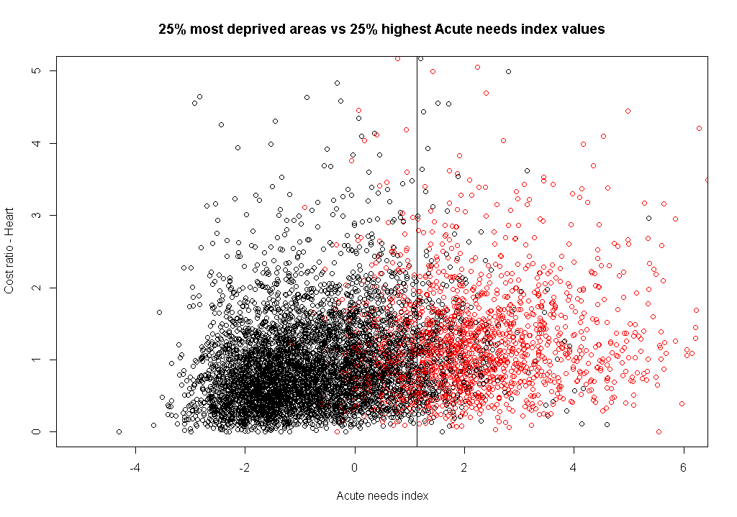

*Figure C-1. Scatter plot of cost ratios against the Acute needs index by deprivation for the acute diagnostic group Heart.*

Figures C-2 to C-3 below show further analysis of the overlap between the needs index and SIMD, as well as between the needs index and rurality, and between SIMD and rurality, in terms of the data zones marked for separation in the modelling. Observations from these graphs are as follows:

* The Acute needs index values increase with deprivation, i.e. the most deprived areas have the highest acute needs index values (Figure C-1).
* The acute needs index values seem to be independent of the rurality classification (Figure C-2).
* Figure C-3 implies that there may be two categories with different SIMD Income ranks – 1. Large urban areas, Other urban areas, Accessible small towns, Remote small towns, Very remote small towns, and 2. Accessible rural, Remote rural, Very remote rural.

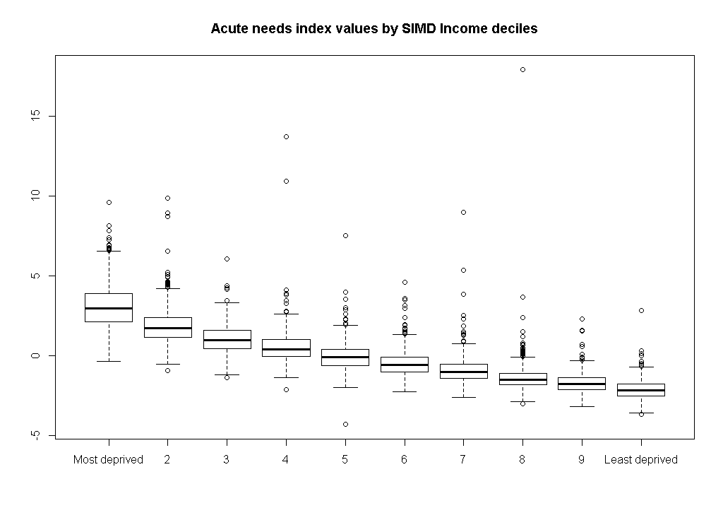

*Figure C-2: Ranges of values of the Acute needs index, by SIMD deciles.*

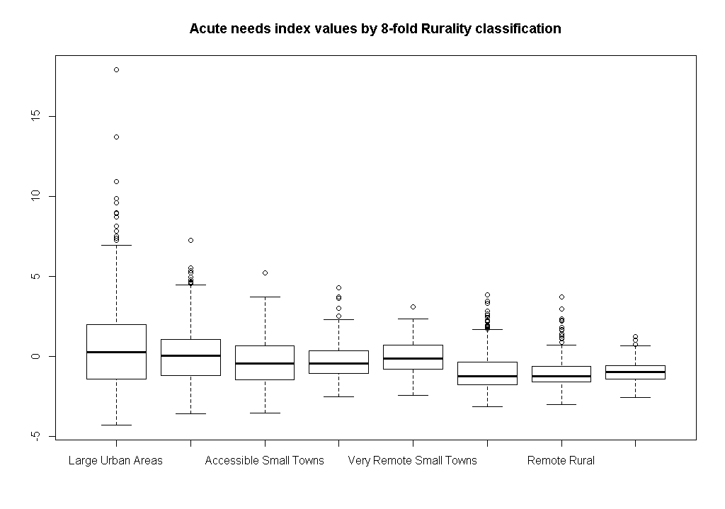

*Figure C-3: Ranges of values of the Acute needs index, by urban-rural category.*

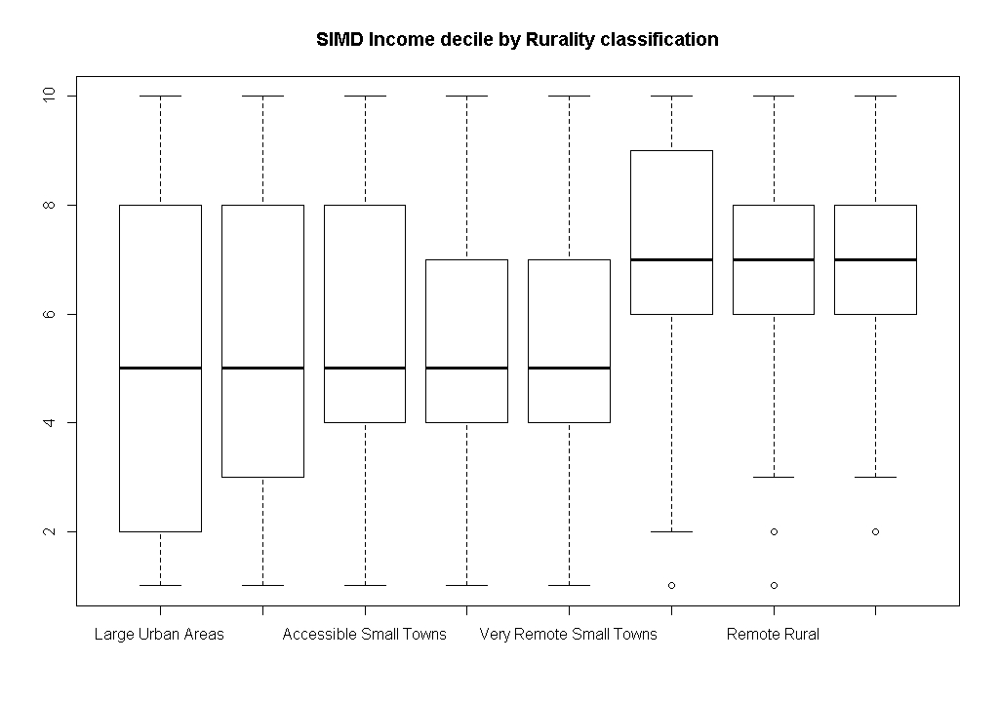

*Figure C-4: Ranges of values of the SIMD deciles, by urban-rural category.*

**C.2 Modelling results**

Both shortfall methods identify significant changes in utilisation in the upper end of the deprivation/Acute needs index range, for some of the cut-points explored. The regression coefficients are given in Table C-1 below, for each diagnostic group. The results can be summarised as follows:

* For Cancer, there is a significant increase in slope in the 25% most income-deprived data zones.
* For Heart, there is a significant increase in slope using both methods, but the magnitude of the increase is greater for the simple shortfall method.
* For Digestive, Injury, Other, Respiratory and Outpatients, excluding the 25% of data zones with the highest *needs index* values leads to an increase in the regression coefficient; but excluding the 25% most *deprived* data zones actually *decreases* the slope.

Generally, the slopes tend to be higher when excluding points based on the needs index rather than on the SIMD value – with the exception of Cancer. The highest significance difference in slope is seen for Other, for the simple shortfall method, with a 25% cut-point; this difference is 0.021.

*Table C-1. Acute needs index regression coefficients, based on all datazones (“unadjusted slope”) and based on just the data zones that are not in the “excluded” group, using various cut-points for exclusion as indicated. Shaded cells indicate significant increases in slope using the shortfall model; values in italics identify significant decreases.*

|  |  |  |  |  |  |
| --- | --- | --- | --- | --- | --- |
| **Diagnostic group** | **Method** | **Cut-point** | | | **Unadjusted slope** |
| **25%** | **15%** | **5%** |
| Cancer | Simple shortfall | 0.073 | 0.062 | 0.055 | 0.054 |
| Deprivation effects | **0.074** | 0.067 | 0.062 |
| Heart | Simple shortfall | **0.130** | **0.131** | **0.120** | 0.109 |
| Deprivation effects | **0.113** | **0.109** | 0.108 |
| Digestive | Simple shortfall | **0.119** | **0.123** | **0.127** | 0.116 |
| Deprivation effects | ***0.098*** | ***0.112*** | ***0.112*** |
| Injury | Simple shortfall | 0.124 | 0.127 | **0.125** | 0.113 |
| Deprivation effects | ***0.098*** | ***0.104*** | 0.113 |
| Other | Simple shortfall | **0.113** | **0.107** | **0.104** | 0.092 |
| Deprivation effects | ***0.084*** | ***0.089*** | **0.093** |
| Respiratory | Simple shortfall | **0.193** | **0.195** | **0.192** | 0.182 |
| Deprivation effects | ***0.171*** | ***0.174*** | ***0.176*** |
| Outpatients | Simple shortfall | 0.032 | **0.034** | **0.037** | 0.034 |
| Deprivation effects | 0.031 | ***0.033*** | ***0.033*** |

The significance of the additional terms in each model, and the adjusted R2, for each diagnostic group at different cut-points, are shown in Tables C-2 (for the simple shortfall method) and C-3 (for the 2007 shortfall method).

Neither method produces a large increase in the adjusted R2 values compared to the reference model, for any diagnostic group. For the simple shortfall method using the Acute needs index, the biggest gain in the adjusted R2 values is observed for Digestive and Other (0.65 and 1.08 percentage points, respectively), using a cut-point of 5%. For the 2007 shortfall method using SIMD, the biggest gain in the adjusted R2 values is observed for Heart and Other (0.54 and 0.76 percentage points, respectively), using a cut-point of 25%; from Table C-1, the direction of the change in slope is an increase for Heart and a decrease for Other.

*Table C-2: R2 values and significance of the spline term for the simple shortfall method*

|  |  |  |  |  |  |  |
| --- | --- | --- | --- | --- | --- | --- |
| Cut-point | **Cancer** | | **Heart** | | **Digestive** | |
| Adj. R2 | Upper spline | Adj. R2 | Upper spline | Adj. R2 | Upper spline |
| no | 6.70% | - | 8.57% | - | 22.36% | - |
| 5% | 6.69% | Not significant | 8.70% | **Significant** | 23.01% | **Significant** |
| 15% | 6.69% | Not significant | 8.77% | **Significant** | 22.66% | **Significant** |
| 25% | 6.71% | Not significant | 8.78% | **Significant** | 22.51% | **Significant** |

|  |  |  |  |  |  |  |
| --- | --- | --- | --- | --- | --- | --- |
| Cut-point | **Injury** | | **Other** | | **Respiratory** | |
| Adj. R2 | Upper spline | Adj. R2 | Upper spline | Adj. R2 | Upper spline |
| no | 13.57% | - | 27.79% | - | 21.99% | - |
| 5% | 13.62% | **Significant** | 28.87% | **Significant** | 22.20% | **Significant** |
| 15% | 13.58% | Not significant | 28.62% | **Significant** | 22.13% | **Significant** |
| 25% | 13.57% | Not significant | 28.53% | **Significant** | 22.10% | **Significant** |

|  |  |  |
| --- | --- | --- |
| Cut-point | **Outpatients** | |
| Adj. R2 | Upper spline |
| no | 45.22% | - |
| 5% | 45.38% | **Significant** |
| 15% | 45.29% | **Significant** |
| 25% | 45.26% | **Significant** |

*Table C-3: R2 values and significance of the additional terms for the 2007 shortfall method*

|  |  |  |  |  |  |  |
| --- | --- | --- | --- | --- | --- | --- |
| Cut-point | **Cancer** | | | **Heart** | | |
| Adj. R2 | factor | interaction | Adj. R2 | factor | interaction |
| no | 6.70% | - | - | 8.57% | - | - |
| 5% | 6.82% | Not significant | Not significant | 8.58% | Not significant | Not significant |
| 15% | 6.82% | Not significant | Not significant | 8.96% | **Significant** | **Significant** |
| 25% | 6.85% | Not significant | **Significant** | 9.11% | **Significant** | **Significant** |

|  |  |  |  |  |  |  |
| --- | --- | --- | --- | --- | --- | --- |
| Cut-point | **Digestive** | | | **Injury** | | |
| Adj. R2 | factor | interaction | Adj. R2 | factor | interaction |
| no | 22.36% | - | - | 13.57% | - | - |
| 5% | 22.48% | **Significant** | Not significant | 13.86% | Not significant | Not significant |
| 15% | 22.52% | **Significant** | Significant | 13.92% | **Significant** | Not significant |
| 25% | 22.68% | **Significant** | Not significant | 13.85% | **Significant** | **Significant** |

|  |  |  |  |  |  |  |
| --- | --- | --- | --- | --- | --- | --- |
| Cut-point | **Other** | | | **Respiratory** | | |
| Adj. R2 | factor | interaction | Adj. R2 | factor | interaction |
| no | 27.79% | - | - | 21.99% | - | - |
| 5% | 28.20% | **Significant** | **Significant** | 22.12% | **Significant** | Not significant |
| 15% | 28.38% | **Significant** | **Significant** | 22.07% | **Significant** | Not significant |
| 25% | 28.55% | **Significant** | **Significant** | 22.08% | **Significant** | Not significant |

|  |  |  |  |
| --- | --- | --- | --- |
| Cut-point | **Outpatients** | | |
| Adj. R2 | factor | interaction |
| no | 45.22% | - | - |
| 5% | 45.30% | **Significant** | **Significant** |
| 15% | 45.26% | **Significant** | **Significant** |
| 25% | 45.24% | Not significant | Not significant |

To visualise the modelling results, the model predictions for the Acute diagnostic group Heart are plotted in Figures C-5 (for the simple shortfall method) and C-6 (for the 2007 shortfall method). The red circles on the graphs represent the 25% of data zones with the highest Acute needs index / SIMD income domain values, respectively.

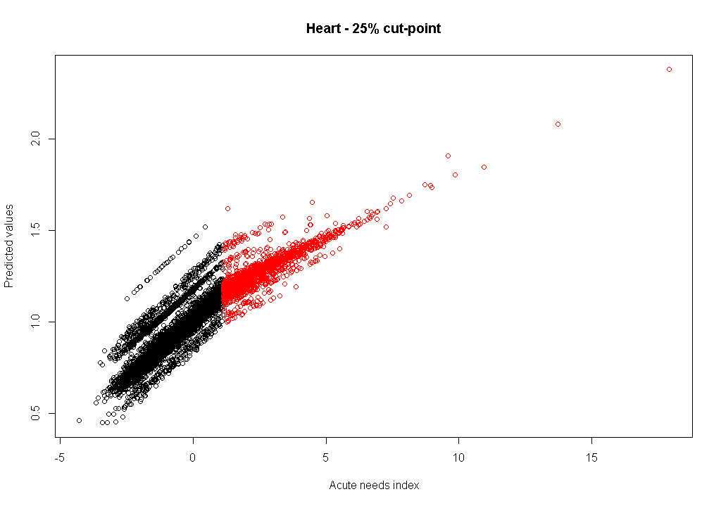

*Figure C-5: Model predictions using the simple shortfall method for the diagnostic group Heart*

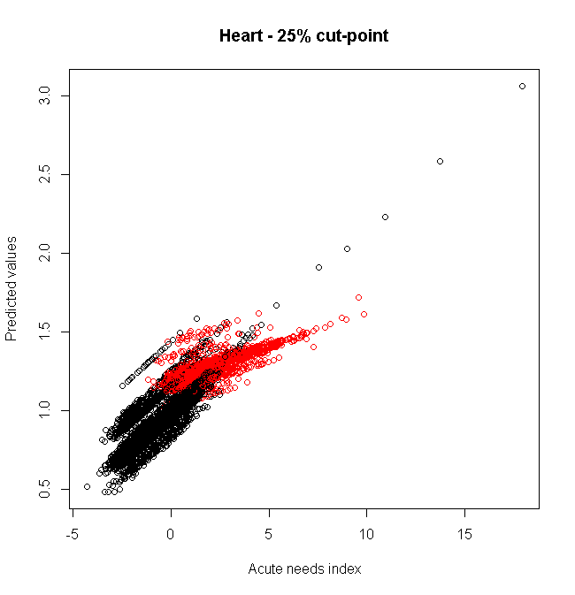

*Figure C-6: Model predictions using the 2007 shortfall method for the diagnostic group Heart*

1. McConnachie and Sutton (2004) ‘Derivation of an Adjustment to the Arbuthnott Formula for Socioeconomic Inequities in Health Care’.
2. <http://www.tagra.scot.nhs.uk/research/>
3. <http://www.dhsspsni.gov.uk/inequalities-health-socialc.pdf>
4. 2011/12 cost ratios are used as the dependent variable; supply variables and Health Board dummy variables are included in the model as usual, the supply variables used being those calculated in 2009.