**TAGRA ACUTE MLC SUBGROUP Monday 6th June 2016**

**UNMET NEED ANALYSIS FOR NEW ACUTE MLC MODEL**

**1. Background and Summary**

Following the May 2016 Acute MLC meeting (paper TAMLC49) and subsequent discussions by email (paper TAMLC53), LLTI + All cause SMR <75 were chosen to be the new Acute index. Paper TAMLC51 showed detailed analysis of the new model and decisions were made based on this that there will neither be different age groups nor urban-rural category indicators added to the new Acute model.

The NHSScotland Resource Allocation Committee (NRAC) Formula relies on historic health service activity data as a basic proxy measure for the need for healthcare services. It is therefore important to check for evidence of any socio-economic inequities in healthcare utilisation and, where appropriate, to adjust the Formula to compensate for any unmet need. There is currently an unmet need adjustment for Heart based on excluding the highest 25% of intermediate zones from the regression, as defined by the needs index.

Unmet need was discussed most recently at the August 2015 Acute MLC meeting (TAMLC33). The paper outlined in detail the unmet need analysis to be done once the new Acute model was chosen. This was to be based on shortfall methods: these methods assume that there should be a constant linear relationship between the cost ratio and the needs index if there was no unmet need, and based on this, identify evidence of unmet need by testing whether there is significant under-utilisation for some subsets of the population.

The Subgroup agreed to look for any evidence of unmet need in data zones at the high end of the Acute needs index, and in data zones with high levels of certain other characteristics: deprivation, urban-rural setting and ethnicity. This approach allows for the possibility of finding unmet need along several different ‘dimensions’ where it may plausibly exist.

This paper presents the results of checking for unmet need related to the needs index, to ethnicity, and to urban-rural setting. The deprivation checks require the use of SIMD 2016, which will not be available until August. (Although SIMD-related unmet need could be checked at the 2001 data zones, this would not be worthwhile as it could not lead to any decision to implement an adjustment.)

Section 2 recaps the previously-agreed methodology for this analysis; section 3 presents the results of each test; and section 4 summarises the conclusions so far.

**2. Methodology**

**2.1 Unmet need related to the needs index: simple shortfall method**

The “simple shortfall method” is used to test whether there is a significant change in the slope of healthcare use (cost ratios) at the highest values of the Acute needs index. Figure 1 illustrates the effect of decreased utilisation in data zones where the needs index is high: the fitted line has a shallower slope, and is therefore less responsive to the underlying need. The simple shortfall method mitigates this by identifying whether the slope is significantly different when it is allowed to change at high needs index values, beyond a cut-off point (Figure 2). If this is the case, the linear model can be fitted only to the bulk of the data zones where unmet need is inferred to be absent, and the fitted line then extrapolated into the data zones where unmet need has been identified.



*Figure 1. Diagram illustrating how the fitted slope is changed by decreased utilisation at high values of the needs index (right hand plot, as compared to left hand plot).*

*Figure 2. Diagram of the simple shortfall method: exclusion of data zones beyond a cut-off point from the regression, and extrapolation of the fitted line.*

The following model is fitted to the data in order to test for a change in slope:

*Cost ratios ~ HB dummies + Supply + Acute needs index + spline*

The ‘spline’ term allows for different slopes in the regression line for areas with the highest needs index values. This can be used to test for significant change in the slope at the upper end of the range of the needs index.

First of all, the cut-off point must be set: all possible cut-off points between 5% and 30% are trialled in the above model and the one that yields the highest explanatory power, i.e. the highest adjusted R2 value, is adopted for the analysis.

Then, if the spline term’s coefficient is significant and negative, this indicates that the slope decreases at the high end of the needs index, i.e. there is evidence of unmet need based on the linearity assumption. Furthermore, if the needs index coefficient is significantly higher with the spline term included than without, this shows that the overall fitted model is affected by the potential unmet need in the way illustrated by Figure 1; and therefore, that an unmet need adjustment – to remove the affected data zones from the regression – would be effective.

Annex A, section A.1 presents more technical detail on the model.

**2.2 Unmet need related to deprivation, urban-rural setting, ethnicity: 2007 shortfall method**

The “2007 shortfall method” (so called because it was used in the 2007 NRAC review) is conceptually very similar to the “simple” shortfall method: it tests whether the data zones with the highest levels of deprivation, urban-rural extremes, or highest proportions of ethnic minorities show lower-than-expected utilisation of Acute healthcare. However, it entails a slightly different methodology in order to incorporate the information on deprivation, rurality and ethnicity.

A binary variable indicates the areas to be excluded – with various trial cut-points tested. Two terms are added to the model, to create an *additional* linear model for the excluded areas which may have a different slope and intercept from the rest of the country:

*Cost ratios ~ HB dummies + Supply + Acute needs index + Binary variable + Interaction term*

If either of these additional terms is significant, there is evidence of different utilisation patterns in the excluded areas – significance in the binary variable indicates a different intercept, i.e. a constant shift in utilisation up or down from the level expected based on the needs index; and a significant interaction term indicates a different slope. A different slope alone does not indicate a shortfall. We may infer an unmet need adjustment is needed if (1) the binary variable is significant, with a negative coefficient, *and* (2) the needs index coefficient is significantly changed. See Annex A, section A.2 for more detail on the model.

**3. Results**

**3.1 Unmet need related to the needs index**

The first step is to decide the optimal cut-off points based on maximising the R2. Table 1 shows the results of this, by diagnostic group.

*Table 1. “Best” cut-off pointsfor the simple shortfall method (see Figure 2).*

|  |  |  |  |  |  |  |  |
| --- | --- | --- | --- | --- | --- | --- | --- |
|  | **Cancer** | **Heart** | **Digestive** | **Injury** | **Other** | **Respiratory** | **Outpatients** |
| **“Best” cut-off point** | 12% | 30% | 5% | 5% | 5% | 5% | 5% |

The adjusted R2 (Table 2) is increased slightly but insignificantly, after including the spline term to the new Acute model, across most diagnostic groups.

*Table 2. Adjusted R2 for (1) new Acute model and (2) simple shortfall model. Highest R2 is shown in bold and italics.*

|  |  |  |  |  |  |  |  |
| --- | --- | --- | --- | --- | --- | --- | --- |
| **Model** | **Cancer** | **Heart** | **Digestive** | **Injury** | **Other** | **Respiratory** | **Outpatients** |
| New Acute Model | 10.9% | 21.0% | 38.6% | 26.0% | 45.1% | 38.2% | 49.3% |
| Simple Shortfall Model | 11.0% | 21.3% | 38.7% | 26.0% | 45.7% | 38.3% | 49.4% |

Table 3 shows the effect of including the spline on the Acute needs index coefficient, as well as showing the coefficient of the spline itself. The needs index coefficient is significantly increased in the shortfall model for Heart and Other (no overlap of the confidence intervals). In each of these cases the spline coefficient is significant and negative, indicating that the slope is shallower in the upper end of the needs index.

*Table 3. Coefficients summary of results for the (1) new Acute model and (2) the simple shortfall model, along with 95% confidence intervals in brackets. Significant spline coefficients are shown in bold and italics. Significantly different index coefficients are shown in grey-shaded cells.*

|  |  |  |  |
| --- | --- | --- | --- |
| **Diagnostic group** | **New Acute model** | **Simple shortfall model** | |
| **Unadjusted new Acute needs index coefficient** | **New Acute needs index coefficient** | **Spline coefficient** |
| **Cancer** | 0.054  (0.048, 0.060) | 0.060  (0.053, 0.068) | ***-0.033***  ***(-0.057, -0.008)*** |
| **Heart** | 0.116  (0.110, 0.122) | 0.138  (0.128, 0.148) | ***-0.050***  ***(-0.069, -0.031)*** |
| **Digestive** | 0.117  (0.112, 0.122) | 0.122  (0.116, 0.127) | ***-0.051***  ***(-0.079, -0.024)*** |
| **Injury** | 0.120  (0.115, 0.126) | 0.123  (0.118, 0.129) | ***-0.031***  ***(-0.061, -0.002)*** |
| **Other** | 0.097  (0.094, 0.100) | 0.104  (0.101, 0.108) | ***-0.079***  ***(-0.096, -0.061)*** |
| **Respiratory** | 0.185  (0.179, 0.192) | 0.190  (0.183, 0.197) | ***-0.055***  ***(-0.092, -0.017)*** |
| **Outpatients** | 0.037  (0.035, 0.039) | 0.039  (0.037, 0.041) | ***-0.025***  ***(-0.037, -0.013)*** |

There is, therefore, a significant shortfall from the expected utilisation in the data zones with the highest needs index values, for Heart (in the highest 30%) and Other (in the highest 5%), which significantly alters the slope of the fitted line as compared to when these data zones are excluded from the regression. Figures 3 and 4 show graphically the effect on the slope. It should be borne in mind that this only indicates downward deviation from linearity at the high end of the needs index and not *necessarily* unmet need.

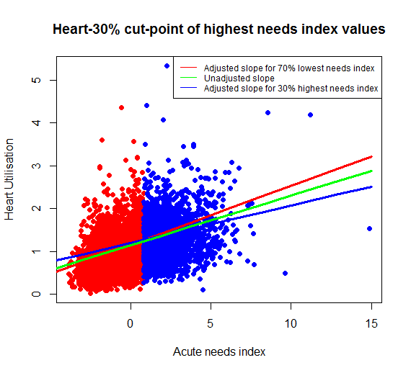

*Figure 3: Scatter plot of Heart cost ratios against Acute needs index, showing the 30% of data zones with the highest needs index, and the effect on the slope when the simple shortfall method is applied with this cut-off.*

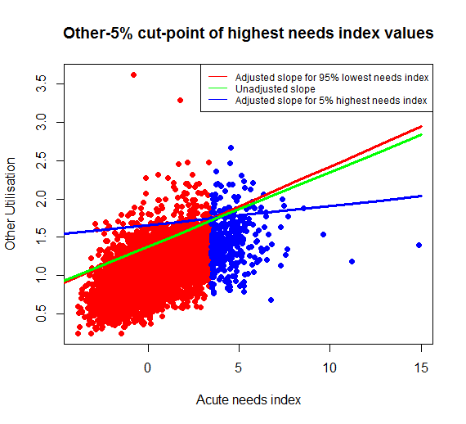

*Figure 4: Scatter plot of Other cost ratios against Acute needs index, showing the 5% of data zones with the highest needs index, and the effect on the slope when the simple shortfall method is applied with this cut-off.*

The result for Heart is consistent with the fact that there is already an unmet need adjustment in the model for Heart. The difference is that the optimal cut-off (based on the adjusted R2 criterion) was found to be 30% based on the current analysis, whereas previously, 25% was adopted – from analysis that had been carried out based on intermediate zones. The difference in adjusted R2 and coefficients between these two possible adjustments (both based on data zones) is shown in Table 4. Using the 30% cut-off results in both a bigger adjusted R2 and a bigger increase to the needs index coefficient, as compared to using the 25% cut-off – although the difference is very small.

*Table 4: Results for simple shortfall method for Heart, using (1) current adjustment based on a 25% cut-off, (2) adjustment suggested by new analysis, based on a 30% cut-off.*

|  |  |  |  |
| --- | --- | --- | --- |
|  | | **25% cut-off** | **30% cut-off** |
| Adjusted R2: | - based on unadjusted model | 21.0% | 21.0% |
| - based on shortfall model | 21.2% | 21.3% |
| Coefficient of needs index: | - based on unadjusted model | 0.116 | 0.116 |
| - based on shortfall model | 0.134 | 0.138 |

An adjustment for Heart also has face validity: untreated heart disease can cause sudden death (with potentially no prior contact with the health services), and so it is plausible that lower levels of resource are utilised where there is unmet need for diagnosis and treatment. This may not be true for conditions such as Cancer, where unmet need would result in late interventions that would still be costly (and perhaps even more costly than early treatment) and so would perhaps not be expected to show up as under-utilisation.

An independent proxy measure for need related to Heart would be the standardised mortality ratio for heart-related deaths – particularly for premature (<75) deaths. By examining the relationship between the Heart SMR and the Acute needs index, we can get a qualitative sense of how high the Heart-related need is at the high end of the needs index. A scatter plot is shown in Figure 5. This indeed shows that areas with high needs index values are also areas where many people die prematurely of heart conditions – and at high values of the needs index, the points are mostly above the best-fit straight line, implying that the need does not tail off at the high end but may even increase above the linear trend. This lends further evidence that the utilisation at the high end of the needs index should be higher than it is, i.e. that there is unmet need.

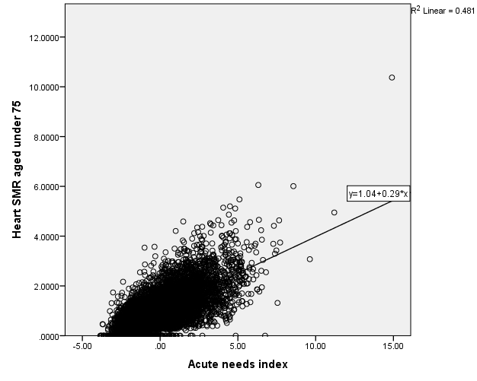

*Figure 5: Scatter plot of Heart SMR < 75 against Acute needs index, with best-fit line shown (linear least squares).*

For Other, it appears that the decrease in slope in the highest 5% of needs index values is mostly caused by a handful of data zones with very high needs index values (see Figure 4). Their relatively low cost ratios may be a chance effect since there are so few of them, in which case they may not reflect true unmet need and the adjustment may not be stable in the future.

**3.2 Unmet need related to ethnicity**

For the analysis, the total Pakistani & Gypsy/Traveller (PGT) population as a percentage of the total for each data zone, from the 2011 census, is used as a measure of ethnicity. These ethnic groups are chosen, as in prior ethnicity analysis, because they were identified as having worse-than-average health outcomes in the ScotStat report[1]. The data zones are then ranked based on their percentage of PGT population. Areas are categorised based on a number of cut-points: successively, the 1%, 5%, 10%, 15%, 20%, and 25% of the total number of data zones with the highest percentage of PGT population.

Table 5 shows that the adjusted R2 is increased slightly (highest increase is 0.3 percentage point) but insignificantly, after including the extra terms for the shortfall model, across most diagnostic groups.

*Table 5. Adjusted R2 for (1) new Acute model and (2) models with the six trial “cut-points” for the 2007 shortfall method relating to ethnicity. Highest R2 is shown in bold and italics.*

|  |  |  |  |  |  |  |  |
| --- | --- | --- | --- | --- | --- | --- | --- |
| **Model** | **Cancer** | **Heart** | **Digestive** | **Injury** | **Other** | **Respiratory** | **Outpatients** |
| New Acute model | 10.9% | 21.0% | 38.6% | 26.0% | 45.1% | 38.2% | 49.3% |
| Shortfall model with 1% cut-point | 10.9% | 21.0% | 38.6% | 26.0% | 45.1% | 38.2% | 49.4% |
| Shortfall model with 5% cut-point | 11.2% | 21.0% | 38.9% | 26.0% | 45.1% | 38.2% | 49.4% |
| Shortfall model with 10% cut-point | 11.1% | 20.9% | 38.8% | 26.0% | 45.1% | 38.2% | 49.3% |
| Shortfall model with 15% cut-point | 11.1% | 20.9% | 38.6% | 26.0% | 45.1% | 38.2% | 49.3% |
| Shortfall model with 20% cut-point | 11.0% | 20.9% | 38.6% | 26.0% | 45.1% | 38.2% | 49.3% |
| Shortfall model with 25% cut-point | 11.0% | 21.0% | 38.6% | 26.0% | 45.1% | 38.2% | 49.4% |

Table 6 shows the effect of including the binary variable and interaction term on the Acute needs index coefficient. Although the extra terms are sometimes significant, the needs index coefficient (i.e. the slope of the overall fitted model) is not significantly changed in the shortfall model for any diagnostic group. An unmet need adjustment relating to ethnicity would therefore not be needed.

*Table 6. Coefficients summary of results for (1) the new Acute model and (2) models with the six trial “cut-points” for the 2007 simple shortfall method relating to ethnicity. 95% confidence intervals are shown in brackets.*

|  |  |  |  |  |  |
| --- | --- | --- | --- | --- | --- |
| **Diagnostic group** | **Unadjusted new Acute Index coefficient** | **Cut-point** | **New Acute index coefficient** | **Significance**  **of binary variable** | **Significance of interaction**  **term** |
| **Cancer** | 0.054  (0.048, 0.060) | 1% | 0.054 (0.048, 0.060) | 🗶 | 🗶 |
| 5% | 0.057 (0.050, 0.063) | ✓ | ✓ |
| 10% | 0.059 (0.052, 0.065) | 🗶 | ✓ |
| 15% | 0.060 (0.053, 0.067) | ✗ | ✓ |
| 20% | 0.060 (0.053, 0.067) | ✗ | ✓ |
| 25% | 0.059 (0.051, 0.066) | ✗ | ✓ |
| **Heart** | 0.116  (0.110, 0.122) | 1% | 0.116 (0.111, 0.122) | 🗶 | 🗶 |
| 5% | 0.117 (0.111, 0.123) | ✗ | 🗶 |
| 10% | 0.116 (0.110, 0.122) | ✗ | 🗶 |
| 15% | 0.116 (0.110, 0.123) | ✗ | 🗶 |
| 20% | 0.116 (0.109, 0.122) | ✗ | 🗶 |
| 25% | 0.118 (0.111, 0.125) | ✗ | 🗶 |
| **Digestive** | 0.117  (0.112, 0.122) | 1% | 0.117 (0.112, 0.122) | ✓ | 🗶 |
| 5% | 0.118 (0.114, 0.123) | ✓ | ✓ |
| 10% | 0.120 (0.114, 0.125) | ✓ | ✓ |
| 15% | 0.119 (0.113, 0.124) | ✓ | 🗶 |
| 20% | 0.117 (0.112, 0.123) | ✗ | 🗶 |
| 25% | 0.118 (0.112, 0.124) | ✓ | 🗶 |
| **Injury** | 0.120  (0.115, 0.126) | 1% | 0.121 (0.116, 0.126) | ✗ | 🗶 |
| 5% | 0.122 (0.116, 0.127) | ✗ | 🗶 |
| 10% | 0.122 (0.116, 0.127) | ✗ | 🗶 |
| 15% | 0.120 (0.114, 0.126) | ✗ | 🗶 |
| 20% | 0.120 (0.113, 0.126) | ✗ | 🗶 |
| 25% | 0.120 (0.113, 0.126) | ✓ | 🗶 |
| **Other** | 0.097  (0.094, 0.100) | 1% | 0.097 (0.094, 0.100) | ✗ | 🗶 |
| 5% | 0.098 (0.095, 0.101) | ✗ | 🗶 |
| 10% | 0.099 (0.095, 0.102) | ✗ | ✓ |
| 15% | 0.099 (0.095, 0.102) | ✗ | ✓ |
| 20% | 0.098 (0.094, 0.101) | ✗ | 🗶 |
| 25% | 0.098 (0.094, 0.102) | ✓ | 🗶 |
| **Respiratory** | 0.185  (0.179, 0.192) | 1% | 0.185 (0.179, 0.192) | ✗ | 🗶 |
| 5% | 0.186 (0.179, 0.193) | ✗ | 🗶 |
| 10% | 0.188 (0.181, 0.195) | ✗ | ✓ |
| 15% | 0.188 (0.180, 0.195) | ✗ | 🗶 |
| 20% | 0.184 (0.176, 0.192) | ✗ | 🗶 |
| 25% | 0.183 (0.175, 0.191) | ✗ | 🗶 |
| **Outpatients** | 0.037  (0.035, 0.039) | 1% | 0.037 (0.034, 0.039) | ✓ | 🗶 |
| 5% | 0.036 (0.034, 0.038) | ✓ | 🗶 |
| 10% | 0.036 (0.034, 0.039) | ✓ | 🗶 |
| 15% | 0.036 (0.034, 0.039) | ✗ | 🗶 |
| 20% | 0.035 (0.033, 0.038) | ✗ | 🗶 |
| 25% | 0.036 (0.034, 0.039) | ✓ | 🗶 |

**3.3 Unmet need related to urban/rural setting**

Remoteness and rurality was measured using the 6-fold Scottish Government Urban Rural Classification (Annex B describes the classification). As per the 2007 NRAC analysis, this was converted into a 3-fold classification by grouping categories as follows: categories 1 & 2 (Urban), category 6 (Remote and Rural) and between them the remaining categories 3, 4 & 5 (Other). “Urban” contains 4837 data zones (69%), “Remote and Rural” contains 425 (6%), and the remainder are contained within the “Other” category.

Two distinct comparisons were carried out. Firstly, remote and rural areas were compared to all other areas, and then all non-urban categories were compared to urban areas. This means that unmet need was tested for at both ends of the urban-rural spectrum.

Table 7 shows that, once again, there is little change to the adjusted R2 after including the extra terms for the shortfall model.

*Table 7. Adjusted R2 for (1) new Acute model and (2) two shortfall models: one with remote and rural areas separated out, and the other with urban areas separated out. Highest R2 is shown in bold and italics.*

|  |  |  |  |  |  |  |  |
| --- | --- | --- | --- | --- | --- | --- | --- |
| **Model** | **Cancer** | **Heart** | **Digestive** | **Injury** | **Other** | **Respiratory** | **Outpatients** |
| New Acute model | 10.9% | 21.0% | 38.6% | 26.0% | 45.1% | 38.2% | 49.3% |
| Shortfall model with remote and rural areas separated | 11.0% | 21.0% | 38.6% | 25.9% | 45.1% | 38.2% | 49.3% |
| Shortfall model with urban areas separated | 10.9% | 21.0% | 38.6% | 26.0% | 45.1% | 38.2% | 49.3% |

Table 8 shows the effect of including the binary variable and interaction term on the Acute needs index coefficient. The needs index coefficient is not substantially changed when including the additional terms – the confidence intervals overlap. The smallest degree of overlap is for Injury, using the shortfall model that separates out urban areas. However, the binary variable is not significant in that case, indicating that there is no under- or over-utilisation as compared to the rest of the country. This should not be regarded as unmet need. Figure 6 shows a scatter plot comparing the Injury cost ratios for urban data zones versus the rest of the country: it is clear that there is no evidence of unmet need.

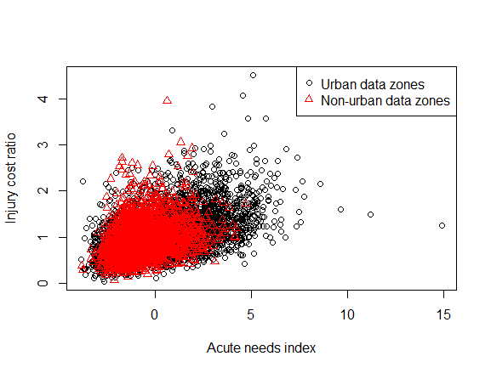

*Figure 6: Scatter plot of Injury cost ratios against Acute needs index, showing urban and non-urban data zones.*

*Table 8. Coefficients summary of results for (1) the new Acute model and (2) two shortfall models: ‘1’ being with remote and rural areas separated out, and ‘2’ being with urban areas separated out. 95% confidence intervals are shown in brackets.*

|  |  |  |  |  |  |
| --- | --- | --- | --- | --- | --- |
| **Diagnostic group** | **Unadjusted new Acute Index coefficient** | **Short-fall model** | **New Acute index coefficient** | **Significance**  **of binary variable** | **Significance**  **of interaction**  **term** |
| **Cancer** | 0.054  (0.048, 0.060) | 1 | 0.053 (0.047, 0.059) | 🗶 | ✓ |
| 2 | 0.056 (0.041, 0.072) | 🗶 | 🗶 |
| **Heart** | 0.116  (0.110, 0.122) | 1 | 0.116 (0.110, 0.121) | ✓ | 🗶 |
| 2 | 0.120 (0.105, 0.135) | 🗶 | 🗶 |
| **Digestive** | 0.117  (0.112, 0.122) | 1 | 0.117 (0.112, 0.122) | ✓ | 🗶 |
| 2 | 0.119 (0.106, 0.131) | ✓ | 🗶 |
| **Injury** | 0.120  (0.115, 0.126) | 1 | 0.121 (0.116, 0.126) | ✗ | 🗶 |
| 2 | 0.104 (0.091, 0.118) | ✗ | ✓ |
| **Other** | 0.097  (0.094, 0.100) | 1 | 0.097 (0.094, 0.100) | ✗ | 🗶 |
| 2 | 0.098 (0.090, 0.107) | ✗ | 🗶 |
| **Respiratory** | 0.185  (0.179, 0.192) | 1 | 0.185 (0.179, 0.192) | ✗ | 🗶 |
| 2 | 0.177 (0.160, 0.194) | ✗ | 🗶 |
| **Outpatients** | 0.037  (0.035, 0.039) | 1 | 0.036 (0.034, 0.038) | ✗ | 🗶 |
| 2 | 0.033 (0.028, 0.039) | ✗ | 🗶 |

**4. Conclusions**

The analysis does not suggest implementing an unmet need adjustment for the data zones with the highest proportion of the population being Pakistani or Gypsy/Traveller – the ethnic groups reported to have the poorest health outcomes. Given this, it is unlikely that any other ethnic groups are under-utilising Acute healthcare to an extent that significantly alters the slope of the fitted model. This is especially the case given that data zones are not generally homogeneous with respect to ethnicity to the same extent that they are with respect to deprivation or urban/rural setting.

There is also no imperative to adjust for unmet need in either the most rural or the most urban data zones.

There is, however, a significant shortfall from the expected utilisation in the data zones with the highest needs index values, for Heart and Other diagnostic groups, which significantly alters the slope of the fitted line as compared to when these data zones are excluded from the regression. It should be borne in mind that this only indicates downward deviation from linearity at the high end of the needs index and not *necessarily* unmet need. However, the new results are consistent with the fact that there is already an unmet need adjustment in the model for Heart; and Figure 5 shows that areas with high needs index values are also areas where many people die prematurely of heart conditions – which is further evidence that the utilisation at the high end of the needs index should be higher than it is, for Heart.

It has not been possible yet to check for unmet need in the most deprived data zones as defined by SIMD, due to the unavailability of SIMD at the 2011 data zones. The subgroup may wish to consider the benefits and drawbacks of carrying out additional unmet need investigation based on SIMD after August and allowing TAGRA to make a final decision on what is implemented.

**Q: Currently, there is an unmet need adjustment for Heart to exclude the 25% of areas with highest need from the regression. Should we recommend changing this to 30% for Heart, and / or introducing an adjustment for Other (excluding data zones in the top 5% of needs index values)?**

A core criteria evaluation is included below.

|  |  |
| --- | --- |
| **Equity** | In general, allowing the fitted model to have a steeper slope through unmet need adjustments arguably helps improve equity by allocating more resources to the most needy. For Heart, using the 30% cut-off results in a bigger increase to the needs index coefficient, as compared to using the 25% cut-off – although the difference is small.  However, it should be considered whether the relationship between the needs index and underlying need – or between need and cost – is simply non-linear and there is no unmet need. If there is deemed to be unmet need, it should also be considered whether greater allocations will help. |
| **Practicality** | No substantial difference in practicality. |
| **Transparency** | No difference in transparency. |
| **Objectivity** | The change in the coefficient (slope of the fitted line) using any of these adjustments is statistically significant.  There is additional evidence for Heart-related unmet need: the new results are consistent with the fact that there is already an unmet need adjustment in the model for Heart; and Figure 5 shows that areas with high needs index values are also areas where many people die prematurely of heart conditions – which suggests that the utilisation at the high end of the needs index should indeed be higher than it is.  Using the 30% cut-off for Heart results in a bigger increase to both the adjusted R2 and the needs index coefficient, as compared to using the 25% cut-off – although the difference between the two is small. |
| **Avoiding perverse incentives** | Neither the current nor the potential new unmet need adjustment sets up a perverse incentive. |
| **Relevance** | No difference in terms of relevance. |
| **Stability** | No difference in stability anticipated for Heart.  For Other, because the optimal cut-off point seems to be 5%, this could possibly be less stable due to fluctuations at the extreme end of the needs index. |
| **Responsiveness** | The current and the potential new adjustment are both able to be updated whenever the needs index values are updated.  For Heart, using the 30% cut-off results in a bigger increase to the needs index coefficient, as compared to using the 25% cut-off – although the difference is small. |
| **Face validity** | For Heart, the old and the potential new adjustment both have face validity: untreated heart disease can cause sudden death and so it is plausible that lower levels of resource are utilised where there is unmet need for diagnosis and treatment. The consistency of the current results with previous analysis (in terms of Heart showing significant under-utilisation) also lends validity.  For Other, lower-than-expected utilisation is more difficult to intuitively understand in terms of unmet need. |

**ANNEX A: Further methodological details**

**A.1 The simple shortfall method**

The spline variable included in the simple shortfall method is defined using the Acute needs index values (*xi*, where *i* represents the data zone and is between 1 and 6976). A spline is included for only the most deprived end (70th to 95th percentiles) and it is defined as:

*xiH* = *xi – k* if *xi > k*

=0 if *xi ≤ k*

where *k* is the percentile being used. The spline variable is included in the linear regression model in addition to the supply variables, Health Board dummies and the Acute needs index. If the sign of the regression coefficient of the spline variable is negative and it is significant (p-value less than 0.05), then there is significant under-utilisation in the data zones with highest needs index values (under the assumption of a linear relationship).

**A.2 The 2007 shortfall method**

The model fitted can be represented algebraically as

$${\text{cost} \text{ratio}}_{i}= β_{0}+{\sum_{k}{β_{k}}\text{HB} \text{dummy}}_{ik}+ β_{14}{\text{IPACX}}_{i}+β_{15}{\text{OPACX}}_{i}+ β_{16}{\text{acute} \text{index}}_{i}+β_{17}{\text{deprived}}_{i}+β_{182219riese, and respectively for ion and rurality effects }{\text{acute} \text{index}}_{i}×{\text{factor}}_{i}+{\text{error}}_{i}$$

for *k* = 1…13, with the subscript *i* referring to the data zone. (There are fourteen HB variables, but one is excluded because only thirteen are mutually independent.)

With $β_{17}$ equal to $β_{0}$ and $β_{18}$ equal to $β_{16}$, the model reverts to the reference model. If $β_{17}$ is significantly different from $β_{0}$ (p-value less than 0.05), then the *intercept* of the regression line is different for the most deprived areas compared to the non-affected areas. However, if $β_{18}$ is significantly different from $β_{16}$, then the *slope* of the regression line is different for the most deprived areas.

**Annex B: Scottish Government 6-fold Urban-Rural Classification**

|  |  |
| --- | --- |
| **1 Large Urban Areas** | Settlements of 125,000 or more people. |
| **2 Other Urban Areas** | Settlements of 10,000 to 124,999 people. |
| **3 Accessible Small Towns** | Settlements of 3,000 to 9,999 people and within 30 minutes drive of a settlement of 10,000 or more. |
| **4 Remote Small Towns** | Settlements of 3,000 to 9,999 people and with a drive time of over 30 minutes to a settlement of 10,000 or more. |
| **5 Accessible Rural** | Areas with a population of less than 3,000 people, and within a 30 minute drive time of a settlement of 10,000 or more. |
| **6 Remote Rural** | Areas with a population of less than 3,000 people, and with a drive time of over 30 minutes to a settlement of 10,000 or more. |

1. <http://www.gov.scot/Publications/2015/08/7995/downloads>