TAGRA ACUTE MLC SUBGROUP Thursday 21st July 2016
UNMET NEED ANALYSIS FOR NEW ACUTE MLC MODEL PART 2

1. Background and Summary
At the June 2016 Acute MLC meeting, results were presented from the unmet need analysis (paper TAMLC55). Shortfall methods were used to look for differences in the relationship between utilisation of services and the new Acute needs index (which comprises the limiting long-term illness ratio and the all-cause standardised mortality ratio for ages 0-74) for neighbourhoods sharing a particular characteristic of interest, as compared to the rest of the country. In particular, the analysis looked for evidence of a shortfall in the use of services in the areas with the highest needs index values, the most urban areas, the most rural areas, and the areas with the largest proportions of their population belonging to particular ethnic groups identified as having higher healthcare needs.
A provisional decision was made to recommend an unmet need adjustment for the Heart diagnostic group, based on excluding the 30% of data zones with the highest needs index values from the regression. This was agreed because:
- The simple shortfall model revealed a significant decrease in the effective gradient between utilisation and needs index, at the high end of the needs index (β₂ < β₁ in Figure 1); moreover, the fitted slope that would be obtained with the top 30% of data zones excluded (β₁) was significantly higher than the ‘unadjusted’ slope obtained by fitting the linear model to all data zones.
- Interpreting the under-utilisation as unmet need made sense for Heart, since unmet need could result in sudden death.
- Supplementary analysis showed that the standardised mortality ratio for heart-related deaths did not tail off at the upper end of the needs index in a similar way to cost, but actually showed an increase in gradient, which further suggests need that is not being met.
- There is currently an unmet need adjustment for Heart, which suggests that the above observations are consistent and robust. (However, this does also highlight that more needs to be done to address the unmet need besides adjusting the allocation, and this should be noted in the recommendations to TAGRA.)
A cut-off point of 30% was chosen because, out of all the trial cut-points used with the simple shortfall model, it resulted in the highest R² value. The recommendation is provisional because it was also agreed to carry out analysis to look for deprivation-related unmet need using SIMD 2016 with the 2007 shortfall method, once SIMD 2016 is released. Paper TAMLC59 provides further detail on the planned analysis and a possible strategy for deciding on a final recommendation.
The analysis highlighted one further diagnostic group – Other – for which the fitted slope would significantly increase if data zones with the highest needs index values were excluded from the regression. However, it is more difficult to judge whether this should be interpreted as unmet need, given the varied mixture of condition groups comprised within Other (Table 1). The analysts were asked to carry out further investigation. This paper presents the analysis around possible unmet need within Other at high values of the needs index (section 2), and summarises the questions and issues for the subgroup to discuss in deciding whether to recommend an unmet need adjustment for Other (section 3).
Table 1. Acute expenditure and activity within ‘Other’, by high-level ICD10 classification
ICD-10 group | Actual spend 2013/14 | Number of episodes 2013/14
Symptoms, signs and abnormal clinical and laboratory findings, not elsewhere classified | £319m | 204,912
Diseases of the musculoskeletal system and connective tissue | £221m | 92,259
Diseases of the genito-urinary system | £198m | 101,434
Diseases of the nervous system | £92m | 38,272
Certain infectious and parasitic diseases | £87m | 40,811
Factors influencing health status and contact with health services | £81m | 57,698
Diseases of the skin and subcutaneous tissue | £71m | 32,433
missing | £70m | 25,176
Diseases of the eye and adnexa | £70m | 50,347
Endocrine, nutritional and metabolic diseases | £51m | 28,893
Mental and behavioural disorders | £38m | 16,406
Congenital malformations, deformations and chromosomal abnormalities | £30m | 9,669
Diseases of the blood and blood-forming organs and certain disorders involving the immune mechanism | £28m | 21,625
Diseases of the ear and mastoid process | £9m | 6,653
Certain conditions originating in the perinatal period | £2m | 1,281

2. Analysis
In paper TAMLC55, evidence was found of a shortfall in utilisation at the high end of the needs index for Other. This was found using the “simple shortfall method”, which involves the use of a model with a break of slope, as illustrated in Figure 1 (mathematical details of this model are included in Annex A). The purpose of fitting this model is to identify whether the effective gradient of the relationship between needs index and cost decreases significantly at the high end of the needs index.
Utilisation
cut-off point
slope β₂
slope β₁
Acute needs index
Figure 1: Illustration of the simple shortfall model.

The analysis found that for Other, β₂ was significantly lower than β₁, and β₁ was significantly higher than the unadjusted slope (i.e. the slope coefficient of the simple linear model), for a large range of cut-off points. This suggested the possibility of unmet need for which an adjustment could make a difference. An adjustment would be implemented in the formula by fitting the simple linear model only to the data zones below a cut-off point; this linear model would have slope equal to β₁, and would be used to predict need for all data zones, effectively extrapolating the fitted line into the data zones above the cut-off point. The highest-R² criterion selected an optimal cut-off point of 5%.
Figure 2 shows the effect of fitting the simple shortfall model (with the 5% cut-off point), as compared to the simple linear model. The line in black shows the fitted simple linear model, while the shortfall model is shown in green. If an unmet need adjustment were adopted with a 5% cut-off, the data zones in red would be excluded from the regression. The dashed green line indicates how the adjusted slope obtained by the regression would be extrapolated.
Analysis was carried out to see whether influential outliers were responsible for the significant deviation from linearity. This was not the case; removing the most outlying points did not change the results.
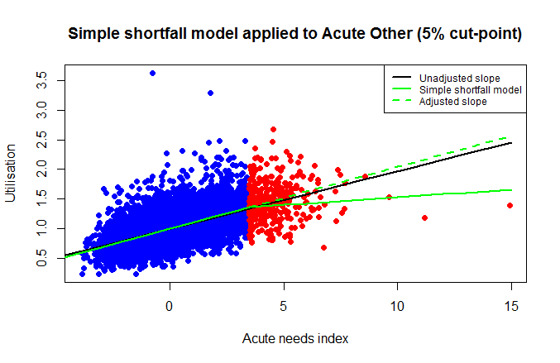
Figure 2: Scatter plot of Other cost ratios against Acute needs index, showing the 5% of data zones with the highest needs index in red, and the effect on the slope when the simple shortfall method is applied with this cut-off.

Figure 3 shows the value of β₁ (with confidence intervals) against trial cut-off point; the unadjusted slope is shown as a reference line. Figure 4 shows the adjusted R² obtained from the shortfall model using each trial cut-off point.
These plots show that:
- The slope β₁ increases continuously with the cut-off point, becoming significantly different from the unadjusted slope by the time a cut-off point of 4% is reached. This suggests that the reduction of the effective gradient towards the high end of the needs index is robust, and not just a result of (possibly random) differences in the few data zones at the very end.
- Although a 5% cut-off point results in the highest adjusted R² value (by a tiny margin), the slope β₁ obtained using a cut-off point of 30% is significantly higher than that obtained with a cut-off point of 5%.
- The adjusted R² is actually near-constant across the range of possible cut-off points.

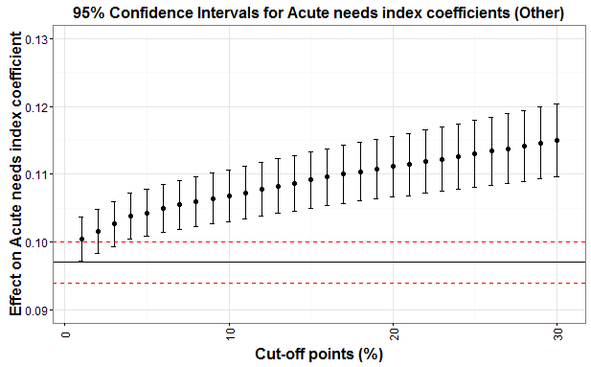
Figure 3: Slope β₁ (see Figure 1) against trial cut-off point, for the simple shortfall model fitted to the “Other” diagnostic group. Error bars represent 95% confidence intervals. The horizontal line shows the unadjusted slope; the 95% confidence interval is indicated with dashed red lines.

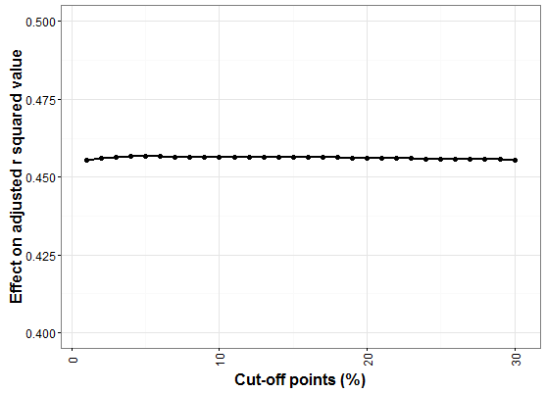
Figure 4: Adjusted R² for the simple shortfall model against trial cut-off point used, for “Other” diagnostic group.

Figure 5 shows a scatter plot with the fitted shortfall model using a 30% cut-off point, for comparison with Figure 2. Note that the difference in gradient between the unadjusted line (black) and the adjusted line (green and dashed green) is visibly larger than in Figure 2.
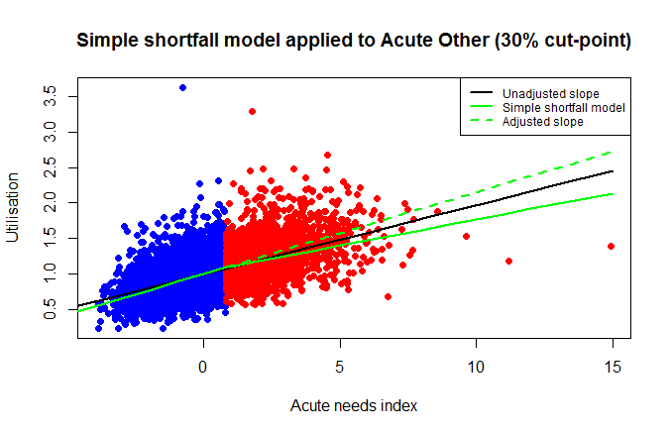
Figure 5: Scatter plot of Other cost ratios against Acute needs index, showing the 30% of data zones with the highest needs index in red, and the effect on the slope when the simple shortfall method is applied with this cut-off.

In paper TAMLC55, the relationship between heart-related premature deaths (measured by the heart SMR <75) and the needs index appeared to be one of proportionality with no tail-off at the high end of the needs index. This lent support to the interpretation of the shortfall as unmet need for these populations. Figure 6 shows a plot the SMR <75 for causes of death corresponding to the Other diagnostic group, against the needs index. Although there is a large amount of scatter, the observation is similar to that for heart-related deaths.

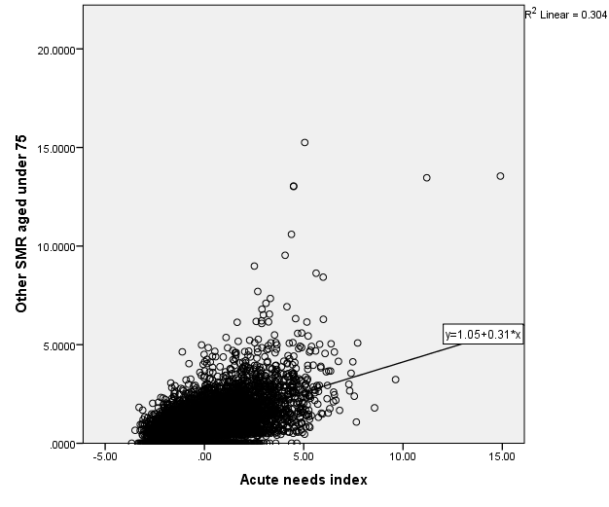
Figure 6: Scatter plot of Other SMR < 75 against Acute needs index, with best-fit line shown (linear least squares).

Finally, to explore whether the non-linearity in Figure 5 is due to one specific ICD-10 group within Other, the two largest ICD-10 groups – Symptoms & signs and Musculoskeletal disease (see Table 1) – were, in turn, excluded from the cost ratios. In both of these cases the non-linearity was still present and not substantially changed from that shown in Figure 5. This implies that no one code group or condition group is responsible for the non-linearity, but rather, that it seems to arise in the combination of all those groups listed in Table 1.

3. Discussion
There are two questions for the subgroup to consider. Firstly, does it make sense to interpret the above analytical results as evidence of unmet need, and therefore, to recommend to TAGRA an unmet need adjustment for Other? Secondly, if an unmet need adjustment is to be recommended, which cut-off point should be used? The following sub-sections provide discussion points for the subgroup to consider.
3.1 Is the deviation from linearity due to unmet need?
Under the assumption of a linear relationship, there is a shortfall in utilisation (age-sex standardised expenditure) at high needs index values. It is unclear whether this should be interpreted as unmet need for Other, given the varied mixture of condition groups comprised within Other (Table 1), and the fact that neither of the two largest code groups appear to account fully for the shortfall observation.
The simple shortfall method relies heavily on the assumption of an underlying linear relationship between needs index and cost, for which no theoretical justification has been provided. Arguably, therefore, evidence from the simple shortfall method is not sufficient to infer unmet need, and should be accompanied by further reasoning (i.e. face validity) if an unmet need adjustment is to be considered.
There are generally higher rates of death with causes corresponding to the Other diagnostic group, in neighbourhoods with the highest values of the needs index (Figure 6). There is no appearance of a tail-off in the gradient of Figure 6 similar to the tail-off in the costs of treatment in Figure 5. This does suggest there may be unmet need; however, we do not know if unmet need would be expected to result in lower costs, or whether the costs might be the same or even higher where there is unmet need (due to, for example, presenting at later stages of illness). Clinical advice has been sought from public health consultants within ISD, but no relevant clinical insights have been suggested.
3.2 If we need an unmet need adjustment, what cut-off point should be used?
Although a 5% cut-off point resulted in the highest adjusted R² value (by a tiny margin) in the analysis, the slope β₁ obtained using a cut-off point of 30% is significantly higher than that obtained with a cut-off point of 5% (Figure 3). It may be worth considering 30% if an unmet need adjustment is to be adopted, given that there is a negligible difference in R² between all of the options; if the non-linearity is deemed to be due to unmet need then the cut-off point that maximises the adjusted slope also maximises equity.
The slope β₁ does continue to increase as the cut-off point is further increased beyond 30% (not shown), but more slowly, and is never significantly higher. Cut-off points beyond 30% would therefore not be worth the loss in precision (Figure 3 shows how the β₁ confidence interval widens as the cut-off is increased).

Annex A: Simple shortfall method
The following model is fitted to the data in order to test for a change in slope:
Cost ratios ~ HB dummies + Supply + Acute needs index + spline
The spline variable is defined using the Acute needs index values (x_{i}, where i refers to the data zone), as:
x_{i}^{H} = x_{i} – k if x_{i} > k
= 0 if x_{i} ≤ k
where k is the needs index value corresponding to the cut-off point being used. This term allows the slope to change at x_{i} = k.
If the sign of the regression coefficient of the spline variable is negative and it is significant (p-value less than 0.05), then there is significant under-utilisation in the data zones with highest needs index values (under the assumption of a linear relationship).

The fitted lines shown in Figure 4 of paper TAMLC55 were projections of the full fitted models, which had included supply variables. As such, they did not appear (in the projection) to go through the centroid of the data points. In Figure 2 of the current paper, the intercept is rescaled in the same way as would be done when evaluating the predictions in the NRAC formula. The slopes are unchanged: these are the needs index coefficient values from full regressions including supply variables.

