TAGRA ACUTE MLC SUBGROUP Wednesday 14th January 2015
EXPLORATORY ANALYSIS – OUTLIERS AND AGE SPLIT

1. Summary
This paper outlines the initial results on the exploratory analysis done by the analytical team mainly on the relationship between age and need by diagnostic group. An initial investigation on the presence of cost ratio outliers and influential points, for all ages, has been performed at Intermediate Zone level using the current needs index (comprised of 2001 Census Limiting Long-term Illness (LLTI) data and all-cause standardised mortality rate ages 0-74). However, the results of this work have not been included in the paper as their relevance is dependent on the outcome of paper TAMLC 20.

The main focus of this paper is the question of whether to split the data into different age groups for the MLC analysis, and if so, whether to use the same age split for all diagnostic groups or to apply different splits. Some initial analysis has been carried out looking at the relationship between age and need by diagnostic group using the age/sex cost curves, using cost and activity data for the 2012/13 financial year. These show that Acute healthcare costs are generally elevated (weakly) in infancy and (strongly) in old age, and that the shape of these curves differs somewhat between diagnostic groups. Input from consultants has been sought on whether clinical knowledge and expertise can provide useful direction for the examination of MLC factors in different age groups, and the general advice received is that it cannot.

2. Age split
2.1 Age split analysis and AST group discussion
Age/Sex cost curves are produced for each Acute diagnostic group and for all Acute patients combined, using cost and activity data for 2012/13, in order to look for indications of where any age splits might occur naturally.
The cost per head, or more specifically cost per person-year (£), is calculated by dividing Scotland’s overall expenditure for the particular diagnostic group (in each age and sex group) by Scotland’s population (in each respective age and sex group). The cost per person-year is therefore not equivalent to the cost per case. The curves produced and applied below (Figure 1) plot the cost per person-year (£) against the age group (the blue line represents males and the green line represents females). For more information on the conditions involved, the top five conditions in each of the Acute diagnostic groups are detailed in Appendix A.

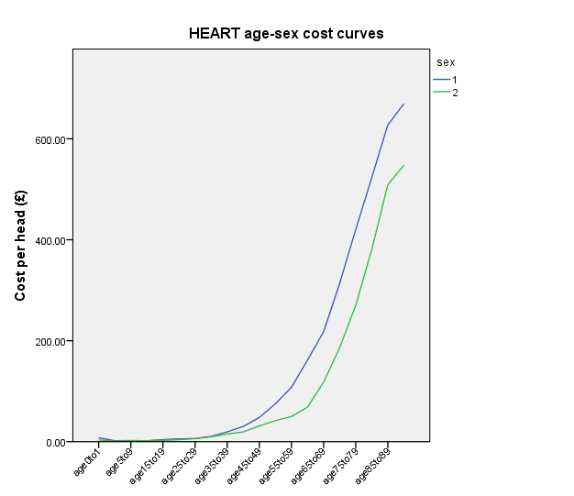
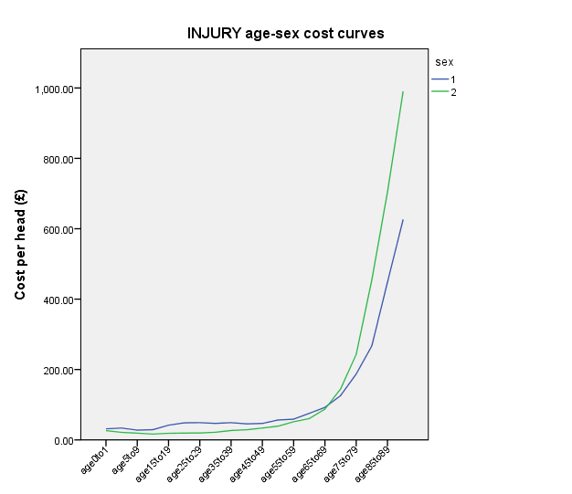
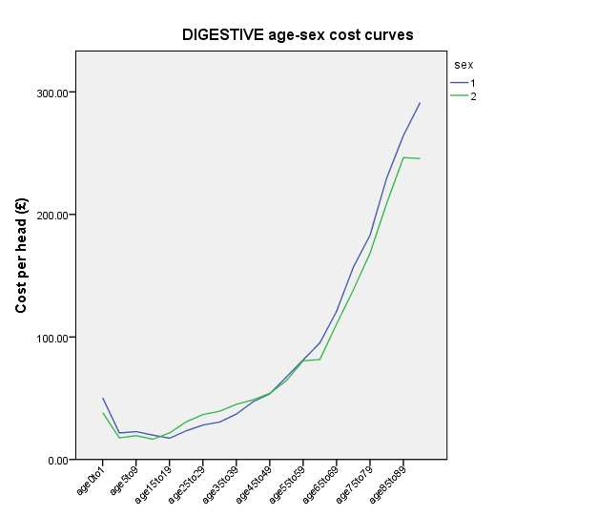
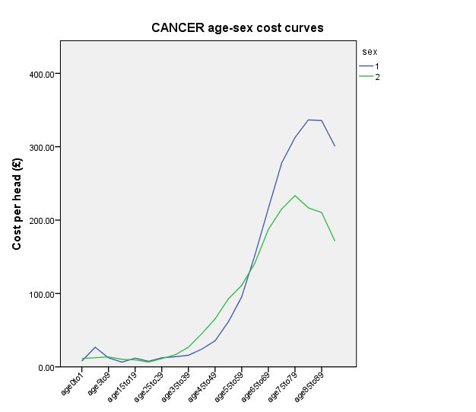
Figure 1: Age/Sex cost curves for each diagnostic group and for all Acute patients combined.

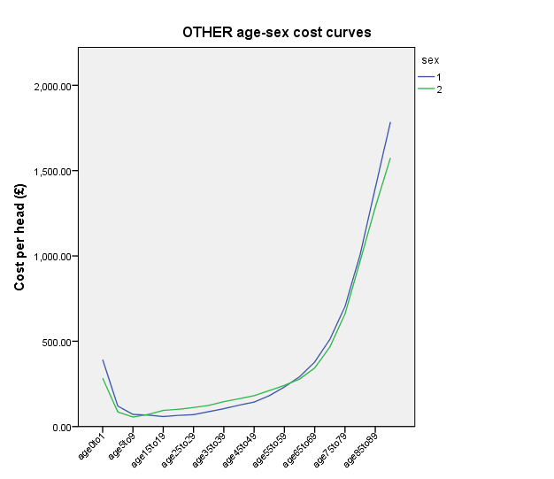
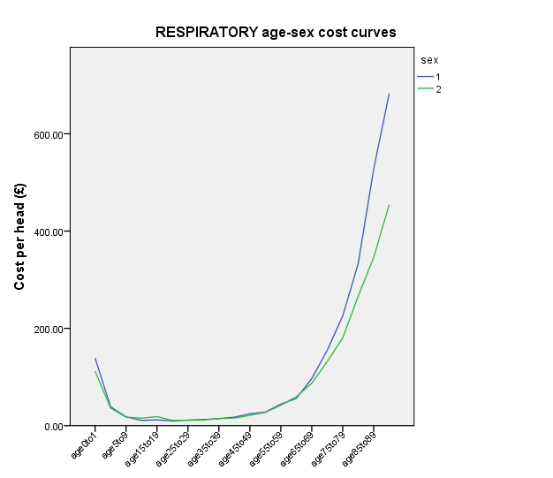
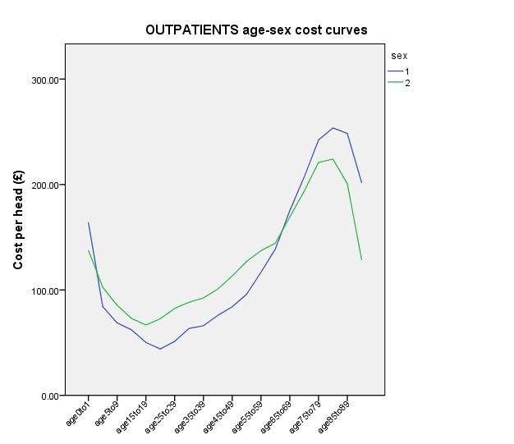
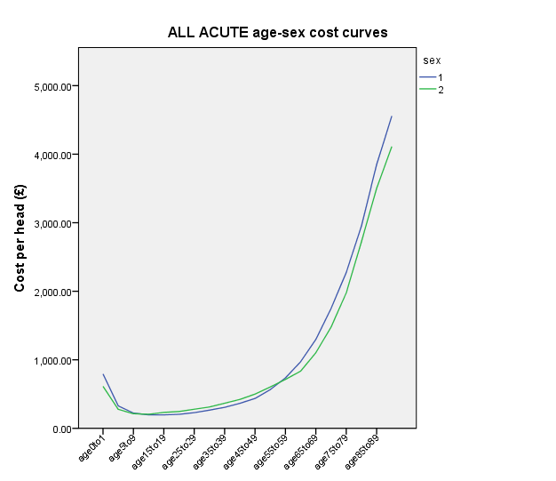
The age/sex cost curves for Cancer Acute (Inpatients and Daycases) and for Acute Outpatients have different shapes compared to the age/sex cost curves for all Acute patients. For cancer, the roll-off at older ages reflects the tendency towards palliative care as opposed to curative treatments in older patients. (The cost curves for specific cancer types are shown in Appendix B, and demonstrate the contributions of different cancers to the specific shapes of the overall curves, including the sex difference.)
However, generally, the cost curves all show a similar weakly elevated healthcare need from infancy into middle childhood, and then a large increase towards old age. This could imply a single age split dividing these two phases, which undoubtedly represent different underlying disease patterns with different determinants that may, therefore, have different relationships with MLC variables such as deprivation. (For example, if it were the case that costly diseases of infancy were mostly genetic or ‘random’ in origin whereas the prevalence of diseases of late adulthood more often reflected environmental and life circumstances, this would imply treating these two groups separately in regard to MLC factors.)
On the other hand, given the relative dominance of late-adulthood within the cost curves, it may be difficult to justify separate modelling for children and younger adults, both in terms of establishing a reliable relationship and in terms of the impact this would make to the formula in practice.
These issues have been discussed with ISD clinical consultants, whose advice has been that there are no confident clinical grounds for imposing a split by age group, and the introduction of any such split should be driven by the data itself. There is indeed likely to be variation in the effect of MLC with age – for example, a ‘deprivation gap’ in cancer survival rates that is observed among older people only – but it is difficult to generalise about such variation; different conditions will vary differently.
2.2 Age split in other countries
There are a number of published reviews summarising resource allocation methodologies in several countries,, which may provide a useful reference point. There appears to be a large diversity in how populations are weighted for additional needs. In some cases, every combination of age band, sex and additional needs factors has its own cell in a large matrix and a corresponding weighting for that particular combination is derived. In other cases, some of the cells in the matrix are combined, or the additional needs factors are treated as independent of age and sex and applied as a single subsequent weighting. This latter approach is used in our nearest neighbour, England, in which additional needs analysis is carried out separately in each care programme but not in different age or sex groupings.

Decisions required from subgroup
- Should we split the analysis into different age groups? If so, how should these be defined?
- Could members of the subgroup propose clinical colleagues that could provide further advice on the age split?

Appendix A: Most frequent ICD10 codes in each diagnostic group
The tables below give the five most frequent diagnoses in each diagnostic group, along with their ICD10 codes, frequencies and percentages within the group. The cumulative percentage column shows, in red, the overall percentage of the group comprised by these five conditions. The top row indicates the total number of diagnoses for the group.
Top 5 ICD10 codes - Cancer
ICD10 code | Frequency | Percent | Cumulative Percent | Diagnosis
Total | 199579 | 100
C50 | 21667 | 10.9 | 10.9 | Malignant neoplasm of breast
C34 | 17013 | 8.5 | 19.4 | Malignant neoplasm of bronchus and lung
C18 | 12084 | 6.1 | 25.5 | Malignant neoplasm of colon
C90 | 8957 | 4.5 | 30 | Multiple myeloma and malignant plasma cell neoplasms
D12 | 7536 | 3.8 | 33.8 | Benign neoplasm of mesothelial tissue
Top 5 ICD10 codes - Heart
ICD10 code | Frequency | Percent | Cumulative Percent | Diagnosis
Total | 148758 | 100
I21 | 21843 | 14.7 | 14.7 | Acute myocardial infarction
I25 | 14555 | 9.8 | 24.5 | Chronic ischaemic heart disease
I48 | 12454 | 8.4 | 32.9 | Atrial fibrillation and flutter
I50 | 11970 | 8 | 40.9 | Heart failure
I63 | 10146 | 6.8 | 47.7 | Cerebral infarction
Top 5 ICD10 codes - Respiratory
ICD10 code | Frequency | Percent | Cumulative Percent | Diagnosis
Total | 133219 | 100
J18 | 30081 | 22.6 | 22.6 | Pneumonia, organism unspecified
J44 | 29469 | 22.1 | 44.7 | Other chronic obstructive pulmonary disease
J22 | 19928 | 15 | 59.7 | Unspecified acute lower respiratory infection
J45 | 8326 | 6.2 | 65.9 | Asthma
J03 | 5733 | 4.3 | 70.2 | Acute tonsillitis
Top 5 ICD10 codes - Digestive
ICD10 code | Frequency | Percent | Cumulative Percent | Diagnosis
Total | 193084 | 100
K80 | 16224 | 8.4 | 8.4 | Cholelithiasis
K57 | 14317 | 7.4 | 15.8 | Diverticular disease of intestine
K52 | 14251 | 7.4 | 23.2 | Other noninfective gastroenteritis and colitis
K29 | 9665 | 5 | 28.2 | Gastritis and duodenitis
K92 | 9523 | 4.9 | 33.1 | Other diseases of digestive system
Top 5 ICD10 codes - Injury
ICD10 code | Frequency | Percent | Cumulative Percent | Diagnosis
Total | 118638 | 100
S72 | 13554 | 11.4 | 11.4 | Fracture of femur
T81 | 8107 | 6.8 | 18.2 | Complications of procedures, not elsewhere classified
S09 | 6302 | 5.3 | 23.5 | Other and unspecified injuries of head
S82 | 6161 | 5.2 | 28.7 | Fracture of lower leg, including ankle
S52 | 6059 | 5.1 | 33.8 | Fracture of forearm
Top 5 ICD10 codes - Other
ICD10 code | Frequency | Percent | Cumulative Percent | Diagnosis
Total | 660654 | 100
R07 | 36738 | 5.6 | 5.6 | Pain in throat and chest
R10 | 33873 | 5.1 | 10.7 | Abdominal and pelvic pain
H26 | 29534 | 4.5 | 15.2 | Disorders of lens - Other cataract
N39 | 28058 | 4.2 | 19.4 | Other disorders of urinary system
Z53 | 17839 | 2.7 | 22.1 | Persons encountering health services for specific procedures, not carried out

Appendix B: Age/sex cost curves for specific cancer types
Age-sex cost curves are shown below for the three most common cancers in each sex. Prostate, trachea, bronchus and lung, and colorectal cancers collectively account for 52% of cancers in men. Breast, trachea, bronchus and lung, and colorectal cancers account for 56% of cancers in women.
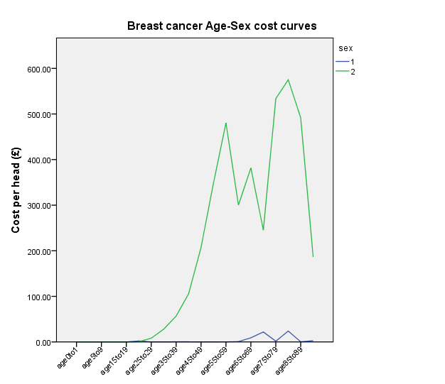
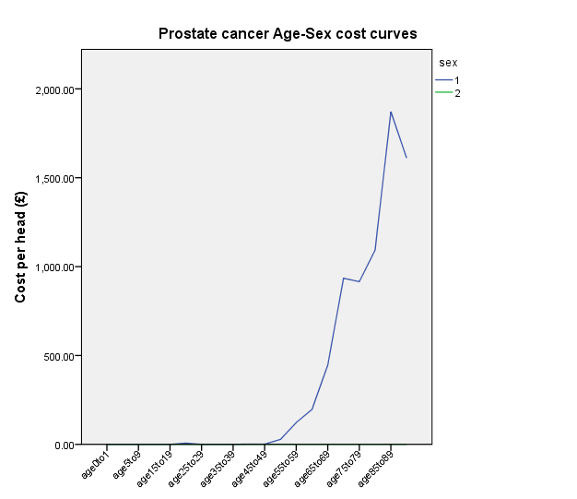
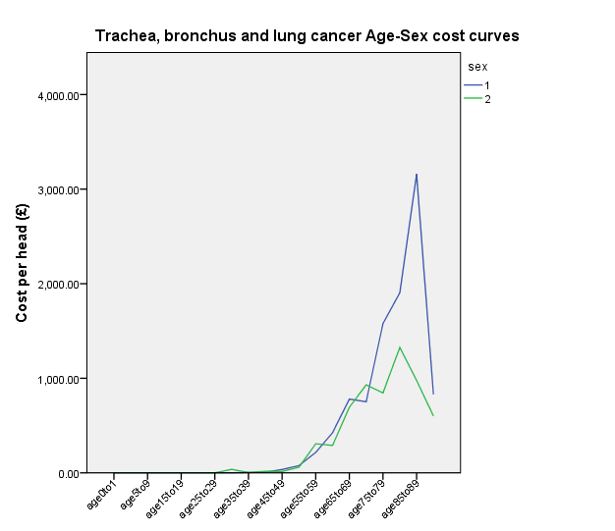
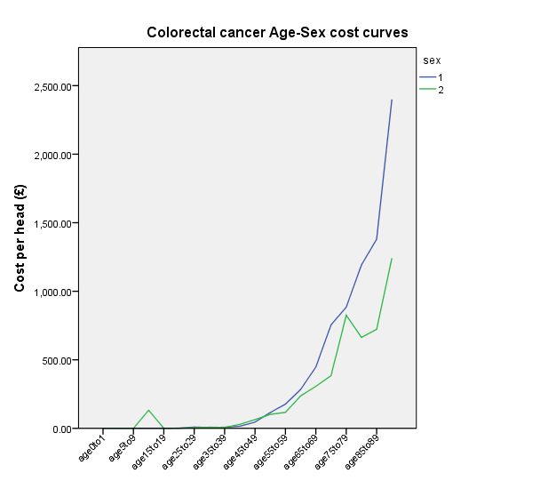
The decrease in the Cancer cost per head after 90 years of age results from a sharp decrease in Trachea, bronchus and lung cancer cost per head in men and a sharp decrease in Breast cancer cost per head in women.
The sex difference in Cancer cost per head after 70 years of age is explained by the higher costs per head in men for Trachea, bronchus and lung cancer and in Colorectal cancer in that age bracket. The higher Cancer cost per head in women between 30 and 60 years age is explained by the sharp increase in Breast cancer cost per head in women.

Rice N and Smith P. Capitation and risk adjustment in health care financing: an international progress report. The Milbank Quarterly 2001; 79(1): 81-113.
Rice N and Smith P. Approaches to capitation and risk adjustment in health care: an international survey. Centre for Health Economics Occasional Paper. Centre for Health Economics, University of York,.1999
Parkin N, McLeod H. Risk equalisation methodologies: an international perspective. CARE Monograph No. 3. Centre for Actuarial Research. University of Cape Town, 2001.

