**TAGRA ACUTE MLC SUBGROUP Wednesday 14th January 2015**

**POTENTIAL CANDIDATE VARIABLES – Issues around SIMD and Redrawn Data Zones**

***Background***

The morbidity and life circumstances adjustment is calculated by looking for the factors that best explain the variation in actual costs of healthcare between small areas for each care programme, using statistical regression analysis. The utilisation of healthcare is represented by the ratio of actual costs (taking into account activity type and length of stay in that specific neighbourhood) to the expected costs (based on the neighbourhood’s population and national age/sex average cost per head) and the analysis looks for the indicators which best predict this cost ratio, across small areas, in a regression analysis.

An important part of updating the existing MLC adjustment for the acute diagnostic groups is the choice of indicators. The TAGRA core criteria of ‘Transparency’ and ‘Face Validity’ imply that we consider and select only indicators which have a theoretical link to acute health need, rather than to undertake a data mining exercise to identify indicators which may not be clearly connected to acute health but which perform well in a statistical sense in a cross-sectional analysis. An extremely detailed paper of Potential Candidate Variables was presented to the Acute MLC subgroup on 12th March 2014 (paper TAMLC03) and a revisited version was presented on 14th May 2014 (paper TAMLC09). This paper provides the latest update of the information available on indicators to improve the Acute Morbidity and Life Circumstances (MLC) part of the NRAC formula.

***1. Summary***

On 6th November 2014, the Scottish Government released the redrawn Data Zones and Intermediate Zones boundaries. The Scottish Index of Multiple Deprivation (SIMD) 2012 domains represent a substantial number of the potential indicators and it has been confirmed by the Scottish Government SIMD team that SIMD 2012 will not be recalculated based on the redrawn Data Zones. The next update of SIMD in 2016 will be based on the new Data Zones.

Another issue arising from the redrawn geographies is that the mid-year population estimates at the redrawn Data Zones will not be available until August 2015 (2001-2014 population estimates) and mid-year population estimates at the old Data Zones may not be available from mid-2014 population estimates onwards. It has not yet been established when the redrawn Data Zones will be incorporated into the NRAC formula.

This paper sets out the key issues relevant to the potential candidate variables and the redrawn Data Zones. Section 2 gives an overview of the consequences of the redrawing of Data Zones for the Acute MLC Review. Section 3 discusses the use of SIMD, noting the background of the discussion around it in the NRAC 2007 Review and in the Mental Health and Learning Difficulties MLC 2011-2012 Review. Expected changes to SIMD in the 2016 revision are also outlined. In Section 4, AST have attempted to outline options on the future work of the Acute MLC Review in light of the issues surrounding the redrawn Data Zones. These options have also been comparatively evaluated against the TAGRA core criteria. ***The subgroup is asked to consider the issues outlined and agree on their preferred option in terms of the future analytical work in relation to the Acute MLC review.***

Finally, section 5 includes information on additional suggested potential candidate variables discussed at previous Acute MLC subgroup meetings. An update on the progress of this is given. ***The subgroup is asked to discuss which of the suggested variables should be considered for further investigation****.*

***2. New Data Zones Release***

On 6th November 2014, the Scottish Government released the redrawn Data Zones and Intermediate Zones boundaries. The new redrawn Data Zones are known as Data Zones 2011 and the new redrawn Intermediate Zones are known as Intermediate Zones 2011, as they have been created following the release of the 2011 Census results. There are 6976 Data Zones 2011 and 1279 Intermediate Zones 2011 (471 Data Zones and 44 Intermediate Zones added). Around 40% of the Data Zones have had their boundaries changed.

In 2005, 683 (10%) of Data Zones 2001 and 57 (5%) of the Intermediate Zones 2001 violate the definitions (Data Zones have populations between 500 and 1000 residents and Intermediate Zones have populations between 2500 and 6000 residents). In 2013, 1140 (18%) of Data Zones 2001 and 130 (11%) of Intermediate Zones 2001 violate the definition. Histograms of the population distributions in 2005 and 2013 at both geographical levels are included in Appendix A. These clearly show how, at both geographical levels, the population distribution has widened over time.

A postcode to Data Zones 2011 lookup is provided by the Scottish Government and it can be used to recalculate all potential candidate variables available at postcode level. A Data Zones 2001 to Data Zones 2011 lookup (giving ‘best-fit’ matches) is not available and will not be produced since the changes are so extensive.

The main sources of data for potential indicators of need are the SIMD 2012, 2011 Census data and ISD data. The availability of these sources at Data Zones 2011 is as follows:

* SIMD 2012 – The SIMD 2012 will not be recalculated at Data Zones 2011. The SIMD 2016, scheduled for release in autumn 2016, will be based on Data Zones 2011.
* National Records Scotland (NRS) data – The 2011 Census data are available at Data Zones 2011 and have already been requested from NRS and will be provided in January 2015. The mid-year population estimates at the redrawn Data Zones will not be available until August 2015 and mid-year population estimates at the old Data Zones may not be available going forward.
* ISD data – The data produced internally by ISD can be recalculated at Data Zones 2011 using the Postcode to Data Zones 2011 lookup provided by the Scottish Government. It is important to note that delays may arise due to unavailability of the data sources at postcode level and data may not be available for the last three years.

Appendix C includes information on all potential variables – source, availability at Data Zones 2001, Intermediate Zones 2001, Data Zones 2011 and Intermediate Geographies 2011, and any additional notes.

***3. Scottish Index of Multiple Deprivation (SIMD)***

There are seven domains in the SIMD – Income, Access, Education, Housing, Crime, Employment and Health – each of which contain a number of variables (Appendix B visualises the structure of SIMD 2012). A score or rate is calculated for each domain, and the scores/rates of the domains are combined in the overall SIMD score.

The current version of SIMD was released in 2012. As stated above, a new version of the SIMD will be available in 2016 following a review, and will be based on the redrawn 2011 Data Zones. SIMD 2012 will not be re-calculated at these new Data Zones.

The suitability of SIMD for use in the MLC adjustment, aside from data availability issues, has been subject to previous discussion within NRAC/TAGRA. This section reviews and updates some of the arguments around the suitability of SIMD (or its sub-components) as Acute MLC potential predictor variables for healthcare need, and outlines what is possible in terms of its use in the current Acute MLC review.

***3.1 Previous use of the SIMD in the NRAC formula***

**NRAC 2007 Review**

The possible use of SIMD as part of the MLC analysis was discussed during the NRAC 2007 Review. This discussion is included in Technical report D[1]:

*“The overall SIMD score and the domain scores are published for Data Zones. The Index has many strengths such as:*

* *Wide range of data sources*
* *Domains values available, for data zones*
* *Relatively robust because it mostly add rates or counts for several complementary phenomena and because shrinkage techniques are applied to give some stability to DZ values*

*There are several potential weaknesses, some of which are common to most multiple domain measures.*

* *Although periodically updated, measures such as SIMD tend to change components or definitions at each update. There may be quite legitimate reasons for these changes, such as changes in the availability, or definition, of the data sources, especially relating to claimant counts.*
* *Although updating with different and improved data may be of benefit when planning local services or identifying neighbourhoods for targeted action, this can be unhelpful for allocation modelling as models have to be re-run and recalibrated when data sources are changed – and significant changes in allocations can result.*
* *Regular updating (without changes of definition) can be complex because of the shrinkage techniques and the difficulties of acquiring some of the data sources.*
* *They are complex to construct.*
* *The weights used to construct both the domain and the overall scores can be open to question.*

*It is also worth noting that the SIMD scores have not been computed for intermediate data zones. Although these values can be aggregated from the published data zone scores, as we have done for some of our exploratory analyses, this is not a strictly valid procedure as the index includes a number of non-linear transformations of component scores. For this reason, and for greater transparency, we will prefer to use individual variables (some of which are used in the SIMD domains) as components of the proposed indexes, rather than the SIMD scores.”*

The weaknesses of the SIMD overall score and the SIMD domain scores listed in the quotation above formed a strong basis for not using SIMD scores in the NRAC 2007 Review. However, subsequent developments and discussions with the Scottish Government SIMD team may change this picture to some extent. The changes described above to the components of SIMDare usually due to improvements in data quality or availability and are in line with the long term strategy for improvements; the requirement for stability is a common one among applications of SIMD, and so this is actually incorporated in any updates to SIMD. The overall SIMD scores (although perhaps not the individual domain indicators) are ensured to be relatively stable. The shrinkage techniques referred to above were removed for the 2012 version of SIMD, although it is not certain that this will not be reintroduced in 2016. While the weights used to combine the multiple domains may be open to question, arguably SIMD is a well-established and well-reviewed instrument for measuring deprivation in multiple categories through a single index, and may therefore perform better than ad-hoc indices based on measures and recording techniques that may be less stable over time. On the other hand, the difficulty in aggregating from Data Zones to Intermediate Zones remains (but this is addressed further in section 3.2 below).

**Mental Health and Learning Difficulties MLC 2011-12 Review**

The review of the Mental Health and Learning Difficulties (MH and LD) component of the MLC part of the formula, which commenced in July 2011 and was finalised in December 2012, chose two of the SIMD domain scores as needs indicators for the under 65 age cohort – Employment and Crime[2]. SIMD 2009 domain scores were used in the review, since SIMD 2012 was not published until December 2012. However, as shown in Table 1, high correlation coefficients are seen between SIMD 2012 and SIMD 2009 domain scores, particularly for the overall index[3]. This implies that if SIMD 2012 data could have been used for the MH and LD MLC Review, the results are likely to have been similar. In the present context, it could also be taken to suggest that using SIMD 2012 instead of SIMD 2016 may be unlikely to change significantly the Acute MLC Review outcomes. However, this can only be taken as indicative, as correlation coefficients between ranks (rather than scores) are difficult to interpret in a precise way.

*Table 1: Pearson’s correlations between SIMD 2009 ranks and SIMD 2012 ranks*

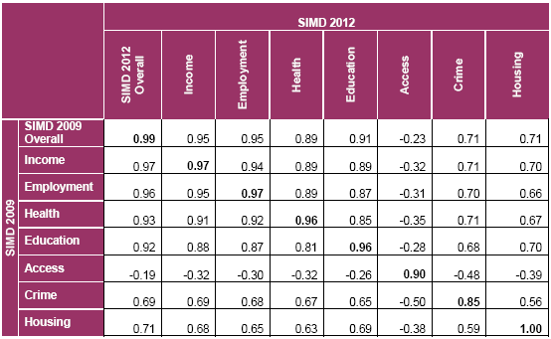

Within the MH and LD MLC review, Intermediate Zones were chosen as the geographical unit; however, SIMD scores are only calculated at Data Zone level. The method used in the MH and LD MLC Review to aggregate Data Zone SIMD 2009 domain scores to intermediate geographies was as follows:

1. For each Data Zone multiply the domain score by the mid year estimate of the population of the Data Zone
2. Sum the products from step 1 for all Data Zones within each intermediate geography
3. Divide the result from step 2 by the population of each intermediate geography

In short, the method used the population as a weight to aggregate the SIMD domain scores from Data Zones to intermediate geographies. One issue with this, in addition to those noted in the NRAC 2007 Review above regarding geographical aggregation, is that the employment domain scores are calculated by Department for Work and Pensions using Data Zone working age population data. This means that aggregating the domain scores using the total Data Zone population may not produce an accurate Intermediate Zone score.

***3.2 Current advice received on SIMD***

SIMD includes seven domains, including a health domain which contains indicators that, if used, would create a circular reference between conducting a needs assessment and directing funding towards need. The health domain score will be collinear to our mortality variables. To mitigate this, Scottish Government have proposed to develop an overall SIMD rank at Data Zone level without the health domain that would help remove the circularity effect.

The analytical team has been informed that there is currently no valid procedure to aggregate SIMD domain scores from Data Zones to intermediate geographies. The Scottish Government SIMD team have instead recommended using an approach which looks at either (1) the proportion of Data Zones within each Intermediate Zone that are ‘deprived’ (at some predefined deprivation level, e.g. the most deprived 15%), or (2) the ratio of the Intermediate Zone’s number of ‘deprived’ Data Zones to the national number of ‘deprived’ zones. These “local and national share methods” are the preferred methods of aggregating deprivation measures up to larger geographies, and remove the need to aggregate scores.

The Scottish Government SIMD team therefore recommends developing local or national share of deprivation by Intermediate Zone, using an SIMD excluding the health domain. This seems to be feasible, although it would mean that candidate predictive models for cost developed at Data Zone and Intermediate Zone level would be based, respectively, on different predictor variables. Also, it is important to bear in mind that a statistical evaluation of SIMD as a potential indicator variable in Acute MLC could only be done now using the old version of the Data Zones. Assuming SIMD appeared a significant predictor of need, coefficients could later be derived using Data Zones 2011 and SIMD 2016 when these data are available.

***3.3 SIMD 2016 expected changes***

Here an outline is given of the anticipated changes to SIMD in the 2016 version, to further inform a decision on its suitability.

Data collection for what was originally regarded as SIMD 2015 was planned to start in September 2014, but due to the delayed release of the 2011 Data Zones (planned for April 2014 but only released in November 2014), the next release of SIMD will now be in 2016 and the data collection will start in September 2015.

SIMD 2016 is expected to stay broadly the same with respect to the seven domains, with no major changes planned. There are minor changes planned to the Income, Employment, Education, Health and Housing domains, due to changes in data collection and improvement in collection methods; these plans are as follows:

* **Income and Employment domains** – it is not yet clear how the domains will change and what data will be available because of the planned universal credits and welfare reform. HM Revenue and Customs and Department for Work and Pensions are committed to providing the data for SIMD 2016.
* **Education domain** – there will be minor changes to the existing variables to capture individual pupil absences rather than total school absences. Research is being conducted to look at improving the minimum tariff achieved at Level 4 examinations.
* **Health domain** – data is now available to the Scottish Government for the actual number of prescriptions dispensed which will replace the previous estimated data.
* **Housing domain** – The housing domain has been identified as an area for improvement. However data to improve or replace census indicators have not yet been identified. The housing domain will be updated to include 2011 census data. If a suitable alternative is found then the *Percentage of people living in households without central heating* is likely to be removed as it is no longer a significant predictor of housing poverty due to the high level of houses with central heating in Scotland.

There are no changes planned to the Access and Crime domains.

The Scottish Government SIMD team have stressed that stability of the overall index is a requirement (and this is evidenced for the previous update in Table 1), and that any changes introduced are usually due to improvements in data quality or availability and are in line with the long term strategy for improvements.

***4. Options and Implications on work plan***

In May 2014, the Acute MLC subgroup reported the following to TAGRA:

* the sub-group aim to conclude the work with a report to the December 2015 meeting of TAGRA proposing a revised acute MLC adjustment;
* if the report is accepted by TAGRA, an impact assessment of the changes would be presented to the April 2016 meeting of TAGRA;
* the new MLC adjustment could then be incorporated into the formula run undertaken during summer 2016;
* and would thus be reflected in the target shares calculated for 2017/18.

In Table 2, AST have outlined the options for the future analytical work of the Acute MLC Review in light of the issues surrounding the redrawn Data Zones and the corresponding implications on the timescales reported to TAGRA. AST have also attempted to comparatively evaluate the option against the TAGRA core criteria in Table 3.

*Table 2: Options for the future analytical work of the Acute MLC Review*

|  |  |  |
| --- | --- | --- |
| **Option** | **Issues** | **Implications on Work Plan** |
| 1. Use Data Zones 2001 for the Acute MLC Review. Then, transfer the same model to Data Zones 2011 and recalculate the coefficients for the construction of the needs index when all relevant data become available (likely to be post-2016). | * The shift between Data Zones 2001 to Data Zones 2011 may change the relationships between the predictor variables and the cost ratios. * If adopted, a further decision would still be required regarding whether SIMD overall scores and domain scores are viewed as appropriate potential indicators of need. The issue also remains that SIMD 2012 overall score and domain scores are only available at Data Zone level. | SOME CHANGE TO WORK PLAN AND TIMESCALES.  Report to TAGRA in December 2015 as planned in terms of the recommended revised adjustment but may impact on the timing of the impact assessment for TAGRA in April 2016. Additional work would be needed to transfer the model to Data Zones 2011 whenever TAGRA decides to base the NRAC formula on the Data Zones 2011. |
| 2. Use Data Zones 2011 for the Acute MLC Review. Limit the potential indicators to those that are available at this geography at the time of the release of the mid-year population estimates at the new geographies (anticipated for August 2015). | * SIMD data at the Data Zones 2011 will not be released until 2016. This would have the effect of excluding the SIMD 2012 overall score and domain scores. * The extent to which such reduction is problematic depends on the extent to which SIMD overall score and domain scores are viewed as appropriate potential indicators of need. | SIGNFICANT CHANGE TO WORK PLAN AND TIMESCALES.  Due to population data unavailability, the analytical work would need to be postponed at least until August 2015. This would lead to a delay in the report to TAGRA to at least August 2016 and would consequently impact on the timing of the impact assessment (likely to be December 2016). The new MLC adjustment would then not be incorporated into the formula run until summer 2017 and would thus not be reflected in the target shares calculated until 2018/19. |
| 3. Postpone Acute MLC review until SIMD 2016 is released based on Data Zones 2011. | * The extent to which such a delay would be justifiable depends on the extent to which SIMD overall score and domain scores are viewed as appropriate potential indicators of need. | MAJOR CHANGE ON WORK PLAN AND TIMESCALES.  The analytical work would need to be postponed to at least the end of 2016 which would mean that the report to TAGRA would be delayed until December 2017. This would consequently impact on the timing of the impact assessment (likely to be April 2018). The new MLC adjustment would then not be incorporated into the formula run until summer 2018 and would thus not be reflected in the target shares calculated until 2019/20. |

*Table 3: Evaluation of options against TAGRA Core Criteria*

|  |  |  |  |
| --- | --- | --- | --- |
| **Criterion** | **Option 1** | **Option 2** | **Option 3** |
| Equity | - A model based on Data Zones 2001 may not be optimal for Data Zones 2011, even with recalculated coefficients | + Uses the most recent Data Zones capturing the current population distribution across Scotland  - If the review is postponed, the corresponding improvement in equity is also postponed | - If the review is postponed, the corresponding improvement in equity is also postponed |
| Practicality | + Minor change to work plan and timescales | - Significant impact on work plan and timescales | - Major impact on timescales |
| Transparency | - More complex option involving transfer of model at a later date | + More straightforward option using Data Zones 2011 only | + More straightforward option using Data Zones 2011 only |
| Objectivity | - Does not make full use of the most recent Data Zones | + Uses the most recent Data Zones | + Uses the most recent Data Zones |
| Avoiding perverse incentives | Cannot differentiate between options | | |
| Relevance | - Does not make full use of the most recent Data Zones | + Uses the most recent Data Zones  - Precludes the exploration of SIMD scores as indicators of need | + Uses the most recent Data Zones  + Allows for the exploration of SIMD scores as indicators of need |
| Stability | ? Introduces a series of changes rather than a single large change | + Uses the most recent Data Zones which are not likely to be changed in the next 10 years | + Uses the most recent Data Zones which are not likely to be changed in the next 10 years |
| Responsiveness | +Makes the first update as soon as practicable  - Unlikely to then make use of the new population data until 2016 | +Makes use of the new population data as soon as practicable  - Delays the indicator update (and any improvements) | - Delays the indicator update (and any improvements)  - Does not make use of the new population data until 2017 |
| Face validity | - Does not make full use of the most recent Data Zones | + Uses the most recent Data Zones  - Precludes the exploration of SIMD scores as indicators of need | + Uses the most recent Data Zones  - Does not make use of the new data until 2017 |

**Based on the strengths and the weaknesses presented in the table above, making a recommendation is challenging.**

* **If Option 1 is chosen as the best option for the Acute MLC Review, the validity of the constructed model can be questioned due to the redistribution of population since the Data Zones 2001 release but there will be no substantial delay in the work plan. If Intermediate Zones are selected as the geographical basis for modelling, this likely reduces the impact of the redistribution, but to what extent is not clear.**
* **If Option 2 is chosen, the Acute MLC Review will be postponed at least until August 2015 but the constructed model will capture the redistribution of the population in the last ten years. However it will exclude SIMD scores from the list of potential needs indicators.**
* **If Option 3 is chosen, the Acute MLC Review will be postponed until the end of 2016 but the constructed model will capture the redistribution of the population in the last ten years and it will be possible to include SIMD scores in the list of potential variables.**

The essential trade off would seem to be between the practical timing arguments in favour of Option 1, versus objectivity and face validity arguments in favour of Options 2/3. The trade-off between Option 2 and Option 3 then depends largely on the extent to which SIMD domain scores are considered suitable to explore as potential indicators of need.

**Decision required from subgroup:**

* The subgroup is asked to consider the issues outlined above and agree on their preferred option in terms of the future analytical work in relation to the Acute MLC review.

***5. Potential Candidate Variables***

An updated version of the paper of Potential Candidate Variables was presented to the Acute MLC subgroup on Wednesday 14th May 2014 (paper TAMLC09). After much discussion by the subgroup, it was agreed that waiting times should no longer be considered as a measure of supply. Also, it was agreed that before ruling out ethnicity, some analysis will be carried out to get a better understanding of the number of Intermediate Data zones with zero activity. Since the last Acute MLC subgroup meeting, this paper provides an update of the information available on indicators of needs.

The following new indicators of need were investigated:

* **High Resource Individuals Count** – Counts of High Resource Individuals at Data Zone level are available for ages 18-64 and over 65.

*This variable is suggested for further investigation.*

* **Did Not Attend Count** – Count of ‘Did Not Attend’ outpatient appointments by Data Zone are available.

*The variable is suggested for further investigation.*

* **Life Expectancy** **(LE)** – LE is an estimate of how many years a person might be expected to live. Data are available at intermediate geography level only and for five time periods: 1994-98, 1996-2000, 1999-2003, 2001-05 and 2003-07.

*The subgroup is asked to discuss whether LE meets the requirements for candidate variables since the most recent data is from 2003-07 and the variable is available only at intermediate geographies.*

* **Healthy Life Expectancy** **(HLE)** – HLE is an estimate of how many years a person might live in a 'healthy' state. It is not estimated for small areas such as Data Zones or Intermediate Zones due to the severe instability.

*This variable is not suggested for further investigation.*

* **Drug counts** – This variable was suggested as a potential indicator of need by Professor Bruce Guthrie at the previous Acute MLC meeting. The availability of the data is still under investigation.

**Decision required from subgroup:**

* Agree on the variables in Section 5 which should be investigated further.

.

***Appendix A: Population distribution over time***

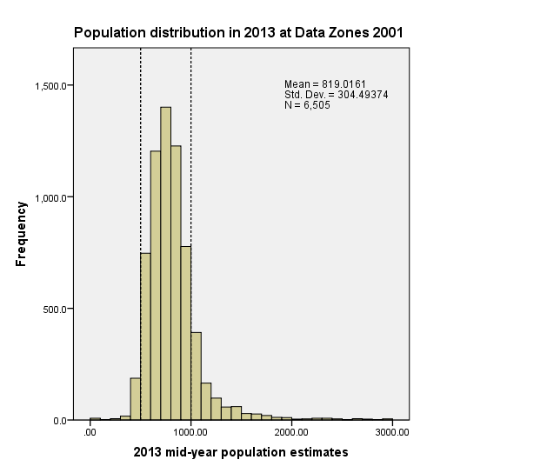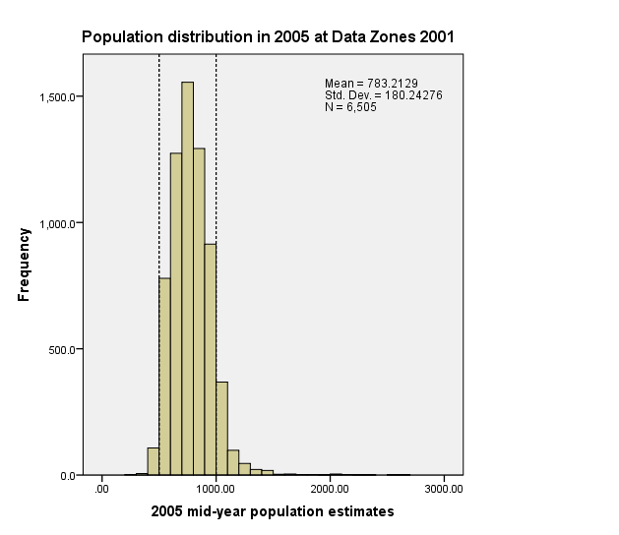Histograms of the Data Zone and Intermediate Zone populations are shown below, for 2005 (left) and 2013 (right). Vertical dashed lines show the original limits of the population according to the definition. The mean and standard deviation are also stated on each plot. These plots visualise the statistical migration of the population over time. The distribution in both cases becomes wider and less symmetric.

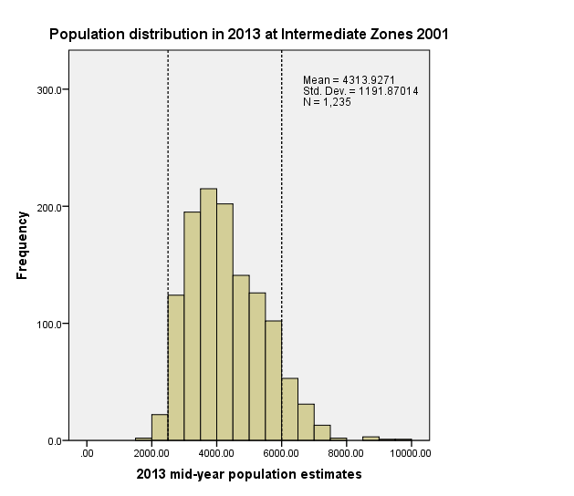

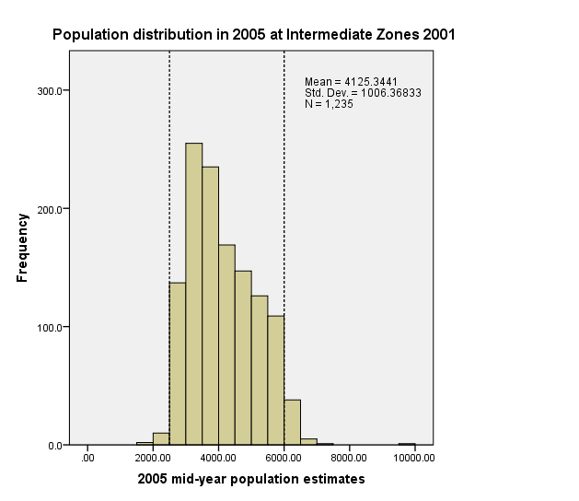

***Appendix B: SIMD structure***



***Appendix C: List of potential indicators***

|  |  |  |  |  |  |  |
| --- | --- | --- | --- | --- | --- | --- |
| **Indicator** | **Data Zone 2001** | **Intermediate Geography 2001** | **Data Zone and Intermediate Geography 2011** | **Timescale** | **Data Source** | **Notes** |
| ***SIMD*** |  |  |  |  |  |  |
| **Employment Domain** |  |  |  |  |  |  |
| Working Age Unemployment Claimant Count averaged over 12 months | x | x | x | 2012 | SIMD |  |
| Working Age Incapacity Benefit recipients or Employment and Support Allowance recipients | x | x | x | 2012 | SIMD |  |
| Working Age Severe Disablement Allowance recipients | x | x | x | 2012 | SIMD |  |
| Employment Domain Rate | ✓ | x | x | 2012 | SIMD |  |
| Count of Employment Deprived People (rounded 5) | ✓ | x | x | 2012 | SIMD | Probabilistically rounded to base |
| **Income Domain** |  |  |  |  |  |  |
| Number of Adults (aged 16-59) receiving Income Support or Income-based Employment and Support Allowance | x | x | x | 2012 | SIMD |  |
| Number of Adults (aged 60 plus) receiving Guaranteed Pension Credit | x | x | x | 2012 | SIMD |  |
| Number of Children (aged 0-15) dependent on a recipient of Income Support, Jobseekers Allowance or Employment and Support Allowance | x | x | x | 2012 | SIMD |  |
| Number of Adults receiving (all) Job Seekers Allowance | x | x | x | 2012 | SIMD |  |
| Number of Children (aged 0-15) dependent on a recipient of Job Seekers Allowance (all) | x | x | x | 2012 | SIMD |  |
| Number of Adults and Children in Tax Credit Families on low incomes | x | x | x | 2012 | SIMD |  |
| Income Domain Rate | ✓ | x | x | 2012 | SIMD |  |
| Count of Income Deprived People (rounded 5) | ✓ | x | x | 2012 | SIMD | Probabilistically rounded to base |
| **Health Domain** |  |  |  |  |  |  |
| Standardised mortality ratio (Source: ISD, 2007-2010) | ✓ | ✓ | x | 2012 | SIMD |  |
| Hospital stays (Continuous Inpatient Stays [CIS]) related to alcohol misuse: standardised ratio | ✓ | ✓ | x | 2012 | SIMD |  |
| Hospital stays (CIS) related to drug misuse: standardised ratio | ✓ | ✓ | x | 2012 | SIMD |  |
| Comparative Illness Factor: standardised ratio | ✓ | ✓ | x | 2012 | SIMD |  |
| Emergency stays (CIS) in hospital: standardised ratio | ✓ | ✓ | x | 2012 | SIMD |  |
| Estimated proportion of population being prescribed drugs for anxiety, depression or psychosis | ✓ | ✓ | x | 2012 | SIMD |  |
| Proportion of live singleton births of low birth weight | ✓ | ✓ | x | 2012 | SIMD |  |
| Health Domain Score | ✓ | x | x | 2012 | SIMD |  |
| **Education Domain** |  |  |  |  |  |  |
| School pupil absences | ✓ | ✓ | x | 2012 | SIMD |  |
| Pupil performance on SQA at stage 4 | ✓ | ✓ | x | 2012 | SIMD |  |
| Working age people with no qualifications | ✓ | ✓ | x | 2012 | SIMD | Census 2001 Data used |
| 17-21 year olds enrolling into full time higher education | ✓ | ✓ | x | 2012 | SIMD |  |
| People aged 16-19 not in full time education, employment or training rate | ✓ | ✓ | x | 2012 | SIMD |  |
| Education Domain Score | ✓ | x | x | 2012 | SIMD |  |
| **Access Domain (Limit times to 240 mins absolute journeys)** |  |  |  |  |  |  |
| Drive time to GP Surgery (mins) | ✓ | ✓ | x | 2012 | SIMD |  |
| Drive time to Post Office (mins) | ✓ | ✓ | x | 2012 | SIMD |  |
| Drive time to Retail Centre (mins) | ✓ | ✓ | x | 2012 | SIMD |  |
| Drive time to Primary School (mins) | ✓ | ✓ | x | 2012 | SIMD |  |
| Drive time to Secondary School (mins) | ✓ | ✓ | x | 2012 | SIMD |  |
| Drive time to Petrol Station (mins) | ✓ | ✓ | x | 2012 | SIMD |  |
| Public Transport to GP Surgery (mins) | ✓ | ✓ | x | 2012 | SIMD |  |
| Public Transport to Post Office (mins) | ✓ | ✓ | x | 2012 | SIMD |  |
| Public Transport to Retail Centre (mins) | ✓ | ✓ | x | 2012 | SIMD |  |
| Access Domain Score | ✓ | x | x | 2012 | SIMD |  |
| **Crime Domain** |  |  |  |  |  |  |
| Recorded Crimes of Violence | x | x | x | 2012 | SIMD |  |
| Recorded Sexual Offences | x | x | x | 2012 | SIMD |  |
| Recorded Domestic housebreaking | x | x | x | 2012 | SIMD |  |
| Recorded Vandalism | x | x | x | 2012 | SIMD |  |
| Recorded Drugs Offences | x | x | x | 2012 | SIMD |  |
| Recorded Common Assault | x | x | x | 2012 | SIMD |  |
| Crime Count | ✓ | x | x | 2012 | SIMD | Crime count of 5 or less is a missing value at Data Zone level |
| **Housing Domain** |  |  |  |  |  |  |
| Persons in households that are overcrowded | ✓ | ✓ | x | 2012 | SIMD | Census 2001 data used |
| Persons in households without central heating | ✓ | ✓ | x | 2012 | SIMD | Census 2011 data used |
|  |  |  |  |  |  |  |
| ***Morbidity*** |  |  |  |  |  |  |
| Low birth weight births | ✓ | ✓ | ✓ | 2011/12 and 2012/13 | ISD | 13/14 data is still not available |
| Death rate under 75 | ✓ | ✓ | ✓ | 2011-2012-2013 | ISD |  |
| Death rate under 75 cancer | ✓ | ✓ | ✓ | 2011-2012-2013 | ISD |  |
| Death rate under 75 CHD | ✓ | ✓ | ✓ | 2011-2012-2013 | ISD |  |
| Death rate under 75 stroke | ✓ | ✓ | ✓ | 2011-2012-2013 | ISD |  |
| All cause SMR 65 and under | ✓ | ✓ | ✓ | 2011-2012-2013 | ISD |  |
| All cause SMR 70 and under | ✓ | ✓ | ✓ | 2011-2012-2013 | ISD |  |
| All cause SMR 75 and under | ✓ | ✓ | ✓ | 2011-2012-2013 | ISD |  |
| Cancer SMR 65 and under | ✓ | ✓ | ✓ | 2011-2012-2013 | ISD |  |
| Cancer SMR 70 and under | ✓ | ✓ | ✓ | 2011-2012-2013 | ISD |  |
| Cancer SMR 75 and under | ✓ | ✓ | ✓ | 2011-2012-2013 | ISD |  |
| Heart Disease SMR 65 and under | ✓ | ✓ | ✓ | 2011-2012-2013 | ISD |  |
| Heart Disease SMR 70 and under | ✓ | ✓ | ✓ | 2011-2012-2013 | ISD |  |
| Heart Disease SMR 75 and under | ✓ | ✓ | ✓ | 2011-2012-2013 | ISD |  |
| Respiratory SMR 65 and under | ✓ | ✓ | ✓ | 2011-2012-2013 | ISD |  |
| Respiratory SMR 70 and under | ✓ | ✓ | ✓ | 2011-2012-2013 | ISD |  |
| Respiratory SMR 75 and under | ✓ | ✓ | ✓ | 2011-2012-2013 | ISD |  |
| Digestive System SMR 65 and under | ✓ | ✓ | ✓ | 2011-2012-2013 | ISD |  |
| Digestive System SMR 70 and under | ✓ | ✓ | ✓ | 2011-2012-2013 | ISD |  |
| Digestive System SMR 75 and under | ✓ | ✓ | ✓ | 2011-2012-2013 | ISD |  |
| Poison & Injury SMR 65 and under | ✓ | ✓ | ✓ | 2011-2012-2013 | ISD |  |
| Poison & Injury SMR 70 and under | ✓ | ✓ | ✓ | 2011-2012-2013 | ISD |  |
| Poison & Injury SMR 75 and under | ✓ | ✓ | ✓ | 2011-2012-2013 | ISD |  |
| Other SMR 65 and under | ✓ | ✓ | ✓ | 2011-2012-2013 | ISD |  |
| Other SMR 70 and under | ✓ | ✓ | ✓ | 2011-2012-2013 | ISD |  |
| Other SMR 75 and under | ✓ | ✓ | ✓ | 2011-2012-2013 | ISD |  |
| Outpatient SMR 65 and under | ✓ | ✓ | ✓ | 2011-2012-2013 | ISD |  |
| Outpatient SMR 70 and under | ✓ | ✓ | ✓ | 2011-2012-2013 | ISD |  |
| Outpatient SMR 75 and under | ✓ | ✓ | ✓ | 2011-2012-2013 | ISD |  |
| High Resource Individuals | ✓ | ✓ | ✓ | 2011-2012 | ISD | 2013 data available after April 2015 |
| Did Not Attend | ✓ | ✓ | ✓ | 2011-2012-2013 | ISD |  |
| Life Expectancy | x | ✓ | x | 2003-2007 | ISD |  |
| Drug counts | Under investigation | | | | | |
|  |  |  |  |  |  |  |
| ***Health/Morbidity Unpaid Care*** |  |  |  |  |  |  |
| Respondent long-term illness | ✓ | ✓ | ✓ | 2011 | Census | Requested |
| Limited activity | ✓ | ✓ | ✓ | 2011 | Census | Requested |
| Unemployed permanent sick | ✓ | ✓ | ✓ | 2011 | Census | Requested |
|  |  |  |  |  |  |  |
| ***Ethnicity*** |  |  |  |  |  |  |
| White | ✓ | ✓ | ✓ | 2011 | Census | Requested |
| South Asian | ✓ | ✓ | ✓ | 2011 | Census | Requested |
| Chinese | ✓ | ✓ | ✓ | 2011 | Census | Requested |
| Black | ✓ | ✓ | ✓ | 2011 | Census | Requested |
| Mixed and other ethnic | ✓ | ✓ | ✓ | 2011 | Census | Requested |
|  |  |  |  |  |  |  |
| ***Health Board Dummy Variables*** |  |  |  |  |  |  |
|  |  |  |  |  |  |  |
| ***Supply Variables*** |  |  |  |  |  |  |
|  |  |  |  |  |  |  |
| GP Supply 1km intrazonal cost | ✓ | ✓ | ✓ | 2011-2012-2013 | ISD |  |
| GP Supply 5km intrazonal cost | ✓ | ✓ | ✓ | 2011-2012-2013 | ISD |  |
| GP Supply 10km intrazonal cost | ✓ | ✓ | ✓ | 2011-2012-2013 | ISD |  |
| IPAC Inpatient supply dist only | ✓ | ✓ | ✓ | 2011-2012-2013 | ISD |  |
| IPACX Inpatient supply dist & popln | ✓ | ✓ | ✓ | 2011-2012-2013 | ISD |  |
| OPAC Outpatient supply dist only | ✓ | ✓ | ✓ | 2011-2012-2013 | ISD |  |
| OPACX Outpatient supply dist & popln | ✓ | ✓ | ✓ | 2011-2012-2013 | ISD |  |
| Inpatient Access – nearest hospital | ✓ | ✓ | ✓ | 2011-2012-2013 | ISD |  |
| Outpatient Access – nearest hospital | ✓ | ✓ | ✓ | 2011-2012-2013 | ISD |  |
| Number of GPs serving intzone | ✓ | ✓ | ✓ | 2011-2012-2013 | ISD |  |

1. REVIEW OF THE RESOURCE ALLOCATION ADJUSTMENT FOR HEALTHCARE NEEDS DUE TO MORBIDITY AND LIFE CIRCUMSTANCES AND OTHER FACTORS (Technical Report D), Carr-Hill, R. and Dixon, P., May 2006 (available [here](http://www.nrac.scot.nhs.uk/wp-content/uploads/docs/consultation/Technical%20Report%20D%20-%20Review%20of%20MLC.pdf))
2. NRAC formula - MLC adjustment: Mental Health and Learning Difficulties Care Programme - Final Report, TAGRA MLC (Morbidity & Life Circumstances) Sub-Group, December 2012
3. Source of table 1: SCOTTISH INDEX OF MULTIPLE DEPRIVATION 2012: A National Statistics Publication for Scotland, Scottish Government, December 2012 (Available [here](http://22fa0f74501b902c9f11-8b3fbddfa1e1fab453a8e75cb14f3396.r26.cf3.rackcdn.com/simd_448749_v7_20121217.pdf))