Acute MLC Review: Formula Impact Assessment

TAGRA(2016)XX
Official Statistics; please treat as restricted until publication on 09:30 Tuesday 13 December 2016. Please contact the Statistical Governance Team (email to: NSS.nssstatsgov@nhs.net) should you become aware of any accidental or wrongful release.
Access is restricted only to named individuals for the sole purpose of ensuring that your organisation can comment on an informed basis at the time of release.

1. Introduction
At the August 2016 TAGRA meeting, the final report from the review of NRAC’s Acute Morbidity and Life Circumstances (MLC) component was presented. This recommended several changes to the Acute MLC model (listed in Annex A), and TAGRA agreed in principle to accept the recommendations. Because of the SG Finance decision to switch to a three-year allocation regime, it was decided that implementation of the changes in the NRAC formula would be carried out in time to inform the 2017/18 shares, a year earlier than originally intended, in order to avoid having to wait a further three years to incorporate these changes. However, it was also agreed that an impact assessment of the changes would be carried out to allow TAGRA a fuller understanding of the effects of the various changes to the formula in this update.
This paper presents the impact assessment. We compare the results at NHS Board level for three different runs:
Run 1: A “population-only” update for 2017/18 using the Age-Sex costs per head, the MLC indices, and the Excess Costs indices from the 2016/17 update, combined with the 2017 population projections.
Run 2: A fuller update for 2017/18 in which the new 2011 geographies are used, and the MLC indices are fully recalculated – but without incorporating the recommendations of the review for Acute. The Age-Sex costs per head, and the Excess Costs unit costs by urban-rural category, are retained from the 2016/17 update and applied to the new data zones.
Run 3: Same as run 2 but with the Acute MLC review recommendations implemented. This run represents the official target shares for 2017/18.
These runs together allow the effects of implementing the review recommendations to be observed separately from changing the geography basis and refreshing the MLC indices. Section 2 shows the changes to all MLC regression coefficients resulting from refreshing the data (run 2) and including the recommendations of the Acute review (run 3). Section 3 looks at the effects of refreshing the MLC models and moving to the 2011 geographies, by comparing Board-level indices for run 1 and run 2. Section 4 then shows the further effect of incorporating the review recommendations, by examining the results of run 3.

2. Needs index coefficients
The regression coefficients of the needs index for each care programme in each run are shown below. Coefficients have mostly increased in moving to the new geography and refreshing the data (runs 2 & 3). This was noted in the Acute MLC review, when results at the 2001 and 2011 geographies were compared. It is at least partly a result of greater variance in the measured cost ratios at the new geography, which implies better differentiation of need between areas in the redrawn geography. For Acute, the bigger increases in run 3 are due to the switch from intermediate zones to data zones – again, this effect was noted in the review.
Table 1: Needs index coefficients for each care programme – runs 1, 2, and 3.
 | Acute |  |  |  |  |  |  | COTE | Maternity
 | Cancer | Heart | Digestive | Injury | Other | Respiratory | Outpatients
Run 1 | 0.036 | 0.096 | 0.107 | 0.100 | 0.085 | 0.168 | 0.031 | 0.083 | -0.027
Run 2 | 0.042 | 0.095 | 0.100 | 0.103 | 0.091 | 0.156 | 0.032 | 0.117 | -0.044
Run 3 | 0.062 | 0.137 | 0.115 | 0.120 | 0.113 | 0.172 | 0.037 | 0.117 | -0.044

 | MHLD |  | GP Prescribing
 | < 65 | ≥ 65 | Cardio | CNS | Gastro | Infections | Musc & Joint | Other
Run 1 | 0.114 | 0.092 | 0.068 | 0.129 | 0.068 | 0.025 | 0.122 | 0.077
Run 2 | 0.125 | 0.167 | 0.083 | 0.159 | 0.080 | 0.063 | 0.137 | 0.091
Run 3 | 0.125 | 0.167 | 0.089 | 0.207 | 0.095 | 0.083 | 0.164 | 0.109

3. Effect of updating the geography and refreshing the MLC indices
Table 2 and Table 3 show the overall Age-Sex, MLC and Excess Costs indices at NHS Board level for runs 1 and 2, respectively. The changes to the Age-Sex indices are minimal – there are no differences at two decimal places. The MLC indices, as expected, have changed a bit more. The Excess Costs indices also show some bigger changes.
Table 2: NHS Board indices for run 1.
NHS Board | Age-Sex index | MLC index | Excess Costs index
Ayrshire & Arran | 1.056 | 1.022 | 0.989
Borders | 1.099 | 0.896 | 1.009
Fife | 1.019 | 0.974 | 0.982
Greater Glasgow & Clyde | 0.970 | 1.100 | 0.991
Highland | 1.066 | 0.952 | 1.084
Lanarkshire | 0.985 | 1.052 | 0.981
Grampian | 0.976 | 0.925 | 1.003
Orkney | 1.074 | 0.933 | 1.212
Lothian | 0.957 | 0.957 | 0.989
Tayside | 1.038 | 0.961 | 0.999
Forth Valley | 0.994 | 0.984 | 0.983
Western Isles | 1.123 | 0.987 | 1.235
Dumfries & Galloway | 1.111 | 0.944 | 1.015
Shetland | 1.014 | 0.907 | 1.225

Table 3: NHS Board indices for run 2.
NHS Board | Age-Sex index | MLC index | Excess Costs index
Ayrshire & Arran | 1.058 | 1.033 | 0.991
Borders | 1.096 | 0.892 | 1.007
Fife | 1.021 | 0.989 | 0.984
Greater Glasgow & Clyde | 0.967 | 1.096 | 0.993
Highland | 1.071 | 0.936 | 1.074
Lanarkshire | 0.987 | 1.055 | 0.984
Grampian | 0.977 | 0.912 | 1.003
Orkney | 1.078 | 0.933 | 1.184
Lothian | 0.955 | 0.959 | 0.991
Tayside | 1.039 | 0.973 | 0.999
Forth Valley | 0.995 | 0.978 | 0.985
Western Isles | 1.123 | 0.970 | 1.205
Dumfries & Galloway | 1.113 | 0.952 | 1.012
Shetland | 1.010 | 0.929 | 1.194

Figure 1 and Figure 2 illustrate the changes due to updating the geography and refreshing the MLC models, on the overall MLC index and (more specifically) the Acute MLC index, respectively. In addition, Figure 3 shows the proportional change in the overall NRAC target share (including the Out of Hours Adjustment) for each Board. These changes partly reflect changes in the distribution of values of the needs indicator variables in each Health Board (SMR<75 has improved to varying degrees in each NHS board since 2006, with the largest improvement being in NHS Greater Glasgow & Clyde - this is consistent with the decrease in GGC’s Acute MLC index).
Figure 1: Overall MLC index by Board, comparing run 2 against run 1. The Scottish average index is equal to 1.
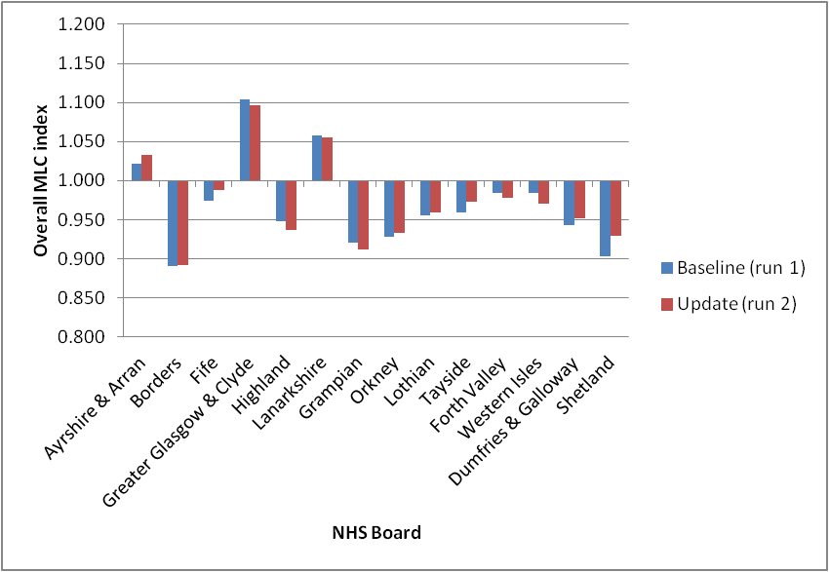

Figure 2: Acute MLC index by Board, comparing run 2 against run 1. The Scottish average index is equal to 1.
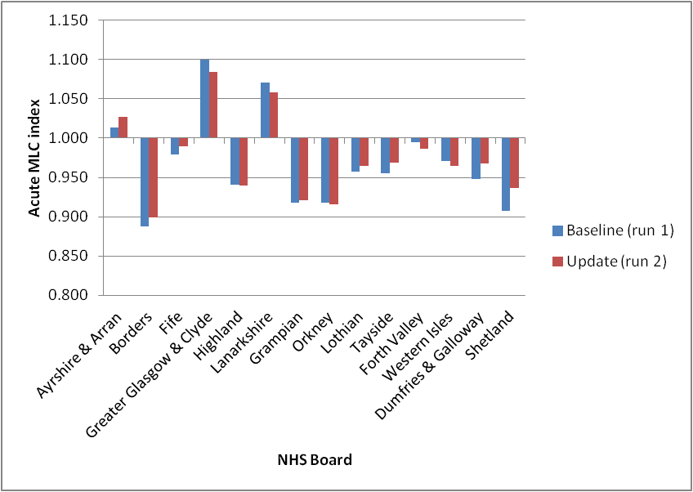
Figure 3: Proportional change in overall target share (including Out of Hours Adjustment) by Board, due to updating the geography and refreshing the MLC models, based on using run 1 as a baseline.
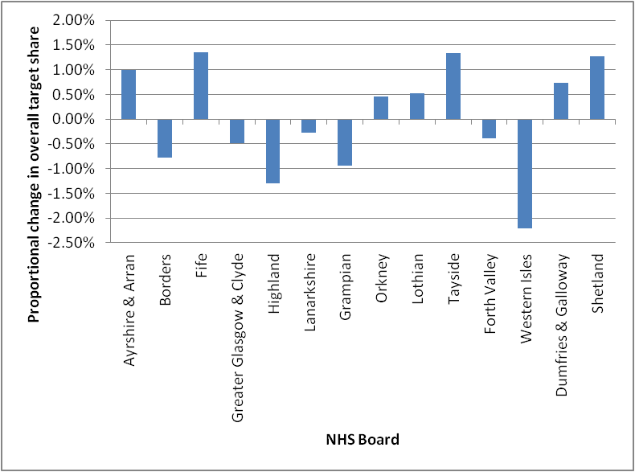

4. Effect of implementing the Acute MLC review recommendations
Table 4 shows the indices from run 3, in which the review recommendations have been implemented.
Table 4: NHS Board indices for run 3.
NHS Board | Age-Sex index | MLC index | Excess Costs index
Ayrshire & Arran | 1.058 | 1.036 | 0.991
Borders | 1.096 | 0.901 | 1.007
Fife | 1.021 | 0.990 | 0.984
Greater Glasgow & Clyde | 0.967 | 1.094 | 0.992
Highland | 1.071 | 0.940 | 1.074
Lanarkshire | 0.987 | 1.053 | 0.984
Grampian | 0.977 | 0.911 | 1.003
Orkney | 1.078 | 0.931 | 1.184
Lothian | 0.955 | 0.957 | 0.991
Tayside | 1.039 | 0.975 | 0.999
Forth Valley | 0.995 | 0.977 | 0.985
Western Isles | 1.123 | 0.979 | 1.204
Dumfries & Galloway | 1.113 | 0.958 | 1.012
Shetland | 1.010 | 0.930 | 1.194

The Age-Sex indices are identical between run 2 and run 3, and the Excess Costs indices are almost identical. There are some changes in the MLC indices due to the changes to the Acute model (GP Prescribing is also affected, since the Acute needs index is now mapped from data zones to practices rather than from intermediate zones to practices) but the differences between run 2 and run 3 are smaller in magnitude than those between either of these runs and run 1. In other words, the changes due to the Acute MLC review are smaller than those due to simply refreshing the MLC regression models.
Figure 4 and Figure 5 illustrate the changes due to the Acute MLC review, on the overall MLC index and (more specifically) the Acute MLC index, respectively. In addition, Figure 6 shows the proportional change in the overall NRAC target share (including the Out of Hours Adjustment) for each Board, on the same scale as Figure 3. It is clear that the changes arising from implementing the review recommendations are much smaller than those due to updating the geography and refreshing the data (Figure 3).

Figure 4: Overall MLC index by Board, comparing run 3 against run 2. The Scottish average index is equal to 1.
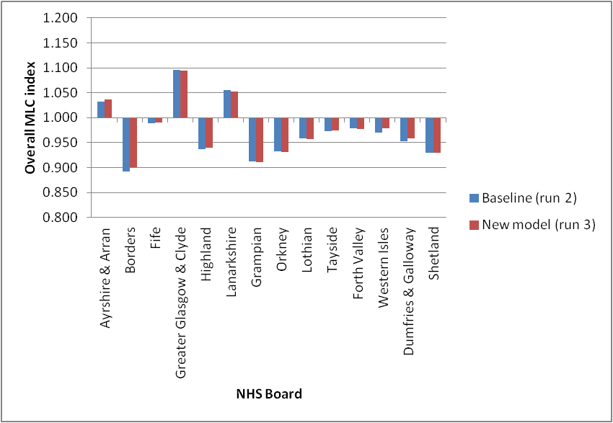
Figure 5: Acute MLC index by Board, comparing run 3 against run 2. The Scottish average index is equal to 1.
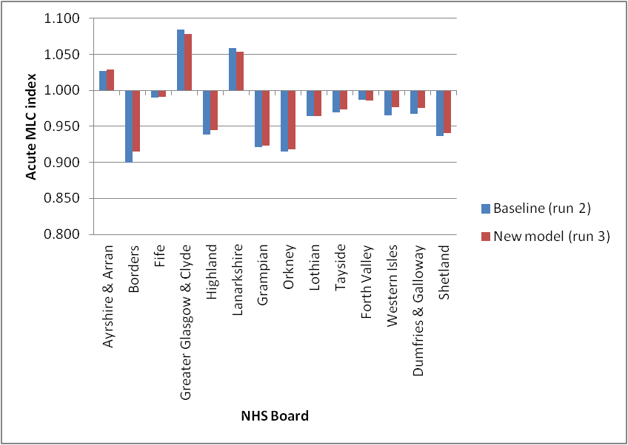

Figure 6: Proportional change in overall target share (including Out of Hours Adjustment) by Board, due to the Acute MLC review, based on using run 2 as a baseline.
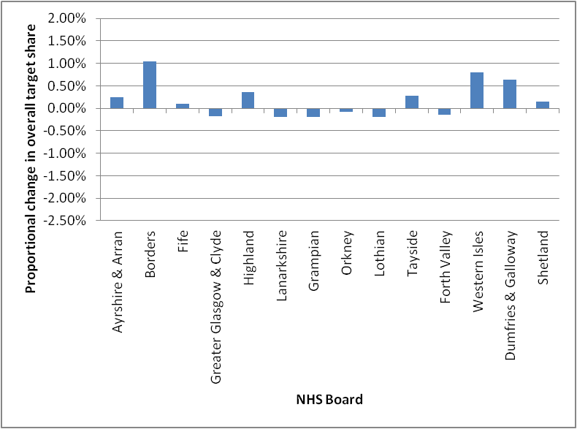

Annex A: Recommendations from the Acute MLC review
The main recommendations resulting from the Acute MLC review are listed below.
Recommendation 1: retain the NRAC costing method, but with the case-mix adjustment derived from summing PLICS components by specialty.
Recommendation 2: retain the linear functional form.
Recommendation 3: change the time span of the Acute MLC cost ratios from 1 year to 3 years.
Recommendation 4: change the geography basis of the Acute MLC adjustment from intermediate zones to data zones.
Recommendation 5: retain the Acute diagnostic groups.
Recommendation 6: continue to model all ages together for the Acute MLC adjustment.
Recommendation 7: continue to use IPACX and OPACX as the supply variables, along with the health board dummies, but use only IPACX for inpatient diagnostic groups and only OPACX for the Outpatients diagnostic group.
Recommendation 8: retain Limiting Long-Term Illness and All-cause Standardised Mortality Ratio ages 0-74 as the needs indicators.
Recommendation 9: introduce a prison indicator (a binary variable) for the Outpatients diagnostic group, to allow additional need associated with prisons to be allocated for.
Recommendation 10: as for the current formula, do not add urban-rural category indicators in the Acute MLC model.
Recommendation 11: implement two unmet need adjustments for:
- the Heart diagnostic group by excluding the 30% of data zones with the highest needs index values from the regression,
- the Other diagnostic group by excluding the 5% of data zones with the highest needs index values from the regression.

The proposed changes to the Acute MLC adjustment are summarised as follows:

 | Current Acute MLC adjustment | Proposed new Acute MLC adjustment
Geography | Intermediate zones | Data zones
Time span | One year’s data is used to calculate the cost ratios | Three years’ data is used to calculate the cost ratios
Diagnostic groups | Heart, Cancer, Respiratory, Digestive, Injuries & Poisoning, Acute Outpatients and Acute Other | No change
Needs indicators | All-cause Standardised Mortality Ratio (SMR) for ages 0-74  Limiting long-term illness (LLTI) rate | Same needs indicators, plus an extra (binary) prison indicator for Acute Outpatients
Supply variables | IPACX and OPACX  Health Board dummies | IPACX for inpatient diagnostic groups, OPACX for Acute Outpatients  Health Board dummies
Unmet need | Adjustment for Heart based on excluding the 25% most deprived intermediate zones from the regression, as defined by SIMD income domain | Adjustment for Heart based on excluding the 30% of data zones with the highest needs index values and for Other based on excluding the 5% of data zones with the highest needs index values.

https://www.nrscotland.gov.uk/statistics-and-data/statistics/statistics-by-theme/vital-events/deaths/age-standardised-death-rates-calculated-using-the-esp - Table 4

