TAGRA Remote & Rural Sub-group

NRAC formula - Excess costs adjustment

FINAL REPORT

December 2012

CONTENTS

Executive Summary

Chapter 1 – Background and introduction

Chapter 2 – The Excess Cost Adjustment

Chapter 3 – The Analysis

3.3 Out of hours GP services
3.2 Scottish Distant Islands Allowance
3.3 Other aspects of the Excess Cost Adjustment

Chapter 4 – Recommendations for TAGRA

Glossary

Annex 1 - Sub-group membership

Annex 2 - The excess costs adjustment in the NRAC formula

Annex 3 – Out of hours services further details

Annex 4 – Scottish Distant Islands Allowance further details

Annex 5 – Urban – rural classification

Annex 6 - De Minimis Costs

Annex 7 – Hospital Costs Functions

EXECUTIVE SUMMARY

Introduction

The NRAC (National Resource Allocation Committee) formula is used to allocate funding to the 14 territorial NHS Boards. In 2011/12, the formula was used to allocate £7.6bn out of a total health budget of £11.4bn.

In Spring 2011, the Remote & Rural sub-group was established to address issues identified by the Technical Advisory Group on Resource Allocation’s (TAGRA) report: The Impact of the NHSScotland Resource Allocation Committee (NRAC) Formula on Remote and Rural Areas of Scotland (2010).

The remit of the group was to recommend to TAGRA (Technical Advisory Group for Resource Allocation) changes to the excess cost adjustment within the NRAC formula, with regard to TAGRA’s core criteria. This will improve the ability of the formula to allocate funds between the territorial NHS Boards on a fair and equitable basis.
The group reported on its progress at each meeting of TAGRA and sought views on the analysis as it progressed. All TAGRA papers and minutes, and the papers for the sub-group, are available on the TAGRA website at http://www.tagra.scot.nhs.uk/.
The excess costs adjustment within the NRAC formula

The key objective for the NRAC formula is to measure relative need for healthcare services, so that resources can be allocated accordingly. Relative need is based on an area’s population and other indicators – the age and sex profile of that population, as well as ‘morbidity and life circumstances’ – those factors over and above age and sex which influence an individual’s need for healthcare services. The formula then assesses the differential, unavoidable costs of providing these services across different geographical areas.
The unavoidable excess cost of supply adjustment is intended to account for variation in the cost of delivering health services in different urban-rural geographies. It is defined as a pure unit cost effect, separate from any expenditure variation generated by differences in case-mix and length of stay etc. These latter are captured by the additional needs adjustment in the morbidity and life circumstances element of the formula. The adjustment is estimated for each of the 10 Scottish Government Urban-Rural Categories (SGURC) and each data zone within a SGURC will have the same value.

There are four elements within the unavoidable excess cost adjustment: hospital services; clinic-based community services; travel-based community services; and, prescribing.

The analysis

The work of the sub-group centred round 3 main areas:

- Developing a feasible adjustment which explicitly recognises GP Out of Hours services.

- Examining the pattern of costs with respect to the Scottish Distant Islands Allowance (SDIA) areas and developing an adjustment to the urban-rural categories.

- Exploring the extent to which the excess cost adjustment adequately captures the fixed costs of health service provision and the robustness of the current urban-rural categorisation.

Out of Hours Services

Currently health boards provide funding for Out of Hours (OOH) Services from their general allocation. The Remote and Rural sub-group explored the possibility of explicitly recognising out of hours services in the NRAC formula. The sub-group sought to devise an indicator of need for Out of Hours Services based on the characteristics of the local populations, and which is adjusted for the costs of service provision across different geographies.

The sub-group concluded that the existing Scottish Allocation Formula (SAF) provided a feasible basis for an OOH services allocation instrument. The SAF is designed to allocate funds for core GP services. The sub-group decided that enhanced weights should be used in the remote and rural element of the SAF to reflect the lack of economies of scale in OOH services. It is proposed that the adjustment should be integrated into the NARC formula by combining the board shares with the NRAC unified board shares using weights calculated from expenditure on Out of Hours services, recorded in the Costs Book, net of the retained element from the Global Sum.

Scottish Distant Islands Allowance

SDIA is paid to staff on particular islands in order to assist in maintaining staff levels in the remote areas of Scotland. The level of SDIA varies, but is in the region of £1,000 to £1,500 per staff member.

In addition, the sub-group demonstrated that even after controlling for SDIA costs, there are differences between the cost of delivery on SDIA versus non-SDIA islands, thus leading to the recommendation to retain the allocation of SDIA costs as part of the NRAC formula.

The Remote & Rural sub-group considered whether adjusting the urban-rural classification within the Unavoidable Excess Costs Adjustment could lead to better reflecting the higher costs in SDIA areas within the formula.

Finally, the sub-group found that even if all the SDIA islands were to provide services in the same manner, using the same number of staff, there would still be differential costs between the different islands. These would not be reflected in the current approach, which assumes that SDIA islands can be treated as a homogenous group. Therefore, the sub-group recommend that an uplift factor to the specific NHS Boards, based on their relative rates of SDIA should be applied.

Unavoidable Excess Costs

The sub-group explored the detail of the methodology and data used in the excess cost adjustment to assess whether there were cost factors which are not fully captured. In addition, the sub-group carried out analysis around de minimis costs, engaged with HERU around their Hospital Costs Function analysis and undertook further statistical analysis of the Urban-Rural classification. The sub-group did not identify further cost factors in the hospital sector which are not presently captured within the existing Unavoidable Excess Costs Adjustment.

There was however some concern expressed about the extent to which the variation in the unit costs of the provision of community care services were fully reflected it the excess cost adjustment. This is an issue that TAGRA is asked to build into the future work programme.

Recommendations for TAGRA

Recommendation 1: There should be an adjustment, based on the Scottish Allocation Formula, which explicitly recognises Out of Hours Services.

Recommendation 2: With regards to SDIA costs:
- There should be an adjustment to the urban rural categories used within the Unavoidable Excess Cost Adjustment element of the NRAC formula.
- There should be NHS Board – specific adjustments included to take into account the different rates of SDIA in place in the different boards.
- SDIA costs should be compensated through the NRAC formula.

Recommendation 3: TAGRA should include a review of the community element of the excess cost adjustment in its work programme, when a reliable national dataset for community services activity and costs becomes available.

TAGRA: Remote & Rural Sub-group
December 2012

CHAPTER 1 – BACKGROUND & INTRODUCTION

background
The NRAC formula is used to allocate funding to the 14 territorial NHS Boards. In 2011/12, the formula was used to allocate £7.6bn out of a total health budget of £11.4bn.

In Spring 2011, the Remote & Rural sub-group was established to address issues identified by the Technical Advisory Group on Resource Allocation’s (TAGRA) report: The Impact of the NHSScotland Resource Allocation Committee (NRAC) Formula on Remote and Rural Areas of Scotland (2010).

Remit and terms of reference
The following remit and terms of reference for the technical sub-group were agreed :-
The remit of the group was to recommend to TAGRA (Technical Advisory Group for Resource Allocation) changes to the excess cost adjustment within the NRAC formula, with regard to TAGRA’s core criteria, which will improve the ability of the formula to allocate funds between the territorial NHS Boards on a fair and equitable basis.
The group was asked to consider:
- Out of Hours Services;
- Establishing an estimate of the de minimis cost of services.

The latter to include consideration of the Scottish Distant Islands Allowance.

Secondary areas of work:
- The treatment of staff and travel costs; and
- The suitability of the use of an adapted Scottish Government urban-rural classification for the Unavoidable Excess Costs Adjustment.

A list of members is attached in Annex B.

TIMESCALES
The Remote & Rural sub-group is a short life working group and is planned to report to TAGRA by Spring 2013.

HOW THE SUB-GROUP CARRIED OUT THE WORK

Core Criteria

The sub-group worked within the same set of Core Criteria as used by TAGRA.

Equity | The primary consideration should be to achieve the greatest possible accuracy in capturing the cost implications of variations in need across the country, in order to develop a formula that delivers the greatest possible equity of access to health services.
Practicality | Use should be made of good-quality, routinely-collected data, in order to produce an administratively feasible formula that can be readily updated.
Transparency | The rationale informing the formula’s methodology should be explicable and any judgements should be made explicit, although this should not lead to over-simplification of details which might add precision to the methods.
Objectivity | The formula should as far as possible be evidence-based, using as necessary the full range of available robust data.
Avoiding perverse incentives | The formula should guard against perverse incentives and any negative consequences which might threaten the integrity of the data.
Relevance | There is a need to avoid the dangers of extrapolation and to make explicit where hard information is being used about one aspect of a service to make some assumption about an area where information is less good or absent.
Stability | There should be a reasonable degree of year-to-year stability in the data sources feeding in to the formula.
Responsiveness | The formula should result in shifts in the allocation of resources in response to changes in the need for healthcare services.
Face validity | The outcome of any changes to the formula should be subjected to a 'common-sense' check.

Reporting and links with TAGRA
The group reported on its progress at each meeting of TAGRA and sought views on the analysis as it progressed. All TAGRA papers and minutes, and the papers for the TAGRA Remote & Rural sub-group, are available on the TAGRA website at http://www.tagra.scot.nhs.uk/.
Involvement of other stakeholders
A presentation by members of the sub-group was made to the Directors of Finance (DoFs) at their meeting on 24th January 2012. The purpose of the presentation was to ensure that the DoFs were aware of the work of the sub-group and to hear any comments or suggestions that they might have.

There was general support for the work from the DoFs, although there was some concern around the de minimis cost work. This was due to this analysis straying into looking at the costs of facilities rather than focussing on the population.

2. THE EXCESS COST ADJUSTMENT WITHIN THE NRAC FORMULA

The key objective for the NRAC formula is to measure relative need for healthcare services, so that resources can be allocated accordingly. Relative need is based on an area’s population and other indicators – the age and sex profile of that population, as well as ‘morbidity and life circumstances’ – those factors over and above age and sex which influence an individual’s need for healthcare services. The formula then assesses the differential, unavoidable costs of providing these services across different geographical areas.
Figure 2.1 The NRAC Formula
 |  |  |  |  |  | Unavoidable excess
Population |  | Age-sex cost weights |  | Additional needs |  | costs of supply
Health Board population % | x | Relative need due to age-sex profile | x | Relative need due to morbidity and life circumstances and other factors | x | Relative costs of providing services to different geographical areas | = | NRAC weighted share %

The NRAC formula is built up from the different care programmes which comprise the total spending being allocated.

- Acute
- Care of the Elderly
- Mental Health & Learning Difficulties
- Maternity
- Community

Together these five care programmes make up the Hospital and Community Health Services (HCHS).

A separate care programme is :-

- GP Prescribing

These two parts of the formula (HCHS and GP Prescribing) have different population bases and so are calculated separately, then combined to produce the final target shares.

The unavoidable excess cost of supply adjustment is intended to account for variation in the cost of delivering health services in different urban-rural geographies. It is defined as a pure unit cost effect, separate from any expenditure variation generated by differences in case-mix and length of stay etc. These latter are captured by the additional needs adjustment in the morbidity and life circumstances element of the formula. The adjustment is estimated for each of the 10 Scottish Government Urban-Rural Categories (SGURC) and each data zone within a SGURC will have the same value.

There are four elements within the Unavoidable Excess Cost Adjustment: hospital services; clinic-based community services; travel-based community services; and, prescribing. The calculations for each element are described below.

Hospital Services:
The excess cost for hospital services is the cost ratio of local to national unit costs calculated at the datazone level. Specifically it is the ratio of the cost of providing the required local services at local unit costs to the (notional) cost of providing those local services estimated at national unit costs. Unit costs are calculated as the average cost per episode, or length of stay, (separately by inpatient/daycase/outpatient) by speciality for the population of the data zone. Note that the denominator in this ratio is the numerator of the ratio used to calculate the morbidity and life circumstances adjustment.

This calculation is undertaken for each of the individual the care programmes: Acute, Care of the Elderly, Mental Health and Learning Difficulties, and Maternity.

Travel-based Community Services:
The estimate of the variation in the cost of travel-based community services is based on a travel simulation model which assumes that professionals are based in settlements and must travel to patient’s homes. The model is based on census output areas data (around 42,000 output areas) and data on the drive time to ‘small’ settlements (3,000 plus people) or ‘large’ settlements (10,000 people). It includes assumptions about contact duration, setup time, island contact time, base location and proportion of home visits.

The estimated time consumption is equal to:

% home visits * (setup time + contact duration + driving time) + % non-home visits * (setup time + contact duration)

The ratio of the data zone to the Scotland average is calculated for each community service and aggregated for the data zone using service expenditure shares. The key determinant of the excess cost adjustment is the settlement size.

Clinic-based Community Services:
The adjustment for clinic-based services is taken from the Scottish Allocation Formula (SAF) for General Medical Services’ practice weighting for remote and rural areas. The SAF weighting uses three practice variables: population density (number of hectares per resident); population sparsity (population in communities of less than 500); road mileage payments (proportion of people which attract road mileage payments). The SAF weightings are mapped from GP practices to data zones and the excess cost adjustment reflects the ratio of individual data zone’s weighting to the national average. The overall community excess cost adjustment assumes that the community services are split 2/3 to 1/3 between travel-based and clinic-based services respectively.

GP prescribing:
The excess cost adjustment relating to GP prescribing is set to 1 across all geographies as a national reimbursement rate applies for all drug prescriptions and dispensing costs are not covered by the resource allocation formula.

Aggregation:
The separate elements of the excess cost adjustment are weighted together to yield the final excess cost adjustment for each data zone, using national programme weights as shown in Table 1 below. The urban-rural categories for which the excess cost adjustment is calculated and the (approximate) proportion of health board populations by category are shown in Table 2 .

Table 2.1: Care Programme Expenditure Weightings:
Acute | Care of the Elderly | Mental Health & Learning Difficulties | Maternity | Community Travel-based | Community Clinic-based | Overall HCHS | GP Prescribing
50.8% | 3.2% | 11.9% | 3.6% | 11.6% | 5.8% | 87% | 13.0%
Source: ISD Scotland (relating to the 2011/12 calculations)

Table 2.2: Proportion of Health Board Population by Urban-Rural Category:
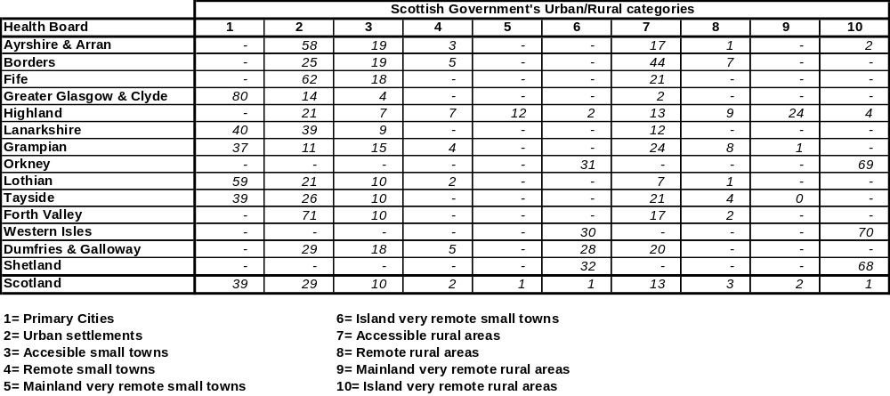

CHAPTER 3 – THE WORK PROGRAMME

3.1 OUT OF HOURS SERVICES

3.1.1 Background

Currently health boards provide funding for Out of Hours Services from their general allocation. The Remote and Rural sub-group explored the possibility of explicitly recognising Out of Hours Services in the NRAC formula. Information on the details of the provision of Out of Hours services is limited, however the NRAC approach abstracts from the particulars of service provision and seeks to identify the underlying demand for services and the unavoidable (unit) costs of providing a service.

Under the provisions of the General Medical Services contract GP practices may opt out of providing ‘Out of Hours’ (OOH) services to their practice population. Practices which opt out have their Global Sum reduced by 6% and the relevant health board (HB) becomes responsible for providing a substitute OOH service. The retained 6% of Global Sum is insufficient to meet the costs of providing the service and Health Boards have hitherto funded the shortfall out of their general allocation.

The cost implications of the opt out vary by Health Board, as the average cost of providing services to a practice population varies by Health Board.

Anecdotal evidence suggests that boards have adopted different approaches to the provision of OOH services. However, the specific approaches adopted by individual boards are not directly relevant. From an NRAC perspective an allocation mechanism should be based on the needs of the population for the service and the unit costs of providing the service in different geographies. It should not reflect the particular structures chosen for the provision of health care, and it should reflect only unavoidable variation in the unit costs of the service.

This implies that what is required is an indicator of need for OOH services based on the characteristics of the local populations and which is adjusted for the costs of service provision across different geographies.

3.1.2 An OOH allocation instrument

The Scottish Allocation Formula (SAF) is the instrument used to allocate ‘Global Sum’ funds for general medical services to GP practices. It is therefore an existing instrument, constructed to reflect the relative variation in the needs of practice populations for general medical services and the variation in cost of providing that service as a result of remoteness and rurality.

Like the NRAC formula the SAF is constructed as a weighted capitation scheme with weights reflecting:

- Age and sex;
- Additional needs;
- Rurality and remoteness
- Market forces adjustment

It should also be noted that the SAF has been in place for a number of years without major update. At present there is work in progress for the updating of aspects of the formula. Future revision of the formula would have implications for the precise distribution of funds, however, the purpose - allocating funds for general practice - would remain relevant.

A key issue is that OOH service providers in rural areas are unlikely to achieve the same economies of scale as providers of the within-hours services. OOH services require a lower volume of service per registered patient and thus a larger geographical size of practice to achieve minimum efficient scale in rural areas. However the geographical size of the practice is constrained by the need to provide home visits to patients within a reasonable time. Therefore remote OOH practices are expected to operate with inefficiently low numbers of patients.

For that reason it would be appropriate to adjust the weights of the remote and rural element of the SAF. To estimate weights specifically for the purpose of reflecting the lack of economies of scale would require a specific research project which would run beyond the time horizon of the sub-group’s December deadline. However, there are SAF remote and rural weights which were empirically estimated for the review of the SAF in 2005/06: ‘Scottish Allocation Formula Review – Report from the Review Group’. Whilst these do not explicitly seek to take account of the economies of scale effect discussed above, the estimated weights are larger than those in the SAF – which would effectively reflect that effect. The standard SAF weights and the alternative weights are set out in the following table.

Table 3.1.2: Remote and Rural Weights in the SAF
 | Current weights | SAF review weights
Constant | 54.542 | 47.612
Hectares per resident | 1.881 | 2.539
Population in settlements <500 people | 0.140 | 1.275
Patients attracting road mileage payments | 0.109 | 0.546

Incorporating these weights allows the (adjusted) SAF to more closely approximate the pattern of OOH expenditure recorded in the Costs Book – this is illustrated below (see Figure 3.1.2).

3.1.3 Population base

ISD data suggest that around 5% of practices provide OOH services but that only around 1% of the Scottish population are covered by those services. In principal the OOH allocation should be applied in respect of the practice populations which are not covered by OOH services provided by the practice. That is, that the 1% of the population covered by practices should be omitted from the allocation.

However, a complication is that some of the practices providing OOH services are being paid by boards to do so. In particular the ‘17C’ practices with local contractual arrangements may have OOH provision specifically mandated. In addition we know that some practices on the standard ‘17J’ GSM contract area also getting paid for the delivery of OOH services. In light of the small numbers involved (1% of the Scottish population), and the desire that the formula should be agnostic regarding the choice of mode of service provision, the sub-group recommended that all practice types should be included.

3.1.4 Illustrating the allocation

The sub-group commissioned Practitioner Services Division (PSD) to produce a SAF allocation which incorporates the enhanced remote and rural weights set out in Table 3.1.2 above. That version of the SAF is hereafter referred to as OOHSAF.

To assess the suitability of the OOHSAF the sub-group compared it with the OOH spend recorded in the Costs Book for 2010-11. Specifically they compared the board spend on OOH recorded in the Costs Book with the indicative allocations of the same total fund to boards using the OOHSAF.

The following chart shows the OOH expenditure by board recorded in the Costs Book, along with the total OOH expenditure allocated to boards using either the standard SAF or the OOHSAF. Note that total OOH expenditure recorded in the Costs Book in 2010-11 was around £75 mn.

It is important to note that caution is needed in this comparison. Variation in recorded OOH expenditure can arise because of differences in efficiency between boards, or differences in expenditure recording practices, as well as differences in the unavoidable costs of providing the OOH services.

Chart 3.1.2: OOH expenditure: Actual and allocated by SAF and OOH
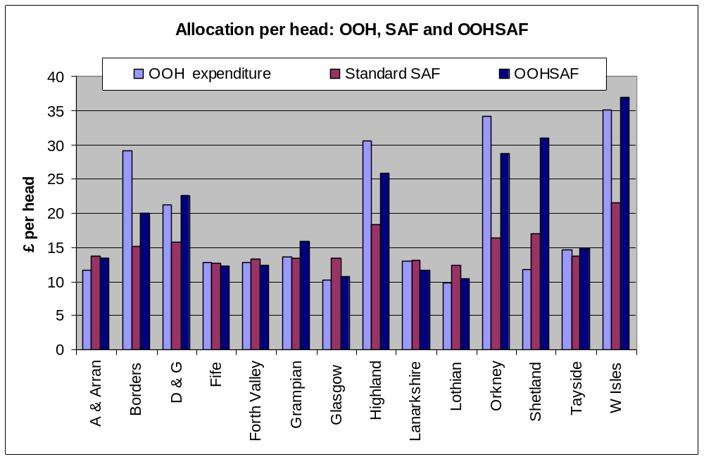

In broad terms the OOHSAF appears to provide a reasonable approximation to the pattern of OOH spend across boards. In particular, compared with the SAF, it substantially improves the fit for Western Isles, Orkney, Lothian, Highland, Glasgow and Dumfries and Galloway. There is some improvement for Borders, Ayrshire and Arran and Tayside. The estimate for Shetland looks an outlier but it is understood, in part, to reflect under-reporting of OOH costs.

3.1.5 Integration with the NRAC formula

The most straightforward method of integrating the OOHSAF allocation instrument into the NRAC formula would be simply to combine the OOHSAF board shares with the NRAC unified board shares using suitable weights.

The obvious candidate for a weight for the OOHSAF would be expenditure on OOH services, recorded in the Costs Book, net of the retained element from the Global Sum.

This approach would be simple to implement as the standard NRAC shares and the OOHSAF shares are only combined when they have been fully calculated.

The sub-group recommend that the OOHSAF allocation instrument is integrated into the formula by this method.

3.1.6 Assessment against TAGRA’s core criteria

As part of making any changes to the NRAC formula, it is important to assess the impact of the change against TAGRA’s core criteria. This is set out below, assuming that the Out of Hours services adjustment is based on using the remote and rural weights from the Scottish Allocation Formula. The Out of Hours Services allocation instrument is then integrated into the NARC formula by combining the board shares with the NRAC unified board shares using weights calculated from expenditure on Out of Hours services, recorded in the Costs Book, net of the retained element from the Global Sum.

Equity
The resulting allocation would be more equitable as it would capture variation in need and the costs of service provision in an area which the current formula does not explicitly model.

Practicality
It utilises an existing formula, though not one developed by NRAC, so the data for calculating the shares are already available from Practitioner Services Division.

Transparency
The details of the SAF are set out in the GMS Statement of Financial Entitlements; the estimation of the revised weights is set out in the paper Scottish Allocation Formula Review – Report from the Review Group.

Objectivity
The SAF is evidence based and is used for the allocation of the entire Global Sum to primary services.

Avoiding perverse incentives
OOH shares are derived from the characteristics of practice populations and the degree of rurality. These are largely independent of board influence.

Relevance
The adjustment is based on actual data and not extrapolated.

Stability
As the shares are derived from population data and rurality they will be relatively stable over time.

Responsiveness
The shares will however be responsive to changing demography in so far as that affects relative demand for health services.

Face validity
It is intuitive to use the SAF as it is evidence based and is used for the allocation of the entire Global Sum to primary services.
3.2 SCOTTISH DISTANT ISLANDS ALLOWANCE

3.2.1 SDIA background

SDIA is paid to staff on particular islands in order to assist in maintaining staff levels in the remote areas of Scotland. The level of SDIA varies, but is in the region of £1,000 to £1,500 per staff member.

The issue of Scottish Distant Islands Allowance (SDIA) costs was first investigated in 2009 by TAGRA (see TAGRA(2009)21 for a summary of work done). Analysis at this time attempted to remove the Scottish Distant Island Allowance costs from the formula, and considered the impact on board allocations. At that time, due to complexity in identifying and removing SDIA costs, and as additional funding had been introduced for the island boards, it was decided not to change the treatment of these costs within the formula.

The Remote & Rural sub-group considered whether adjusting the Urban-Rural classification within the unavoidable excess costs adjustment could lead to better reflecting these SDIA costs within the formula. Full details are available in annex 4 and here: http://www.tagra.scot.nhs.uk/sub-groups_RR.html.

3.2.2 Analysis of urban – rural classification and costs

Within the hospital element of Unavoidable Excess Costs calculations in the NRAC formula, Scotland is currently divided into 10 urban rural categories:

1 = Large urban areas. 5b = Island very remote small towns.
2 = Other urban areas. 6 = Accessible rural areas.
3 = Accessible small towns. 7 = Remote rural areas.
4 = Remote small towns. 8a = Mainland very remote rural areas.
5a = Mainland very remote small towns. 8b = Island very remote rural areas.

Two of these categories, 5b and 8b, relate to islands.
These two categories can be further subdivided into:
- 5c: Island very remote small towns without SDIA
- 5d: Island very remote small towns with SDIA
- 8c: Island very remote rural areas without SDIA
- 8d: Island very remote rural areas with SDIA

In making this classification change it is worth considering whether there is sufficient difference between these areas to justify splitting the zones. The following graphs show the difference in costs between the SDIA data zones and the non-SDIA data zones. In both cases, SDIA data zones have higher costs than non-SDIA data zones.

Chart 3.2.1 Acute Costs in SDIA and Non-SDIA Data Zones in Category 5b
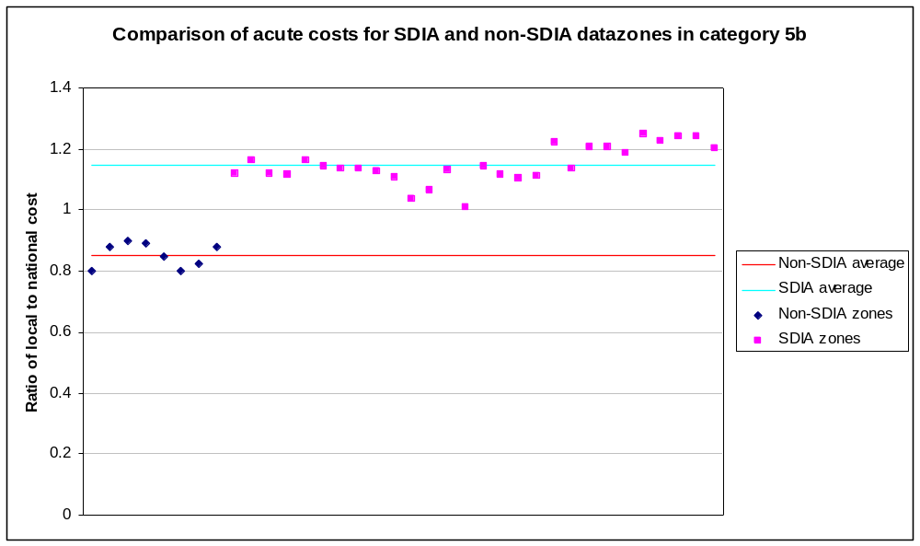

Chart 3.2.2 Acute Costs in SDIA and Non-SDIA Data Zones in Category 8b
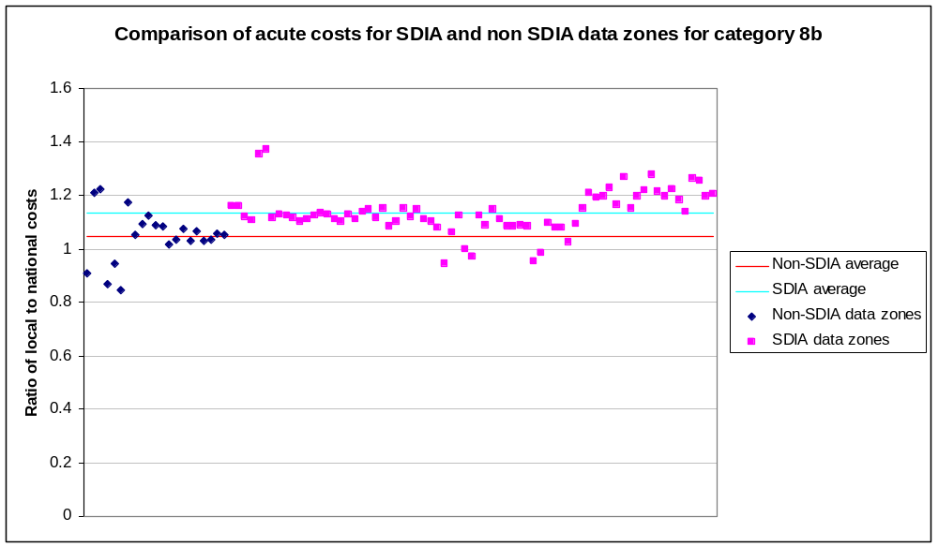

Further analysis was undertaken to estimate the contribution of the SDIA to the costs differential between SDIA and non-SDIA areas (see details in Annex 4). That analysis demonstrated that the clear cost difference between SDIA and non-SDIA islands persists even when SDIA costs are excluded. In fact not much more than a quarter of the cost difference can be attributed to SDIA per se. Therefore the issue of whether or not SDIA costs are included is important to the affected boards’ allocations, but for the wholly island boards the move to the more disaggregate urban rural classification is found to be equally important. For NHS Highland and NHS Ayrshire & Arran, the adoption of the alternative urban rural classification is the more influential issue.

3.2.3 Rationalizing urban rural categories

The earlier analysis expanded the current 10-fold urban rural classification used in the unavoidable excess cost adjustment to a 12-fold classification, creating two new SDIA-specific zones. This meant that some of the categories became extremely small. In particular, the category ‘Non-SDIA islands – very remote small towns’ contained only 0.1% of the Scottish population.

In an attempt to eliminate these very small categories, the six categories relating to ‘very remote’ areas of Scotland were aggregated together to form two new categories: ‘SDIA islands’ and ‘Very remote (non-SDIA) areas’. This did not affect the assessment of these areas. The simpler structure is therefore considered an improvement on the 12-fold classification that had been created.

3.2.4 Incorporating board-specific SDIA rates

The previous analysis treated SDIA as a common factor across the island boards. However, in reality the rate of SDIA differs across the different boards, meaning they face different costs. An adjustment has therefore been made to SDIA boards’ allocations, increasing or decreasing their allocation depending on whether their rate of SDIA is above or below average.

Table 3.2.1 – Rates of SDIA in the different islands
Area | SDIA rate
Shetland | £1,618
Orkney | £1,078
Western Isles, Tira, Jura, and Islay | £917

This means that, even if all the SDIA islands were to provide services in the same manner, using the same number of staff, there would still be differential costs between the different islands. These would not be reflected in the current approach, which assumes that SDIA islands can be treated as a homogenous group.

This is difficult to adjust for within the formula approach. One possible method would be to apply an uplift factor to the specific boards, based on their relative rates of SDIA. A methodology for this is shown below:

Average rate of SDIA: £1,152 (average of affected boards weighted by SDIA staff spend)

Rates of SDIA relative to the average:
- Orkney -6%
- Western Isles -20%
- Shetland +40%
- Highland -20%

SDIA costs as a percentage of total costs: 1.8%

Uplift factor for each NHS Board (Relative rate of SDIA * 1.8%)
- Orkney -0.1%
- Western Isles -0.4%
- Shetland +0.7%
- Highland -0.4%

The relevant uplift factor is then applied to the unavoidable excess cost index for the zones within the new SDIA category.

The advantage of this approach is that it avoids a cost reimbursement to the island boards for SDIA. Essentially, the approach attempts to identify what staff costs would be under a notional ‘common’ approach to service delivery across the different islands, and then apply differential uplifts depending on how SDIA costs vary within the islands. It does not try to reflect boards’ choices about staffing models.

3.2.5 SDIA conclusion

Based on the proceeding analytical evidence, the sub-group recommend to TAGRA the following:

- SDIA costs are retained within the formula,
- The simplified 8-fold urban rural classification is used which includes a separate category for SDIA,
- NHS Board - specific adjustments are included to account for the different rates of SDIA in place in the different NHS Boards.

3.2.6 Assessment against TAGRA’s core criteria

As part of making any changes to the NRAC formula, it is important to assess the impact of the change against TAGRA’s core criteria. This is set out below, assuming that (a) SDIA costs are retained within the analysis, (b) the simplified 8-fold urban rural classification is used, and (c) board-specific adjustments are included to account for the different rates of SDIA in place in the different boards.

Equity
The change would appear to be more equitable. There is reasonable evidence to support the view that the current urban-rural classification does not fairly distinguish between the costs of islands which incur the SDIA and those that do not.

Practicality
The potential adjustment is based on the same data as the current adjustment, and so is equally practical.

Transparency
Use of the SDIA to differentiate between islands is a clearly explicable approach. The slight rationalization of the number of urban rural categories used in the unavoidable excess costs adjustment may help improve the transparency of the formula; however, the introduction of board adjustments for SDIA on top of the urban rural classifications may be seen as making the formula more complex and less comprehensible.

Objectivity
The potential adjustment is based on the same data as the current adjustment, and so is equally objective.

Avoiding perverse incentives
The reduction in the number of urban rural categories under the proposed 8-fold adjustment means that there is no longer any zone solely populated by one NHS Board, although NHS Highland continues to dominate the new ‘very remote (non-SDIA) areas’ category. There may therefore be some small reduction in potential perverse incentives.

Relevance
The new adjustment is based on the same data as the current adjustment, and so is equally relevant.

Stability
Data are based on three year averages at data zone level, and so should be reasonably stable. However, relative stability of the new smaller geographies versus the larger ones has not yet been tested.

Responsiveness
The potential adjustment is based on the same data as the current adjustment, and so is equally responsive.

Face validity
The general approach to the potential adjustment is the same as the current one, and so should have equally face validity. The change introduced, distinguishing between islands which do and do not incur the SDIA, should also be readily understandable.

3.3 OTHER ASPECTS OF THE EXCESS COST ADJUSTMENT

3.3.1 Background
The issues the group were tasked with considering included:
- exploring the possibility that there were fixed (or de minimis) costs associated with the provision of health services which were not captured by the excess cost adjustment;
- assessing the suitability of the urban-rural classification.

The group adopted a multi-pronged approach, undertaking a number of strands of research including: exploring the detail of the excess cost calculations and the data sources; estimating the de minimis cost of service provision; examining hospital cost functions analysis; and, undertaking ANOVA (Analysis of Variance) of the urban rural classification.

The details of the exercise to estimate the de minimis costs incurred in the provision of a Rural General Hospital are set out in Annex 6. This found that the total costs were around £3.2 million per annum. Annex 7 describes the background to the hospital cost functions work. The group had been minded to ask HERU (Health Economics Research Unit) to update this work but there is an element of data which is sourced from the census and that was not available in time to undertake that work.

It should be noted that both the de mininis and hospital costs functions approach are quite different to the NRAC approach. The NRAC excess cost methodology categorises costs of health services on the basis of the residence of the patients: these alternative approaches categorise costs according to the location of health service infrastructure or facilities.

The following paragraphs set out the work exploring the coverage of the excess cost adjustment and the urban-rural classification.

3.3.2 Unavoidable excess cost adjustment:
3.3.2.1 Methodology
The complete Unavoidable Excess Cost Adjustment (UECA) has a number of elements reflecting differences between service programmes. To make this examination tractable we will focus on one part of the UECA – hospital costs. The hospital cost element has a substantial weight and has been the subject of the ‘de mininis’ analysis and the ‘hospital costs functions’ work (see annexes 6 and 7).

There are two main parts to the UECA method for hospital services: first, the calculation of the cost ratios at the data zone level; second, the estimation of the average cost ratios for the urban/rural categories. These are considered separately below.

The hospital UECA compares the actual costs of treating patients in a data zone with the cost of treating them had the unit costs of care been national average unit costs (rather than the actual costs). That is, it calculates the ratio of actual treatment costs to national average costs (at the speciality level). Details of the cost ratio calculation approach from NRAC Technical Report E http://www.nrac.scot.nhs.uk/research.htm.

3.3.2.2 Data
The specific data used for the hospital costs ratio combines activity data (SMR) with the speciality level cost data in SFR (Scottish Finance Return) 5.2. Thus the unit costs will encompass all the costs of treating patients at a board including the fixed costs of the board and the hospital – which are allocated to patient treatment services.

The basic expenditure source used for the calculation of costs is the Costs Book. See the following link to the Costs Book Manual (and reconciliation to the Annual Accounts) for definitions of the cost data. http://www.isdscotland.org/Health-Topics/Finance/Costs/Reference-Information.asp

A board which had to maintain a large hospital or number of hospital beds or hospital staff, relative to its number of patients (because it had a small population), will have a high average cost per patient. That is, it will have a high cost per patient compared to the national average cost – and this will be captured as high cost ratio.

In practice there are cross (health board) border transfers of patients and the UECA average cost of treating the patients in a data zone reflects this: it is the cost of treatment for data zone residents irrespective of where the treatment occurs. The cost ratio for the data zone will reflect an average of the costs of the board of residence for patients treated in the home board and the costs of the board of treatment for patients treated in another board.

That ensures that the estimated cost ratio reflects the average cost to the board of treating its resident population. Note that the methodology for estimating the unit costs of treatment will shortly be reviewed as part of TAGRA’s work programme (Acute Costs Review).

3.3.2.3 Averaging cost ratios:
The ratio of local to national costs at the data zone level are not simply averaged across all the data zones within individual health boards. The NRAC approach seeks to relate service requirements and costs to objective factors such as, for example, deprivation and to abstract from the differences in the models of service delivery between boards. In the case of the UECA the determinants of cost are held to be the degree of rurality of the local areas and therefore the SG urban/rural classification is used as a basis for the averaging of costs. It is assumed that the effect of rurality on costs is broadly constant within the particular urban/rural category.

By averaging costs across the urban/rural category the formula seeks to identify unavoidable costs – those which relate to real differences in the environment within which local services are delivered. As such the allocation may not fully reflect the observed variation in costs as some of that variation may be avoidable (e.g. it may arise from inefficiencies). However, it does require that the urban/rural categories provide a reasonably robust stratification of geographical regions respect to unavoidable costs of service delivery.

The sub-group has already uncovered an example where it was deemed that the categorisation did not adequately reflect the variation in costs – in respect of the SDIA. In this case an urban/rural category spanned SDIA and non-SDIA areas and this generated an average cost of treatment which did not fully reflect the costs faced by a board which was fully in the SDIA category. This issue is explored further in the section on Analysis of Variance below.

3.3.2.4 Conclusion
Following this detailed exploration the sub-group have not identified fixed (de minimis) or other costs in the hospital sector which are not feeding though to the excess cost adjustment. There was therefore not found to be a justification for an adjustment for de minimis costs.

There was however some concern about the extent to which the variation in the unit costs of the provision of community care services were fully reflected it the excess cost adjustment. This was an issue which the sub-group did not have time to explore in detail. TAGRA therefore asked to build this work into the future work programme.

3.3.3 Statistical Analysis of the Urban-Rural Classification
Additional analysis was undertaken to further explore the statistical properties of the urban-rural classification. Specifically using Analysis of Variance (ANOVA) techniques to compare the variation of the small area cost ratios within urban-rural categories to the variation between categories.

The ANOVA was conducted using the cost ratios for the following care programmes: Acute, Maternity, Care of the Elderly and Mental Health. All cost ratios are based on 2007-2009 data. Detailed methodology and analyses for all care programmes are available in the annex 5 and in paper TRR 27 http://www.tagra.scot.nhs.uk/sub-groups_RR.html. The following section presents analysis for the acute care programme only.

3.3.3.1 Background to Analysis of Variance
Essentially ANOVA is a technique used to test whether there are statistically significant differences between two or more independent groups. More specifically, ANOVA is a technique that can be used to test the hypothesis that the means among 2 or more groups are equal, under the assumption that the sampled populations are normally distributed, the observations are independent and there are equal variances for each group.

Null hypothesis: (Cost ratio) Means of the (urban-rural) groups are equal.

Alternative hypothesis: There is a difference between (cost ratio) means for the (urban-rural) groups.

3.3.3.2 Analysis

The following section provides results from using ANOVA to test if the (Acute) excess cost ratio means are equal between the 8 fold (Scottish Government) urban-rural classes.

Response variable: Acute cost ratio (2007-2009)
Predictor variable: 8 fold (Scottish Government) urban-rural classification

The SDIA Islands group consistently tended to be statistically significantly different compared to the cost ratio means of other groups across Acute, Maternity, Care of the Elderly and Mental Health care programmes. This supports the evidence that the SDIA Islands should be a separate classification.

The other non SDIA groups generally had more normal distributions and less variation in their cost ratios. These other groups did not consistently exhibit statistically significant differences across urban-rural categories – the pattern varied by category and care programmes. This may in part be due to cross border flows, in particular for acute care.

3.3.3.3 Conclusion
There appears no clear evidence from this analysis that these other groups should be reclassified.

Table 3.3.1: (Acute) Least squares means for Scottish Government’s urban-rural 8 fold classification

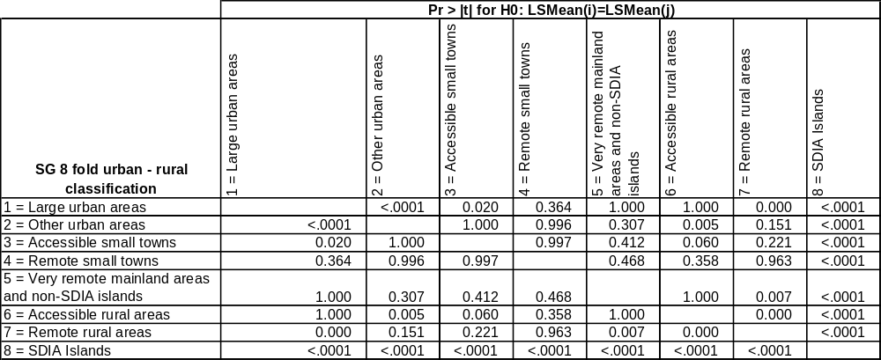

The null hypothesis (Cost ratio means of the (urban-rural) groups are equal) can be rejected if there is a p-value of less than the alpha level of 0.05.

Most means of the urban-rural groups are not statistically significantly different. The exception was the SDIA group, which was found to be statistically different from all the other group means groups (p-value is less than 0.05).

CHAPTER 4 – RECOMMENDATIONS FOR TAGRA

Recommendation 1: There should be an adjustment, based on the Scottish Allocation Formula, which explicitly recognises Out of Hours Services.

Recommendation 2: With regards to SDIA costs,
- There should be an adjustment to the urban rural categories used within the Unavoidable Excess Cost Adjustment element of the NRAC formula.
- There should be NHS Board – specific adjustments included to take into account the different rates of SDIA in place in the different boards.
- SDIA costs should be retained and allocated using the NRAC formula.

Recommendation 3: TAGRA should include a review of the community element of the excess cost adjustment in its work programme, when a reliable national dataset for community services activity and costs becomes available.
GLOSSARY

ANOVA – Analysis of Variance

ASD – (Health) Analytical Services Division, Scottish Government

GMS – General Medical Services

GP – General Practitioner

GROS – General Register Office for Scotland (now National Records of Scotland)

HB – (NHS) Health Board

HCHS - Hospital and Community Health Services

ISD – Information Services Division, Scotland

MLC – Morbidity & Life Circumstances

NHS – National Health Service (Scotland)

NRAC – National Resource Allocation Committee

OOHS – Out of Hours Services

PCEC – Primary Care Emergency Centre

PTI - Practice Team Information, National Services Scotland

SDIA – Scottish Distance Islands Allowance

SG – Scottish Government

TAGRA – Technical Advisory Group for Resource Allocation

UECA – Unavoidable Excess Costs Adjustment

URC – (Scottish Government) Urban-Rural classification

ANNEX 1 – SUB-GROUP MEMBERSHIP
The membership of the group is made up of a combination of NHS board members, academics/experts in the area, and analysts from the Scottish Government:

Jill Vickerman (Chair) (Scottish Government)
Alan Gray (Deputy Chair) (NHS Grampian)
Paddy Hopkins (NHS Highland)
Professor Bob Elliot, (University of Aberdeen) (Until August 2012)
Dr Patricia Norwood (University of Aberdeen) (from September 2012)
Ralph Roberts (NHS Shetland)
Sarah Taylor (NHS Shetland)
Colin Marsland (NHS Shetland)
Gerry O’Brien (NHS Orkney)
Ian Donald (NHS Tayside)
Craig Marriott (NHS Dumfries & Galloway)
Dr Sheena MacDonald (NHS Borders)
Annie Ingram (North of Scotland Planning Group) (until January 2012)
Peter Gent (North of Scotland Planning Group) (from August 2012 )
Marion Fordham (NHS Western Isles)
Iain Pearce (SG) (until February 2012)
Angela Campbell (Scottish Government)
Dr Paudric Osborne (Scottish Government) (from February 2012)
Ellen Lynch (Scottish Government) (from January 2012)
Robbie Pearson (Scottish Government)

ANNEX 2 - THE EXCESS COSTS ADJUSTMENT IN THE NRAC FORMULA

The key objective for the NRAC formula is to measure relative need for healthcare services, so that resources can be allocated accordingly. Relative need is based on an area’s population and other indicators – the age and sex profile of that population, as well as ‘morbidity and life circumstances’ – those factors over and above age and sex which influence an individual’s need for healthcare services. The formula then assesses the differential, unavoidable costs of providing these services across different geographical areas.
Figure Annex 2.1 The NRAC Formula
 |  |  |  |  |  | Unavoidable excess
Population |  | Age-sex cost weights |  | Additional needs |  | costs of supply
Health Board population % | x | Relative need due to age-sex profile | x | Relative need due to morbidity and life circumstances and other factors | x | Relative costs of providing services to different geographical areas | = | NRAC weighted share %

The NRAC formula is built up from the different care programmes which comprise the total spending being allocated.

- Acute
- Care of the Elderly
- Mental Health & Learning Difficulties
- Maternity
- Community

Together these five care programmes make up the Hospital and Community Health Services (HCHS).

A separate care programme is :-

- GP Prescribing

These two parts of the formula (HCHS and GP Prescribing) have different population bases and so are calculated separately, then combined to produce the final target shares.

ANNEX 3 - OUT OF HOURS SERVICES: FURTHER DETAILS

Relatively limited information is available on the provision of OOH services. Expenditure on OOH by boards has been separately recorded in the Costs Book since 2008/09 and a specific data collection on OOH was undertaken by Health Analytical Services Division (Scottish Government) for 2008/09.

The following table provides the most detailed available information on OOH activity by HB, for 2008/09. This shows that a total of 823,381 consultations were provided by OOH services across Scotland. The Practice Team Information (PTI) estimates published by ISD for 2008/09 estimate the number of GP and practice nurse consultations for Scotland at 22.7 million. This suggests that the number of OOH consultation was around 4% of the number of consultations which took place within GP practices.

Table Annex 3.1: OOH activity by Health Board, 2008/09.
 | PCEC | Home Visit | Phone Advice | Other Clinical Staff | Total
Ayrshire & Arran | 27,856 | 20,735 | 5,792 |  | 54,383
Borders | 8,795 | 4,138 | 4,702 |  | 17,635
Dumfries & Galloway | 10,637 | 7,512 | 3,447 | 1,849 | 23,445
Fife | 17,483 | 11,915 | 7,848 | 15,614 | 52,860
Forth Valley |  |  |  |  | 44,205
Grampian | 46,852 | 23,723 | 10,926 |  | 81,501
Greater Glasgow & Clyde | 137,500 | 39,562 | 34,290 | 11,646 | 222,998
Highland | 33,679 | 9,867 | 6,086 | 1,134 | 50,766
Lanarkshire | 52,121 | 15,457 | 8,365 | 2,890 | 78,833
Lothian | 68,079 | 20,232 | 23,873 |  | 112,184
Orkney | 941 | 508 | 303 | 23 | 1,775
Shetland | 495 | 419 | 322 | 13 | 1,249
Tayside | 54,622 | 9,141 | 14,594 |  | 78,357
Western Isles | 1,234 | 865 | 1,019 | 72 | 3,190
Scotland | 460,294 | 164,074 | 121,567 | 33,241 | 823,381
Source: Health ASD, Scottish Government

The following table sets out expenditure on OOH as recorded in the Costs Book, expenditure per head, an estimate of the 6% contribution retained from the Global Sum and the implied net additional contribution by HB. Note that this is an approximate comparison.

Table Annex 3.2: Health Board expenditure on OOH services, the retained 6% of global sum, £ 000 and spend per OOH population
Health Board | GP Out of Hours Expenditure 2010-11* | OOH spend per hd | Retained 6% 2012** | Implied additional spending
Ayrshire & Arran | 4,498 | 12 | 1,624 | 2,875
Borders | 3,381 | 29 | 541 | 2,839
Dumfries & Galloway | 3,298 | 21 | 749 | 2,549
Fife | 4,816 | 13 | 1,463 | 3,353
Forth Valley | 3,952 | 13 | 1,264 | 2,688
Grampian | 7,775 | 14 | 2,357 | 5,418
Greater Glasgow & Clyde | 13,514 | 10 | 5,437 | 8,077
Highland | 9,852 | 35 | 1,518 | 8,334
Lanarkshire | 7,640 | 13 | 2,397 | 5,243
Lothian | 8,657 | 10 | 3,355 | 5,302
Orkney | 704 | 39 | 90 | 613
Shetland | 268 | 16 | 82 | 186
Tayside | 6,127 | 15 | 1,780 | 4,348
Western Isles | 962 | 39 | 160 | 802
Scotland | 75,445 | 14 | 22,817 | 52,628
Source: * Costs Book 2011; ** Health ASD, Scottish Government calculation.

This data suggests that HB spend around £75 mn on OOH services across Scotland and that they retain a contribution from the Global Sum of around £23 mn. The Global Sum is around £380 mn which suggests that the spend on OOH is equivalent to around 20% of the Global sum. This implies that OOH expenditure is much higher than the share of activity would imply.

However, the more relevant comparison may be with all primary medical expenditure (£678 mn) as the PTI includes consultations relating to other aspects of general practice and not just the activity funded under by the Global Sum. In this case the proportion of expenditure on OOH falls to 11% - still disproportionately high in relation to the share of consultations.

According to the data in Table 2 there is wide variation in spend per capita on OOH services across Scotland. Four HB (Borders, Highland, Orkney and Western Isles) are estimated to spend more than twice as much per capita as the Scotland average.

General Practice contract types

There are two broad types of practices: those which have the GMS allocation from the SAF (17J) and those which have specific contractual arrangements with boards (2C & 17C). The definitions are set out in the following Table. The contracts with the latter can include payments for OOH services, so although the practice provides the OOH service, the board would contribute additional funding.

Table Annex 3.3: General Practice contract types
2C | In general terms, this is most likely to mean that the practice is run by the NHS Board (as opposed to being run by GPs and/or other partners, as is the case for practices with 17C or 17J contract types). With effect from 1st April 2004, The Primary Medical Services (Scotland) Act 2004 amended The National Health Service (Scotland) Act 1978 by placing a duty on NHS Boards to provide or secure 'primary medical services' for their populations. NHS Boards can do so by making arrangements with 17C and/or 17J practices (see below). Additionally they can arrange for services to be provided directly (this is known as 'direct provision') or via another organisation (this is known as a 'Health Board Primary Medical Services' contract). These additional options are included under Section 2C of the 1978 Act.
17C | A 'Section 17C' practice (formerly known as 'Personal Medical Services' or 'PMS' practice) is one that has a locally negotiated agreement, enabling, for example, flexible provision of services in accordance with specific local circumstances. Section 17C is in respect of The National Health Service (Scotland) Act 1978, as amended under The Primary Medical Services (Scotland) Act 2004.
17J | A 'Section 17J' or 'GMS' (General Medical Services) practice is one that has a standard, nationally negotiated contract. Within this, there is some local flexibility for GPs to opt out of certain services (such as additional services) or opt in to the provision of other services (such as enhanced services). Section 17J is in respect of The National Health Service (Scotland) Act 1978, as amended under The Primary Medical Services (Scotland) Act 2004.

Population base

ISD data suggest that around 5% of practices provide OOH services but that only around 1% of the Scottish population are covered by those services. In principal the OOH allocation should be applied in respect of the practice populations which are not covered by OOH services provided by the practice. That is, that the 1% of the population covered by practices should be omitted from the allocation.

However, a complication is that some of the practices providing OOH services are being paid by boards to do so. In light of the small numbers involved (1% of the Scottish population), and not wanting to construct a formula reflecting service provision, the sub-group recommended that all practice types should be included.

ANNEX 4 – SDIA

This annex contains details and analysis around the costs of the Scottish Distant Island’s Allowance. The first section contains a summary of the main analysis and conclusions, the second section contains more detailed analysis. In addition, all papers from the sub-group can be found at the following link:
http://www.tagra.scot.nhs.uk/sub-groups_RR.html

SECTION 1 – Summary of main analysis conclusions

Background

The issue of Scottish Distant Islands Allowance (SDIA) costs was first investigated in 2009 by TAGRA (see TAGRA(2009)21 for a summary of work done). Analysis at this time attempted to remove the Scottish Distant Island Allowance costs from the formula, and considered the impact on board allocations. At that time, due to complexity in identifying and removing SDIA costs, and as additional funding had been introduced for the island boards, it was decided not to change the treatment of these costs within the formula.

The analysis undertaken by the Remote & Rural sub-group takes a slightly different approach. Rather than attempting to remove SDIA costs from the formula, it seeks to consider whether adjusting the urban-rural classification within the unavoidable excess costs adjustment could lead to better reflecting these costs within the formula.

Costs of islands

Within the hospital element of unavoidable excess costs calculations in the NRAC formula, Scotland is currently divided into 10 urban rural categories, as shown in the table below.
Table Annex 4.1: Percentage of each NHS Board’s population in each urban-rural category as at 2005
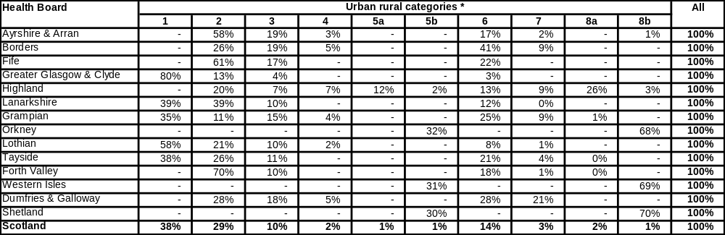
Note: "-" indicates zero, "0%" indicates less than 0.5%.
Source: NRAC Final Report, Table 6.3.
* Key to categories
1 = Large urban areas. 5b = Island very remote small towns.
2 = Other urban areas. 6 = Accessible rural areas.
3 = Accessible small towns. 7 = Remote rural areas.
4 = Remote small towns. 8a = Mainland very remote rural areas.
5a = Mainland very remote small towns. 8b = Island very remote rural areas.

Two of these categories, 5b and 8b, relate to islands.
These two categories can be further subdivided into:
- 5c: Island very remote small towns without SDIA
- 5d: Island very remote small towns with SDIA
- 8c: Island very remote rural areas without SDIA
- 8d: Island very remote rural areas with SDIA

As shown in the table below, this change essentially creates separate categories for the wholly island boards, although for NHS Highland Islay, Jura& Colonsay, and Tiree are also included in 8d.

Table Annex 4.2: Percentage of each NHS Board’s population in each urban-rural category (extended) as at 2005
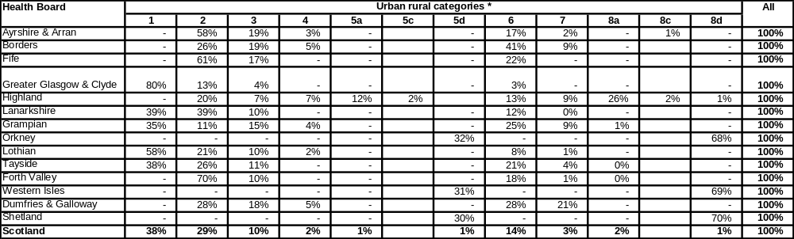

In making this change it is worth considering whether there is sufficient difference between these areas to justify splitting the zones. The following graphs show the difference in costs between the SDIA data zones and the non-SDIA data zones. In both cases, SDIA data zones have significantly higher costs than non-SDIA data zones.
Chart Annex 4.1

Chart Annex 4.2

The analytical evidence suggests that that SDIA costs are higher than those for non-SDIA islands. As a consequence, the sub-group recommend to TAGRA the following:
- SDIA costs are retained within the analysis,
- the simplified 8-fold urban rural classification is used, and
- board - specific adjustments are included to account for the different rates of SDIA in place in the different boards.

Paper TRR08, set out a possible change to the urban rural categories used within the unavoidable excess cost adjustment in order to better account for costs related to the Scottish Distant Islands Allowance (SDIA). The analysis demonstrated that islands which were required to pay SDIA to staff had significantly higher costs than those which were not. Further analysis was undertaken to understand whether this was purely due to the influence of SDIA costs, or whether there were other factors influencing the results.

Impact of removing SDIA costs

Section 2 reports the results of removing completely the costs of SDIA from the NRAC formula. Due to difficulties in obtaining disaggregate SDIA, the analysis is relatively crude and the results should be taken as indicative only. However, the results show that even after removing SDIA costs, there are differences between the cost of delivery on SDIA versus non-SDIA islands. This is particularly true for services within small towns on islands. SDIA costs appear to account for not much more than a quarter of the difference between the two types of islands.

Rationalizing urban rural categories

The earlier analysis expanded the current 10-fold urban rural classification used in the unavoidable excess cost adjustment to a 12-fold classification, creating two new SDIA-specific zones. This meant that some of the categories became extremely small. In particular, the category ‘Non-SDIA islands – very remote small towns’ contained only 0.1% of the Scottish population.

In an attempt to eliminate these very small categories, the six categories relating to ‘very remote’ areas of Scotland were aggregated together to form two new categories: ‘SDIA islands’ and ‘Very remote (non-SDIA) areas’. This did not affect the assessment of these areas, although rescaling effects meant that there was a reduction in the target allocations of the affected boards of 0.1%. The simpler structure is therefore considered an improvement on the 12-fold classification that had been created. The detail of the adjustment is reported in Section 2.

Incorporating board-specific SDIA rates

The previous analysis treated SDIA as a common factor across the island boards. However, in reality the rate of SDIA differs across the different boards, meaning they face different costs. An adjustment has therefore been made to SDIA boards’ allocations, increasing or decreasing their allocation depending on whether their rate of SDIA is above or below average. This is reported fully in Section 2.

*********************************

SECTION 2- Detailed SDIA Analysis

Expectations

Before describing the analysis, it is worth setting out some of the context of the SDIA, and some of the expectations of the analysis.

SDIA is paid to staff on particular islands in order to assist in maintaining staff levels in the remote areas of Scotland. The level of SDIA varies, but is in the region of £1,000 to £1,500 per staff member. It therefore represents a relatively small amount of total staff costs, and a necessarily smaller amount of total costs.

By way of context, total payroll, SDIA costs, and board expenditure is shown in the table below for the SDIA Boards.

Table Annex 4.2 – Allocations, staff costs, and SDIA costs for year 2007/08
Board | General revenue allocation (£m) | Staff costs (£m) | SDIA costs (£m) | SDIA costs as % total | SDIA costs as % staff
Orkney | £28.7 | £19.3 | £0.57 | 2.0% | 3.0%
Shetland | £33.9 | £19.2 | £0.84 | 2.5% | 4.3%
Western Isles | £53.6 | £30.3 | £0.74 | 1.4% | 2.4%
Highland | £445.8 | Tbc | £0.50 | 0.1% | tbc

SDIA costs were therefore equivalent to between 1.4% and 2.5% of the general revenue allocation to the three wholly island boards in 2007/08. The cost are there not negligible; however, a reasonable a priori expectation would be that the results of the previous analysis, which suggested a difference between the costs of SDIA and non-SDIA islands of at least 10%, will not see a large change following the removal of SDIA costs.

Methodology

A relatively crude methodology has been applied. This reflects the fact that SDIA cost data cannot be easily broken down to different services or treatment types. The stages used to remove SDIA costs are set out below.

- For each NHS Board, SDIA costs have been allocated to hospital care programmes using national care programme weights;
- Within each care programme, SDIA costs have been allocated to individual data zones based on the distribution of local cost.

This approach is shown below for NHS Highland, which has the simplest calculations as the SDIA islands within NHS Highland, Islay, Tira, and Jura, are represented by only four data zones.

Table Annex 4.3 - Example of allocation of SDIA costs to zones
Step | Data
NHS Highland SDIA | £56,000
Care programme weights | Acute
National weights for hospitals | 72%
Assumed SDIA in acute services in Highland | £40,572 | (= £56,000 x 72%)
Data zones | Acute expenditure | Acute expenditure (%) | Allocated SDIA | Acute expenditure with SDIA removed
S01000723 | £1,033,310 | 15% | £6,035 | £1,027,276
S01000726 | £2,122,663 | 31% | £12,398 | £2,110,265
S01000755 | £1,727,277 | 25% | £10,088 | £1,717,189
S01000831 | £2,063,215 | 30% | £12,051 | £2,051,165
Highland total | £6,946,467 | 100% | £40,572 | £6,905,896

The above process has been carried out for each of the affected NHS Boards, and for each of the hospital care programmes. Once new costs have been calculated for each data zone, the previous analysis has been repeated.

It should be noted that there is a slight inconsistency in the calculations, as technically SDIA costs should be removed from the calculation of national average costs, as well as from the costs of the islands. However, as at the total SDIA spend in Scotland of £2.7m represents less than 0.05% of total general revenue expenditure, this is not expected to significantly affect the results.

Results

As expected, the result of removing SDIA costs from the previous analysis is to reduce the difference in costs between the SDIA and non-SDIA islands. This is shown in the following table for the average across all care programmes.

The change in costs for the SDIA islands is, as was expected, small, at 3% for both very remote small towns and very remote rural areas. The gap between SDIA and non-SDIA islands therefore remains broadly the same size, at least 9%.

Table Annex 4.4 – Change in cost differential between SDIA and non-SDIA islands with removal of SDIA costs
 | Very remote small towns |  |  |  | Very remote rural areas
Category | SDIA islands | Non-SDIA islands | Gap (abs) | Gap (%) | SDIA islands | Non-SDIA islands | Gap (abs) | Gap (%)
With SDIA cost ratio | 1.18 | 0.88 | 0.30 | 34% | 1.19 | 1.06 | 0.13 | 12%
Without SDIA cost ratio | 1.15 | 0.88 | 0.26 | 30% | 1.15 | 1.06 | 0.09 | 9%
Change (abs) | -0.04 | None | -0.04 |  | -0.03 | None | -0.03
Change (%) | -3% | None | -12% |  | -3% | None | -27%

For allocation purposes, if SDIA costs were to be removed from the NRAC formula, there would need to be some changes to other allocations to ensure that SDIA costs were fairly treated.

Summary

The analysis has demonstrated that there remains a clear cost difference between SDIA and non-SDIA islands that persists even when SDIA costs are excluded. Not much more than a quarter of the cost difference can be attributed to SDIA. The issue of whether or not SDIA costs are included is important to the affected boards’ allocations, but for the wholly island boards the move to the more disaggregate urban rural classification is found to be equally important. For NHS Highland and NHS Ayrshire & Arran, the adoption of the alternative urban rural classification is the more influential issue.

Simplification of the urban rural categories

Creating two new urban rural categories to reflect the costs of SDIA islands will increase the number of categories from 10 to 12. The implications of this are:

- The formula is more complex
- Existing categories will become smaller and therefore likely to be less stable,
- There is an increase in the number of categories containing only a single NHS Board, thus increasing the risk of perverse incentives.

The size of the affected categories is shown in the table below, as proportion of the Scottish population. The new SDIA subdivisions of the existing categories are shown shaded and in italics.

Table Annex 4.5 – Size of different urban rural categories
Urban rural category | Share of Scottish population
Mainland – very remote rural areas | 0.7%
Mainland – very remote small towns | 1.6%
Island – very remote rural areas | 1.3%
Of which, SDIA islands | 1.0%
Of which, non-SDIA islands | 0.3%
Island – very remote small towns | 0.5%
Of which, SDIA islands | 0.4%
Of which, non-SDIA islands | 0.1%

One alternative approach would be to combine some of the different categories to reduce the number. For example:

The categories: Mainland – very remote small towns
Mainland – very remote rural areas
Non-SDIA islands – very remote small towns
Non-SDIA islands – very remote rural areas

Can be combined to create a new category, ‘5e – Very remote (non-SDIA) areas’

The categories: Very remote small towns – SDIA islands
Very remote rural areas – SDIA islands

Can be combined to create a new category, ‘8e – SDIA islands’.

This reduces the numbers of categories to 8. The sizes of these new categories are shown in the following table:

Table Annex 4.6 – Size of rationalized urban rural categories

Urban rural category | Share of Scottish population
Very remote (non-SDIA) areas | 2.7%
SDIA islands | 1.4%

The revised distribution of population across the categories by board is shown in the following table.
Table Annex 4.7 - Distribution of population in new urban rural categories
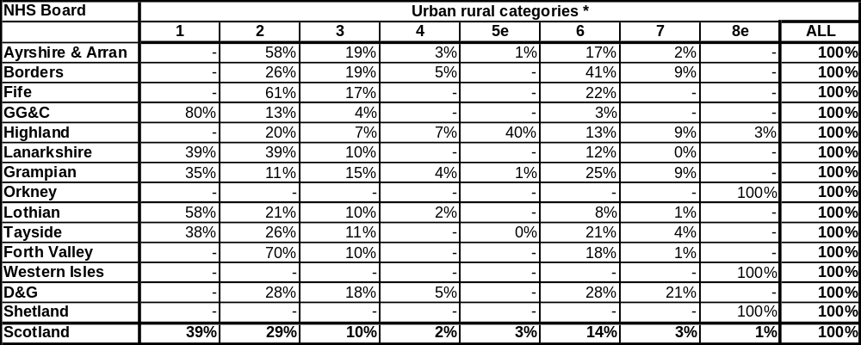

The categories shown here are:
- Large urban areas
- Other urban areas
- Accessible small towns
- Remote small towns
5e. Very remote mainland areas and non-SDIA islands
- Accessible rural areas
- Remote rural areas
8e. SDIA islands

Under this approach, there is no longer any urban rural category with all its population from a single NHS Board, although NHS Highland continues to dominate the ‘very remote mainland’ category, with slightly over 90% of zones coming from this board.
The distribution of zones within category 5e is shown in the graph below, showing which previous category they came from. There is no clear pattern of zones coming from a given category being particularly higher or lower. Although those from 5a (island very remote small towns) are perhaps slightly below the others, the very small number of these zones makes drawing firm conclusions difficult. This in itself is an argument for aggregating these zones within a larger urban-rural category.

Chart Annex 4.3: Ratio of local to national cost for zones within category 5e, split by previous category to which the zone belonged
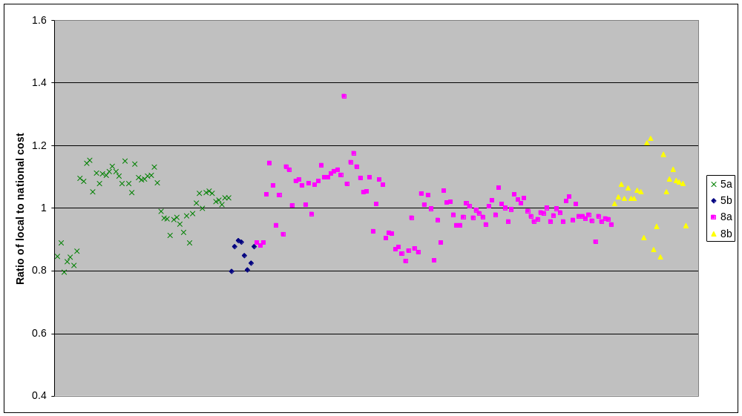
Note: 5a: Very remote small towns – mainland 5b: Very remote small towns – island
8a: Very remote rural areas – mainland 8b: Very remote rural areas – island

Variation in SDIA between boards

The approach discussed thus far has been to treat the SDIA as a common factor across the island boards which increases their unavoidable excess costs. However, whilst these islands have no choice but to pay the SDIA, the rates of SDIA are not common to all areas. The more remote islands are required to pay a higher rate, as shown in the table below.

Table Annex 4.8 – Rates of SDIA in the different islands
Area | SDIA rate
Shetland | £1,618
Orkney | £1,078
Western Isles, Tira, Jura, and Islay | £917

This means that, even if all the SDIA islands were to provide services in the same manner, using the same number of staff, there would still be differential costs between the different islands. These would not be reflected in the current approach, which assumes that SDIA islands can be treated as a homogenous group.

This is difficult to adjust for within the formula approach. One possible method would be to apply an uplift factor to the specific boards, based on their relative rates of SDIA. A methodology for this is shown below:

Average rate of SDIA: £1,152 (average of affected boards weighted by SDIA staff spend)

Rates of SDIA relative to the average:
- Orkney -6%
- Western Isles -20%
- Shetland +40%
- Highland -20%

SDIA costs as a percentage of total costs: 1.8%

Uplift factor for each NHS Board (Relative rate of SDIA * 1.8%)
- Orkney -0.1%
- Western Isles -0.4%
- Shetland +0.7%
- Highland -0.4%

The relevant uplift factor is then applied to the unavoidable excess cost index for the zones within the new SDIA category.

The advantage of this approach is that it avoids a cost reimbursement to the island boards for SDIA. Essentially, the approach attempts to identify what staff costs would be under a notional ‘common’ approach to service delivery across the different islands, and then apply differential uplifts depending on how SDIA costs vary within the islands. It does not try to reflect boards’ choices about staffing models.

Further points

The initial work of the sub-group was presented to TAGRA. Whilst TAGRA welcomed the work, they noted some concern over the implications within the disaggregation of the current ‘island – very remote small towns’ category. This suggests that the costs of delivering services on non-SDIA islands in these categories is some 10% to 20% lower than the Scottish national average.

Part of this results may simply be caused by the fact that there is a very small number of areas within this category, just eight data zones. This problem is perhaps overcome by moving these zones into the new category of ‘very remote mainland and non-SDIA areas’, which would have an average cost higher than the Scottish national average.

Finally, there may be some concern over the above approach, given that the island boards currently receive an additional allowance for SDIA, and if their NRAC target allocation is increased to reflect SDIA costs then there would be an element of double counting in their allocations. One possible approach would be to incorporate the SDIA allocation within the general allocation of the NHS Boards, whilst re-baselining the current allocations to ensure that island boards do not lose out financially through this change.

ANNEX 5 – URBAN – RURAL CLASSIFICATION

Introduction:

Analysis and discussions undertaken by the sub-group have not yielded evidence of missing cost elements in the excess cost adjustment. However, the work of the sub-group has uncovered anomalies in the composition of the urban-rural categories used to aggregate the small area cost ratios for the excess cost adjustment.

This annex reports some additional analysis which has been undertaken to further explore the statistical properties of the urban-rural classification. Specifically it uses Analysis of Variance (ANOVA) techniques to compare the variation of the small area cost ratios within urban-rural categories to the variation between categories.

The ANOVA is conducted using the cost ratios for the following care programmes: Acute, Maternity, Care of the Elderly and Mental Health. All cost ratios are based on 2007-2009 data. This annex presents analysis for the Acute care programme. Detailed methodology and analyses for all care programmes are available in paper TRR27
(http://www.tagra.scot.nhs.uk/sub-groups_RR.html).

Background to Analysis of Variance

Essentially ANOVA is a technique used to test whether there are statistically significant differences between two or more independent groups. More specifically, ANOVA is a technique that can be used to test the hypothesis that the means among 2 or more groups are equal, under the assumption that the sampled populations are normally distributed, the observations are independent and there are equal variances for each group.

Null hypothesis: Means of the (urban-rural) groups are equal.

Alternative hypothesis: There is a difference between means for the (urban-rural) groups.

Applying ANOVA to Acute excess cost ratios by the 8 fold (Scottish Government) urban-rural classification

The following section provides results from using ANOVA to test if the (Acute) excess cost ratio means are equal between the 8 fold (Scottish Government) urban-rural classes.

Response variable: Acute cost ratio (2007-2009)
Predictor variable: 8 fold (Scottish Government) urban-rural classification

Testing assumptions

Assumption 1: Independent observations

Observations are independent.

Assumption 2: Data is distributed normally (or approximately normal)

- Histograms (graphs 1-8) for 8 fold (Scottish Government) urban-rural classification

1 = Large urban areas
2 = Other urban areas
3 = Accessible small towns
4 = Remote small towns
5 = Very remote mainland areas and non-SDIA (Scottish Distant Islands Allowance) islands
6 = Accessible rural areas
7 = Remote rural areas
8 = SDIA Islands

Error: Reference source not found

Error: Reference source not found

Error: Reference source not found

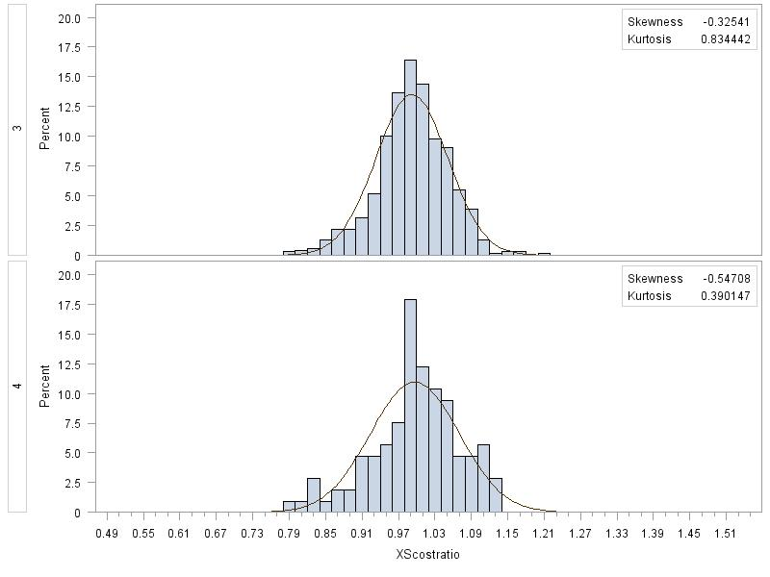

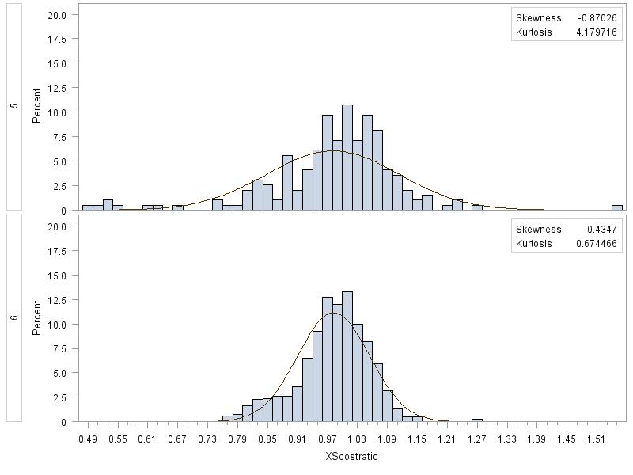

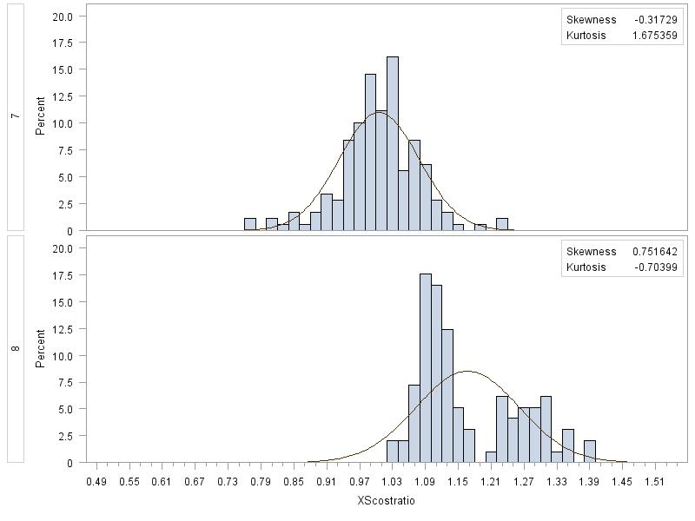

Graphs 1-7 look fairly normally distributed but graph 8 looks possibly bimodal.

ANOVA is robust against moderate departures from the assumptions of normality and equal variance (especially for larger sample sizes). Due to the large number of observations used in this ANOVA, the normality assumption is satisfied.

Assumption 3: Equal variances
Levene’s Test for homogeneity of variance:
Null hypothesis = variances are equal (p-value > 0.05)
Alternative hypothesis = variances are not equal (p-value < 0.05)

A p-value is a probability associated with your test statistic. It measures the chance of getting results at least as strong as yours if the claim (null hypothesis) were true.

Table Annex 5.1: Testing for equality of means (Levene’s test)

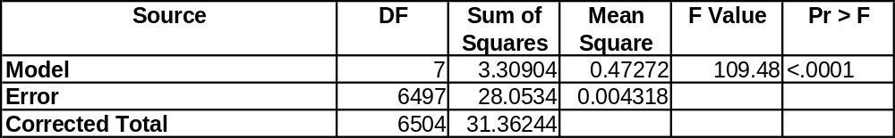
The p-value of <0.0001 is less than the alpha level of 0.05 and therefore the null hypothesis can be rejected. The variances are not equal.

As the variances are not equal, Welch’s (1951) variance weighted one way ANOVA has been implemented.

Welch’s (1951) variance weighted one way ANOVA results

The following Welch’s variance one way ANOVA includes Tukey’s multiple comparison method. Tukey’s multiple comparison method examines the differences between two group means. All possible combinations of two group means are produced. Table 2 provides the (Acute) excess cost ratio least squares mean by the Scottish Government’s 8 fold urban – rural classification. Table 3 provides the p-values from pairwise comparisons of all possible combinations of group means.

Table Annex 5.2: (Acute) excess cost ratio least squares mean by the Scottish Government’s 8 fold urban – rural classification

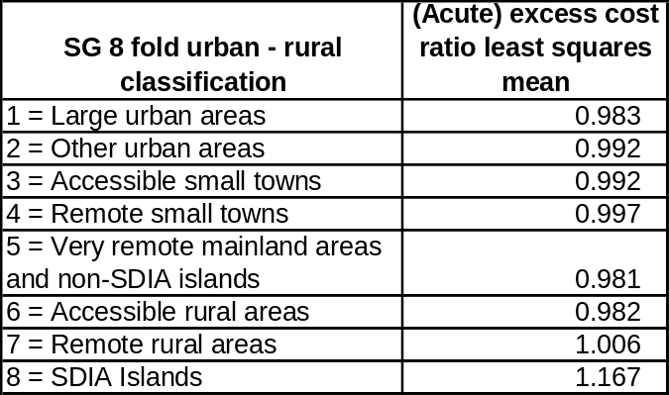
Table Annex 5.3: (Acute) Least squares means for Scottish Government’s urban-rural 8 fold classification

The null hypothesis can be rejected if there is a p-value of less than the alpha level of 0.05.

The table shows that for the SDIA Islands group, that the mean is statistically significant to all the other groups (p-value is less than 0.05). In addition, there are statistically significant differences between means for the following combinations:
Large urban areas and Other urban areas; Large urban areas and Remote rural areas; Other urban areas and Accessible rural areas; Accessible small towns and Large urban areas; Very remote mainland…..and Remote rural areas; Accessible rural areas and Remote rural areas.
Summary of main findings for the acute programme :

- Most means of the urban-rural groups are not statistically significantly different. The exception was the SDIA group, which was found to be statistically different from all the other group means.

- Possible bimodal (2 peaks) distribution of cost ratios for the SDIA group, which suggests the SDIA classification could be separated further.

Conclusion

The SDIA Islands group consistently tends to be statistically significantly different compared to the other groups. This supports the evidence that the SDIA Islands should be a separate classification.

There is some evidence to suggest that the SDIA Islands group could be further split in two (based on the distribution of cost ratios), although careful consideration would be needed as this may result in excessively small groupings.

The other groups generally had more normal distributions and less variation in their cost ratios. These other groups did not consistently exhibit statistically significant differences across urban-rural categories – the pattern varied by category and care programmes. This may in part be due to cross border flows, in particular for acute care. There appears no clear evidence from this analysis that these other groups should be reclassified.

ANNEX 6 – DE MINIMIS COSTS

The sub-group explored as to whether there was evidence of a De minimis cost of hospitals that was not already captured as part of the NRAC Unavoidable Excess Costs adjustment.

The starting point of the work was to define the minimum staff and service requirements for a Rural General Hospital, as set out in Delivering for Remote and Rural Healthcare. This defined a Rural General Hospital as a facility capable of providing 24/7 acute medical and surgical emergency care. Based upon the comments provided by those present at the meeting, and the information set out in the above report, the initial staff and other requirements for such a hospital have been taken as:

Staff requirements
- Medical consultant: rota of three
- Specialist general surgeons: rota of three
- Anaesthetist consultant: rota of three
- Advanced nurse practitioner: rota of three
- Specialist nurse: rota of three
- General nurse with special interest: rota of three
- General nurse: rota of three

Physical requirements
- 14 beds
- A theatre

Costs for these requirements have been derived from a number of sources. Staff costs have been sourced from Agenda for Change pay bands and ISD’s Scottish Workforce Information Standard System (SWISS). Some definitional difficulties have been encountered: e.g. ‘remote and rural’ is not recognized as a specialty within SWISS. The definitions used to derive staffing costs, and the staffing costs themselves, are shown in the table below. Note that staff costs show total cost to the employer, including employer national insurance contributions and pension costs, for example, rather than the gross salary received by the employee.
Table Annex 6.1 - Staff definitions and costs used in calculations
Staff type | Definition for cost purposes | 2011/12 staff cost
Medical consultant | Average consultant cost | £145,400
Specialist general surgeon | Average consultant cost | £145,400
Anaesthetist consultant | Average consultant cost | £145,400
Advanced nurse practitioner | Agenda for Change Band 8A | £57,100
Specialist nurse | Average Agenda for Change cost across all specialist nurses | £46,717
Generalist nurse with special interest | Mid-point of specialist nurse and general nurse | £40,871
General nurse | Average Agenda for Change cost across all non-specialist nurses | £34,857

Costs for physical requirements have been sourced from the 2009/10 Costs Book, reports R141X and R040X. For theatre costs, the total allocated, i.e., excluding staff or supplies, cost of theatres of £137.8m has been averaged across the 370 theatres in Scotland to provide an average allocated cost per theatre of £372k. An uplift of approximately 6% has been applied to move from 2009/10 to 2011/12 prices, giving a final cost of £394k.

For the bed costs, the average allocated cost per case of £884 has been divided by the average length of stay of 5.1 days to obtain a cost of £173 per bed per day, which is assumed to equate to a cost of £63k per bed per year. An uplift of approximately 6% has been applied to move from 2009/10 to 2011/12 prices, giving a final cost of £66,832.

Combining all these separate costs, as shown in the table below, provides an overall cost of approximately £3.1m per year.

Table Annex 6.2 – Unit and total costs by staff type
Cost item | Unit cost (£) | Units | Total cost (£)
Medical consultant | £145,400 | 3 | £436,200
Specialist general surgeon | £145,400 | 3 | £436,200
Anaesthetist consultant | £145,400 | 3 | £436,200
Advanced nurse practitioner | £57,100 | 3 | £171,300
Specialist nurse | £46,717 | 3 | £140,151
Generalist nurse with special interest | £40,871 | 3 | £122,613
General nurse | £34,857 | 3 | £104,571
Beds | £66,832 | 14 | £935,641
Theatre | £394,479 | 1 | £394,479
TOTAL |  |  | £3,177,858

With this work in mind, the sub-group revisited the methodology of the current Unavoidable Excess Costs Adjustment (UECA) within the NRAC formula. For ease of reference, the hospital Excess Costs part is replicated here:

There are two main parts to the UECA method for hospital services: first, the calculation of the cost ratios at the data zone level; second, the estimation of the average cost ratios for the urban/rural categories. These are considered separately below.

Unavoidable excess cost adjustment – calculating local cost ratios:

The hospital UECA compares the actual costs of treating patients in a data zone with the cost of treating them had the unit costs of care been national average unit costs (rather than the actual costs). That is, it calculates the ratio of actual treatment costs to national average costs (at the speciality level). Details of the cost ratio calculation approach from NRAC Technical Report E http://www.nrac.scot.nhs.uk/research.htm.

The specific data used for the hospital costs ratio combines activity data (SMR) with the speciality level cost data in SFR (Scottish Finance Return) 5.2. Thus the unit costs will encompass all the costs of treating patients at a board including the fixed costs of the board and the hospital – which are allocated to patient treatment services.

The basic expenditure source used for the calculation of costs is the Costs Book. See the following link to the Costs Book Manual (and reconciliation to the Annual Accounts) for definitions of the cost data. http://www.isdscotland.org/Health-Topics/Finance/Costs/Reference-Information.asp

A board which had to maintain a large hospital or number of hospital beds or hospital staff, relative to its number of patients (because it had a small population), will have a high average cost per patient. That is, it will have a high cost per patient compared to the national average cost – and this will be captured as high cost ratio.

In practice there are cross (health board) border transfers of patients and the UECA average cost of treating the patients in a data zone reflects this: it is the cost of treatment for data zone residents irrespective of where the treatment occurs. The cost ratio for the data zone will reflect an average of the costs of the board of residence for patients treated in the home board and the costs of the board of treatment for patients treated in another board.

That ensures that the estimated cost ratio reflects the average cost to the board of treating its resident population. Possible exceptions are considered below in the section on transfer costs and the section on cross-border charging. Note that the methodology for estimating the unit costs of treatment will shortly be reviewed as part of TAGRA’s work programme (Acute Costs Review).

Unavoidable excess cost adjustment – averaging cost ratios:

The ratio of local to national costs at the data zone level are not simply averaged across all the data zones within individual health boards. The NRAC approach seeks to relate service requirements and costs to objective factors such as, for example, deprivation and to abstract from the differences in the models of service delivery between boards. In the case of the UECA the determinants of cost are held to be the degree of rurality of the local areas and therefore the SG urban/rural classification is used as a basis for the averaging of costs. It is assumed that the effect of rurality on costs is broadly constant within the particular urban/rural category.

By averaging costs across the urban/rural category the formula seeks to identify unavoidable costs – those which relate to real differences in the environment within which local services are delivered. As such the allocation may not fully reflect the observed variation in costs as some of that variation may be avoidable (e.g. it may arise from inefficiencies).

In conclusion, the sub-group considered that all the costs of treating patients in a NHS board - including the fixed costs of the board and the hospital –are allocated to patient treatment services and therefore, are already included within the NRAC formula. The sub-group therefore, were unable to identify or evidence any unavoidable excess costs incurred by NHS Boards which were not being already incorporated into the NRAC formula.

ANNEX 7 – HOSPITAL COSTS FUNCTIONS

The attempt to model Hospital Costs Functions was based on research as part of a PhD (The effects of rurality and remoteness on hospital costs, University of Aberdeen, 2006). The methodology used is briefly summarised below.

The research considered data on all hospitals in Scotland, as published in the Costs Book, between 1998/99 to 2002/03.

It sought to explain total hospital cost. Two types of total costs were analyzed: short run and long run costs. Using Costs Book definitions, short run costs were taken as direct costs only, whilst long run costs were taken as both direct and allocated costs.

In both cases, cost was assumed to vary with:
- Activity;
- Available beds;
- Average length of stay;
- Rurality; and
- Specialty.

A number of different rurality measures were considered. These are based on the eight-fold Scottish Government Urban Rural Classification. In general, the measures define the rurality of a hospital depending on the location of its patients, as opposed to the location of the hospital itself. The rurality of patients can be combined in a number of different ways, for example, a simple average across all discharged patients, or weighted by the expenditure associated with each patient. Depending on which of the 8 classifications are used, the measure can emphasize either rurality or remoteness. The measures are shown in the table below.

Measure | Definition
1 | Discharge weighted, from:  Accessible, remote/very remote rural areas
2 | Discharge weighted, from:  Accessible, remote/very remote rural areas; remote/very remote small towns
3 | Discharge weighted, from:  Remote/very remote rural areas or small towns
4 | Cost weighted, from:  Accessible, remote/very remote rural areas
5 | Cost weighted, from:  Accessible, remote/very remote rural areas; remote/very remote small towns
6 | Cost weighted, from:  Remote/very remote rural areas or small towns

Each hospital is assigned a score calculated as the proportion of its patients from the urban rural classification included in the measure. The highest score possible is 1, and the lowest 0. For example, under measure 1, a hospital where none of the patients came from accessible or remote/very remote rural areas would have a score of 0, and if all the patients came from these areas it would have a score of 1.

The third measure, which emphasizes remoteness rather than rurality, was found to be the most reliable, in that it was least affected by model form.

Due to the way that the model is structured, it is not possible to produce simple measures of how rurality affects cost, as rurality is a continuous measure, rather than defining particular areas or hospitals as either being or not being rural. However, the research suggested that an increase in the rurality measure of 1% would lead to an increase in hospital costs of 0.2%. Note that since the rurality measure is defined as being between 0 and 1, it is possible for large percentage changes and therefore cost changes to occur. For example, when comparing a hospital with a score of 1 against one with a score of 0.5, this represents a 100% increase in the rurality measure, and therefore all other things being equal the model assumes the more rural hospital would have costs which were 20% higher.

Further papers are available here:
http://www.tagra.scot.nhs.uk/sub-groups_RR.html

http://www.tagra.scot.nhs.uk/research.html
http://www.tagra.scot.nhs.uk/research.html
The provision of a GP is a fixed cost and, as the number of patients covered by that GP increases the average cost of provision per patient declines. Minimum efficient scale is the number of patients at which the average cost per patient reaches the lowest feasible level. Where minimum efficient scale is not reached the service will operate at higher cost per patient than would otherwise be the case.
Source: NHS Circular: PCS(SDIA)2009/1
Note that for the calculation of the ratio the same (volume of) health care is used in the numerator and denominator – but with actual unit costs or national unit costs of those treatments applied. Differences in the level (i.e. volume) of treatments per person are captured by the MLC and the age-sex elements of the formula.
All costs relevant to the NRAC formula – i.e. not including capital costs.
fds.oup.com/www.oup.com/pdf/13/9780199252312_chapter1.pdf
http://www.itl.nist.gov/div898/handbook/prc/section4/prc43.htm
Boslaugh, Sarah et al: Statistics in a nutshell
The assumption of normality can be relaxed if the data is approximately normally distributed or if enough data are collected. SAS® Introduction to Statistics using SAS®9.2: ANOVA, Linear Regression and Logistic Regression.
Within the GROS population counts, Jura and Colonsay are treated as a single area.
SWISS payroll data. Total cost, all NHSScotland staff, minus exclusions.
As the adjustment is being applied to the unavoidable excess costs of services, it is not possible to remove SDIA costs from Community services. These services are based on a separate piece of analysis which looks at variation in either travel times, for travel-based services, or the cost of maintaining GP clinics, for clinic-based services. Direct cost information is not available for these.
Note that, as the unavoidable excess cost adjustment is based on three years of data, expenditure data represent cumulative costs over three years, rather than a singe year’s spend.
Source: NHS Circular: PCS(SDIA)2009/1
fds.oup.com/www.oup.com/pdf/13/9780199252312_chapter1.pdf
http://www.itl.nist.gov/div898/handbook/prc/section4/prc43.htm
Boslaugh, Sarah et al: Statistics in a nutshell
The assumption of normality can be relaxed if the data is approximately normally distributed or if enough data are collected. SAS® Introduction to Statistics using SAS®9.2: ANOVA, Linear Regression and Logistic Regression.
SAS Essentials: Mastering SAS for Research (p203)
Rumsey, Deborah J: Statistics for Dummies (2nd Edition)
Alternatively, these services could be delivered by a GP with a special interest.
Note that for the calculation of the ratio the same (volume of) health care is used in the numerator and denominator – but with actual unit costs or national unit costs of those treatments applied. Differences in the level (i.e. volume) of treatments per person are captured by the MLC and the age-sex elements of the formula.
All costs relevant to the NRAC formula – i.e. not including capital costs.
All costs relevant to the NRAC formula – i.e. not including capital costs.

