Prisoner Healthcare Funding and the Resource Allocation Formula

TAGRA(2015)09

- Summary
In November 2011 the responsibility for the provision of healthcare to prisoners in Scotland was transferred from the Scottish Prison Service (SPS) to the National Health Service. Initially funds were allocated on a historic spend basis, with the money transferred directly to the NHS Board where the service was being delivered.
In June 2012, the Finance Department at Scottish Government undertook a review of the baseline budget for prisoner healthcare in all NHS Boards. The report concluded that the funding provided to NHS Boards to provide prisoner healthcare was adequate, and that there was not a strong desire amongst NHS Boards to develop a bespoke funding formula for prisoner healthcare. However it recommended that a specific review should be undertaken of budget transfer mechanisms required to support significant reconfiguration of the prisoner population and implementation of the recommendations by the Commission on Women Offenders to hold more women in local prisons.
In August 2014 TAGRA agreed to develop a basic costing model for prisoner healthcare. A subgroup was set up with TAGRA representatives from NHS Boards, the Analytical Services Division of the Scottish Government, and ISD, as well as Andreana Adamson, Chair of the National Prisoner Healthcare Network (NPHN).
A model was developed using prison healthcare spend data and prison population data for the year 2013/2014. There is currently no dataset to support the calculation of activity-based and other relative cost measures for prisoner healthcare, and so the model is based on expenditure data collected specifically for this exercise.
The model is designed to support the allocation of the total spend on prisoner healthcare by applying weights to different population groups. The cost of healthcare per year for an adult male prisoner is given as 1, and the cost of healthcare for young offenders and females is calculated relative to that. The results are shown in the table below:
Prisoner group | Relative cost per person per year
Male Young Offender (16-20) | 0.56
Male Adult (21+) | 1
Female (16+) | 2.37

These results give an estimate of the average relative cost of healthcare for prisoners in each prisoner group across the whole prison estate. It would not be appropriate to infer that healthcare in any specific prison could be delivered at the same cost as these national averages as there are many aspects of the prisoner healthcare service which have not been taken into account, for example the differing healthcare needs of different prisoner population groups within the broad categories of the model. However the model does provide a starting point for discussion around budget transfer.
Note that the model does not provide recommendations on the relationship between the average cost of prisoner healthcare and that for the general population.
- Prisoner healthcare data
There is currently no dataset to support the calculation of activity-based and other relative cost measures for prisoner healthcare. All primary care contacts are recorded in a bespoke version of the primary care IT system Vision, but activity is not recorded consistently as the system is not used for national reporting. Prescribing information is available through the monthly dispensing data produced by pharmacies and sent to NHS Boards, but not at individual prisoner level.
This lack of data limited the options for developing a robust costing model. The final model is based on prison healthcare spend data (provided by the NHS Boards) and prison population data (provided by the SPS) for the year 2013/2014. All NHS Boards submitted prison expenditure data, although NHS Tayside was unable to separate out spending for its two prisons Perth and Open Estate. Prison population data was supplied both as an annual average population count, and a snapshot of the population on a single day by age and sex.
In addition to the analysis of overall spend, some analysis of prison prescribing data was carried out. This showed that prescribing costs for women are roughly twice those for men, and showed no significant benefits from assessing different age groups separately. This analysis was not pursued further as prescribing only accounts for a small part of the overall expenditure. (The analysis was carried out before the new Hepatitis C drugs were introduced in October 2014.)
- A model for prisoner healthcare costs
The relationship between the annual spend on prisoner healthcare and the characteristics of the prison population was explored using regression analysis. A number of models were developed to test the relationship between gender, age and spend. The models showed a clear difference in spend between males and females, and between male young offenders and adults. There was insufficient evidence to determine a difference in spend between other age groups. The models assumed that all costs were variable, i.e. no fixed costs.
The best performing model assumed different costs for male young offenders (16-20), male adults (21+) and females (16+). The results are shown in Table 1, and a scatter plot showing the actual spend versus the values predicted by the model is shown in Figure 1.
Table 1. Relative healthcare cost per prisoner per year
Prisoner group | Relative cost per person per year
Male Young Offender (16-20) | 0.56
Male Adult (21+) | 1
Female (16+) | 2.37
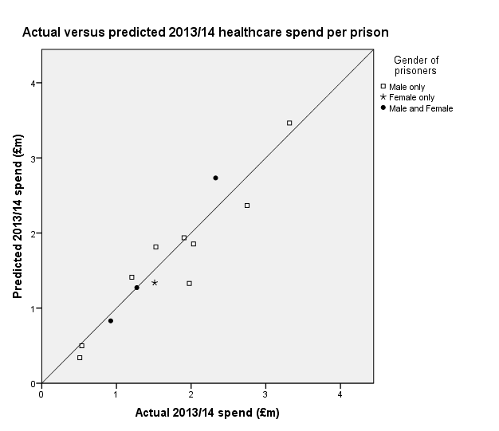
Figure 1. Scatter plot of actual versus predicted healthcare spend for 2013/14 financial year

The model explains 97.2% of the variability of healthcare expenditure data, and for six of the 13 prisons the predicted values are within 10% of the actual spend. However for two of the prisons (Inverness and Kilmarnock) the predicted values are over 30% less than the actual spend. This may be due to limitations in the model which are discussed in the next section.
It is not surprising that the cost per female prisoner is considerably more than that for men. In common with many other jurisdictions, the female prison population in Scotland is characterised by significant histories of substance abuse; mental and physical ill health; multiple social and economic deprivation; sexual, physical and emotional abuse; self harm and significant personality disorder traits.

- How to use the model
To estimate an appropriate budget share for an NHS Board, the model should be used as follows:
The units of healthcare cost for NHS Board X = m + 0.56y + 2.37f where m, y and f are the estimated average daily populations of male adult, male young offender and female prisoners in NHS Board X for that year, respectively.
The total units of healthcare cost across Scotland = M + 0.56Y + 2.37F where M, Y and F are the estimated average daily populations of male adult, male young offender and female prisoners across Scotland for that year, respectively.
The corresponding calculation for prisons will give an estimated budget share by prison.

- Limitations of the model
The model gives an estimate of the average relative cost of healthcare for prisoners in each prisoner group across the whole prison estate. It would not be appropriate to infer that healthcare in any specific prison could be delivered at the same cost as these national averages as there are many aspects of the prisoner healthcare service which have not been taken into account. The following limitations of the model should be taken into account when interpreting the results:
- Data quality. The analysis was based on spend data provided by the NHS Boards. Some NHS Boards reported problems in identifying accurate spend data for prisons, especially where healthcare was provided across more than one prison or where services were provided across the NHS Board.
- No allowance for fixed costs. All analysis was based on the count of the prison population without taking into account the capacity of the prison. There may be fixed costs associated with the capacity which have not been taken into account, and which could have distorted the final results.
- Differences in healthcare need. The model assumes a similar cost for prisoners in each of the main prisoner groups. In practice the healthcare needs of different groups of prisoners vary widely, for example older prisoners are likely to have more long term conditions than younger prisoners. The model does not take this into account.
- Differences in turnover. Higher turnover leads to greater demand on the healthcare service. Turnover was not included in the model.
- Different models of care and investment. The model is based on expenditure, not utilisation. No account is taken of different models of care and their relative efficiencies or of different levels of investment in prisoner healthcare by the different NHS Boards.
- Model does not measure healthcare need. The model is calculated based on healthcare expenditure, not need. Unmet need, for example, is not measured or included.
- Model stability. The analysis is based on a single year of data. Greater stability would be achieved by using data from a longer time period.

- Comparison with baseline funding
The model has been developed using the actual spend data for 2013/14 financial year. The baseline budget for prisoner healthcare funding was set in 2012/13; here the predictions of the model are checked against the baseline budget using average daily populations for the year 2012/13. The results of the comparison are shown in Table 2 and Figure 2.
The comparison indicates that the baseline funding for Grampian and Highland was substantially higher (percentage-wise) than the predicted spend from the model, and the funding for Lothian was lower.

Table 2. Funding and predicted spend for 2012/13 financial year for each NHS Board.

№ | NHS Board | Funding (£’000) | Predicted spend (£’000)* | Difference  (£’000)* | Difference  (%)
1 | Ayrshire and Arran  (Kilmarnock) | 1,634 | 1,604 | 30 | 1.8%
2 | Dumfries and Galloway  (Dumfries) | 569 | 537 | 32 | 5.6%
3 | Forth Valley  (Cornton Vale, Glenochil, Polmont) | 4,539 | 4,772 | -233 | -5.0%
4 | Grampian  (Aberdeen, Peterhead) | 1,386 | 855 | 531 | 38.3%
5 | GG&C  (Barlinnie, Greenock, Low Moss) | 5,955 | 6,088 | -133 | -2.2%
6 | Highland  (Inverness) | 554 | 375 | 179 | 32.3%
7 | Lanarkshire  (Shotts) | 1,355 | 1,485 | -130 | 9.6%
8 | Lothian  (Addiewell, Edinburgh) | 4,406 | 5,036 | -630 | -14.3%
9 | Tayside  (Open Estate, Perth) | 2,833 | 2,480 | 353 | 12.5%
Scotland |  | 23,231 | 23,232 | - | -

* The predicted spend is rounded and the column sums to 23,232; the Scotland total is correct if the calculation is done to the nearest pound.
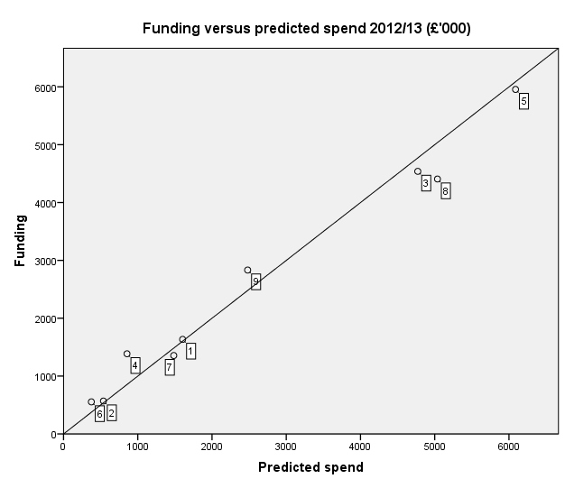
Figure 2. Funding versus predicted spend for 2012/13 financial year by NHS Board

