REVIEW OF CASE-MIX ADJUSTMENT WITHIN THE MLC COSTING METHOD

PAPER TAMLC 17

1. Introduction

The current NRAC costing method includes one case-mix adjustment, which arises in the calculation of the MLC Cost Ratios and uses a simple linear regression approach based on the Average Cost per Episode and Average Length of Stay. At the Acute MLC Subgroup meeting on the 26th of August, analyses based on three alternative approaches to a case-mix adjustment , two of which were based on PLICS (Patient Level Information Costing System) data and one of which was based on HRG (Healthcare Resource Group) data, were presented to the group (see paper TAMLC 13).

In order to inform the discussion, the three alternative approaches, in addition to the current NRAC case-mix adjustment approach, were evaluated against TAGRA’s core criteria. It was agreed by the subgroup members that the HRG method should not be considered further as it failed to meet many elements of TAGRA’s core criteria.

There was an extensive discussion around the analyses of the two methods based on the PLICS data (the two methods are referred to as PLICS “components” and PLICS “regression”) and concerns were raised about the considerable differences in the Cost of admission and Cost per day percentage splits (see Section 3 for definitions) by specialty in relation to each other and the current NRAC method. AST were asked to investigate these differences and report back to the subgroup.

2. Summary

Following further examination of the methodology, it has transpired that the methodology used in the PLICS regression analysis reported to the subgroup in August was not consistent with the current NRAC regression approach. This was the basis of many of the large differences between the PLICS regression method on one hand and the PLICS components / current NRAC methods on the other.

The present paper summarizes the results of the existing NRAC case-mix adjustment approach, the PLICS components approach and revised results from the PLICS regression approach. All three methods have been comparatively evaluated against the TAGRA core criteria. This paper sets out the key issues relevant to the choice between the case-mix approaches and concludes with a recommendation from AST to adopt the PLICS components case-mix adjustment approach.

It is important to note that, even were this recommendation to be adopted, this would not result in the PLICS data being used to as part of the main costing methodology. Rather, the PLICS data would be used for the specific purpose of defining the speciality-level parameters associated with a case-mix adjustment based on length of stay.

3. Definitions and context within NRAC costing method

The Acute MLC subgroup has previously considered four potential options for the general costing approach of the Acute MLC review: these are discussed in the ‘Proposal to TAGRA on the Costing Method for the Acute MLC Review’ paper presented to TAGRA on 29th May 2014. The option that was recommended by the subgroup and accepted by TAGRA is; ‘to retain the current NRAC Costing Method for the Acute MLC review; reviewing the Fixed and Variable percentage cost split methodology and selecting the most appropriate indicators based on this method, the formula acute costing method would continue unchanged until the next Acute MLC review’.

The present paper follows on from Paper TAMLC 13 and continues to deal with the “review of the Fixed and Variable percentage cost split methodology”. The terminology of Fixed and Variable percentage cost split stems from the fact that the existing NRAC approach provides a case-mix adjustment based on Length of Stay. Within such an approach, the Actual Cost (at a national level) of an episode of care is defined by the Length of Stay (d) and two estimated parameters; the Fixed cost (f, in £, independent of the Length of Stay) and the Variable cost (v, in £ per day, which is then multiplied by the Length of Stay in days).
The term “percentage cost split” refers to a simple metric for comparing the relative importance of the Fixed (f) and Variable (v) cost components, along with the national Average Length of Stay for that speciality ( ), defined as follows.
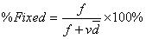

For a case-mix adjustment based on a linear model between Length of Stay and Actual Cost, the percentage cost split terms provides one way to fully summarize the case-mix adjustment parameters. In practical terms, the percentage cost split terms can be thought of as giving the proportion of the actual cost associated with an average length episode of care that is associated with the fixed and variable components.
As explained in Paper TAMLC13, it was decided that the terms ‘Fixed cost’ and ‘Variable cost’ would be renamed as follows (and this terminology is used henceforth in this paper);
- Fixed cost should be known as Cost of admission;
- Variable cost should be known as Cost per day.

The actual cost (at a national level) of an episode of care, as determined using the case-mix adjustment, is then used as the numerator in the MLC Cost Ratios, which assess the variation in actual Need (proxied by cost), relative to the level of need (proxied by cost) which would be expected given the age and sex composition of a local population. The latter term is estimated from age-sex cost-curves constrained by the total actual cost (at a national level) and hence is also dependent on the choice of case-mix adjustment method. For more information on the definition of the MLC Cost Ratios, please refer to Paper TAMLC 04. The Cost Ratios form the dependent variable upon which the Acute Indicators will be regressed at the subsequent model fitting stage. Consequently, changes to the case-mix adjustment method will lead to changes in the MLC Cost Ratios, and this may then affect which Acute Index predictors best explain the variability in the Cost Ratios.

4. Details of the three case-mix adjustment methodologies

Current NRAC case-mix adjustment
The current NRAC case-mix adjustment uses a simple linear regression approach based on the Average Cost per Episode and Average Length of Stay, aggregated to hospital level, to obtain Cost of admission and Cost per day percentage cost splits (see Section 3 in paper TAMLC13 for more information, but the regression slope relates to the Cost per Day and the regression intercept to the Cost of Admission). There are only five regressions for five specialty types (General Medicine, General Surgery, Gynaecology, Obstetrics and Special Care Baby Unit), the results from which are then applied to all other specialties. We do not have any evidence on the reliability of this extension of the estimated parameters.

PLICS case-mix adjustment methods
Two separate approaches to using costing data from the 2012/13 PLICS file have been explored. In both cases, the data used includes inpatients only and excludes the following patients / cost categories:
- Any patients with zero costs
- Patients treated at private hospitals

The first PLICS-based method (the “PLICS components method”) derives the Cost of admission and Cost per day percentage cost splits by separately summing the relevant components from the PLICS costing file for each episode of care in every specialty. As such, this method does not require any regression analysis to estimate the case-mix adjustment parameters.

The costs applied per day (i.e. “per day” costs) consist of the following direct costs:
- Medical
- Nursing
- Laboratory
- Radiology
- Pharmacy
- Allied Health Professional Other
- Other direct care (after any High Cost Items exclusions)

The costs applied on admission include the following direct costs:
- Medical
- Laboratory
- Radiology direct costs
- High cost items costs and theatre department/medical procedure related costs are excluded from the “per day” costs and are considered to be admission type costs.

The percentage cost splits for each speciality are calculated as follows:
Cost per day % = PLICS "per day" costs /(PLICS “per day” costs + PLICS “admission” costs)
Cost of admission % = (100 - Cost per day %)

All of the cost terms in the above equations are PLICS Direct Costs, rather than the PLICS Total Costs. The Total Costs also include a substantial component (generally 30 – 40%, by speciality) of Allocated Costs, but at present these are allocated in proportion to the fixed and variable components of the Direct Costs, such that their inclusion would make no difference to the percentage cost splits (see Annexes A and B in paper TAMLC13 for more information). As the PLICS method remains under development, it is possible that the allocated cost apportioning method may change in future, which could then affect the validity of the approach used here.

The second PLICS method (the “PLICS regression method”) returns to the linear regression approach to deriving case-mix adjustment parameters, as used in the current NRAC method. However, instead of using the Average Cost per Episode and Average Length of Stay aggregated to hospital level as the regression variables, the PLICS costing files allows for the use of individual Cost per Episode and Length of Stay to be used instead. In other words, the regression observations now constitute individual episodes of care, rather than averages within a given hospital. Regressions are undertaken for each speciality using data from all hospitals in Scotland.

The calculation of PLICS Direct Costs undertaken within the costing file is itself based on the Length of Stay associated with that episode of care. Insofar as no other factors influence the episode-level Direct Costs, one should expect that the PLICS components and PLICS regression approaches will yield identical estimates of the case-mix adjustment parameters. As such, the regression method provides us with a way to investigate the extent to which other factors are indeed present within the PLICS Direct Costs. Investigation of the regression results reveals that one major additional factor for many specialities is the existence of different imposed relationships between Direct Cost and Length of Stay associated with different hospitals (an example of this can be found in Annex A). This presence of such defined sub-populations within the national costing data means that the formal statistical requirements of the regression method cannot be met in these cases, which then introduces structural uncertainty into the resultant case-mix adjustment parameter estimates.

5. Analyses of alternative approaches

Cost of admission / Cost per Day percentage cost split

The following section provides the results from the analyses carried out using the two PLICS based approaches, in comparison with the current NRAC approach. All the analyses have been carried out in alignment to Costs Book specialties, in order to make the options comparable. The percentage cost splits for the three approaches are shown in Table 1.

Table 1: Cost of admission and cost per day splits by specialty – comparison of the current NRAC case-mix adjustment (excluding Teaching Hospitals) and the two PLICS case mix-adjustments
Specialty | Cost of admission (%) |  |  | Cost per day (%)
Specialty | NRAC | PLICS components | PLICS regression | NRAC | PLICS components | PLICS regression
Accident & Emergency | 0 | 13.3 | 31.3 | 100 | 86.7 | 68.7
Acute Other | 79.8 | 44.2 | 47.8 | 20.2 | 55.8 | 52.2
Cardiac Surgery | 66.8 | 66 | 78.3 | 33.2 | 34.0 | 21.7
Cardiology | 31.8 | 29.5 | 25.2 | 68.2 | 70.5 | 74.8
Clinical Oncology | 0 | 12.3 | 18.0 | 100 | 87.7 | 82.0
Communicable Diseases | 35.3 | 9.2 | 14.9 | 64.7 | 90.8 | 85.1
Coronary Care Unit | 0 | 20.4 | 31.8 | 100 | 79.6 | 68.2
Dental | 71.4 | 62.2 | 61.7 | 28.6 | 37.8 | 38.3
Dermatology | 18.8 | 12.1 | 11.0 | 81.2 | 87.9 | 89.0
Ear, Nose & Throat | 69.3 | 60.7 | 63.4 | 30.7 | 39.3 | 36.6
Gastroenterology | 31.8 | 14.0 | 14.2 | 68.2 | 86.0 | 85.8
General Medicine | 31.8 | 15.9 | 16.6 | 68.2 | 84.1 | 83.4
General Practice | 26.6 | 2.4 | 7.6 | 73.4 | 97.6 | 92.4
General Surgery (exc Vascular) | 47.8 | 46.1 | 47.7 | 52.2 | 53.9 | 52.3
Geriatric Assessment | 0 | 7.3 | 11.5 | 100 | 92.7 | 88.5
Gynaecology | 59.9 | 56.7 | 51.1 | 40.1 | 43.3 | 48.9
Haematology | 46.5 | 13.1 | 11.1 | 53.5 | 86.9 | 88.9
Intensive Care Unit | 0 | 12.2 | 19.9 | 100 | 87.8 | 80.1
Maxillofacial Surgery | 71.8 | 68.5 | 68.6 | 28.2 | 31.5 | 31.4
Medical Oncology | 31.8 | 10.8 | 13.8 | 68.2 | 89.2 | 86.2
Medical Other | 31.8 | 5.7 | 10.2 | 68.2 | 94.3 | 89.8
Medical Paediatrics | 33 | 24.8 | 19.5 | 67 | 75.2 | 80.5
Nephrology | 11.2 | 13.6 | 8.3 | 88.8 | 86.4 | 91.7
Neurology | 0 | 10.4 | 8.6 | 100 | 89.6 | 91.4
Neurosurgery | 62.2 | 53.6 | 51.6 | 37.8 | 46.4 | 48.4
Obstetrics GP | 33.4 | 12.5 | 12.5 | 66.6 | 87.5 | 87.5
Obstetrics Specialist | 0 | 24.2 | 24.2 | 100 | 75.8 | 75.8
Ophthalmology | 73.3 | 54.1 | 64.7 | 26.7 | 45.9 | 35.3
Oral Surgery & Medicine | 69.2 | 62.8 | 67.8 | 30.8 | 37.2 | 32.2
Orthopaedics | 55 | 55.2 | 56.5 | 45 | 44.8 | 43.5
Plastic Surgery & Burns | 63.6 | 62.2 | 60.5 | 36.4 | 37.8 | 39.5
Rehabilitation Medicine | 0 | 2.3 | 1.6 | 100 | 97.7 | 98.4
Respiratory Medicine | 0.1 | 10.4 | 6.9 | 99.9 | 89.6 | 93.1
Rheumatology | 29.3 | 12.7 | 0.0 | 70.7 | 87.3 | 100.0
Spinal Paralysis | 0 | 1.7 | 1.8 | 100 | 98.3 | 98.2
Surgical Paediatrics | 55.6 | 47.8 | 47.9 | 44.4 | 52.2 | 52.1
Thoracic Surgery | 66.8 | 54.6 | 67.4 | 33.2 | 45.4 | 32.6
Urology | 47.8 | 50.4 | 50.5 | 52.2 | 49.6 | 49.5
Vascular Surgery | 47.8 | 42.6 | 43.6 | 52.2 | 57.4 | 56.4
For over half of specialities (23 out of 39), there is a general similarity between the % cost splits derived from all three sets of approaches (i.e. differences between them of less than ten percentage points). For the remaining 16 specialities, it is generally the existing NRAC method that differs by a greater extent from both of the two PLICS methods. In only two of these cases (General Medicine and Obstetrics GP) are the NRAC method results based on regression analysis of those specialities themselves, the remaining cases being ones where the NRAC results have been extrapolated from other specialities.

For all but five specialties, the percentage cost splits derived from both the PLICS components and PLICS regression methods yield very similar results to one another (i.e. differences between them of less than ten percentage points). Of the five specialties which differ by a greater extent (Accident and Emergency, Cardiac Surgery, Coronary Care Unit, Rheumatology and Thoracic Surgery), these remain less than fifteen percentage points. These specialities are likely to be ones for which substantial variability by hospital exists within the costing data (see example for Rheumatology in Annex A), leading to greater structural uncertainty within the results derived from the regression method.

MLC Cost Ratios

There will be a brief presentation at the subgroup meeting on the composition of the cost ratios (for two datazones) in relation to the current NRAC case-mix adjustment and the two alternative PLICS approaches.

The MLC cost ratios for each diagnostic group, aggregated to Intermediate geography level, have been calculated for all three approaches using the current NRAC Costing Method.
Figures 1 and 2 show the comparisons between the current NRAC case-mix adjustment approach and the two alternative PLICS based case-mix adjustments as scatter plots (one for each diagnostic group). The line y=x has been fitted on the graph in grey to show where all the points should be lying, if the methods were to yield identical results.

Figure 1: Scatter plots comparing the MLC cost ratios, at Intermediate Geography level, as derived from the NRAC and PLICS components approaches.

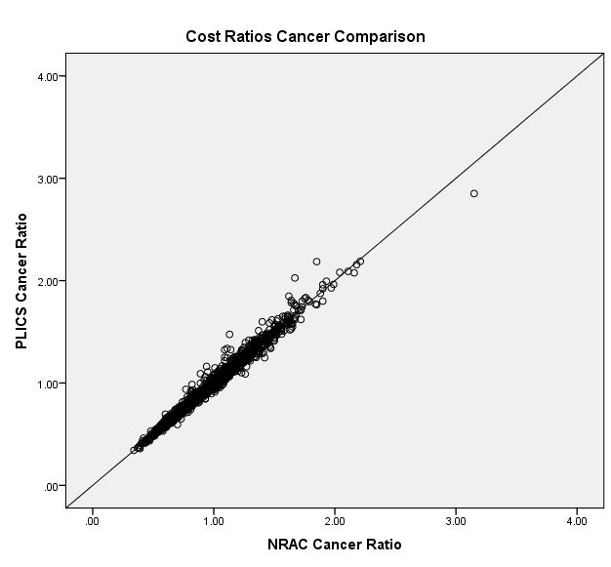
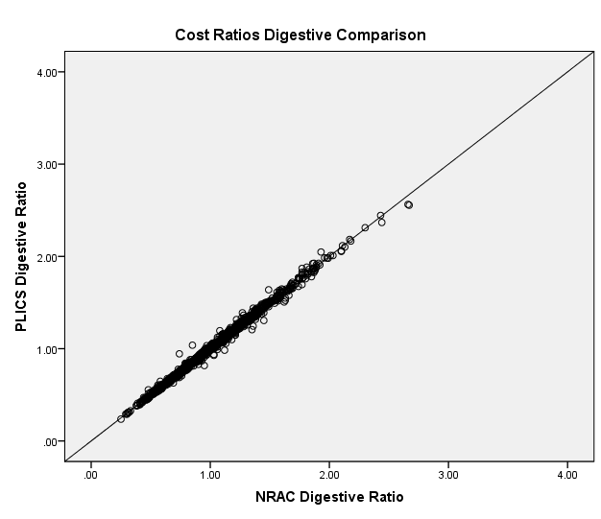
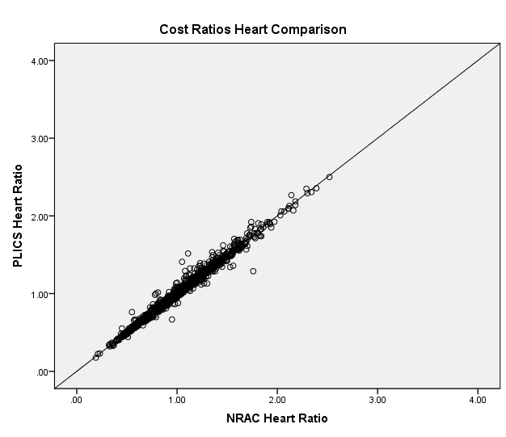

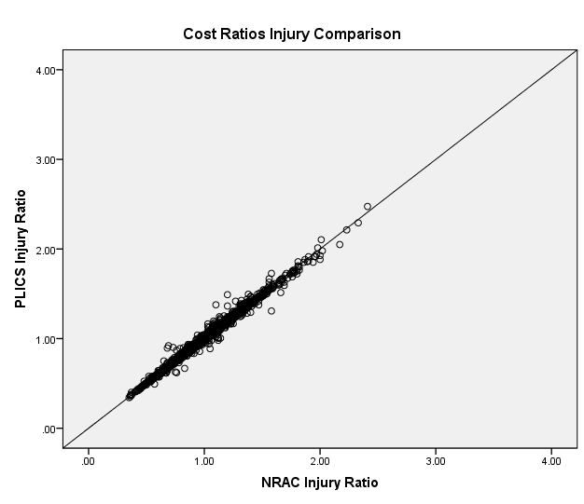
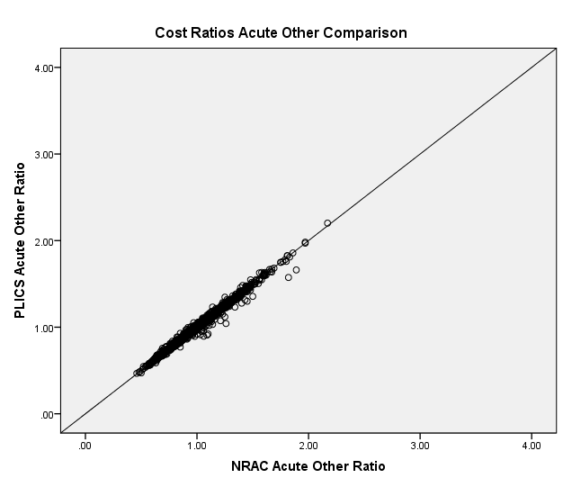
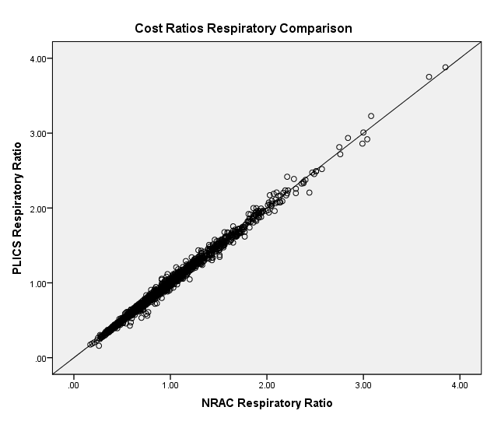

Figure 2: Scatter plots comparing the MLC cost ratios, at Intermediate Geography level, as derived from the NRAC and PLICS regression approaches.

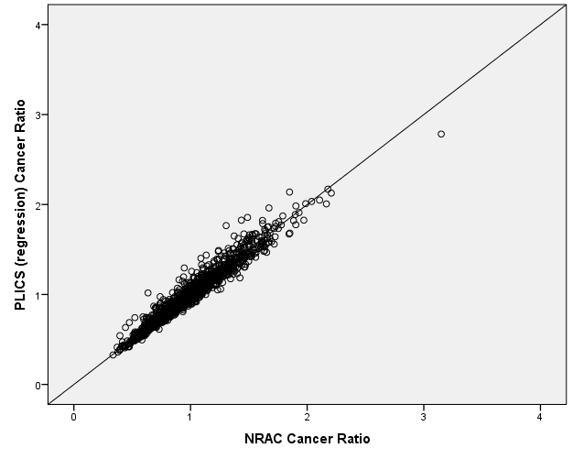

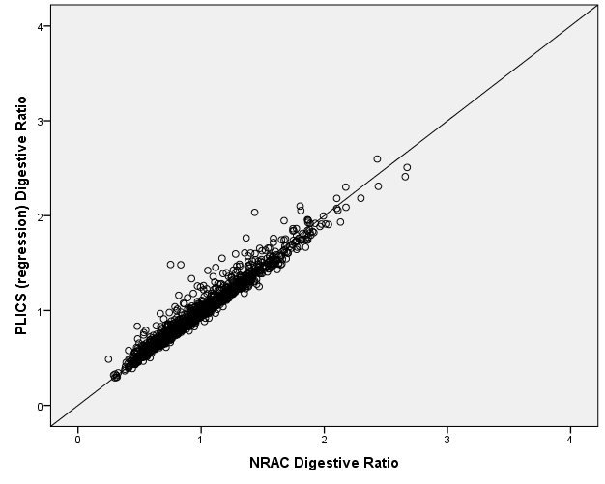
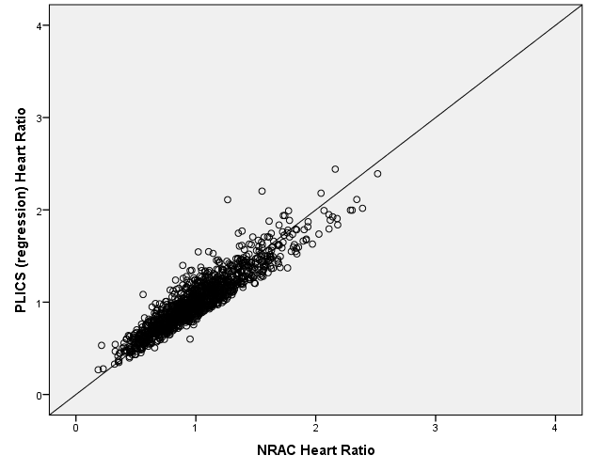

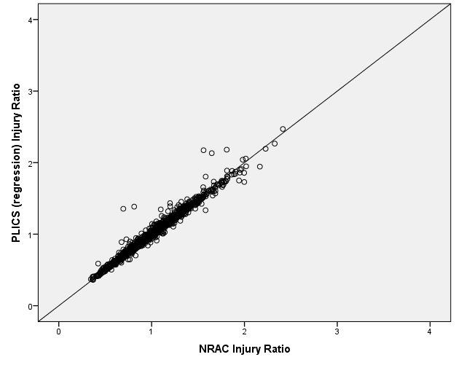

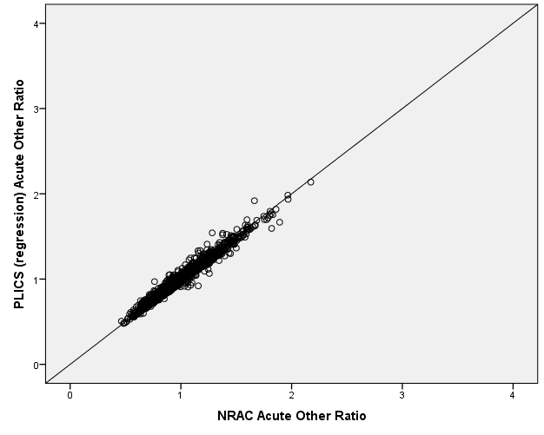

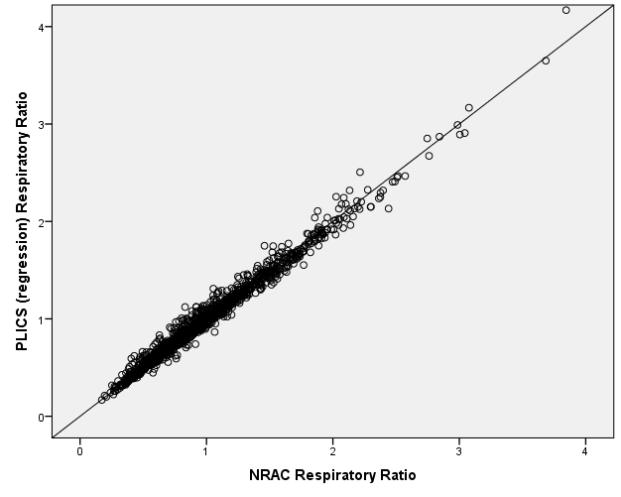

The scatter plots in both Figures 1 and 2 show clear linear positive relationships, with relatively little scatter, between the Cost Ratios obtained under all three methods and all diagnostic groups. This suggests that the differences that exist in the percentage cost splits (Table 1) do not generally lead to substantial differences in Cost Ratios when aggregated to Intermediate geography level. However, the extent of the scatter around the line y=x (particularly for Heart and Digestive) is slightly greater for the NRAC to PLICS regression comparison (Figure 2) than was seen for the NRAC to PLICS components comparison (Figure 1). This indicates that the differences in percentage cost splits seen between the two PLICS methods for those specialities may lead to somewhat more substantial differences, relative to the current NRAC method, in the resultant Cost Ratios.

6. Summary comparisons between the Cost Ratios derived from the three approaches

Correlation co-efficients

In order to quantitively compare the degree of similarity between the MLC Cost Ratios derived from the three case-mix adjustment methods, we can use the correlation coefficients between the Intermediate Geography level cost ratio data (as shown on the scatter plots in Figures 1 and 2).

Table 2 affirms that there are significant positive linear relationships among the Cost Ratios derived from all three methods, for all of the six diagnostic groups. For all diagnostic groups, the highest correlations are those between NRAC and PLICS components methods (>0.99). Comparisons between either of these first two methods on one hand and the PLICS regression method on the other also yield high correlations (0.97 - 0.99), with the exception of the Heart diagnostic group where the coefficients are 0.93. This reaffirms the finding in the previous section that it is for this diagnostic group where the most substantial differences arise.

Table 2: Correlation coefficients between the three methods

PLICS (C) = PLICS components, PLICS (R) = PLICS regression. The correlation coefficient measures the strength of a linear relationship and ranges from -1 to 1 where;
-1 indicates a perfect negative linear relationship
0 indicates no linear relationship
1 indicates a perfect positive linear relationship.

Cancer | NRAC | PLICS (C) | PLICS  (R)
NRAC | 1 | 0.99 | 0.97
PLICS (C) | 0.99 | 1 | 0.98
PLICS(R) | 0.97 | 0.98 | 1

Digestive | NRAC | PLICS (C) | PLICS  (R)
NRAC | 1 | 0.998 | 0.97
PLICS (C) | 0.998 | 1 | 0.98
PLICS(R) | 0.97 | 0.98 | 1

Heart | NRAC | PLICS (C) | PLICS  (R)
NRAC | 1 | 0.99 | 0.93
PLICS (C) | 0.99 | 1 | 0.93
PLICS(R) | 0.93 | 0.93 | 1

Acute Other | NRAC | PLICS (C) | PLICS  (R)
NRAC | 1 | 0.99 | 0.98
PLICS (C) | 0.99 | 1 | 0.99
PLICS(R) | 0.98 | 0.99 | 1

Respiratory | NRAC | PLICS (C) | PLICS  (R)
NRAC | 1 | 0.996 | 0.99
PLICS (C) | 0.996 | 1 | 0.99
PLICS(R) | 0.99 | 0.99 | 1

Model fitting

The model fit between the existing Acute Index (calculated by standardizing the two needs drivers, SMR_75 and under and Limiting long-term illness - done using the sum of the Z-scores) and a given set of Cost Ratios is determined via a linear regression model, weighted by the population of each intermediate geography zone. This linear model is as shown below,

Cost ratio ~ Acute Index + Health Board Dummies + Supply Variables + Error,

The model-fit can be quantified in an R² value. R² is a measure of how close the data points are to the linear regression line created from the above model. An R² value of 0 indicates that the model is not explaining any of the variability of the response data around the mean (i.e. the linear regression line is not a good fit to the data). An R² value of 1 indicates that the model is explaining all of the variability of the response data around the mean (i.e. the linear regression line is a perfect fit to the data). The model-fit values obtained for the three sets of Cost Ratios derived from the three case-mix adjustment approaches are summarized in Table 3.

Table 3: R² values for the three approaches

Diagnostic Group | NRAC | PLICS components | PLICS regression
Cancer | 0.25 | 0.23 | 0.23
Digestive | 0.60 | 0.60 | 0.57
Heart | 0.27 | 0.27 | 0.31
Injury | 0.41 | 0.39 | 0.39
Acute Other | 0.62 | 0.61 | 0.62
Respiratory | 0.57 | 0.57 | 0.56

Given the close similarity of the Cost Ratios derived from the NRAC and PLICS components methods (Section 5), it is unsurprising that the subsequent model-fit R² values are very similar for these two methods. The R² values for the PLICS regression are also similar to those for both the NRAC and PLICS components methods. The PLICS regression method yields a slightly lower R² value for the Digestive diagnostic group and a slightly higher one for the Heart Diagnostic group. However, in neither case are these differences statistically significant.

It would not be appropriate to use the model fitting R² values as a discriminating criterion between the validity of the three approaches, because; a) the existing Acute Index was derived in reference to Cost Ratios calculated using the current NRAC method and b) the R² values depend on the degrees of averaging / aggregation within each method. Instead, the R² values can only be used as a pragmatic guide as to whether the adoption of one of the alternative options would lead to any substantial change to the model-fit supplied by the existing Acute Index. Based on the present analysis, the adoption of either PLICS method would not lead to any significant differences in model fit, at least when considering the present level of data aggregation.

7. Evaluation of options against the TAGRA core-criteria

In order to inform discussion, AST have attempted to evaluate the existing method and the two PLICS options against the TAGRA core-criteria in Table 4.

Table 4: Evaluation of options against the TAGRA core-criteria

 | Equity | Practicality | Transparency
Existing NRAC method | - Based on estimates from only 5 specialties | - Requires regression analysis | - Relies on untested assumption that 5 speciality type regressions can be applied to other specialities
Option 1 – PLICS component method | + All specialty splits are calculated, so might be expected to better capture variation | + Does not require regression analysis  +Based on data that will be updated in future | + Simplest method to communicate
Option 2 – PLICS regression method | + Regression is run for all specialties, so might be expected to better capture variation | - Requires regression analysis  +Based on data that will be updated in future | + Fairly simple method to communicate

 | Objectivity | Avoiding perverse incentives | Relevance
Existing NRAC method | - Does not make use of up to date costing data  - Based on estimates from only 5 specialties | No distinction between options | - Method relies on extrapolation of only 5 speciality level regressions to all other areas
Option 1 – PLICS component method | + Makes use of up to date costing data  + All specialty splits are calculated | No distinction between options | + Case-mix adjustment parameters are available for all specialities
Option 2 – PLICS regression method | + Makes use of up to date costing data  + All specialty splits are calculated | No distinction between options | + Case-mix adjustment parameters are available for all specialities

 | Stability | Responsiveness | Face validity
Existing NRAC method | (Is the existing method) | - Relies on an old method and not the most up to date costing data | As true value of Cost Ratios are unknown, there is no objective standard against which face validity can be assessed.  All four approaches yield generally similar Cost Ratios at the Diagnostic Group / Intermediate Geography level, implying that making Face Validity distinctions between them will be challenging.  Some Cost of Admission / Cost per Day estimates have been shared with DOFs/Financial Planners and CPHMs but it has not been possible to identify which method makes more sense from a clinical perspective
Option 1 – PLICS component method | + Leads to very similar cost ratio outcomes to existing method | + Uses up to date costing data  - PLICS methodology for Allocated costs may change in future, which would then effect the present costing method
Option 2 – PLICS regression method | + Leads to very similar cost ratio outcomes to existing method | + Uses up to date costing data  - PLICS methodology for Allocated costs may change in future, which would then effect the present costing method

Based on the strengths and weaknesses presented in the table above, it is clear that the known disadvantages (as outlined in Section 3 of Paper TAMLC 13) of the existing NRAC method mean that either of the two PLICS approaches will lead to an improvement against the core criteria. The analysis undertaken here affirms this in showing that for the majority of specialities where the case-mix adjustment parameters derived from the NRAC method differ from the PLICS based ones, these differences occur in cases where the NRAC results have been extrapolated from another speciality. In particular, a shift to a PLICS based method would remove the 0% cost of admission results seen for many specialities under the existing method.

Making a recommendation between the two PLICS options is more challenging, as the two methods necessarily produce very similar output for most specialities. There are, however, two strong arguments in favour of the components method over the regression one. Firstly, the PLICS components approach has the practicality advantage of not requiring regression analysis to derive the percentage cost split terms and is easier to explain in simple terms. Secondly, the use of a simple regression based method is not well justified (in an analytical sense) in the case of specialities for which substantial by-hospital differences in Costs per Day exist within the overall costing data. It is likely that the only specialities for which the two methods differ will be ones for which this is the case, and in these cases the components derived case-mix adjustment parameters are likely to be more robust. However, the only speciality where there is a clear face validity distinction is Rheumatology where the use of the PLICS components method would again avoid the 0% cost of admission result suggested by the regression method.

8. Recommendation

On the basis of objectivity and face validity arguments, combined with the use of more up to date costing data sources, there is a clear recommendation to move from the existing method to a PLICS based method. As the wider PLICS approach will continue to be developed over the coming years, the adoption of such an option here would represent a forward looking choice. Such a choice would also allow for the inclusion of a PLICS-based element within the NRAC formula, without entailing its use as the basis of the entire Acute MLC costing methodology. On the basis of analytical, communicability and certain face validity concerns, the PLICS component method is recommended over the PLICS regression one.

Annex A
Investigation of the PLICS regression results for Rheumatology
Rheumatology
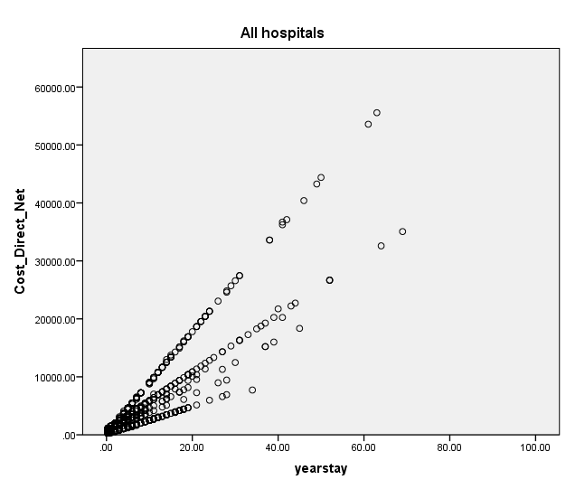
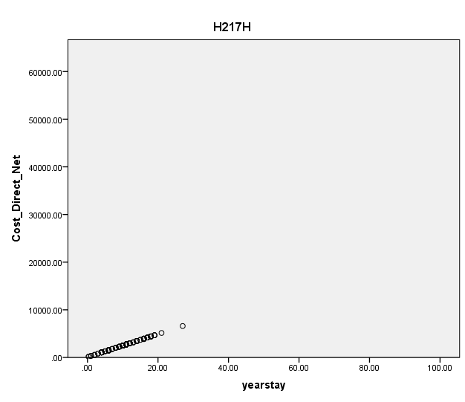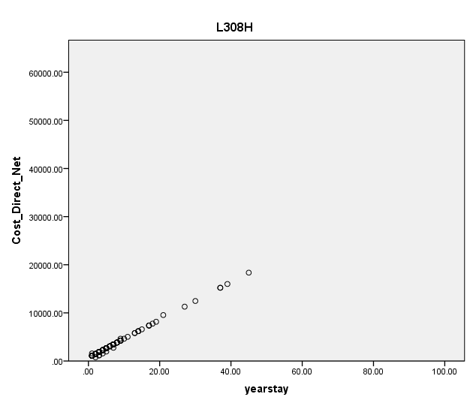

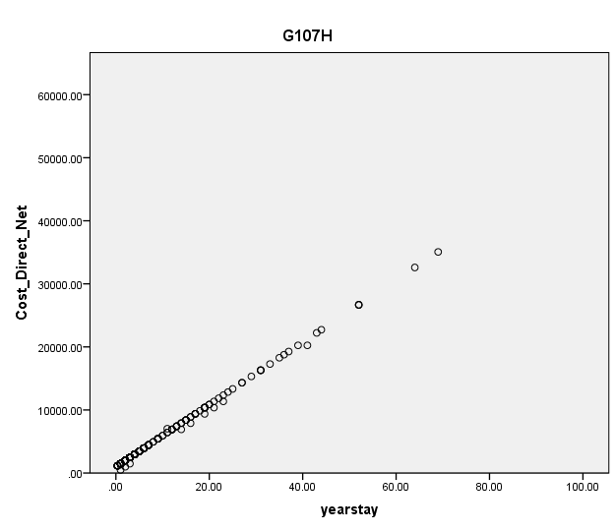
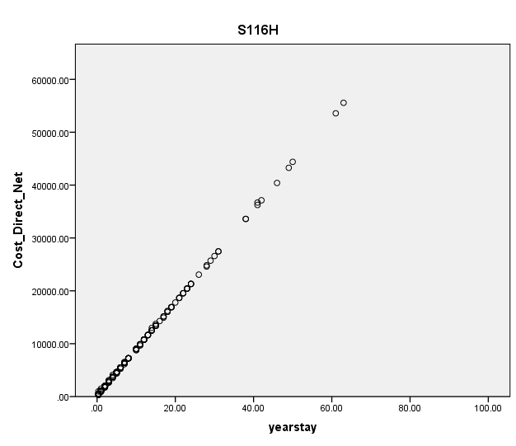
Total = 1366, H217H = 239, L308H = 102, G107H = 435, S116H = 243

Hospital Key
H217H = Ross Memorial
L308H = Wishaw General
G107H = Glasgow Royal Infirmary
S116H = Western General, Edinburgh

