TAGRA ACUTE MLC SUBGROUP Tuesday 9th June 2015
EXPLORATORY ANALYSIS – AGE SPLIT
Background
The Review of the Mental Health and Learning Difficulties MLC adjustment resulted in the adoption of an age split at age 65, with a different needs index for each of the two age groups. This is implemented in the NRAC Formula as follows: for each Intermediate Zone, the prediction of ‘need’ (predicted cost ratio) is carried out separately for the two age groups; each age group’s predicted need is then multiplied by the expected costs for that age group, to adjust the expected costs for the effect of MLC; the sum of these two adjusted costs for the Intermediate Zone is then used in the calculation of the shares.
The question of introducing an age split in the Acute MLC component was previously discussed at the January meeting of the Subgroup. This discussion recognised that there are two possible modifications that could be applied to the Acute MLC adjustment: the use of different coefficients for the needs index in different age groups; and the use of different needs indexes for different age groups. A further possibility is that no MLC adjustment is required at all for some ages or an age split is not deemed appropriate at all given that any variations in costs due to the age-sex profile of the population should largely be captured in the formula by the age-sex adjustment.
Age-sex cost curves for Acute healthcare in Scotland, by diagnostic group, were presented in paper TAMLC19; these showed some variation in shape between diagnostic groups, but generally indicated that the cost per head of Acute healthcare is much higher in older age. These curves gave no indication of whether the relationship between MLC and healthcare utilisation might vary with age, but they did suggest that capturing need within the older population was particularly important in seeking to model healthcare costs.
Advice from ISD clinical consultants so far has been that there are no confident clinical grounds on which to introduce a split by age group, and that the introduction of any such split should be driven by the data itself. The Subgroup therefore decided that an initial assessment of the need for an age split should be undertaken using the current reference model with a range of possible age splits, to explore how the relationship between the indicators of need and healthcare utilisation varies with age.
1. Summary
This paper presents the results of the testing referred to above. In Section 2 presents Scotland level summary statistics around Acute healthcare costs and activity in different age groups; differences between the diagnostic groups can be observed. Section 3 describes the results of linear regressions of cost ratios upon the Acute needs index using a number of different possible age splits. Section 4 discusses these results and provides some questions for the Subgroup to consider.
2. Total expenditure and activity
In this section, Acute expenditure and activity are analysed at a national level to understand how healthcare utilisation varies with age, in different diagnostic groups. This can help inform the age split; for example, to check that an age split would not result in excessively low activity in one age group, or to help gauge the likely impact of an age split on overall cost predictions. Data from the 2012/13 financial year is used.
2.1. Expenditure
Table 1 shows how the total Acute healthcare expenditure (by diagnostic group) would be split between the two age groups, for an age split at 65, 70 or 75. There is some variation between diagnostic groups: the percentage spent on the older age group is particularly high for Heart, and particularly low for Outpatients. Figure 1 gives this information in greater detail: a line plot visualises the variation in Acute costs by patient age.
Table 1. Total spend for 2012/13 financial year by diagnostic group and age (65, 70 and 75 cut-off points).
Total spend 2012/13  (£ millions) | all ages | <65 | <70 | <75
Total spend 2012/13  (£ millions) | all ages | ≥65 | ≥70 | ≥75
Cancer | 399.4 | 179.6 (45.0%) | 237.0 (59.4%) | 291.1 (72.9%)
Cancer | 399.4 | 219.8 (55.0%) | 162.3 (40.6%) | 108.3 (27.1%)
Digestive | 346.9 | 194.1 (55.9%) | 227.1 (65.5%) | 259.6 (74.8%)
Digestive | 346.9 | 152.8 (44.1%) | 119.8 (34.5%) | 87.3 (25.2%)
Heart | 407.3 | 127.6 (31.3%) | 175.0 (43.0%) | 229.2 (56.3%)
Heart | 407.3 | 279.7 (68.7%) | 232.2 (57.0%) | 178.0 (43.7%)
Injury | 390.8 | 168.9 (43.2%) | 194.6 (49.8%) | 224.8 (57.5%)
Injury | 390.8 | 221.9 (56.8%) | 196.2 (50.2%) | 166.0 (42.5%)
Other | 1,314.7 | 698.5 (53.1%) | 801.5 (61.0%) | 909.3 (69.2%)
Other | 1,314.7 | 616.1 (46.9%) | 513.2 (39.0%) | 405.3 (30.8%)
Respiratory | 291.5 | 111.3 (38.2%) | 137.6 (47.2%) | 169.1 (58.0%)
Respiratory | 291.5 | 180.1 (61.8%) | 153.9 (52.8%) | 122.3 (42.0%)
Outpatients | 582.7 | 396.2 (68.0%) | 445.4 (76.4%) | 489.7 (84.0%)
Outpatients | 582.7 | 186.5 (32.0%) | 137.3 (23.6%) | 93.1 (16.0%)

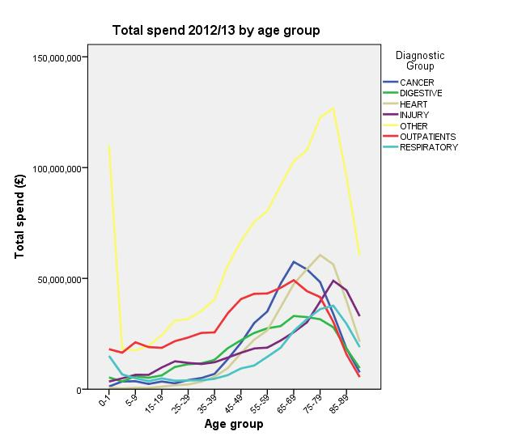
Figure 1. Total spend for 2012/13 financial year by diagnostic group and age.
2.2. Activity
Table 2 shows the Acute healthcare activity broken down in the same way as for the costs in Table 1. Population is also shown at the bottom. Comparing the percentages of activity in each age group with the percentage of population in that age group, it is clear that the activity is proportionally higher in the ‘older’ population – particularly for Cancer, Heart, and Respiratory. Figure 2 shows the activity by age, similarly to Figure 1 for costs. This clearly shows that there are differences in the ‘peak’ age (for which the activity is at its highest) between diagnostic groups.

Table 2. Number of episodes in 2012/13 financial year by diagnostic group and age; population by age.

 | all ages | <65 | <70 | <75
 | all ages | ≥65 | ≥70 | ≥75
Cancer episodes | 199,581 | 96,677 (48.4%) | 126,547 (63.4%) | 153,182 (76.8%)
Cancer episodes | 199,581 | 102,904 (51.6%) | 73,034 (36.6%) | 46,399 (23.2%)
Digestive episodes | 193,086 | 122,076 (63.2%) | 139,877 (72.4%) | 156,164 (80.9%)
Digestive episodes | 193,086 | 71,010 (36.8%) | 53,209 (27.6%) | 36,922 (19.1%)
Heart episodes | 148,762 | 55,782 (37.5%) | 73,135 (49.2%) | 92,304 (62.0%)
Heart episodes | 148,762 | 92,980 (62.5%) | 75,627 (50.8%) | 56,458 (38.0%)
Injury episodes | 118,641 | 70,741 (59.6%) | 77,638 (65.4%) | 85,040 (71.7%)
Injury episodes | 118,641 | 47,900 (40.4%) | 41,003 (34.6%) | 33,601 (28.3%)
Other episodes | 684,139 | 406,546 (59.4%) | 460,840 (67.4%) | 516,126 (75.4%)
Other episodes | 684,139 | 277,593 (40.6%) | 223,299 (32.6%) | 168,013 (24.6%)
Respiratory episodes | 133,220 | 61,031 (45.8%) | 72,535 (54.4%) | 86,151 (64.7%)
Respiratory episodes | 133,220 | 72,189 (54.2%) | 60,685 (45.6%) | 47,069 (35.3%)
Outpatient episodes | 1,411,707 | 997,445 (70.7%) | 1,114,331 (78.9%) | 1,214,710 (86.0%)
Outpatient episodes | 1,411,707 | 414,262 (29.3%) | 297,376 (21.1%) | 196,997 (14.0%)
Population | 5,313,600 | 4,387,849 (82.6%) | 4,673,581 (88.0%) | 4,895,114 (92.1%)
Population | 5,313,600 | 925,751 (17.4%) | 640,019 (12.0%) | 418,486 (7.9%)

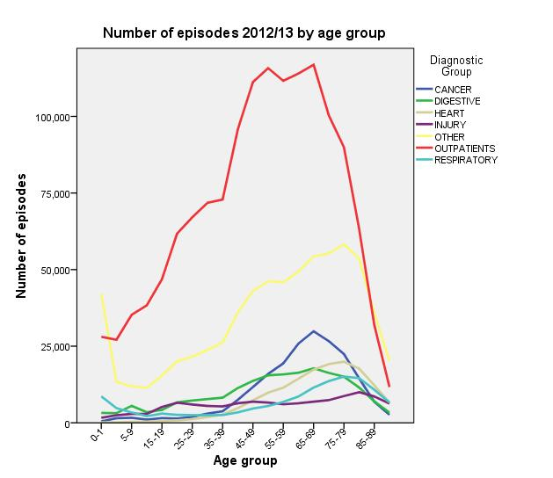
Figure 2. Number of episodes for 2012/13 financial year by diagnostic group and age.

2.3. Cost per head and Cost per episode
Two further visualisations are given in Figures 3 and 4: the variation in the cost per episode with age and with diagnostic group (Figure 3); and the cost per head of population, again in age bands by diagnostic group (Figure 4).
For most diagnostic groups, the cost per episode increases with age from late adulthood onwards; thus, the increase in cost with age is driven not just by an increase in activity but also by an increase in the complexity of the activity. The exception is Outpatients, for which the cost per episode appears to be relatively independent of age. The cost per episode is also elevated in early childhood for some diagnostic groups.
The cost per head of population shows a stronger increase with age, due to the combined effects of the increasing cost per episode, increasing number of episodes, and shrinking population with age. For Outpatients and Cancer, the cost per head actually decreases again at very old ages. This reflects the younger ‘peak’ age for the activity in these diagnostic groups compared to most others (Figure 2).
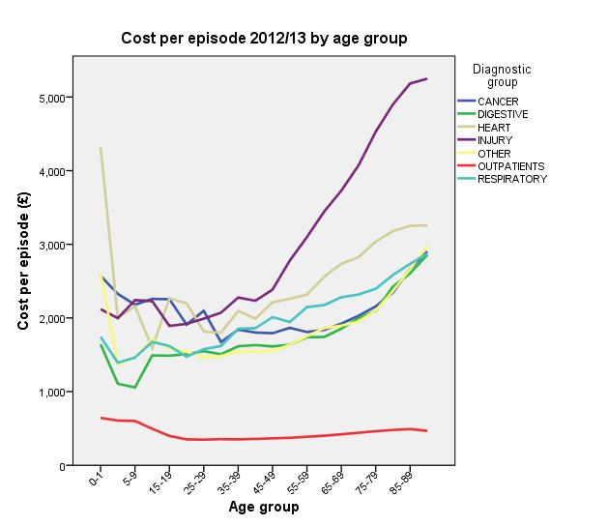
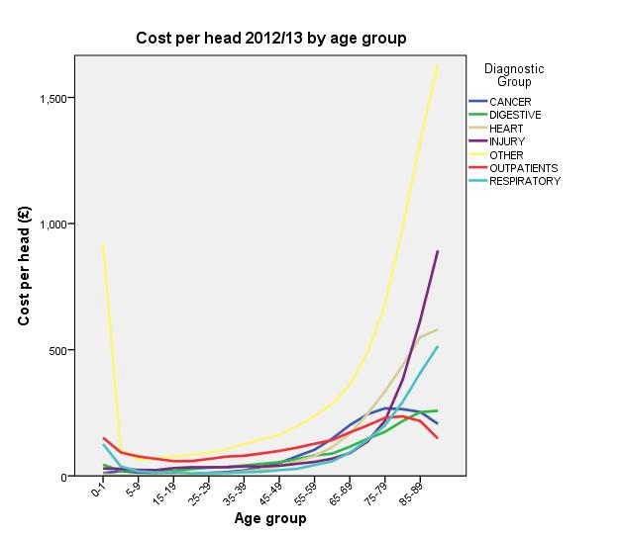
Figure 3. Cost per episode for 2012/13 financial year by diagnostic group and age.
Figure 4. Cost per head for 2012/13 financial year by diagnostic group and age.

2.4 Age-sex weightings
Within the NRAC Formula, adjustments are made to the base population to account for the age-sex composition of the population; the relative additional needs due to morbidity and life circumstances (MLC) and other factors; and the relative unavoidable excess costs of providing services to different geographical areas. Within the age-sex adjustment, the formula predicts the expected resources required in each small area based on national average costs per head by age and sex (age/sex cost curves) to create an age-sex cost-weighted population index. The MLC component then takes account of any additional need, above that which should already be captured by the age – sex weightings. Therefore the variations in cost per episode / total costs by age outlined in Sections 2.1 to 2.3 should largely already be captured in the formula by the age - sex weightings.
3. Regression analysis
In this section, the performance of the reference model on all-age data is compared with its performance on ‘older’ and ‘younger’ ages taken separately – using a variety of age group splits. Four diagnostic groups – Cancer, Heart, Other and Outpatients – are chosen for this analysis; these are the most expensive groups in terms of overall cost.
The current Acute MLC indicators of need are the all cause Standardised Mortality Ratio (SMR) in ages 0-74, and the Limiting Long-Term Illness (LLTI) ratio. The sum of the z-scores of these two variables is the current needs index in the NRAC formula. As part of the Acute MLC Review process, these indicators have been refreshed with up-to-date data: the SMR is calculated using death records from 2008 to 2012 calendar years, and the LLTI ratio is calculated using 2011 Census data. These indicators are the same regardless of the age group considered.
The utilisation of healthcare is represented by the ratio of the actual costs of healthcare in the age group considered (taking into account activity type and length of stay in that specific neighbourhood) to the expected costs in that age group (based on the neighbourhood’s population and the national average costs per head). The cost ratios are calculated at Data Zones and averaged over 3 financial years: 2011/12, 2012/13 and 2013/14.
The Acute MLC adjustment is based on linear regression of these cost ratios upon the needs index. Health board ‘dummy’ variables and supply variables are included in the regressions, to avoid predicting effects that are largely due to variations in supply; however, only the coefficient of the needs index is used to predict healthcare cost in the formula. The adjusted R² values and the needs index coefficient values are presented below for the different age groupings.
3.1. Adjusted R² values
Adjusted R² values – the percentage of variance in the cost ratios that is explained by the model – are commonly used as a goodness of fit measure. These are shown in Table 3, for regressions on all-ages data, and on data split by age at 65, 70 and 75 years of age. These do not allow comparison of the overall explanatory power between an all-ages models and models with an age split, but it can be noted that for all cases with an age split – with the exception of Cancer split at age 65 – the adjusted R² is higher for the younger group than for the older group.

Table 3. Adjusted R² values obtained from fitting the reference model, by diagnostic group and age grouping.
Adjusted R² values | all ages | <65 | <70 | <75
Adjusted R² values | all ages | ≥65 | ≥70 | ≥75
Cancer | 12.8% | 5.9% | 8.2% | 11.0%
Cancer | 12.8% | 8.9% | 5.9% | 3.2%
Heart | 18.9% | 16.5% | 20.8% | 22.2%
Heart | 18.9% | 5.7% | 3.4% | 1.4%
Other | 42.5% | 35.6% | 40.2% | 42.6%
Other | 42.5% | 17.5% | 13.2% | 9.2%
Outpatients | 56.3% | 49.9% | 52.6% | 54.5%
Outpatients | 56.3% | 35.4% | 29.1% | 21.9%

3.2. Regression Coefficients
Regression coefficients for the Acute needs index are shown in Table 4, along with the 95% confidence intervals, for Cancer, Heart, Other and Outpatients. For all diagnostic groups except Cancer, there is a consistent pattern: the coefficient for the younger group is significantly higher, while the coefficient for the older group is significantly lower, than the all-ages coefficient (no overlap of the confidence intervals). This shows that the dependence of healthcare utilisation on the Acute Index is stronger in the younger population, and weaker for older people – in the case of Outpatients, the coefficient even becomes negative for the older group. Additionally, the age-split coefficients are at their highest values with the split at 65; both coefficients increase as the split is moved from 75 to 70 and then to 65. This means we cannot identify an age (within the examined range) at which a step change in the dependence occurs; rather, the variation appears to be continuous.
For Cancer, there appears to be no significant change in the coefficient values with the introduction of an age split, except when the split point is at age 75; here, the younger group has a larger coefficient than the older group, as for the other diagnostic groups, but the difference is more moderate.

Table 4. Acute index regression coefficient values obtained from fitting the reference model, along with 95% confidence intervals, by diagnostic group and age grouping.
Acute Index  regression coefficients  95% Confidence intervals | all ages | <65 | <70 | <75
 | all ages | ≥65 | ≥70 | ≥75
Cancer | 0.047  (0.041; 0.053) | 0.049  (0.040; 0.059) | 0.051  (0.042; 0.059) | 0.060  (0.053; 0.067)
Cancer | 0.047  (0.041; 0.053) | 0.055  (0.048; 0.063) | 0.056  (0.046; 0.065) | 0.030  (0.019; 0.041)
Heart | 0.107  (0.101; 0.113) | 0.179  (0.169; 0.190) | 0.168  (0.159; 0.176) | 0.155  (0.147; 0.162)
Heart | 0.107  (0.101; 0.113) | 0.063  (0.055; 0.070) | 0.050  (0.042; 0.059) | 0.033  (0.023; 0.043)
Other | 0.091  (0.088; 0.094) | 0.113  (0.108; 0.117) | 0.112  (0.108; 0.116) | 0.109  (0.106; 0.113)
Other | 0.091  (0.088; 0.094) | 0.059  (0.054; 0.064) | 0.050  (0.045; 0.056) | 0.042  (0.035; 0.048)
Outpatients | 0.032  (0.030; 0.034) | 0.041  (0.039; 0.044) | 0.040  (0.038; 0.043) | 0.039  (0.036; 0.041)
Outpatients | 0.032  (0.030; 0.034) | 0.008  (0.004; 0.012) | -0.001  (-0.005; 0.004) | -0.011  (-0.017; -0.005)

3.3. Further investigation of the diagnostic group ‘Heart’
Since Heart has the largest coefficients overall, it is selected for further analysis. Firstly, scatter plots are produced (Figure 5) of the cost ratios for all ages, under- and over-65s, and under- and over-75s. These confirm the interpretation of the regression coefficients above: cost ratios for younger ages appear to increase with the Acute index, whereas for older ages, there is less of an obvious relationship.
Secondly, a wider variety of age split points are used, to further explore the patterns observed in Table 4. Tables 5 and 6 show the coefficients and R² values for the regressions, respectively, using age split points of 40, 50, 60, 65, 70, and 75, as well as an all-ages grouping. With a split at age 50 or below, the pattern of higher R² for younger ages becomes reversed. The coefficient for the younger age group does not change significantly as the split point is shifted from 60 to 50, and then decreases as the split point is moved to 40. This means that the strongest dependence of cost upon Acute index occurs around age 50-60.

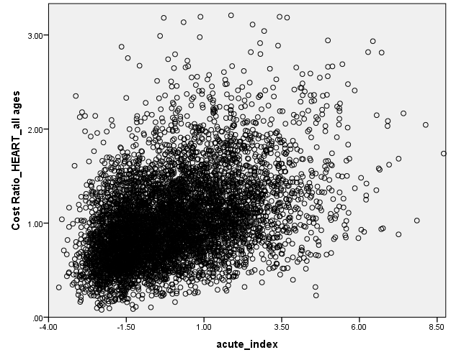
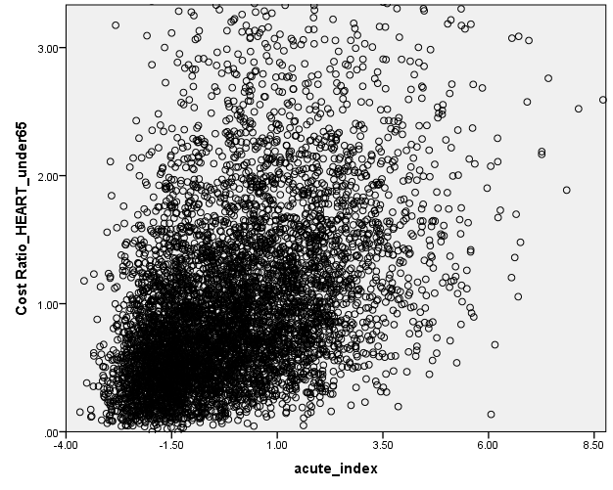
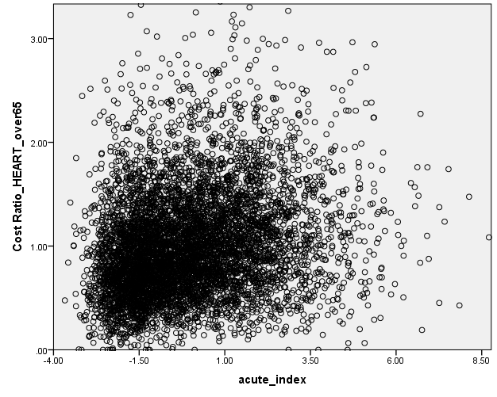
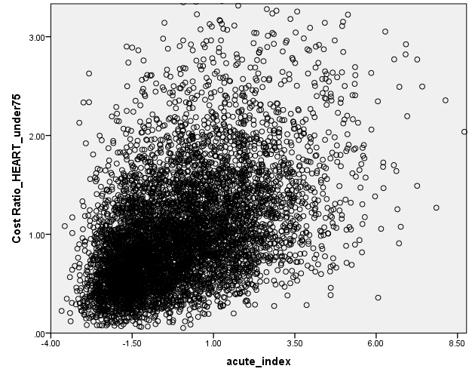
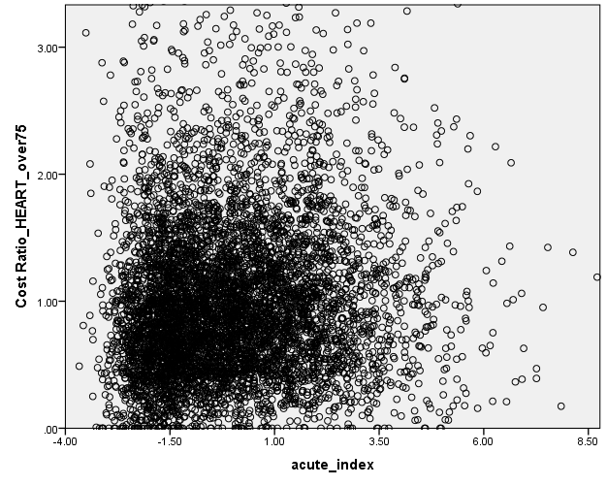
Figure 5. Scatter plots of Heart cost ratios against Acute Index for all ages (top), under- and over-65s (middle), and under- and over-75s (bottom). Note that the axes’ limits are set to be the same to allow direct comparison; this has excluded some few points from the plots.

Table 5. Acute index regression coefficient values for Heart obtained from fitting the reference model, for a variety of age split points, along with 95% confidence intervals.
Acute Index regression coefficients  95% Confidence intervals | < | ≥
40 | 0.149  (0.121; 0.177) | 0.103  (0.097; 0.109)
50 | 0.193  (0.176; 0.210) | 0.092  (0.086; 0.098)
60 | 0.190  (0.178; 0.203) | 0.075  (0.068; 0.081)
65 | 0.179  (0.169; 0.190) | 0.063  (0.055; 0.070)
70 | 0.168  (0.159; 0.176) | 0.050  (0.042; 0.059)
75 | 0.155  (0.147; 0.162) | 0.033  (0.023; 0.043)
all ages | 0.107  (0.101; 0.113)

Table 6. Adjusted R² values for Heart obtained from fitting the reference model, for a variety of age split points.
Adjusted R² values | < | ≥
40 | 1.8% | 17.1%
50 | 7.8% | 13.9%
60 | 13.7% | 8.7%
65 | 16.5% | 5.7%
70 | 20.8% | 3.4%
75 | 22.2% | 1.4%
all ages | 18.9%

4. Discussion
It could be argued that the variations in cost per episode / total costs outlined in Sections 2.1 to 2.3 should largely already be captured in the formula by the age - sex adjustment. However, the analysis presented in Sections 2 and 3 provides some evidence that the strength of the relationship between the Acute needs index and healthcare utilisation does vary with age for most diagnostic groups. Modelling costs for different age groups separately may therefore be justified – or possibly even the exclusion of older ages from the MLC adjustment, if no substantive relationship between utilisation and indicators of need exists for that group. However, the variation appears to be continuous across a range of ages, so the question of how best to split the age groups does not have a clear answer.
In addition, the modelling analysis in this paper is necessarily limited to the current reference model; it is unknown whether the patterns observed would be replicated using other potential needs indicators, or whether different patterns would be seen. It is also unclear whether different needs indicators should be used for ‘older’ and ‘younger’ age groups.
The analysis gives initial results and may inform the strategy for selecting the indicators, any appropriate age split and diagnostic groupings, once the data at the new geography becomes available. However, an impractically large number of regressions would be needed to explore every possible combination of indicator(s), age split point and diagnostic groupings.
The subgroup are asked to consider whether an appropriate age split should be investigated further and if so some questions for the Subgroup to discuss are outlined as follows:
- What criteria should be used to decide if an age split is justified? There is no obvious single criterion. Discussions within AST to date have not come up with a solution.
- What are our practical options for how to approach any regression analysis with a range of potential combinations of indicator(s), age split points and diagnostic groupings?

- How should the position of a split point be chosen? Should this be the same for all diagnostic groups in the interests of practicality (and because the diagnostic groupings are also open to possible change), or do we need a more precise optimisation?

- What are the priorities for the next steps?

