Report Summary: Stabilising the Unavoidable Excess Costs component of NRAC (TAGRA 2018).

- Context for Change
The Excess Cost adjustment is one of the 4 components of the NRAC formula, and reflects the variation in the costs of delivering health services across different geographies. It is based on the ratio of local to national cost per unit of healthcare activity (episode) over 3 yrs at the Datazone level, using an average calculated for each of the 8 NRAC Urban-Rural (UR) Categories.
In the 2015 the updating of the Age-Sex and Excess Costs components of NRAC generated a large increase in the Excess Costs index for Care of the Elderly (COTE) in Urban-Rural category 8. This resulted in an unreasonably steep increase in the overall Board-level index for the Island Boards. On the grounds of the core criterion of ‘face validity’ the update for COTE was not applied in that formula run: the 2014 cost ratios were retained instead, with an explanatory note added to the publication.
In recent years there have been changing levels of COTE activity recorded in SDIA areas, which give rise to large fluctuations in unit costs (as expenditure is more stable). COTE consists of Geriatric Long Stay (GLS) episodes and it is a specialty considered out of date: reduction in activity may be caused by changes in specialty classification and treatment protocols. In addition, SDIA areas have a very small share of the national population and are therefore prone to random activity fluctuations.
Analysis shows that cost per day has risen for all the UR areas, demonstrating the costs of fixed overheads against a reduction in activity. The increase for SDIA’s was markedly higher, especially 2012 and 2013, when only 1 hospital, Gilbert Bain Hospital in Shetland, recorded any COTE expenditure and activity. Using one UR-8 hospital’s recorded activity, with a small population, as a predictor of costs in Orkney, Western Isles etc, can result in large fluctuations, which contravenes the core criterion of ‘stablility’.
A compounding factor is that the COTE index is included in the final shares using national care programme weights, even though the programme is very small in this UR category. This means that the transmission of the fluctuation to final shares is excessive.
- Proposed Solution
The solution ISD proposes is to merge COTE with the Acute, for the purposes of the Excess Cost calculations only. This would be achieved by summing local costs and calculating an overall, combined cost ratio for the two care programmes.
The rationale behind this merger is;
- Combining COTE and Acute at the unit cost calculations stage would ensure that the COTE cost ratios are included in the formula with the implicit local care programme expenditure weight and thus avoid any excessive fluctuation affecting the final shares in a disproportionate way.
- Acute is the most appropriate programme to merge with, as the reclassification of GLS activity will be into Acute Specialties. In addition, due to the relative size of Acute to the COTE programme, the proposed combined index will not be unduly influenced by large changes on COTE unit costs.

- Additional Considerations
- A previous review, identified unit costs in SDIA to be significantly different to similar very remote areas, such as UR Cat 5, justifying this very small category. However, the small size of this category is part of the cause behind the COTE instability: it is therefore reasonable to reconsider the UR classification, as part of the work to resolve the issue.
- Re-testing the 2012 report using the three, 3-year windows; (2009/10 – 2011/12), (2011/12 – 2013/14) and (2012/12 -2014/15), was performed to evaluate if indices for Cat 5 and Cat 8 were significantly different. The relative magnitudes of the unit costs, including Acute, appear to be unstable over these time periods, especially for Cat 5 areas. The 2012 review identifying Cat 8 (SDIA) as higher than those for Cat 5, may have been the results of random fluctuations as opposed to a systemic, robust and repeatable and real difference.

- Conclusions
- Merge COTE and Acute care programmes (for Excess Costs only). This will be manageable to implement for this year’s report and will mitigate excessive weighting being applied to COTE in SDIA (Urban-Rural Category 8) areas.
- Monitor Urban-Rural Category 5 & 8, to see if a trend of similar unit costs can be identified or if further examples of instability develop, consider merging the two categories.

Stabilising the Unavoidable Excess Costs component of the NRAC formula

TAGRA (2018)

1. Background
The Excess Costs component of the NRAC formula (for Acute, Care of the Elderly, Maternity, and Mental Health & Learning Difficulties) relates to the unavoidable excess cost of providing healthcare services in remote and rural settings. It is designed to take these into account in the target shares, ensuring that the overall Board shares reflect not only the needs of the population but also the cost of providing the needed services.
The Excess Costs calculation:
- is based on a cost ratio: the ratio of the local cost per unit of healthcare activity (e.g. a hospital episode), to the national average cost of the same unit of activity
- is based on three years of costs and activity, and is calculated at data zone level
- uses averaging across the eight NRAC Urban-Rural categories (see table 1 below) as the basis for predicted cost ratios in the allocation period
- includes a small additional adjustment for Scottish Distant Islands Allowance (SDIA) staff costs – an additional amount added to salaries to help maintain staff levels in the remote areas of Scotland
- results in an Excess Costs ‘index’ – a measure in which 1 represents the national average, a value greater than 1 indicates greater than average expected unit costs, and vice versa
Table 1: 8-fold urban-rural classification used in NRAC following the 2012 review
Category | Description | Number of data zones
1: Large urban areas | Same as category 1 from SG 8-fold UR classification | 2,319
2: Other urban areas | Same as category 2 from SG 8-fold UR classification | 2,518
3: Accessible small towns | Same as category 3 from SG 8-fold UR classification | 663
4: Remote small towns | Same as category 4 from SG 8-fold UR classification | 151
5: Very remote (non-SDIA) areas | Comprises parts of categories 5 and 8 from SG 8-fold UR classification (all areas except SDIA islands) | 205
6: Accessible rural areas | Same as category 6 from SG 8-fold UR classification | 802
7: Remote rural areas | Same as category 7 from SG 8-fold UR classification | 217
8: SDIA islands | Comprises parts of categories 5 and 8 from SG 8-fold UR classification (SDIA islands only) | 101

In the 2015 run of the formula, the Age-Sex and Excess Costs components were updated. A large increase in the Excess Costs index was observed for Care of the Elderly (COTE) in Urban-Rural category 8, which represents the Scottish Distant Islands Allowance (SDIA) areas – covering Western Isles, Shetland, Orkney, and some islands within NHS Highland. This resulted in an unreasonably steep increase in the overall Board-level index for the Island Boards (compare Tables 2 and 3). The update was not applied for COTE: the previous year’s cost ratios were retained instead, with the following note added to the publication:
“HCHS Excess Cost Adjustment Care of the Elderly only: For the data zones from the SDIA (Scottish Distant Islands Allowance) Islands Urban-Rural category, the unit costs have been replaced with those used in the previous update. This is because in recent years, very low activity levels were accompanied by very high unit costs in one hospital, which would lead to a large degree of instability in the board level excess cost indices for this care programme. Further work will be undertaken to adjust the standard formula method, so as to prevent such instabilities from arising in future.”
The further work mentioned in the note has been carried out, and this paper presents the results and a proposed fix. TAGRA is asked to discuss and approve the proposed change to the Excess Costs calculation.

Table 2: The Excess Cost Index from the summer 2014 update at Health Board level (Care of the Elderly highlighted in grey). Based on data from 2009/10, 2010/11 and 2011/12.
Health Board | Acute Excess Costs Index | COTE Excess Costs Index | MHLD Excess Costs Index | Maternity Excess Costs Index | HCHS Excess Costs Index | HCHS Overall Index | NRAC HCHS Share
Ayrshire & Arran | 0.989 | 1.039 | 0.977 | 1.027 | 0.990 | 1.079 | 7.38%
Borders | 0.997 | 1.061 | 0.984 | 1.034 | 1.008 | 1.001 | 2.11%
Fife | 0.988 | 1.003 | 0.960 | 1.010 | 0.982 | 0.992 | 6.80%
Greater Glasgow & Clyde | 1.005 | 0.874 | 1.009 | 0.951 | 0.991 | 1.044 | 22.28%
Highland | 1.013 | 1.207 | 1.108 | 1.126 | 1.083 | 1.092 | 6.49%
Lanarkshire | 0.987 | 0.986 | 0.967 | 1.002 | 0.981 | 1.013 | 12.28%
Grampian | 1.002 | 1.012 | 1.010 | 1.002 | 1.003 | 0.902 | 9.94%
Orkney | 1.136 | 2.238 | 1.130 | 1.339 | 1.209 | 1.227 | 0.49%
Lothian | 1.001 | 0.924 | 0.997 | 0.972 | 0.990 | 0.910 | 14.84%
Tayside | 1.000 | 0.979 | 1.002 | 0.993 | 0.999 | 1.015 | 7.87%
Forth Valley | 0.986 | 1.002 | 0.963 | 1.011 | 0.983 | 0.956 | 5.39%
Western Isles | 1.135 | 2.236 | 1.129 | 1.338 | 1.231 | 1.353 | 0.67%
Dumfries & Galloway | 0.997 | 1.101 | 1.003 | 1.048 | 1.013 | 1.078 | 2.97%
Shetland | 1.140 | 2.247 | 1.134 | 1.344 | 1.220 | 1.153 | 0.50%

Table 3: The Excess Cost Index from the summer 2015 update at Health Board level (Care of the Elderly highlighted in grey). Based on data from 2011/12, 2012/13 and 2013/14. The COTE index update was not applied in the target shares due to unreasonably large changes compared to those in Table 2.
Health Board | Acute Excess Costs Index | COTE Excess Costs Index | MHLD Excess Costs Index | Maternity Excess Costs Index | HCHS Excess Costs Index | HCHS Overall Index | NRAC HCHS Share
Ayrshire & Arran | 0.989 | 0.980 | 0.977 | 1.026 | 0.988 | 1.063 | 7.31%
Borders | 0.997 | 1.002 | 0.986 | 1.034 | 1.007 | 0.990 | 2.10%
Fife | 0.987 | 0.947 | 0.960 | 1.010 | 0.980 | 0.973 | 6.68%
Greater Glasgow & Clyde | 1.006 | 0.825 | 1.007 | 0.951 | 0.990 | 1.058 | 22.54%
Highland | 1.013 | 1.172 | 1.111 | 1.125 | 1.083 | 1.097 | 6.54%
Lanarkshire | 0.987 | 0.930 | 0.967 | 1.003 | 0.980 | 1.013 | 12.32%
Grampian | 1.003 | 0.952 | 1.010 | 1.002 | 1.002 | 0.906 | 9.96%
Orkney | 1.135 | 5.665 | 1.128 | 1.340 | 1.314 | 1.309 | 0.53%
Lothian | 1.001 | 0.870 | 0.996 | 0.971 | 0.988 | 0.907 | 14.69%
Tayside | 1.000 | 0.926 | 1.001 | 0.992 | 0.997 | 0.995 | 7.72%
Forth Valley | 0.986 | 0.947 | 0.963 | 1.011 | 0.981 | 0.958 | 5.39%
Western Isles | 1.133 | 5.658 | 1.127 | 1.338 | 1.351 | 1.491 | 0.75%
Dumfries & Galloway | 0.996 | 1.039 | 1.002 | 1.052 | 1.013 | 1.059 | 2.94%
Shetland | 1.139 | 5.686 | 1.133 | 1.345 | 1.317 | 1.206 | 0.52%

2. Origin of the instability
As indicated in the note above, the issue with the COTE care programme is in the low levels of activity recorded over recent years in SDIA areas (category 8). This results in large fluctuations in the calculated unit cost.
Care of the Elderly consists entirely of Geriatric Long Stay (GLS) episodes, a specialty that is often considered to be out of date. The reduction in activity over time could be due to changes in the classification of such episodes as well as changes in treatment norms. Additionally, category 8 simply represents a very small proportion of the population of Scotland. It is likely to be particularly prone to fluctuations in activity for that reason.
Figures 1 to 3 show activity (occupied bed days), expenditure, and cost per day (i.e. expenditure divided by activity) for COTE in each Urban-Rural category. These figures show that both expenditure and activity have decreased, with Urban-Rural category 8 having no activity at all since 2013.
Most Urban-Rural categories show an increase in the cost per bed day, showing perhaps the effect of overheads remaining fixed while activity decreases. In the case of category 8, the increase in unit cost was rather sharp from 2009 to 2013, right before activity ceased. In fact, in 2012 and 2013, only one hospital within the SDIA areas – Gilbert Bain Hospital in Shetland – recorded any COTE expenditure and activity. The Excess Cost predictions for COTE would therefore be based on the recorded activity of a single hospital, for all SDIA areas, if updates were to carry on as usual. This is not acceptable: not only does it result in large fluctuations, it also does not make sense to predict costs in Orkney, Western Isles or other places based on activity at a single hospital in Shetland.
A further factor is that the change in the index for COTE is transmitted to the final shares using the national care programme weights, rather than local programme weights.
Figure 1: Occupied bed days for COTE in each Urban-Rural category, from 2004 to 2016. The lines connect UR categories over the years.
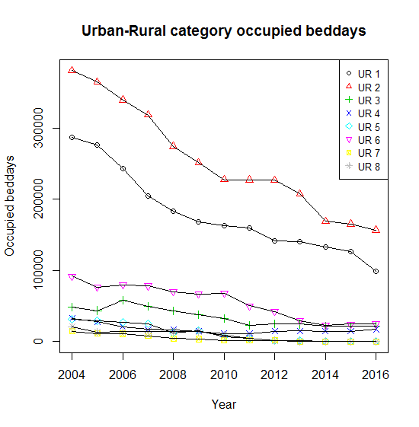
Figure 2: Expenditure for COTE in each Urban-Rural category, from 2004 to 2016. The lines connect UR categories over the years.
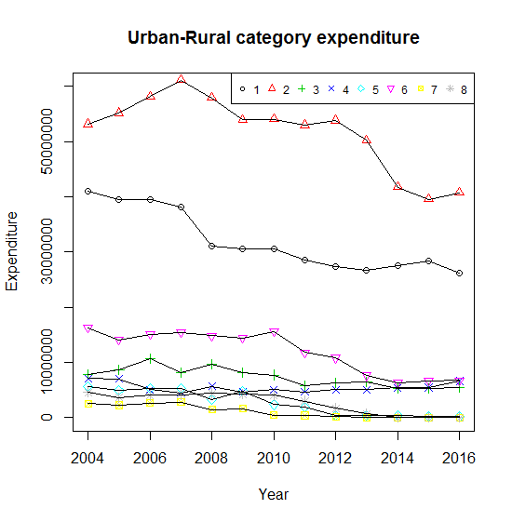

Figure 3: Expenditure divided by occupied bed days for COTE in each Urban-Rural category, from 2004 to 2016. The lines connect UR categories over the years.
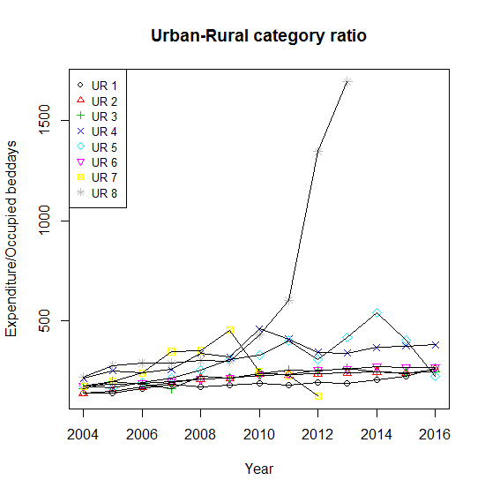

3. Proposed fix: combining Acute and COTE
It is proposed that Acute should be merged with COTE for the purposes of the Excess Cost calculations. This would be done by summing local costs and calculating an overall cost ratio for the two care programmes.
As stated in section 2, the instability in COTE is amplified by applying the national care programme weights in all eight UR categories when eventually combining the care programmes. In SDIA areas, the proportion of expenditure on COTE is clearly far lower than it is at national level, so applying national care programme weights gives it a greater weight than is reasonable in those areas. Combining COTE and Acute at the unit cost calculations stage would allow the true relative weights to be reflected in the Excess Costs index for these two care programmes.
Acute is the most appropriate programme to combine COTE with, since any reclassification of GLS activity and costs is likely to be into one of the Acute specialties. Also because of the large size of the Acute care programme, the combined index is not likely to be unduly influenced by large changes in COTE unit costs.
The results of testing the merging of the two care programmes are shown in Table 4. Comparing the columns for COTE before and after the merge (Table 3 vs Table 4), it is clear that the merging of Acute and COTE does dampen the effect of instability in the COTE activity.

Table 4: The updated Excess Cost Index for each Hospital care programme at Health Board level (COTE and Acute highlighted in grey) after the merge. Based on data from 2012/13, 2013/14 and 2014/15.
Health Board | Acute Excess Costs Index | COTE Excess Costs Index | MHLD Excess Costs Index | Maternity Excess Costs Index | HCHS Excess Costs Index | HCHS Overall Index | NRAC HCHS Share
Ayrshire & Arran | 0.997 | 0.996 | 0.997 | 0.999 | 0.994 | 1.084 | 7.41%
Borders | 1.006 | 1.005 | 1.004 | 1.012 | 1.014 | 1.006 | 2.13%
Fife | 0.993 | 0.993 | 0.982 | 0.979 | 0.986 | 0.997 | 6.83%
Greater Glasgow & Clyde | 0.990 | 0.989 | 0.990 | 0.984 | 0.984 | 1.036 | 22.11%
Highland | 1.055 | 1.056 | 1.106 | 1.127 | 1.104 | 1.113 | 6.61%
Lanarkshire | 0.989 | 0.989 | 0.983 | 0.978 | 0.984 | 1.015 | 12.31%
Grampian | 1.001 | 1.000 | 1.007 | 1.008 | 1.002 | 0.901 | 9.93%
Orkney | 1.172 | 1.172 | 1.101 | 1.263 | 1.193 | 1.211 | 0.49%
Lothian | 0.992 | 0.991 | 0.989 | 0.985 | 0.986 | 0.906 | 14.78%
Tayside | 0.997 | 0.996 | 0.999 | 0.997 | 0.997 | 1.014 | 7.86%
Forth Valley | 0.992 | 0.991 | 0.984 | 0.981 | 0.988 | 0.960 | 5.41%
Western Isles | 1.171 | 1.170 | 1.100 | 1.262 | 1.212 | 1.331 | 0.66%
Dumfries & Galloway | 1.007 | 1.006 | 1.022 | 1.026 | 1.018 | 1.083 | 2.98%
Shetland | 1.177 | 1.176 | 1.105 | 1.268 | 1.206 | 1.140 | 0.49%

This appears to stabilise the formula while retaining the very small category 8. It is still possible that the small size of this category could cause further instabilities in the future in other care programmes. For completeness, we look at this issue in the next section.

4. Reconsidering the Urban-Rural classification
As a result of the 2012 Remote & Rural Review (Paper TAGRA(2012)012), the previous 10-fold Urban-Rural classification was replaced by the 8-fold classification in Table 1. This was done by reorganising the categories for ‘very remote’ areas: the 10-fold classification had distinguished between towns and rural communities, and between mainland and island geographies, resulting in four ‘very remote’ categories; whereas in the 8-fold classification, the only distinction within ‘very remote’ areas is between SDIA and non-SDIA areas, i.e. just two categories. The SDIA category (category 8), however, was much smaller in terms of population than any of the previous categories. The review found that the unit costs in category 8 were significantly different from those in other areas, including similarly very remote areas, justifying the creation of this very small category.
Since the small size of category 8 is part of the reason for the COTE Excess Costs instability, as part of the work to resolve this issue, it is reasonable to reconsider the structure of the UR classification.

4.1 Do the 2012 conclusions still hold?
To re-test the conclusions of the 2012 report, Excess Cost indices have been calculated by care programme for each of the eight UR categories, using three different 3-year windows of data: (2009/10, 2010/11 and 2011/12); (2011/12, 2012/13 and 2013/14); and (2012/13, 2013/14 and 2014/15). Confidence intervals were calculated in order to evaluate whether the indices for categories 5 (very remote non-SDIA areas) and 8 (SDIA areas) were significantly different. The results were as follows:
- For Acute, the indices were not significantly different using the most recent data (2012/13, 2013/14 and 2014/15). For the other time windows they were significantly different.
- For Mental Health & Learning Difficulties, the indices were significantly different using data from (2011/12, 2012/13 and 2013/14) and (2012/13, 2013/14 and 2014/15). However, counter-intuitively, category 5’s ratio was higher than that of category 8 during these windows. The indices were not significantly different using data from (2009/10, 2010/11 and 2011/12).
- For Maternity, the indices were only significantly different using data from (2009/10, 2010/11 and 2011/12).
- COTE has too few observations in category 8 for formal testing to be possible.
Since the relative magnitudes of the unit costs in different urban-rural categories – even for Acute – appear to be somewhat unstable over time, particularly for category 5 in relation to others, it is possible that the finding in the Remote & Rural review of significantly higher costs in category 8 compared to category 5 might have resulted from random fluctuations rather than a systematic and robust real difference. Given the very small size of these two categories, it is worth considering their potential contribution to instability in the Excess Costs indices and the possibility that an alternative classification might perform better.

4.2 Cluster analysis
A hierarchical clustering method was employed to investigate the natural structure of the data zone-level cost ratios. This method could help to reveal whether the current Urban-Rural classification truly groups together areas with similar unit costs, or whether a different grouping is suggested by the data.
We chose to investigate natural clustering only within UR categories 5 and 8. These categories are both classified as very remote, with SDIA allocations being thought to be the main cause of unit cost differences. Since their cost ratios are not always significantly different, it is reasonable to consider the possibility of regrouping the data zones within these two categories to improve stability.
Using the hierarchical method to reduce the data zones into two or three clusters, the clusters that emerge do not coincide well with the existing urban-rural categorisation, nor with the Scottish Government classification. Separate analyses using Maternity, MH&LD, and a combined Acute—COTE care programme find different clustering patterns for each care programme. Presumably, also, different time periods would give rise to different clusters.

4.3 Discussion
Since their cost ratios are not always significantly different, and category 8 does not always have higher unit costs than category 5, it is reasonable to consider the possibility of regrouping the data zones within these two categories to improve stability. Because the clustering analysis did not yield a consistent result, the only reasonable suggestion would be to merge the two into a single category. This would help to further mitigate the potential instability inherent in the small size of category 8. On the other hand, the SDIA areas were separated out in the 2012 Remote & Rural Review because of the known additional cost of paying SDIA to staff, in order to allow this additional cost to be picked up in the unit cost analysis. While this additional cost may not necessarily result in significantly higher overall unit costs for category 8 compared to category 5, the face validity of treating these areas separately would be lost if the two categories were merged.

5. Conclusions
From the analysis in the preceding sections, the following recommendations are suggested to mitigate future instability in the Excess Cost index (particularly for COTE):
1. Merge COTE with Acute (for Excess Costs only). This is straightforward to implement, and helps by avoiding excessive weight being applied to COTE in category 8 where the activity levels are now extremely low.
2. Monitor Urban-Rural categories 5 and 8 in the future, to see whether there is a trend towards not significantly different unit costs. If so, and especially if further instability is encountered, consider merging the two categories.

As the care programmes were not merged for the Age-Sex and Morbidity and Life Circumstances (MLC) components, the final Excess Costs Indices for Acute and COTE differ slightly following rescaling.

