TAGRA(2011)02

approaches to the review of the morbidity and life circumstances adjustment

background
- Following TAGRA(2010)23, it is planned to under take the review of the Mental Health & Learning Difficulties care programme using the same approach as NRAC: a regression-based analysis. However, in a recent paper published in the journal of the Royal Statistical Society, two academics have criticised this approach, and suggested that an alternative approach should be sought. TAGRA should be aware that academics who produced the English formula have submitted a strongly worded rebuttal of the criticisms in the paper. Nonetheless, it is worth considering whether there are alternative approaches that could form the basis of a new MLC adjustment.
- Annex A provides further information on the role of the MLC adjustment within the current NRAC formula.

Purpose
- AST have undertaken a review of different approaches and available data, many of which were considered at the time of NRAC, and concluded that, other than the regression-based approach, there is one feasible alternative: this is the prevalence based approach used in Wales.
- This paper sets out the options for the review of the mental health and learning difficulties morbidity and life circumstances (MLC) adjustment within the NRAC formula, and considers their feasibility and potential implications for the formula.
- TAGRA is asked to decide whether it would like AST to include consideration of the prevalence based approach in the remit for the subgroup.

description of prevalence based approach
- Although typically described as the prevalence based approach, as it is based on prevalence data from GP practices recorded through the Quality and Outcomes Framework (QOF) it is therefore still a utilization based approach to some degree.
- The best example of the prevalence approach is that used in Wales. Rather than a population, age-sex, MLC, unavoidable excess cost approach, their allocation is takes the following approach:
  - Prevalence;
  - Age-sex adjustment;
  - Unavoidable excess cost adjustment.

- The age-sex adjustment is apparently the same as the approach to age-sex used in Scotland and the non-stratified parts of the English formula.
- For hospital services such as Mental Health & Learning Difficulties, the adjustment for unavoidable excess costs this is based on an approach similar to the Arbuthnott formula’s.

practicality of the prevalence based approach
Coverage
- The QOF reports raw prevalence rates in the populations of participating GP practices based on the activity of doctors. Prevalence data is available specifically for both Mental Health and Learning Difficulties.
- Mental health measures only serious mental illness, defined as schizophrenia, bipolar affective disorder or other psychoses; it does not include more general conditions.
- Learning difficulties covers only the over 18 population. Prevalence of learning difficulties conditions as measured by the QOF is at approximately 0.5% of the Scottish population. This is lower than the standard estimate of national prevalence rates, at about 2%, which is attributed to the fact that patients with learning difficulties may not attend GP practices.
- There are a range of other indicators which could be considered relevant to the MH&LD care programmes: for example, dementia, hypertension, and depression.
- In 2009/10, 882 practices reported Learning Difficulties prevalence rates; 972 reported Mental Health prevalence rates; these represent 86% and 95% of the 1,027 practices in the 2009/10 NRAC formula.
- These levels of coverage vary by each NHS Board, as shown in the table below. It is clear that, whilst most NHS Boards have good coverage, there are some boards where coverage is more patchy, particularly for mental health.

Table 1 - Rates of GP practices reporting QOF data by NHS Board
NHS Board | Proportion of GP practices reporting mental health data (%) | Proportion of GP practices reporting learning difficulties data (%)
Ayrshire & Arran | 93% | 97%
Borders | 100% | 100%
Fife | 93% | 98%
Greater Glasgow & Clyde | 91% | 98%
Highland | 58% | 80%
Lanarkshire | 95% | 99%
Grampian | 85% | 96%
Orkney | 43% | 43%
Lothian | 88% | 94%
Tayside | 94% | 99%
Forth Valley | 83% | 97%
Western Isles | 67% | 83%
Dumfries & Galloway | 89% | 100%
Shetland | 30% | 80%
Scotland | 86% | 95%

- There are therefore concerns over the fairness of the prevalence-based approach for those boards with lower participation by GP practices in the QOF.
Feasibility
- Regardless of the concerns with Equity, it would be feasible to develop an MLC adjustment. Further detail on the prevalence approach is provided in Annex B. Further detail on alternative approaches which have been investigated and considered unsuitable is provided in Annexes C & D.

Recommendation
- Although it would be feasible to investigate moving to an MLC index based on prevalence data, AST recommend that this approach is not taken further, due to concerns over the Equity for those NHS Boards with lower participation. It could be considered as an option in other care programmes.

Decision required by tagra
TAGRA is asked to:
- Agree not to progress work on the prevalence based approach within the Mental Health & Learning Difficulties care programme further at this time; and
- Reaffirm its decision to continue with a regression based approach within the Mental Health and Learning Difficulties Care Programme.

Health Analytical Services Division
Health Finance Directorates
April 2011
ANNEX A – The role of the MLC adjustment in the NRAC formula

The MLC adjustment is the third element of four-stage NRAC process, shown in the figure below:
 | Population |  | Age-sex cost weights |  | Additional needs (MLC) |  | Unavoidable excess costs of supply
 | NHS Board population % | x | Relative need due to age-sex profile | x | Relative need due to morbidity and life circumstances and other factors | x | Relative costs of providing services to different geographical areas | = | NRAC weighted share %

It may be helpful to clarify the nature of the calculations undertaken in each stage to more fully understand the purpose of the MLC adjustment.
 | Age-sex cost weights |  | Additional needs (MLC) |  | Unavoidable excess costs of supply
 | Expected activity due to age-sex |  | Actual local activity |  | Cost of activity delivered locally
 | Expected activity due to age-sex |  | Expected activity due to age-sex |  | Cost of activity delivered nationally

The MLC adjustment, therefore, is concerned primarily with determining how activity may vary with factors such as deprivation and other life circumstances.
ANNEX B - Prevalence based approach – QOF data
Coverage
The QOF (Quality Outcomes Framework) reports raw prevalence rates (i.e., not adjusted for age or sex) in the populations of GP practices based on the activity of doctors. Prevalence data is available specifically for Mental Health & Learning Dificulties.
Here, mental health measures only serious mental illness, defined as schizophrenia, bipolar affective disorder or other psychoses; it does not include more general conditions.
Learning difficulties covers only the over 18 population. Prevalence of learning difficulties conditions as measured by the QOF is at approximately 0.5% of the Scottish population. This is lower than the standard estimate of national prevalence rates, at about 2%, which is attributed to the fact that patients with learning difficulties may not attend GP practices.
There are a range of other indicators which could be considered relevant to the MH&LD care programmes: for example, dementia, hypertension, and depression.
In 2009/10, 882 practices reported Learning Difficulties prevalence rates; 972 reported Mental Health prevalence rates; these represent 86% and 95% of the 1,027 practices in the 2009/10 NRAC formula.
These levels of coverage vary by each NHS Board, as shown in the table below. It is clear that, whilst most NHS Boards have good coverage, there are some boards where coverage is more patchy, particularly for mental health.
Table B1 - Rates of GP practices reporting QOF data by NHS Board
NHS Board | Proportion of GP practices reporting mental health data (%) | Proportion of GP practices reporting learning difficulties data (%)
Ayrshire & Arran | 93% | 97%
Borders | 100% | 100%
Fife | 93% | 98%
Greater Glasgow & Clyde | 91% | 98%
Highland | 58% | 80%
Lanarkshire | 95% | 99%
Grampian | 85% | 96%
Orkney | 43% | 43%
Lothian | 88% | 94%
Tayside | 94% | 99%
Forth Valley | 83% | 97%
Western Isles | 67% | 83%
Dumfries & Galloway | 89% | 100%
Shetland | 30% | 80%
Scotland | 86% | 95%

Stability of data
Comparing prevalence rates by GP practice between 2008/09 and 2009/10, it appears that prevalence data is extremely stable. This will in part be due to the fact that GP prevalence registers show all patients on the practice list who have been diagnosed with a disease, rather than reflecting new diagnoses in one year. There will therefore be a large level of ‘carry over’ from one year to the next.

Disadvantages of the QOF data
The disadvantages associated with the QOF data are:
- Data is based on GP activity. This may not closely reflect activity in the hospitals where the MH&LD is allocating resources, and also does not allow any distinction to be drawn as to the types of services being delivered, e.g. day cases or inpatients. The relationship between the QOF prevalence measures and NHS Board activity rates are shown below:

Although in some cases there are very large differences between activity and prevalence, there are similar differences between the current NRAC MH&LD index and activity.
- Link between prevalence and need. Data is not a true reflection of prevalence, but rather shows diagnosed cases. If different areas enjoy different rates of success in diagnosing cases, allocations will be biased toward these areas, rather than truly reflecting the underlying prevalence of conditions.
- Lack of link to cost data. The prevalence approach assumes that all patients have on average the same cost. There is no way of determining whether costs are higher for patients in rural, urban, or deprived areas, for example.

Feasibility
Given the availability of QOF data, it appears feasible to apply a simple prevalence-based approach to the allocation of MH&LD. This would simply replace the MLC adjustments for the allocation. Lacking data on cost, a new method may need to be derived for the unavoidable excess cost adjustment.
Ability of QOF data to address equity concerns
Basing allocation purely on prevalence/contacts, with zero patient data, would greatly limit ability to consider impacts on different social groups.
ANNEX C – Prevalence based approach – PTI survey data
ISD’s Practice Team Information (PTI) collect data on activity at approximately 60 GP practices across Scotland. Although they do not specifically collect data on MH&LD, they do collect data for various conditions that could be viewed as linked to MH&LD:
- Dementia;
- Depression;
- Eating disorders;
- Hypertension;
- Multiple sclerosis

Unlike published QOF data, contacts are broken down by age and sex, and standardized by deprivation. It may therefore be possible to construct both an age-sex index and a MLC index using PTI data, although this would require further investigation.
The disadvantages associated with the PTI data are:
- Data is based on GP activity and is not specific to Mental Health & Learning Difficulties. This may not closely reflect activity in the hospitals where the MH&LD is allocating resources;
- Data is based on a very small sample of practices;
- Link between prevalence and need. Data is not a true reflection of prevalence, but rather shows diagnosed cases. If different areas enjoy different rates of success in diagnosing cases, allocations will be biased toward these areas, rather than truly reflecting the underlying prevalence of conditions. This is a greater risk with a small sample size; and
- Lack of link to cost data. The prevalence approach assumes that all patients have on average the same cost. There is no way of determining whether costs are higher for patients in rural, urban, or deprived areas, for example.

Stability
The PTI data does not appear particularly stable over time. This is shown for the different diseases in the charts below:

Dementia:
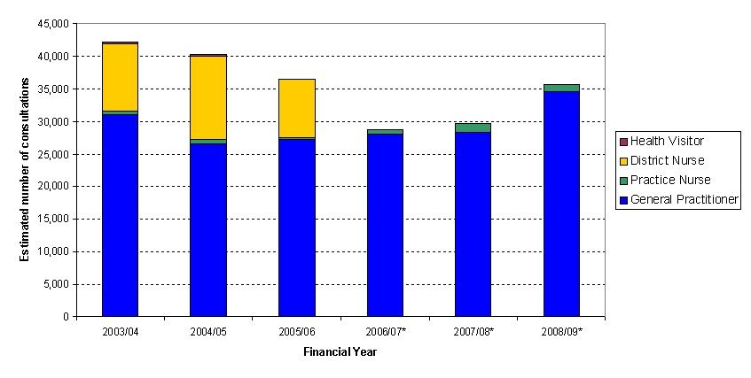

Depression:
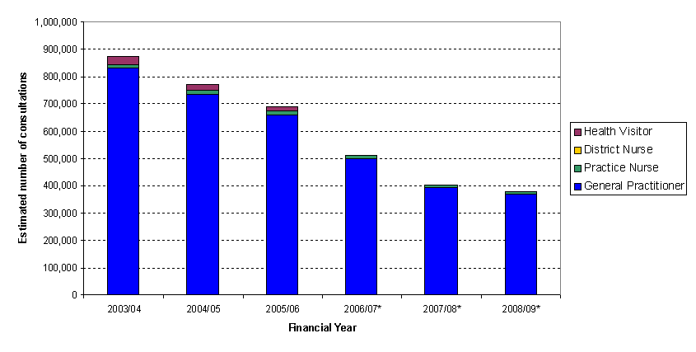

Hypertension:
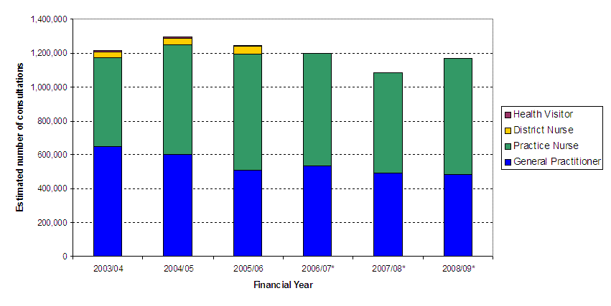

Feasibility
It will certainly be feasible to develop alternative prevalence based age-sex costs for MH&LD based on the PTI data, although there may be some concerns over their robustness due to the sample size. It is not clear whether an MLC adjustment could be developed, or an associated adjustment for the unavoidable excess costs of geography.

ANNEX D – Direct prevalence measure – Scottish Health Survey
The Scottish Health Survey (SHS) collects data on the Warwick-Edinburgh Mental Well-Being Scale (WEMWBS). This provides national level data, broken down by age and sex.
However, due to the small sample size of the survey, data is not currently available below the Scotland level. Four years of data is viewed as necessary to provide estimates by administrative area. This will not be available until summer 2012.
It would in theory be possible to produce bespoke estimates for the NRAC allocation by using the age-sex data, but this would need to be discussed with SHS statisticians, and would reduce confidence in the results for the smaller NHS Boards.
It is also worth noting that, for WEMWBS and other survey indicators, there tends to be a decline in need among elderly populations. This may indicate a difficulty in obtaining data from elderly populations with, e.g. dementia, which would make the data unsuitable for NRAC allocations.
Health surveys do not gather responses from children, although parents are asked to provide information on their children’s health.
Feasibility
Given the current limited nature of the data, and the lack of confidence in the data below the national level, this approach is not considered feasible at the current time.

