TAGRA(2011)12

treatment of rural costs in other funding formulae

background
- Following the update on the work of the Remote and Rural Subgroup presented to TAGRA at its last meeting (see TAGRA(2011)11), TAGRA requested information on the approach to rural funding in other countries.

Purpose
- A review of international approaches to the treatment of rural costs in other funding formulae was carried out for NRAC, and is contained in Technical Report E. This paper revisits this work, and considers whether there have been any changes since the time of the report, and also looks specifically at whether other countries make use of top-slicing for rural funding.

key points
- Of particular relevance to the work being undertaken by the Remote and Rural Subgroup is the degree to which top-slicing of funding is used for rural services. Of the countries reported in NRAC Technical Report E (excluding Scotland), six have some form of rurality adjustment. Of these, three have some degree of top-slicing in their allocations to deal with rural costs. These are: New Zealand, New South Wales in Australia, and Northern Ireland.
- The approaches adopted in New South Wales and Northern Ireland are of particular interest as they are directly based on hospitals. New South Wales adopt an approach which is similar to that considered by the Remote and Rural Subgroup in their paper TRR13. This involves an assessment of the fixed cost associated with running a hospital, and using this as the basis of allocations to regions. In Northern Ireland an economy of scale formula is used to calculate directly how hospital costs vary with the number of episode in a hospital.
- The key differences between the approaches in New South Wales and Northern Ireland is that both of these countries specify the number of hospitals per region within their calculations.
- In New South Wales, a standard of 2 hospitals per 100,000 population is used. Regions receive the rurality adjustment for each hospital that they have above this level.
- In Northern Ireland, hospital numbers are based on comparing a ministerially agreed national service design requirement for numbers of hospitals against a theoretical cost-minimization system. Regions are then compensated for the additional cost of the hospitals that are run under the agreed system.
- Further details on the approaches adopted in different countries is provided in Annex A.

action required from tagra
- TAGRA is asked to:
- Note the approaches to rural funding used in other countries; and
- Consider if there are any approaches used in other countries that it would like the Remote and Rural subgroup to investigate for Scotland.

Iain Pearce
Analytical Services Division
Health Finance and Information
Health and Social Care Directorate

ANNEX A – Rural funding in other resource allocation formulae
Australia (New South Wales)
The New South Wales (NSW) approach to rural costs is of particular interest, as it includes a ‘Small Hospital Factor’. This is designed to reflect the fact that there are fixed costs associated with hospitals, and that rural areas have to maintain a larger number of hospitals than is the case in more metropolitan areas.
An assessment of the drivers of hospital costs found that case-mix, bed-days, non-inpatient episodes, and fixed costs together provided a good explanation of total cost. Fixed costs were assessed to be approximately A$500,000.
The number of hospitals within each region over the rate of 2 hospitals per 100,000 population is then calculated, and this number is multiplied by A$500,000. E.g., if a region has 6 hospitals per 100,000 population, this is 4 more than the 2 hospital per 100,000 Australian standard, and so the additional fixed costs of this region is four times A$500,000, or A$2m.
The precise derivation for the ‘2 hospitals per 100,000 population’ standard is unclear. It appears to be the approximate rate in the metropolitan areas of NSW. The actual rate appears not to be used, as there are issues with counting facilities in metropolitan areas as there have been a range of administrative mergers.
The small hospital factor is one of a range of rurality focussed allocations within the Australian formula. In an attempt to avoid double counting, regions which already have additional funding through other allocations have their small hospital factor reduced.
The distributive pattern this approach implies is shown in the Table A1. The impact of the methodology is essentially to redistribute funding away from Sydney, the capital of NSW, which accounts for almost two-thirds of the state’s population. 113 hospitals are counted as eligible. It is not know how many hospitals there are in NSW; however, assuming a rate of 2 per 100,000 population in Sydney, there would be approximately 200. Therefore, approximately 55% of hospitals may operate in less populated areas. This could be seen as reasonable, given that two-thirds of the population lives within the Sydney conurbation.
The small hospital factor appears to be quite a small element of overall funding, in part because there are other rural related funding adjustments within the formula, and there is a desire to avoid double counting these. Total funding in 2003/04 was A$23.9m. This compares to a total health spend by the area health boards of A$6.7bn. The small hospital factor there accounts for only around 0.5% of total funding.
Note that the final small hospital factor shown in the table is not directly proportional to the number of hospitals, due to adjustments for other rurality factors, such as dispersion, to avoid double counting.

Table A1 - Small hospital factor in New South Wales, 2003/04
 | Number of Facilities in Rural Areas Greater than the 2.0 per 100,000 residents | Final small hospital factor (A$000’s) | Final small hospital factor (%)
Central Sydney | 0 | - | 0%
Northern Sydney | 0 | - | 0%
Western Sydney | 0 | - | 0%
Wentworth | 0 | - | 0%
South Western Sydney | 0 | - | 0%
Central Coast | 0 | - | 0%
Hunter | 5 | 2,457 | 10%
Illawarra | 0 | - | 0%
South Eastern Sydney | 0 | - | 0%
Northern Rivers | 9 | 2,968 | 12%
Mid North Coast | 4 | - | 0%
New England | 16 | 2,536 | 11%
Macquarie | 14 | 4,112 | 17%
Mid Western | 16 | 3,191 | 13%
Far West | 12 | 3,201 | 13%
Greater Murray | 24 | 2,719 | 11%
Southern | 13 | 2,725 | 11%
TOTAL | 113 | 23,909 | 100%
Source: NSW Health Resource Distribution Formula Technical Paper (2005 revision)

Northern Ireland
The Northern Ireland approach is also of interest, as it contains an adjustment specifically based on the concept of economies of scale in service provision, combined with an assessment of the required number of facilities.
The assessment of fixed costs is the outcome of analysis attempting to link the cost per episode (measured by HRG) to the scale of the hospital. The broad results are illustrated in the figure below. As can be seen in the figure, the research identified both economies and diseconomies of scale, i.e., there are higher costs associated with operating both smaller and larger hospitals. The optimal size of a hospital is in the region of 40,000 episodes per year.

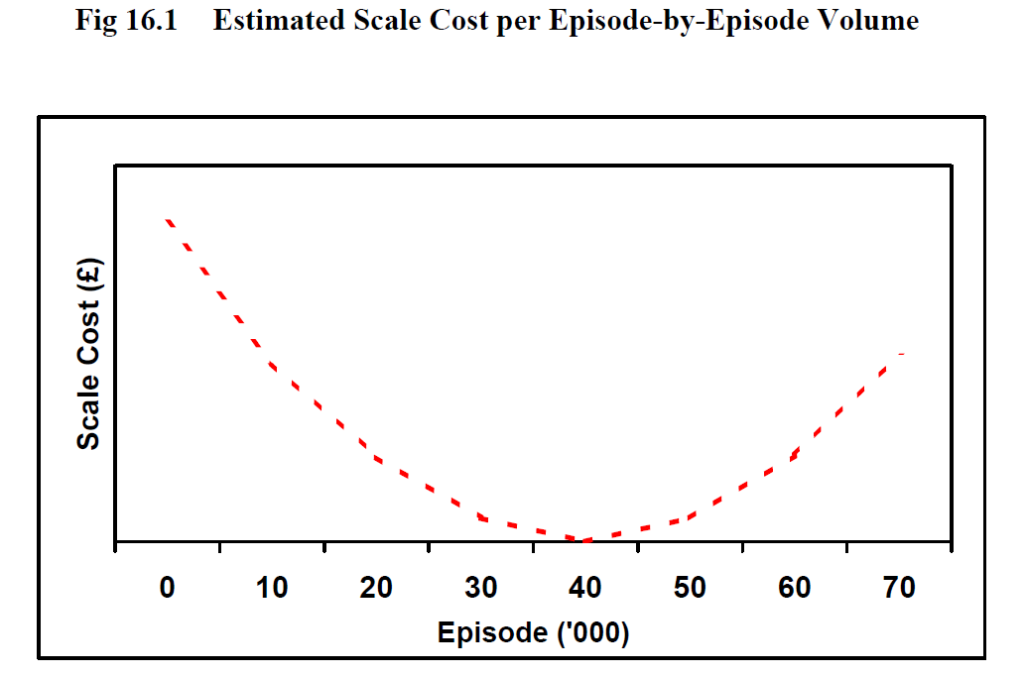
Source: The Fourth Report of the Capitation Formula Review Group, DHSSPSNI
This analysis has been combined with Delivering Better Services. This is a centrally managed programme in which the 15 acute hospitals in Northern Ireland will be reconfigured to become nine acute hospitals and seven local hospitals. This configuration is compared to a theoretical configuration, derived through the Simple Model of Spatial Services (SMOSS) which minimizes cost. The additional cost of operating the Delivering Better Services model, compared to the theoretical model, can then be calculated for each area.
This additional cost then becomes a top-sliced element of regional funding.

New Zealand
New Zealand also uses a top-slicing approach for rural health care, although the calculations used are not published in publicly available documents. An estimate of total additional costs of rurality for New Zealand is estimated, primarily based on a ‘rurality premium’ and diseconomy of scale payments. These are not clearly defined, but appear to be an element of funding contracts in New Zealand – although it is now moving away from it, healthcare in New Zealand has historically been provided through a purchaser/provider model as used in England. Other examples of cost are a price premium paid to rural maternity providers where the volume of births is below the threshold level expected of a metropolitan maternity provider.
The total budget for the rural element of funding was NZ$80m in 2003/04. This appears to represent about 1% of total costs in New Zealand. Ministry of Health direct health funding in this year was NZ$8,531m, although it is not clear how much of this was allocated by the population based formula.
The rural element of funding is distributed between boards based on their relative share of population living more than one hour from a settlement of over 30,000 people.

Finland
There is no evidence of changes to approaches to funding in Finland. The adjustment for rural costs is subjective, with islands/archipelagos with no road connection to the mainland receiving an increase of 10%, and areas defined as slightly or deeply remote receiving an increase of 5% and 15% respectively.

Wales
There does not appear to have been any changes to the Welsh approach to rural funding since the time of NRAC. The Welsh distribution formula uses a drive-time based model to inform community services. This is not top-sliced, and overall the Welsh approach appears similar to that currently used in Scotland.

Canada (Alberta)
There have been major changes to the structure of health services in Alberta since the time of the NRAC report. The previous nine regional authorities were merged into a single ‘superboard’ known as Alberta Health Services in 2008. It appears that with this change the allocation formula for allocation between different regions is no longer used.
ANNEX B – Potential replication of international approaches in Scotland
Some preliminary analysis has been carried out on replicating these approaches in Scotland.
Number of hospitals
Scotland has approximately 125 hospitals, a rate of 2.4 per 100,000 population. However, there is some difficulty over the definition of a hospital: the number of hospitals has increased from 90 in 2007/08, due to counting an increased number of community facilities as community hospitals. A more stable measure might be to use the number of large, general, or teaching hospitals, which has remained at 38 hospitals over the last four years.
The distributive pattern implied by taking the number of hospitals relative to the Scottish average is shown in the table below, calculated on the basis of a fixed cost of £3.7m per hospital.
NHS Board | Assessed facilities above average |  | Funding on basis of
NHS Board | All hospitals | LGT hospitals | All hospitals | LGT hospitals
A&A | 0.0 | 0.3 | £0.0 | £1.2
Borders | 5.3 | 0.2 | £19.6 | £0.6
Fife | 0.0 | 0.0 | £0.0 | £0.0
GG&C | 0.0 | 0.0 | £0.0 | £0.0
Highland | 11.6 | 2.7 | £42.9 | £10.1
Lanark. | 0.0 | 0.0 | £0.0 | £0.0
Grampian | 10.0 | 0.0 | £37.0 | £0.0
Orkney | 0.5 | 0.9 | £1.9 | £3.2
Lothian | 0.0 | 0.0 | £0.0 | £0.0
Tayside | 4.5 | 1.1 | £16.5 | £4.0
Forth V. | 0.0 | 0.0 | £0.0 | £0.0
W. Isles | 2.4 | 0.8 | £8.8 | £3.0
D&G | 4.5 | 0.9 | £16.5 | £3.4
Shetand | 0.5 | 0.8 | £1.7 | £3.1
Scotland | 39.2 | 7.7 | £144.9 | £28.5

The total funding affected amounts to 1.9% of total NRAC funding under the ‘all hospitals approach’, and 0.4% of total NRAC funding under the basis of ‘large, general, and teaching hospitals’.
Economies of scale
An initial attempt has been carried out to identify economies of scale in hospitals in Scotland. At this point, no disaggregation has been carried out by case-mix or activity type. Instead, gross cost per case across all specialties has been regressed on total activity at the hospital level. The overall goodness of fit is relatively poor (adjusted R² = 12.6%) but it is possible to identify an economies of scale relationship which, similar to the findings in Northern Ireland, suggest that unit costs are minimized at activity levels of approximately 40,000 per year.

http://www.dhsspsni.gov.uk/index/hss/developing_better_services/dbs_new_hospital_network.htm

