TAGRA(2011)15

UPDATE ON DATA GAPS

PURPOSE

- At the last meeting of TAGRA, the analytical support team were asked to provide an update on data gaps that had been identified by NRAC. This paper provides an update on the gaps identified by NRAC and the degree to which they are being closed.

BACKGROUND

- The NRAC report identified a number of gaps in data that acted as constraints in developing the formula. These are reproduced in Annex A, and fall broadly into three group:
- Prescribing – obtaining more complete patient data on prescriptions, to allow the current sample-based approach to be replaced;
- Community – there were numerous recommendations relating to community services, primarily noting the need for nationally consistent patient-level data sets; and
- Ethnicity – obtaining ethnicity data on patient records.

DEVELOPMENTS SINCE NRAC

Prescribing

- Paper TAGRA(2011)01 described the changes in the CHI completeness in the ePharmacy warehouse. This has resulted in the sample of patients for prescribing activity being replaced with the use of the full data set in future formula runs. This data gap is therefore now considered closed.

Community

- The developing of a robust and nationally comparable data set for community is a significant challenge that, despite being of interest for a significant time, has not yet been achieved. Work to attempt to drive developments in this area has been undertaken by the Community Cost and Activity Data Working Group, which was reported to TAGRA at its last meeting in August in paper TAGRA(2011)11. Work has not progressed sufficiently to allow a substantive update to TAGRA at this time, but it is intended to provide a further update at the next meeting.

Ethnicity

- Ethnicity data should be collected as part of SMR01 (acute inpatient and day cases) and SMR00 (acute outpatients). Completeness of this data is, however, variable across the different regions of Scotland, although it has improved since the time of the NRAC report. As shown in the table below, there has been a marked increase in the completeness of ethnicity data since 2008, particularly for SMR01, although completeness levels are still lower than those of England.
Figure 1 - Completeness of ethnicity data for Scotland
- However, as shown in Figure 2 below for SMR01 data, the improvement at the Scotland level conceals significant variation between the NHS Boards. The Golden Jubilee is clearly the best performer, whilst some boards, notably Western Isles, have very low rates of completion. The SMR00 data shows a similar level of variation.

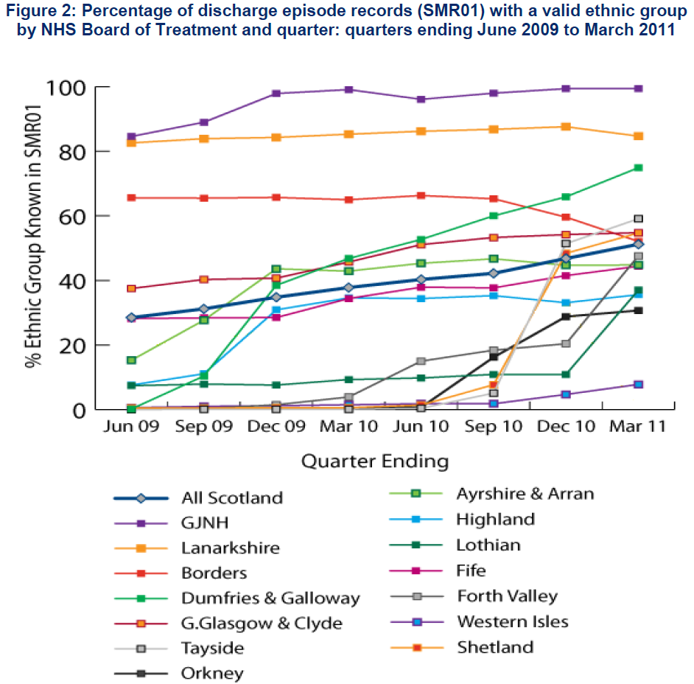
- Two areas of SMR01 ethnicity data have been considered to date. These are:
- Is there any evidence that the current set of data should not be used, given the lack of completeness?
- Given current information on ethnicity, is there any evidence that ethnicity is a factor in explaining differing levels of activity between boards?
- The first of these questions can be investigate by considering whether or not the current breakdown of ethnicity of patients is accurate. It is not possible to be definitive in this matter, as the true ethnic profile of patients is not known. One possible approach is to consider whether there is any evidence that the level of completeness affects the reported level of ethnicity data. This has been investigated using a panel approach, which considers the proportion of activity related to non-white patients against the rate of completeness by NHS board over the last ten quarters. This approach finds, at the Scotland level, that there is no evidence that the rates of activity by ethnicity being reported by boards has changed as the rates of completeness have improved (see Annex B).
- It is difficult to say whether this conclusion holds across all NHS Boards. The model error by NHS Board (also shown in Annex B) is generally quite flat over time. However, there is a statistically significant upward slope, although this appears small. The degree to which this is caused by the variable data in Orkney, which appears to account for approximately half the variation, has yet to be determined.
- Overall, therefore, the main concern with the activity data appears to be not that the incomplete data may be inaccurately reflecting the nature of activity, but rather than due to its incompleteness it cannot currently be used in analysis.
- On the question of how ethnicity levels of activity, analysis to date has been quite limited. There is obviously a subjective issue as to how to define a measure of ‘ethnicity’. Here, the proportion of the population that is non-white has been used. This is the most practical measure that can be taken from the data. Other measures of interest, such as non-UK national, are not possible, as the coding used on the SMR returns does not distinguish between, for example, British Indians or Indian immigrants. The only available data source for ethnic populations is the census, so there is a significant difference in time between the two sources. The two are compared in Figure 3 below. There is a clear correlation between the proportion of population that is non-white and the proportion of patients that are non-white, but it is not clear whether activity can be expected to be higher or lower than the ethnic population. It should be noted that only crude activity is being considered here, and it is not age-sex adjusted.

Figure 3 - Comparison of non-white census population and non-white patients from SMR01 (2010Q4)

- Although no detailed analysis has yet been undertaken on the SMR00 (outpatients) data set, as noted above there are differences with the SMR01 data. The graph below compares the proportion of patients that are non-white for SMR01 and SMR00. Again, there is a strong correlation between the two, but it also appears that rates of activity relating to non-whites is higher in acute outpatient facilities than in acute inpatient and day cases.

Figure 2 - Differences in the level of reported non-white patients between SMR00 and SMR01

Actions for TAGRA

- TAGRA is asked to discuss the identified data gaps and recently collected ethnicity data.

Health Analytical Services
Health Finance and Information Directorate
November 2011
ANNEX A – NRAC recommendations relating to data issues
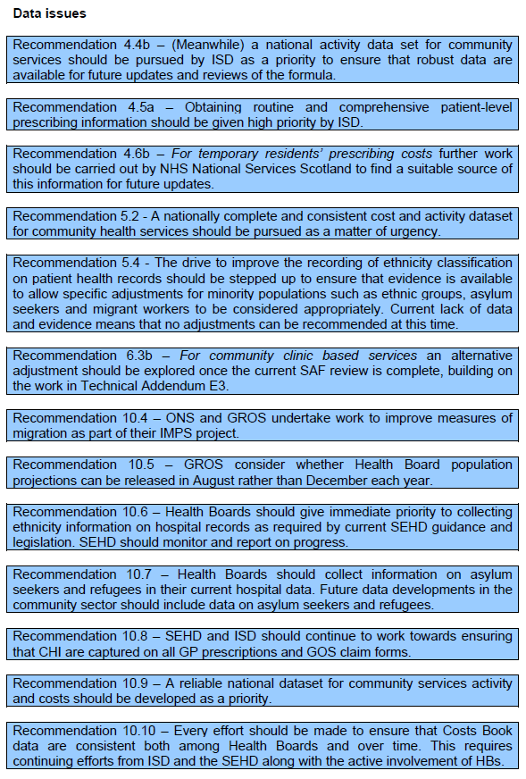
Annex B – Model of the relationship between rate of non-white patients and completeness in SMR01

Model 1: Fixed-effects, using 149 observations
Included 15 cross-sectional units
Time-series length: minimum 9, maximum 10
Dependent variable: Ethnicity

 | Coefficient | Std. Error | t-ratio | p-value
const | 0.033591 | 0.0122157 | 2.7498 | 0.00679 | ***
Completeness | -0.0380151 | 0.0346542 | -1.0970 | 0.27463

Mean dependent var | 0.021276 |  | S.D. dependent var | 0.060213
Sum squared resid | 0.459653 |  | S.E. of regression | 0.058788
R-squared | 0.143382 |  | Adjusted R-squared | 0.046771
F(15, 133) | 1.484118 |  | P-value(F) | 0.119690
Log-likelihood | 219.2797 |  | Akaike criterion | -406.5595
Schwarz criterion | -358.4963 |  | Hannan-Quinn | -387.0322
rho | 0.146245 |  | Durbin-Watson | 1.623963

Test for differing group intercepts -
Null hypothesis: The groups have a common intercept
Test statistic: F(14, 133) = 1.46419
with p-value = P(F(14, 133) > 1.46419) = 0.13313

Distribution free Wald test for heteroskedasticity -
Null hypothesis: the units have a common error variance
Asymptotic test statistic: Chi-square(15) = 3.2308e+007
with p-value = 0

