NRAC formula - Excess Costs adjustment
Impact assessment analysis
Paper TAGRA(2013)01B

- Introduction

The NRAC (National Resource Allocation Committee) formula is used to allocate funding to the 14 territorial NHS Boards. In 2011/12, the formula was used to allocate £7.6bn out of a total health budget of £11.4bn.

In Spring 2011, the Remote & Rural sub-group was established to consider issues identified by the report of the Technical Advisory Group on Resource Allocation: The Impact of the NHSScotland Resource Allocation Committee (NRAC) Formula on Remote and Rural Areas of Scotland (2010).

The remit of the group was to recommend to TAGRA (Technical Advisory Group for Resource Allocation) potential improvements to the excess cost adjustment within the NRAC formula, having regard to TAGRA’s core criteria. The objective was to enhance the ability of the formula to allocate funds between the territorial NHS Boards on a fair and equitable basis. Full details of the subgroup’s final report (including recommendations) can be found at:
http://www.tagra.scot.nhs.uk/subgroups_RR.html.
- Background

The work of the subgroup centred round 3 main areas:

- Developing a feasible adjustment which explicitly recognises the costs of GP Out of Hours services.

- Examining the pattern of costs with respect to the Scottish Distant Islands Allowance (SDIA) areas and developing an adjustment to the urban-rural categories.

- Exploring the extent to which the excess cost adjustment adequately captures the fixed costs of health service provision and the robustness of the current urban-rural categorisation.

In December 2012, the Remote & Rural Subgroup presented 3 recommendations to TAGRA:

Recommendation 1: There should be an adjustment, based on the Scottish Allocation Formula, which explicitly recognises Out of Hours Services.

Recommendation 2: With regards to SDIA costs:
- There should be an adjustment to the urban rural categories used within the Unavoidable Excess Cost Adjustment element of the NRAC formula.
- There should be NHS Board specific adjustments included to reflect the different rates of SDIA in place in the different boards.
- SDIA costs should be compensated through the NRAC formula.

Recommendation 3: TAGRA should include a review of the community element of the excess cost adjustment in its work programme, when a reliable national dataset for community services activity and costs becomes available.

These recommendations were all accepted by TAGRA.

- Aim

This paper presents the impact of introducing the recommendations 1 (Out of Hours (OOHs)) and 2 (Scottish Distant Islands Allowance (SDIA)) on NHS Board target shares. 2013/14 NRAC target shares (which are available in Annex A) are used as a baseline against which impact is measured. The magnitude of the impact is characterised in two ways: the change in board shares of the total in percentage point (pcp) terms; and, the proportionate change in the shares of individual boards.
4. Key points

Table 1 presents the combined impact of the adjustments recommended by the Remote and Rural subgroup. The overall effect is, broadly, a slight shift in funding towards the more rural health boards.

Table 1: Comparison between baseline NRAC 2013/14 target shares and SDIA & OOHs adjusted NRAC 2013/14 target shares
Notes: Figures are rounded.
Impact arrow is based on the proportionate change to a health board’s share.
In terms of the percentage point changes to formula shares the effect is modest. The largest increase is for NHS Western Isles: 0.019 percentage points (pcp); the largest decrease is for NHS Greater Glasgow & Clyde: 0.042 pcp. In terms of the proportionate effect (relative difference) on a health board’s share, the largest increase is for NHS Shetland: 3.67%; the largest reduction is for NHS Greater Glasgow & Clyde: 0.18%.

- Analysis

Sections 5i – 5iii provide analysis of the impact on the NRAC target share of the SDIA and OOH recommendations individually and then combined. Further detailed health board shares are available in Annex C.

  - Scottish Distant Islands Allowance (SDIA) only

The major aspect of the SDIA adjustment is a re-categorisation of the urban-rural categories to construct a separate SDIA area category. SDIA areas exhibit higher costs than other areas, so the effect of the change is to increase the excess cost adjustment for those boards with a substantial SDIA exposure. At the same time the excess cost adjustment is reduced for those boards which previously did not have substantial SDIA exposure, but which included data zones in the same urban-rural categories that previously contained SDIA data zones.

The effect of the adjustment on target shares is set out in Table 2. In broad terms the SDIA boards experience an increase in target shares of around 0.01 percentage points each. There is a reduction in shares for NHS Highland (0.017 pcp) and NHS Ayrshire & Arran (0.009 pcp), whilst the other boards are largely unaffected.

Table 2: Comparison between baseline NRAC 2013/14 target shares and SDIA adjusted NRAC 2013/14 target shares
Notes: Figures are rounded.
Impact arrow is based on the proportionate change to a health board’s share.

The proportionate increase (relative difference) for individual health board’s shares is largest for NHS Shetland: 2.95%; NHS Orkney (2.37%) and NHS Western Isles (2.19%). The largest proportionate reduction is for NHS Highland: 0.26%. These proportionate changes are illustrated in Chart 1.

Chart 1: Proportionate change to board shares: NRAC 2013/14 target shares and SDIA adjusted NRAC 2013/14 target shares
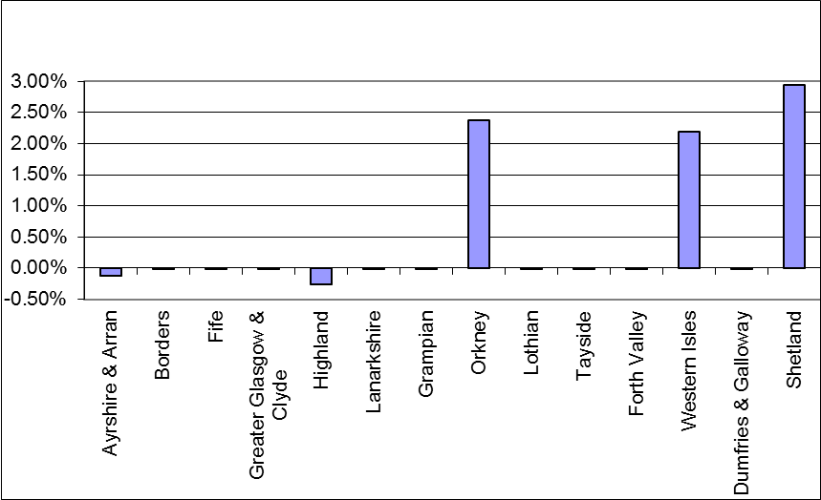

  - Out of Hours (OOHs) only

The OOH adjustment incorporates an element of the Scottish Allocation Formula (SAF) into the NRAC formula. The SAF is used to distribute fund to GP practices and, like NRAC, takes account of population and cost characteristics of local areas. The modified version of the SAF being combined with the NRAC formula is referred to as OOHSAF. The OOHSAF element is weighted to reflect the expenditure which boards contribute (in the aggregate) to provide OOH services. The following table sets out the NRAC baseline shares alongside the OOH SAF shares and presents the combined (adjusted NRAC) shares.

It can be seen that there are substantial differences between the NRAC formula shares and the OOHSAF shares; however, the relatively small weight for the OOHSAF ensures that the combined (adjusted) NRAC shares remain quite close to the NRAC shares.

Table 3: Baseline NRAC shares, Out of Hours SAF shares and the Adjusted OOHSAF NRAC shares, 2013/14.
Notes: wt = expenditure weight
Figures are rounded.

Table 4 and Chart 2 present the comparison of the OOHSAF adjusted shares with the baseline NRAC shares.

In percentage point terms the largest increase is for NHS Highland: 0.033 pcp; the largest decrease is for NHS Greater Glasgow & Clyde: 0.038 pcp.

Proportionately, the largest increase is for NHS Western Isles: 0.82%; other boards which see an increase include NHS Shetland (0.74%), NHS Orkney (0.57%) and NHS Highland (0.52%); whilst the largest decrease is for NHS Greater Glasgow & Clyde: 0.16%; followed by NHS Lothian (0.13%) and NHS Lanarkshire (0.12%).

Table 4: Comparison between baseline NRAC 2013/14 target shares and OOHs adjusted NRAC 2013/14 target shares
Notes: Figures are rounded.
Impact arrow is based on the proportionate change to a health board’s share.

Chart 2: Proportionate change to board shares between 2013/14 baseline NRAC model and the revised model incorporating OOHs adjustment
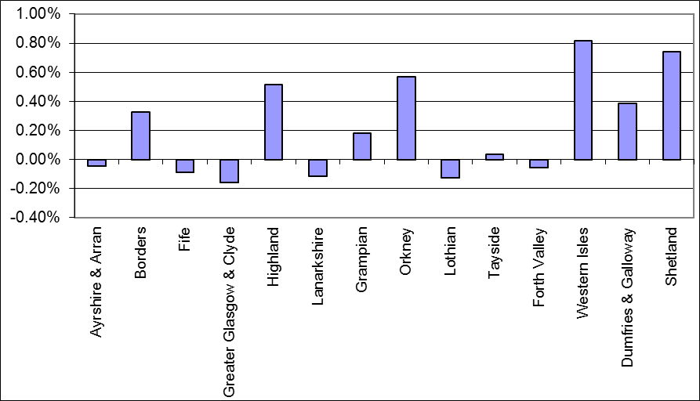

  - Combined SDIA and OOHs adjustment

Table 5 and Chart 3 display the impact for the combined SDIA and OOH adjusted NRAC shares.

In terms of percentage point changes to the target shares the largest increases are for NHS Western Isles, NHS Shetland, NHS Grampian and NHS Highland (ranging from 0.016 pcp to 0.019 pcp). The largest percentage point reductions are for NHS Greater Glasgow & Clyde, NHS Lothian, NHS Lanarkshire and NHS Ayrshire & Arran where the declines are in the range of 0.042 pcp to 0.012 pcp.

In terms of the proportionate change (relative difference) to a board’s own share the largest increases are NHS Shetland, NHS Western Isles and NHS Orkney, with increases in the range 2.92% to 3.67%. The proportionate reductions are largest for NHS Greater Glasgow & Clyde, NHS Ayrshire & Arran and NHS Lothian, with declines in the range 0.18% to 0.14%.

In general the proportionate increases are substantially larger than the proportionate decreases as the boards which are seeing an increase in their share are those with relatively small baseline shares.

Table 5: Comparison between baseline NRAC 2013/14 target shares and SDIA & OOHs adjusted NRAC 2013/14 target shares
Notes: Figures are rounded.
Impact arrow is based on the proportionate change to a health board’s share.

Chart 3: Proportionate change to board shares: 2013/14 baseline NRAC model and the revised model incorporating SDIA and OoHs

- Conclusion

The analysis has demonstrated that the inclusion of the SDIA and OOHs adjustment to the NRAC formula has greatest impact on NHS Shetland, NHS Western Isles and NHS Orkney, all of which see an increase in their target share when compared to the current NRAC model. The remaining health boards are affected to a much lesser extent, although it should be noted that there are small reductions in target shares for six NHS Boards.

The impact analysis does not indicate any anomalies with the proposed recommendations (face validity check) and therefore TAGRA are invited to:

- Discuss the findings with reference to TAGRA’s core criteria (see Annex D)
- Confirm the following recommendations in future NRAC formula updates from 2013.

Recommendation 1: There should be an adjustment, based on the Scottish Allocation Formula, which explicitly recognises Out of Hours Services.

Recommendation 2: With regards to SDIA costs:
- There should be an adjustment to the urban rural categories used within the Unavoidable Excess Cost Adjustment element of the NRAC formula.
- There should be NHS Board – specific adjustments included to take into account the different rates of SDIA in place in the different boards.
- SDIA costs should be compensated through the NRAC formula.

NRAC Formula Analytical Support Team
Scottish Government & Information Services Division (ISD) Scotland
March 2013

Annex A 2013/14 NRAC Target Shares and Indices (Baseline model)

Table A1: 2013/14 NRAC Target Shares

Table A2: 2013/14 NRAC Indices

Annex B – Comparison of baseline NRAC 2013/14 excess costs indices and SDIA adjusted excess cost indices

Charts B1-B6, provided over the following pages, demonstrate the impact of incorporating the SDIA recommendation into the NRAC formula on each excess costs index. A value of 1 for the excess costs indices corresponds to the Scottish average, so an increase or decrease in a Board’s index should be interpreted as an increase or decrease relative to the Scottish average.

Chart B1 displays a comparison between the NRAC 2013/14 acute excess costs index to the SDIA adjusted acute excess costs index. It can be seen that by incorporating an adjustment for SDIA, NHS Orkney, NHS Western Isles and NHS Shetland all increase their acute index value. There is little or no change for the remaining health boards.

Chart B1: Comparison of baseline NRAC 2013/14 acute excess costs index and SDIA adjusted 2013/14 acute excess costs index
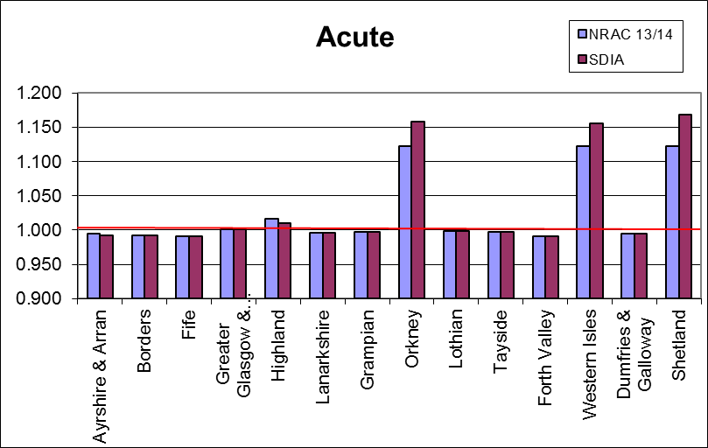

When the NRAC 2013/14 Mental Health & Learning Disabilities excess costs index is compared to the SDIA adjusted Mental Health & Learning Disabilities excess costs index (Chart B2), it can be seen that NHS Orkney, NHS Western Isles and NHS Shetland all increase their index value. There is a small decline for NHS Highland’s excess costs index. There is little or no change for the remaining health boards.

Chart B2: Comparison of baseline NRAC 2013/14 Mental Health & Learning Disabilities excess costs index and SDIA adjusted 2013/14 Mental Health & Learning Disabilities excess costs index
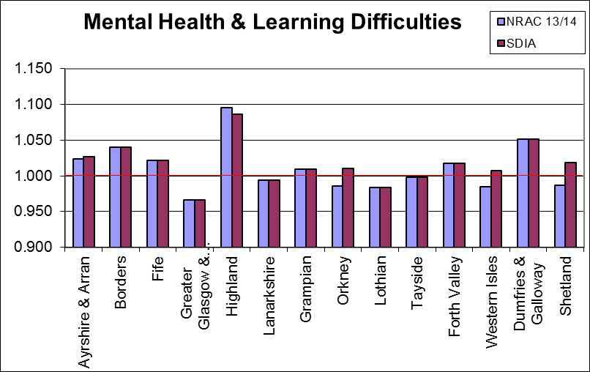

When the NRAC 2013/14 Care of the Elderly excess costs index is compared to the SDIA adjusted Care of the Elderly excess costs index (Chart B3), it can be seen that NHS Orkney, NHS Western Isles, NHS Shetland and (to a small extent) NHS Highland all increase their index value. There is little or no change for the remaining health boards.

Chart B3: Comparison of baseline NRAC 2013/14 Care of the Elderly excess costs index and SDIA adjusted 2013/14 Care of the Elderly excess costs index
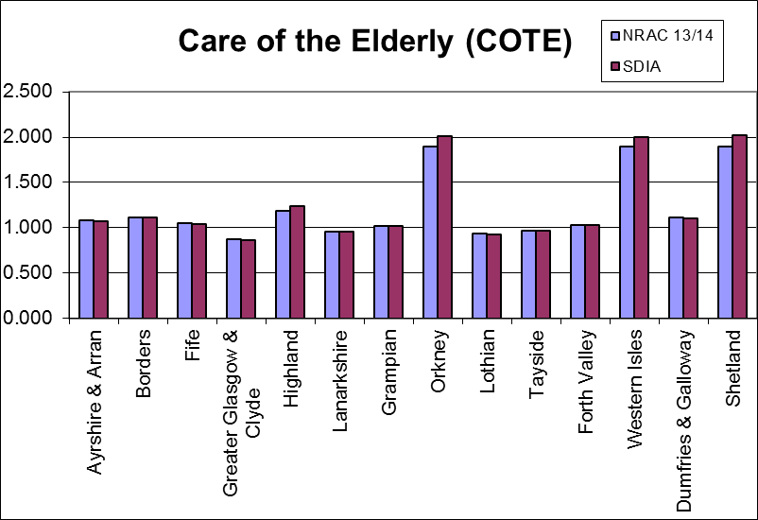

Chart B4 displays a comparison between the NRAC 2013/14 Maternity excess costs index to the SDIA adjusted Maternity excess costs index. It can be seen that by incorporating an adjustment for SDIA, NHS Orkney, NHS Western Isles and NHS Shetland all increase their Maternity index value. There is little or no change for the remaining health boards.

Chart B4: Comparison of baseline NRAC 2013/14 Maternity excess costs index and SDIA adjusted 2013/14 Maternity excess costs index
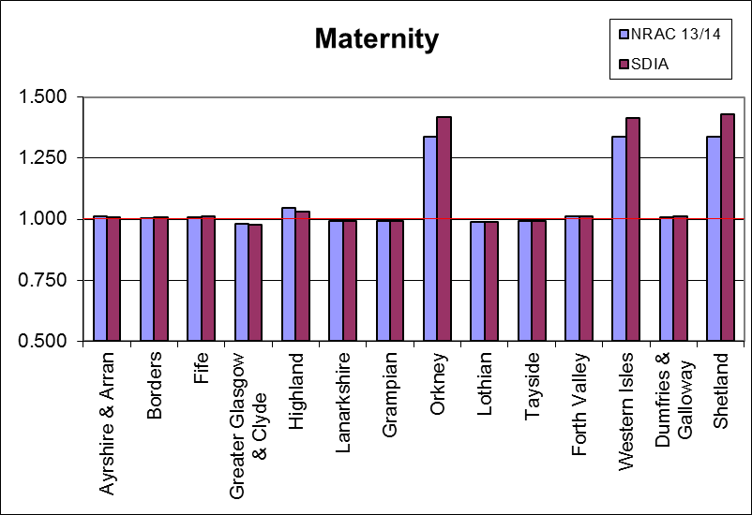

When the NRAC 2013/14 overall excess costs index is compared to the SDIA adjusted overall excess costs index (Chart B5), it can be seen that NHS Orkney, NHS Western Isles, NHS Shetland all increase their index value. There is little or no change for the remaining health boards.

Chart B5: Comparison of baseline NRAC 2013/14 overall hospital excess costs index and SDIA adjusted 2013/14 overall hospital excess costs index
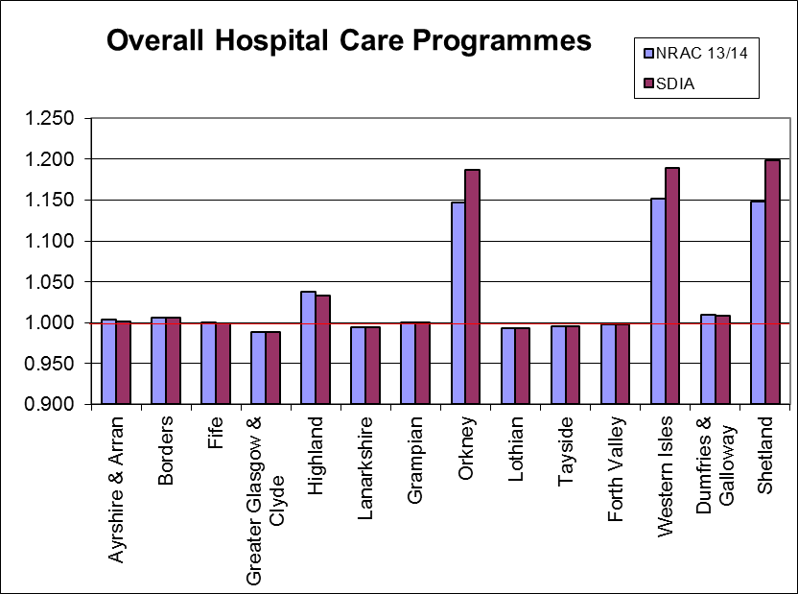

Annex C – Individual Board Shares

Charts A1 to A14 show the target shares of each NHS Board when the SDIA and OoHrs adjustment is incorporated separately and then the impact on the target share when they are both included. The key on the x-axis is as follows:

NRAC 13/14 SDIA: Impact on the 2013/14 NRAC target share as a result of including the Scottish Distant Islands Allowance adjustment.

NRAC 13/14 OOHSAF: Impact on the 2013/14 NRAC target share as a result of including the Out of Hours adjustment.

NRAC 13/14 SDIA & OOHSAF combined: Impact on the 2013/14 NRAC target share as a result of including the Scottish Distant Islands Allowance adjustment and the Out of Hours adjustment.
The y-axis is the NRAC target share.

Note that the 2013/14 target share (baseline) is included as a reference (pink) line on each of the charts.

Chart C1: Impact on (NHS Ayrshire & Arran) 2013/14 NRAC target share by adjustment
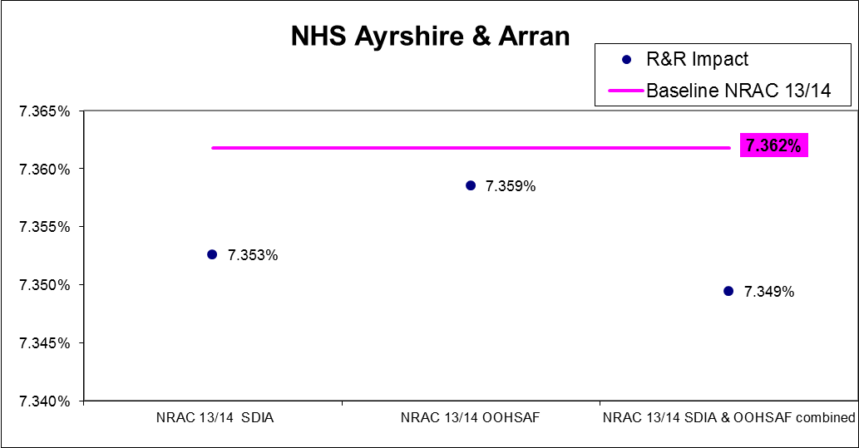
Note: Y axis (Target share) does not start at zero.

Chart C2: Impact on (NHS Borders) 2013/14 NRAC target share by adjustment
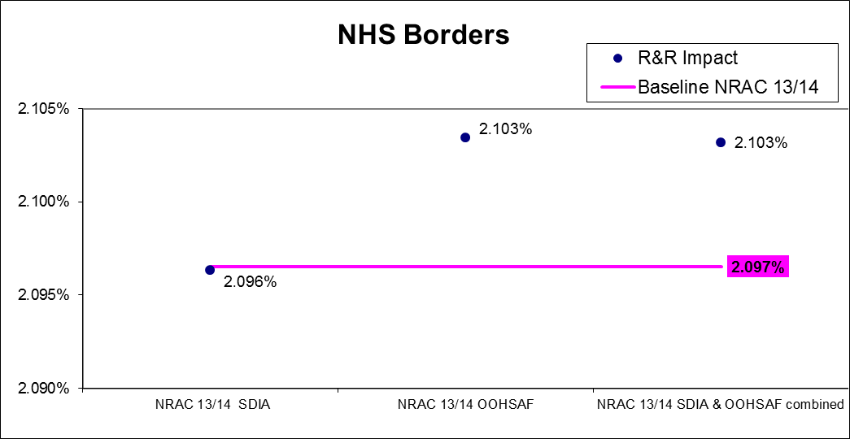
Note: Y axis (Target share) does not start at zero.

Chart C3: Impact on (NHS Dumfries & Galloway) 2013/14 NRAC target share by adjustment
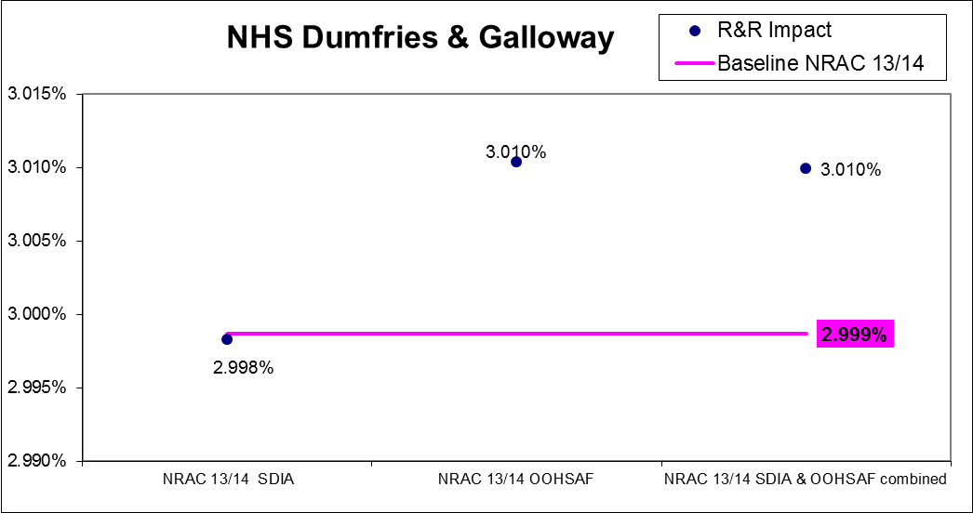
Note: Y axis (Target share) does not start at zero.

Chart C4: Impact on (NHS Fife) 2013/14 NRAC target share by adjustment
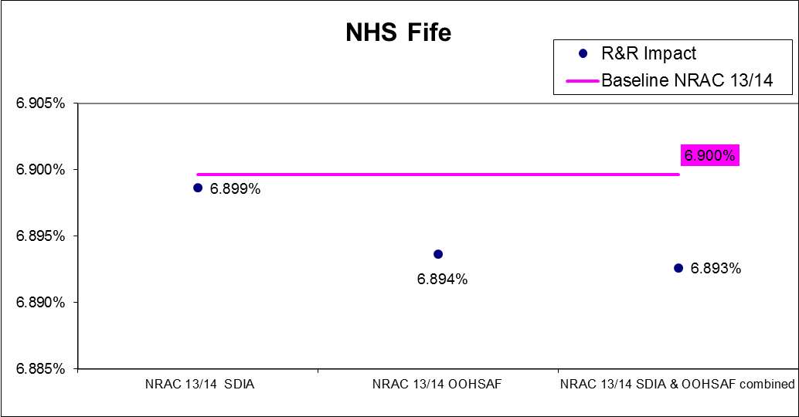
Note: Y axis (Target share) does not start at zero.

Chart C5: Impact on (NHS Forth Valley) 2013/14 NRAC target share by adjustment
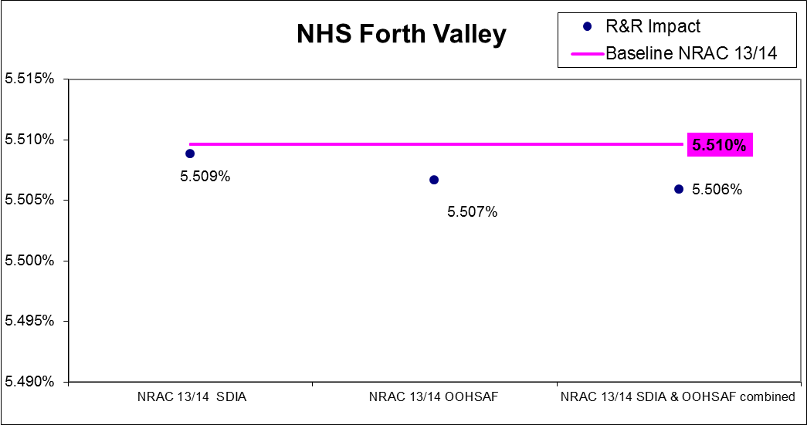
Note: Y axis (Target share) does not start at zero.

Chart C6: Impact on (NHS Greater Glasgow & Clyde) 2013/14 NRAC target share by adjustment
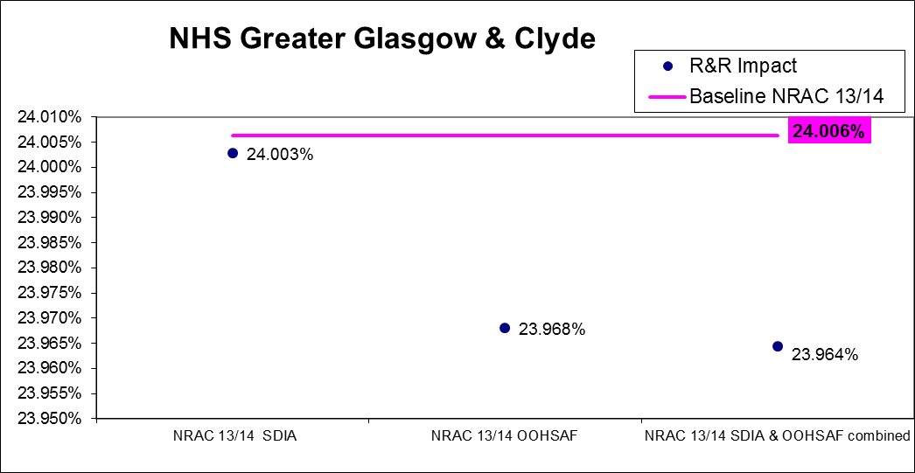
Note: Y axis (Target share) does not start at zero.

Chart C7: Impact on (NHS Grampian) 2013/14 NRAC target share by adjustment
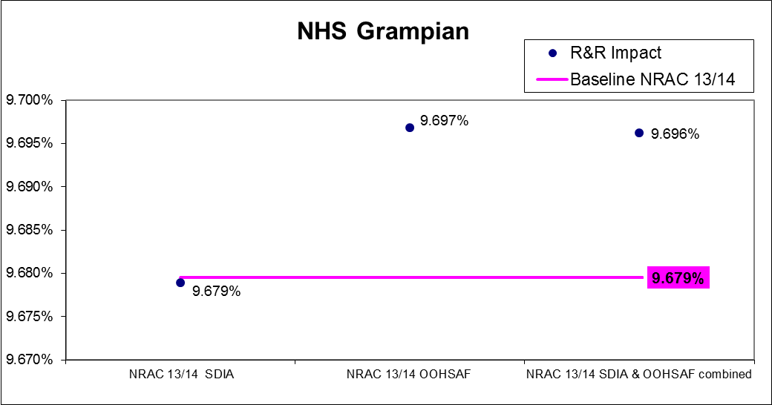
Note: Y axis (Target share) does not start at zero.

Chart C8: Impact on (NHS Highland) 2013/14 NRAC target share by adjustment
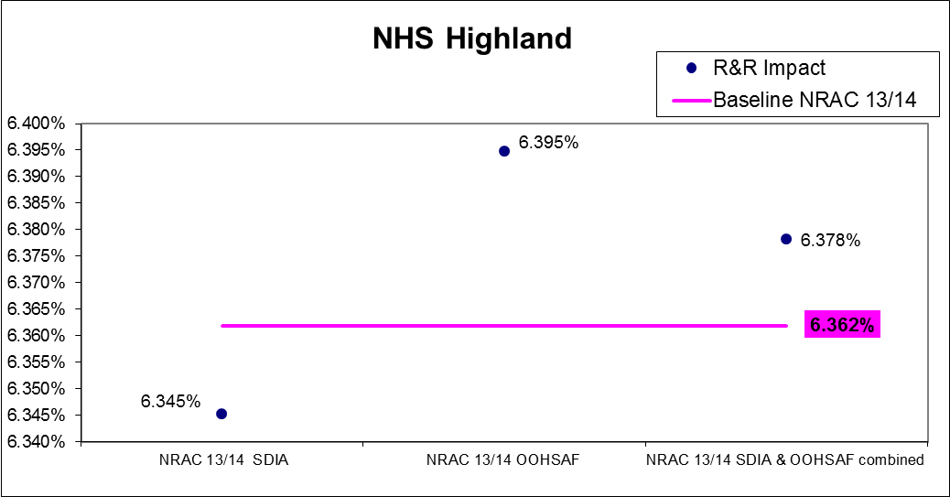
Note: Y axis (Target share) does not start at zero.

Chart C9: Impact on (NHS Lanarkshire) 2013/14 NRAC target share by adjustment
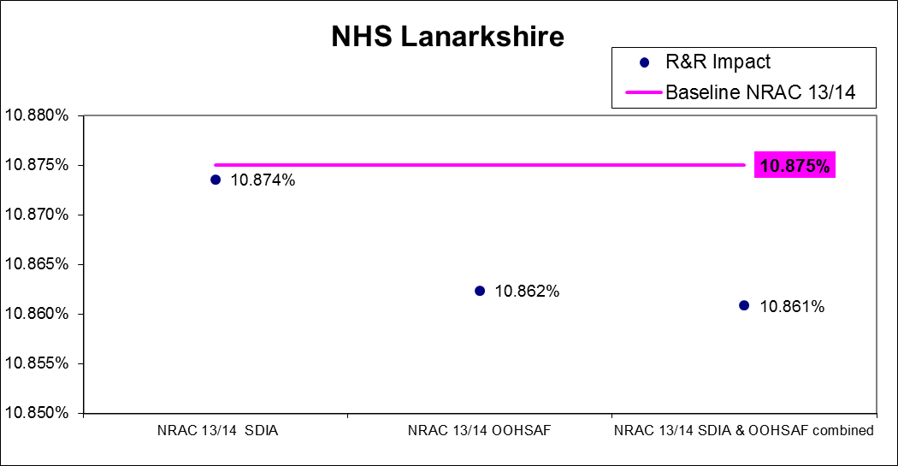
Note: Y axis (Target share) does not start at zero.

Chart C10: Impact on (NHS Lothian) 2013/14 NRAC target share by adjustment
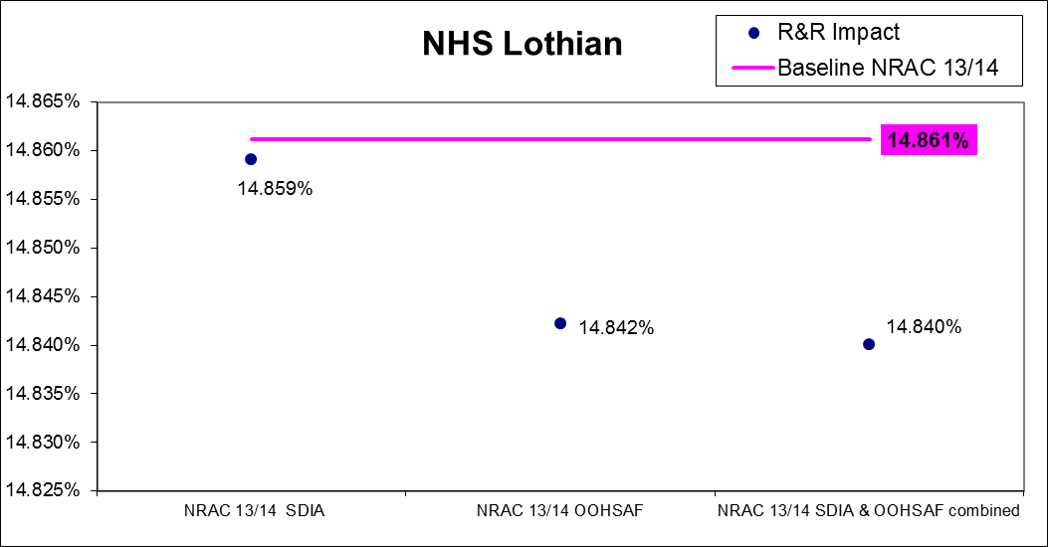
Note: Y axis (Target share) does not start at zero.

Chart C11: Impact on (NHS Orkney) 2013/14 NRAC target share by adjustment
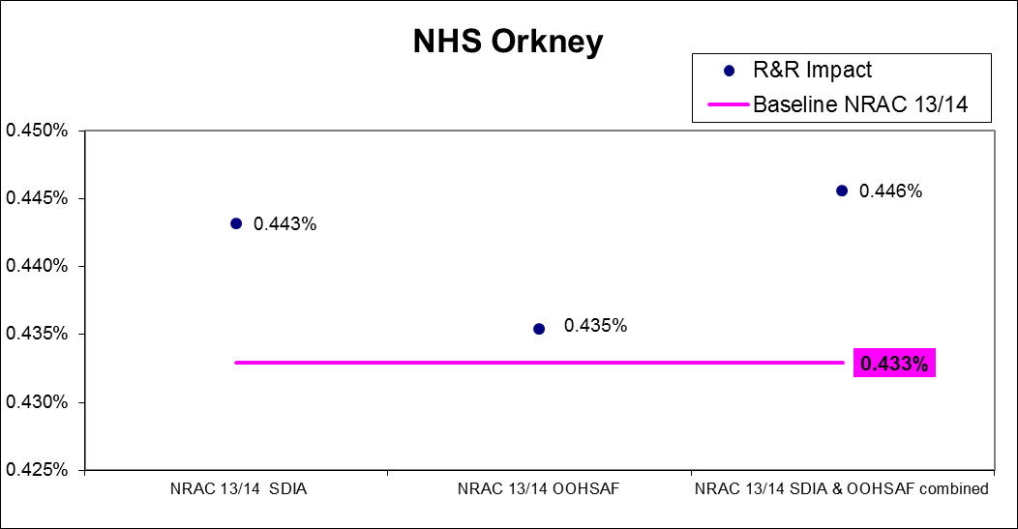
Note: Y axis (Target share) does not start at zero.

Chart C12: Impact on (NHS Shetland) 2013/14 NRAC target share by adjustment
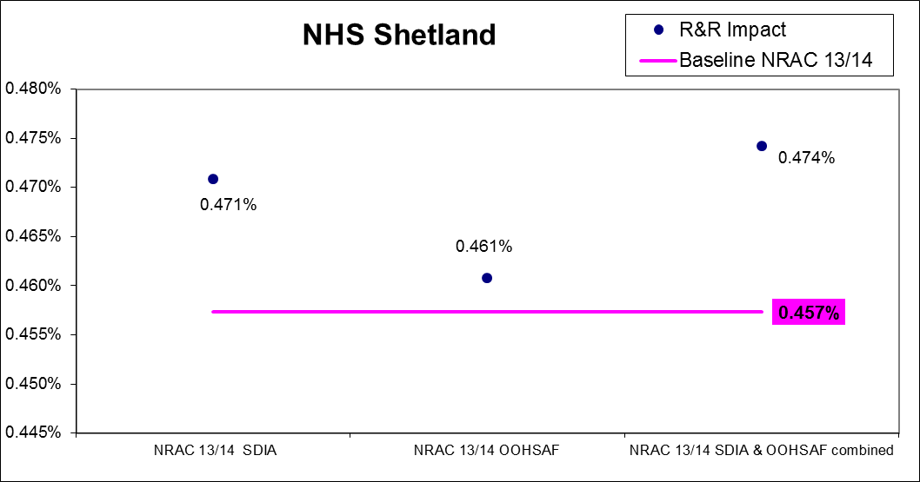
Note: Y axis (Target share) does not start at zero.

Chart C13: Impact on (NHS Tayside) 2013/14 NRAC target share by adjustment
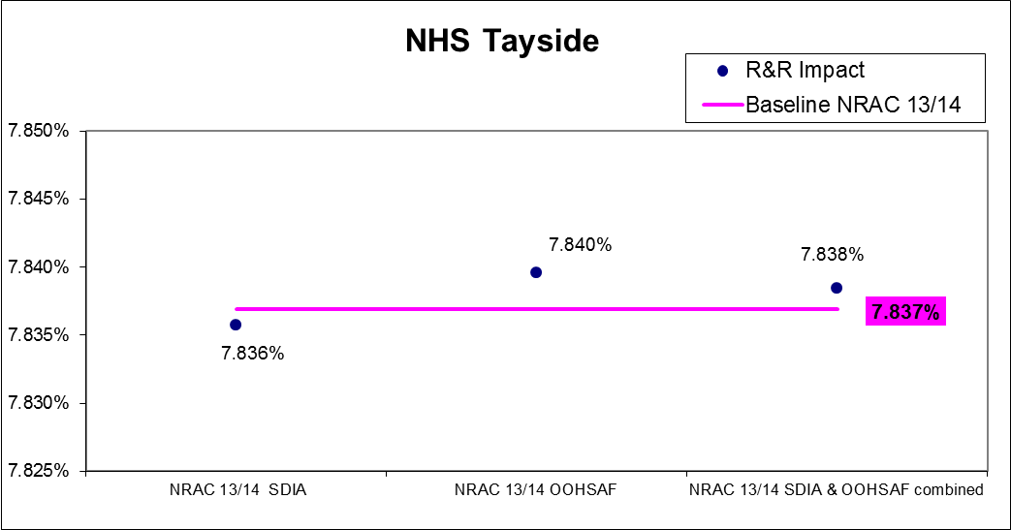
Note: Y axis (Target share) does not start at zero.

Chart C14: Impact on (NHS Western Isles) 2013/14 NRAC target share by adjustment
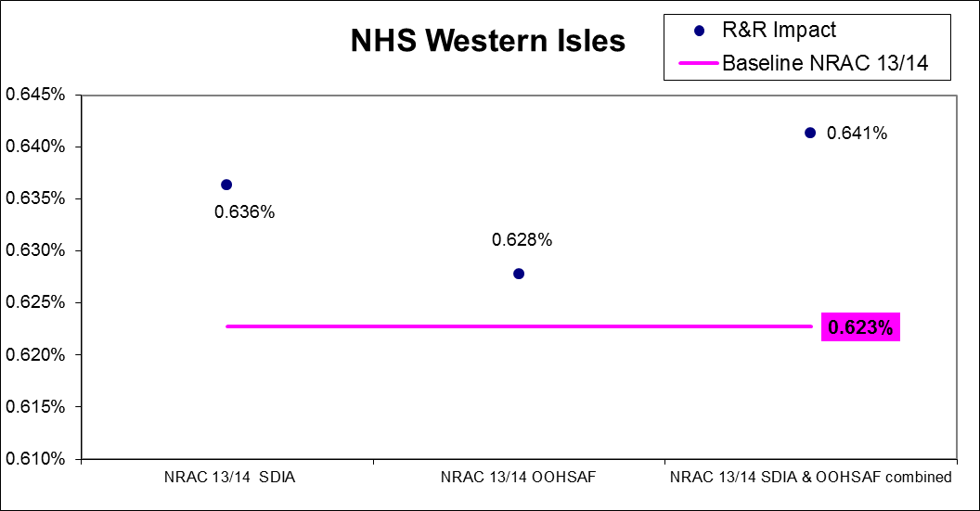
Note: Y axis (Target share) does not start at zero.

Annex D – TAGRA Core Criteria

Equity | The primary consideration should be to achieve the greatest possible accuracy in capturing the cost implications of variations in need across the country, in order to develop a formula that delivers the greatest possible equity of access to health services.
Practicality | Use should be made of good-quality, routinely-collected data, in order to produce an administratively feasible formula that can be readily updated.
Transparency | The rationale informing the formula’s methodology should be explicable and any judgements should be made explicit, although this should not lead to over-simplification of details which might add precision to the methods.
Objectivity | The formula should as far as possible be evidence-based, using as necessary the full range of available robust data.
Avoiding perverse incentives | The formula should guard against perverse incentives and any negative consequences which might threaten the integrity of the data.
Relevance | There is a need to avoid the dangers of extrapolation and to make explicit where hard information is being used about one aspect of a service to make some assumption about an area where information is less good or absent.
Stability | There should be a reasonable degree of year-to-year stability in the data sources feeding in to the formula.
Responsiveness | The formula should result in shifts in the allocation of resources in response to changes in the need for healthcare services.
Face validity | The outcome of any changes to the formula should be subjected to a 'common-sense' check.

http://www.tagra.scot.nhs.uk/research.html

