TAGRA –2013/14 to 2014/15 work plan
TAGRA(2013)14

Introduction
- This paper updates TAGRA’s high level work plan between 2013/14 and 2014/15. TAGRA have previously confirmed that they would like the developmental projects outlined below, to be undertaken between 2013/14-2014/15. This is in addition to the full NRAC formula run in 2013/14 which will need to be run three times in order to meet Health Finance requirements and incorporate the latest population data (see Annex B for further details). There will be a population only formula update in 2014/15. The main change from the previous version of this work plan, is the addition of a 4th fomula run in order to provide a response on the proposed datazone boundary changes (http://www.scotland.gov.uk/Publications/2013/10/2961).
WORK PLAN
- The following TAGRA work plan has been proposed for 2013/14-2014/15:
  - Review of acute costs
  - Review of MLC (acute care programme) (see also Annex A)
  - Review of population estimates
  - Transfer of Prisoner healthcare
  - Highlands & Islands Travel Scheme
  - Annual NRAC formula runs
  - SAF formula review
  - Impact assessment and consultation response for the proposed new datazones

The following tables outline the resource estimates required to undertake the programme of work, timescales and project leads. Note, the work plan excludes resourcing required for routine NRAC work, for example, answering Parliamentary Questions, briefing, ad hoc queries which occur throughout the year.

Project | Estimate of Analytical Support Team resource required | Estimate of wider resources required | Project  timescales | Project lead | TAGRA representative | Progress –  Green /  Amber / Red | AST Risks
Population estimates (Phase 1) | 6 days | National Records of Scotland, NHS GG&C, City of Glasgow Council, NHS CR, ISD Scotland data linkage team | 2012/13-2013/14 | Kirsty MacLachlan | Paul James / Linda De Caestecker | GREEN
Acute costs review | 60 days | Currently the subgroup is working on number of options, this will help to explore the different methodologies and to provide some initial findings – the work will feed into the acute MLC work in November | April - April 2014 | Roger Black | Roger Black | GREEN | Subgroup members availability
NRAC 2014/15 formula run | 65 days | NRS population figures, health board boundary changes, SAF(OoH) and SDIA uplift factor | May - December 2013 | Roger Black | Roger Black | GREEN | Publication of population estimates delay
Highlands & Islands Travel Scheme | 10 days |  | October 2013 | Angela Campbell | Angela Campbell | GREEN
Transfer of Prisoner healthcare | 30 days |  | November 2013 | Roger Black | Roger Black | GREEN
Morbidity & Life Circumstances (Acute) | 16 months |  | February 2014 –2015 | Karen Facey | Karen Facey | GREEN | AST Staff resources  Assumes the analysis does not throw up unexpected findings which merit further investigation.
NRAC 2015/16 formula run | 15 days |  | May-August 2014 | Roger Black | Roger Black | GREEN
SAF Formula Review | Still to be scoped | The analytical work will be undertaken by the same members of the ISD NRAC team, and some of the ASD team. A further 1 or 2 people from ASD are likely to be involved in the work. Also input from PSD will be required. | Approx 2 years from August 2013 | Angela Campbell/  Lynda Nicholson | Angela Campbell/  Lynda Nicolson | GREEN | This project is yet to be scoped – must keep this manageable and focus on the key requirements of a revised SAF formula.
Datazone review |  |  | January 2014 | Roger Black | Roger Black
Code to Risk:
Red – Significant risk to being delivered on time
Amber – Risk to elements of project not being delivered on time, or a small risk to the delivery of the project being late
Green – Project progressing to schedule
Scheduling of projects

RISKS TO DELIVERY
- These projects represent TAGRA Analytical Support Team’s ambitions for the coming two years in addition to the annual formula update. There is a risk that they cannot be delivered due to resource constraints but by building the work plan over two years this means there is greater flexibility around when different work programmes can be taken forward. For example, the ISD team is now running 4 separate formula runs during 2013/14, due to:
  - unforeseen circumstances of the NHS boundary changes,
  - the delay with the Census datazone population figures, and
  - to be able to respond to the consultation on the proposed new datazone boundaries.
This has been able to be accommodated by shifting some other pieces of work.
Required resources
- Some of these projects, by their nature, are potentially open ended. They can also be dependent on other pieces of work that are out with the control of the TAGRA team. For example, whilst the review of the acute costs is relatively well defined and a self-contained pieces of work, it is dependent on the IRF costing work becoming available for use in the formula and other applications. Projects such as the review of the MLC acute adjustment and the population estimates project are potentially extremely lengthy pieces of work. It is difficult to specify the timescales and resources required to undertake this work thoroughly, as there is a risk that any initial review of the area identifies issues which are currently unknown, either requiring further detailed analysis or opening entirely new avenues of investigation.
- This work plan contains an additional significant project, the SAF Formula review. The resources required to carry out this work are being found from within Health ASD and ISD teams, and some of this is additional to the current TAGRA support team, but most of the staff involved are the same people – this was one of the key reasons for bringing this work under the TAGRA oversight. It will continue to be a challenge to meet all the requirements of the projects set out in this work plan and will be the focus of continuous oversight by ISD and ASD senior management.
Other risks
- The population estimates project in addition will involve data sharing and therefore several data controller approval stages. It is difficult to estimate accurately the time it will take to put all the permissions in place.
CONCLUSION
- TAGRA members are invited to note the updated high level work plan. A further update will be available for April’s TAGRA meeting.
TAGRA Analytical Support Team (Health ASD & ISD)
December 2013
ANNEX A – High level outline of MLC Acute Care Programme Review
- Preparation of activity and cost data for the seven diagnostic groups
- Read Robertson Centre for Biostatistics report and other relevant materials
- Identification of potential indicators
- Scope stability of activity and cost data and preferred size of analysis
- Initial test of data stability, agreed potential functional forms, age splits, 'medium' list of indicators, and preferred geographies
- Initial statistical results
- Agree short list of indicators, final functional form, age split and geography - initial assessment against core criteria
- Statistical results
- Assessment against TAGRA core criteria
- Analysis of final preferred set of options
- Assessment against TAGRA core criteria
- Draft Final Report
- Present recommendations to TAGRA

ANNEX B1 - VARIOUS FORMULA RUNS TO INCORPORATE DIFFERENT POPULATION METHODOLOGIES
introduction

- This paper provides information about the proposed population methodologies that will be used to run the 2014/15 NRAC formula, and highlights the necessity to run the formula three times.

BACKGROUND: The use of population data in the NRAC formula

- The size of the population in each Health Board is the basis for a weighted capitation resource allocation formula i.e. the NRAC formula. The formula starts with each Health Board’s share of the Scottish population and then applies adjustments for relative need for healthcare and excess costs of supply. Therefore it is important that the population data used in the formula are as accurate and up to date as possible.
- The NRAC formula is used in the allocation of around 70% of the total NHS Budget between the 14 territorial NHS Boards in Scotland. This provides funding to NHS Boards for the provision of Hospital & Community Health Services (HCHS) and GP Prescribing. The Formula calculates target shares (percentages) for each NHS Board based on a weighted capitation approach that starts with the number of people resident in each NHS Board area. For HCHS, this is the Health Board’s resident population using the re-based population projections (see ANNEX B2 for an explanation of re-based population projections). For the GP prescribing the CHI population forms the base. As projections are not available for the CHI population the CHI population count is deflated to match the re-based projection used for HCHS (see ANNEX B2).
KEY POINTS
- Due to delays with the release of health board population estimates and small area (datazone) population estimates from 2011 Census, an adjustment to the population methodology is proposed in order to meet Health Finance’s deadline of the end of August 2013.

- It is proposed that the 2010-based projections of 2014 are not used in the 2014/15 NRAC formula run for the target shares. Instead, it is proposed that the 2012 Mid Year Population Estimates (for health board by single year of age and sex) are used, as this is the most up-to-date population data available which incorporates the 2011 Census information.

- The NRAC formula will need to be run three times in order to meet Health Finance’s end of August deadline, and then again to incorporate the most up-to-date (2012) and accurate small area population estimates. It will be run a final time on the new health board boundaries.

- The NRAC target shares produced by the end of August will be provisional, and the target shares (planned to be) produced by December will be final.

POPULATION ESTIMATES AVAILABILITY
- NRAC requires Mid-Year estimates (MYEs) populations (at health board, council area and datazone) plus population projections at health board and council area level in order to run the formula every year. Due to the delays with the release of health board population estimates and small area (datazone) population estimates from 2011 Census, an adjustment to the population methodology is proposed below in order to meet Health Finance’s deadline of the end of August 2013.

- Timings for publication of NRS population data (To note: health boards would not be able to receive population estimates which were used in calculating their NRAC target share until after NRS have published the relevant population estimate)

  - 2011 Census estimates by Health Board (by single year of age and sex) – Already published on 23rd July 2013.
  - 2012 Mid Year Population estimates by Health Board (by single year of age and sex) – Due for publication on 8th August 2013.
  - 2011 Census population estimate by datazone (by single year of age and sex) – Due for publication around late Sept / early Oct 2013.
  - 2012 Small Area Population Estimates (SAPE) (i.e. datazones) (by single year of age and sex) – Due for publication around Nov/Dec 2013.
  - 2012-based population projections (includes estimates for 2012 and 2014) (by single year of age and sex) – Due for publication Spring 2014

PROPOSED FORMULA RUNS
- In order to meet the Health Finance’s deadline of the end of August 2013, it will mean that the NRAC formula will need to be run twice in order to incorporate the most up-to-date and accurate small area population estimates (which will not only impact on the health board NRAC target share, but also sub health board target shares which are used to distribute funding locally).

  - Provisional 2014/15 NRAC formula run

- It is proposed that the 2010-based projections of 2014 are not used in the 2014/15 NRAC formula run for the provisional target shares. Instead, it is proposed that the 2012 Mid Year Population Estimates (for health board by single year of age and sex) are used as this is the most up-to-date population data available which incorporates the 2011 Census information. The 2010-based population projections do not incorporate information from the 2011 Census and as a consequence, there could be wide variation between health boards in the accuracy of the projected population estimate for 2014 (see ANNEX B3 for comparison between 2011 Census estimates and the 2011 Rolled forward estimates). This is important as the formula is more concerned with each health board’s relative share of the population rather than the actual count.
- In addition to using health board population estimates in the NRAC formula, small area (datazone) population estimates are also used but are rescaled to the more up-to-date health board population estimate.
- In a routine formula update, small area population estimates are usually a year behind the mid year (health board) population estimates (small area population projections are not available). However, in order to meet the end of August deadline, 2011 small area population estimates will have to be used and rescaled to the 2012 mid year (health board) population estimates. This is not ideal as the 2011 small area estimates will have been rolled forward from the 2001 Census and as a consequence, the NRAC shares produced by the end of August will be provisional and will need to be revised once more up-to-date small area population estimates are available later this year.

  - Final 2014/15 NRAC formula run

- It is proposed that the final NRAC target shares will include more up-to-date small area population estimates based on information from the 2011 Census. The preferred option is to use the 2012 Small Area Population Estimates (SAPE) which should be available Nov/Dec 2013 as this will align to the 2012 Mid Year Population (Health Board) Estimates which will also be used in the formula. Although the final and provisional target shares may not differ greatly, it is important for those who use the formula to allocate resources at a sub health board geography to have the best available small area population estimates.

  - Final 2014/15 NRAC formula run to incorporate the health board boundary changes

- All calculations are the same as in point 10 above, except that the aggregation is done at the new health board boundaries.
CONCLUSION
- TAGRA members are invited to agree the proposed population methodology for NRAC (provisional and final).
TAGRA Analytical Support Team (Health ASD & ISD)
August 2013
ANNEX B2 – The use of population data in the NRAC formula

Explanation of re-based population projections

For HCHS: Re-based population projections are a simple adjustment made to the NRS population projections, by updating them using the most up-to-date MYEs that have been published since the Health Board level projections were published.

For example, to re-base the 2010-based projection of 2014 using 2012MYE the calculation is:

(2012 MYE) + [ (2010-based projection of 2014) – (2010-based projection of 2012)]

This takes account of the over- or under-estimation of the projection in the year to 2012, and applies this adjustment to the projection between 2012 and 2014.

For GP Prescribing: the population figures used with the GP prescribing part of the formula are based on the Community Health Index (CHI) population. The CHI population is deflated to match the rebased projection; this method is used as projections are not available for CHI populations. Rescaling factors based on council areas’ MYE and population projections are applied to CHI population to match the HCHS rebased projection.

ANNEX B3 - Comparison between 2011 Census estimates and the 2011 Rolled forward estimates

Chart 1 & table 1 below illustrate the potential variation between geographic areas when comparing the 2011 Census estimates with the 2011 roll forward estimates. The ‘2011 roll forward estimates’ are the population estimates which have been rolled forward from the 2001 Census to create the mid-year estimate for 2010. They have then been rolled forward from June 2010 to March 2011 to provide a census day estimate. Note health board level estimates from the Census are not available until August 2013 and therefore the variation is provided by local authorities for illustrative purposes.

Chart 1
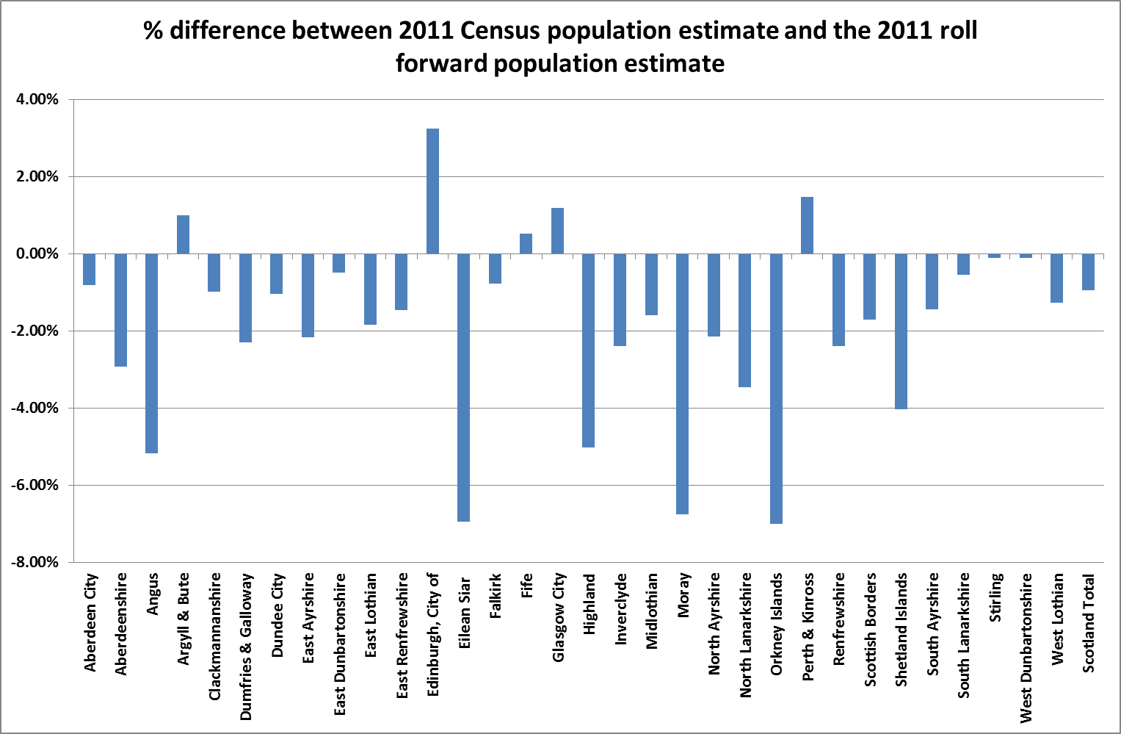

Table 1: Comparison between 2011 Census estimates and the 2011 Rolled forward estimates

