TAGRA(2009)08
TAGRA Paper: use of nrac formula at CHp and GP practice level

Introduction
- The NRAC formula is derived from a rich dataset of need indices built up from small area statistics at a census datazone level. The main purpose of the formula is to calculate NHS Board level resource shares, however, the use of small area statistics provides an opportunity use this dataset for informing discussions about resource needs at a local level and to support this NRAC information has also been made available at a CHP level (www.nrac.scot.nhs.uk).
- The Shifting the Balance of Care delivery group and COSLA are developing an Integrated Resource Framework (IRF) that aims to provide NHS Boards and their Local Authority partners with information on existing resource patterns, cost drivers and local drivers of need. This work has generated a demand for more detailed information at a CHP and sub-CHP level. In particular, information at a locality and GP practice level on current resource patterns and areas of relative under- or over- provision of services relative to need. .
- As part of the IRF programme the Scottish Government is keen to make available NRAC information to CHPs so they can start to match current resource patterns to estimated needs and to investigate material variations between these. However, the Hospital and Community Health Service (HCHS) element of the NRAC formula is built up from census datazone units whilst most service planning is actually done using GP practices as the unit of the analysis. Providing this information at a GP practice level presents a number of methodological and presentational issues due to differences in population data and boundary definitions.

Purpose
- This paper sets out a proposal for providing NRAC information at a sub NHS Board level to support service planning at both a CHP and GP practice level across NHS Scotland. It highlights the technical issues associated with providing these data and seeks approval to issue provisional data to CHPs based on the 2008/09 NRAC dataset.

Calculation of NRAC Shares at a CHP and GP Practice Level
- In order to calculate NRAC shares at a GP practice level an exercise was undertaken in February 2009 to attribute datazone information to GP practices.
- This exercise used data from the 2008/09 ‘provisional’ NRAC run and assigned Age and Sex, Morbidity and Life Circumstances and Excess Cost indices for each HCHS care programme to individual GP practices. This attribution exercise used the same mapping file used to construct the prescribing element of the NRAC formula. The exercise ensured that each GP practice could be assigned an NRAC need index based on the weighted average characteristics of its component datazones. A number of manual adjustments were then required to align the 2008/09 dataset with the latest GP practice list for Scotland due reflect recent practice mergers, openings or closures.
- Resource shares are then calculated by applying these need indices to practice populations which are aggregated into CHPs. However, it is not clear what the most appropriate population measure should be for presenting resource shares at a GP practice and CHP level. There are three alternative methods:
  - List size inflation adjusted GP populations: the theoretically correct way (currently used in the prescribing formula) is to use GP list sizes adjusted for list size inflation. This would constrain practice populations to the total for Scotland. However, individual GPs understand their list size and as such a list size arbitrarily ‘shrinked’ to match the total population of the local council area may lack clinical credibility;
  - Unadjusted list size GP populations: unadjusted list sizes are the most frequently used population units at a sub-Board level. GPs recognise and understand their own list size but total populations are 6-7% higher than expected and this differential impact may alter the resource shares;
  - Census datazone populations: these are the units currently used to calculate CHP shares. However, as noted above, they are not meaningful from a service planning context. CHP census based populations are also slightly different to those based on list sizes because census populations are based on postcode of residence whilst GP lists can contain people who reside in different CHP or Board areas.
- Figure 1 overleaf illustrates that the choice of population unit does influence the overall need characteristics at a CHP level due to the way population data is used to weight together the need indices and also due to slightly different boundary definitions (i.e. cross boundary flow issues). It illustrates CHP relative need indices based on unadjusted list size populations and census populations. In general, the variances are relatively small.

Figure 1. CHP Need Indices as defined by GP Practice List Size and Census Datazone Geography

Presentation of results
- As illustrated above, the method of calculation of CHP weighted populations will slightly influence the resource share results for different organisations. This will lead to one practical problem in that the CHP and Board shares that are calculated by aggregating GP practice populations will be different to those reported by ISD. As noted above, this difference is attributable to the alternative definition of CHP populations, one based on postcode of residence and the other based on CHP practice populations.
- There is a risk that users will be confused by the differences in shares and also that Boards will select the method that produces the Board share that best supports their established arguments for or against NRAC.
- However, in a practical sense it is important to weigh up the relative pros and cons of using theoretically correct data which is of less use for local planning versus using more user friendly data which includes slight variances to the NRAC formula.
- Figures 2 and 3 illustrate how GP practice and CHP resource share data can be presented at an NHS Board level without highlighting these issues by presenting the information relative to the Board average. Figure 2 illustrates relative need indices by GP practice and CHP centred around the Board average. Figure 3 illustrates resource shares. Further analytics and graphical analysis have also been built into the model but are not shown here.

Figure 2. Screen Shot from a Sub Board NRAC Model – Needs Analysis
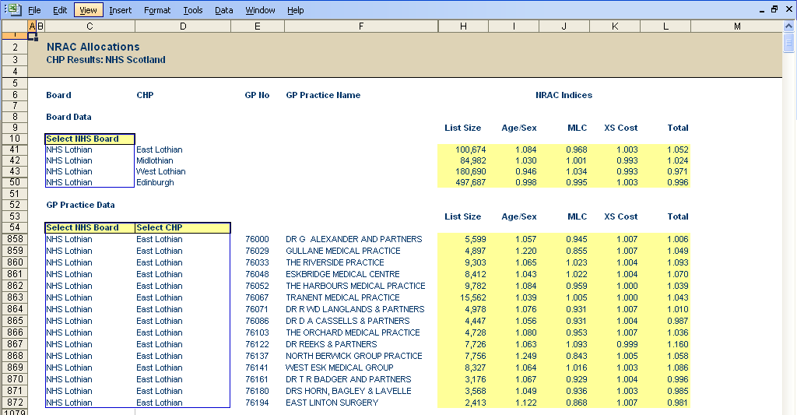
Need indices centred around Board average

Figure 3. Screen Shot from a Sub Board NRAC Model – Share Analysis
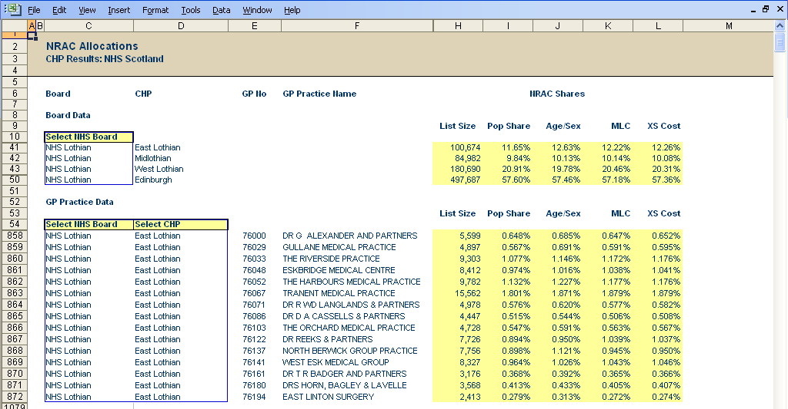
CHP shares sum to 100%

GP practice shares sum to CHP total

- Following discussions with ISD Scotland and the Analytical Services Division it is considered that presenting sub-Board need indices and allocations in this way will maintain the integrity of the existing NRAC formula whilst providing useful information for planning at a GP practice and sub-Board level.

Conclusion
- Given the richness of data used to calculate the NRAC formula its use for local planning purposes at a sub-Board level should be encouraged. However, to ensure that information is relevant and useful for service planners it is important that these data are presented in a user friendly format and using where possible use GP practices as the main unit of analysis. It is understood that NHS England are considering moving the primary unit of analysis in their weighted capitation formula to a GP practice level.
- Whilst there are a number of minor methodological inaccuracies from presenting data in this way we consider that it is more than compensated for by ease of use. In addition, it is considered unlikely that this will undermine the validity of the existing NRAC approach applied at an NHS Board level.

Next steps
- Sub-Board level GP and CHP shares will be made available to NHS Boards on request including those Boards taking part in the IRF pilots. This information will be based on the provisional data used for the 2008/09 NRAC formula.
- It is proposed that ISD Scotland makes available GP practice level and CHP level NRAC data using information from the latest formula. This analysis and model will need to be maintained annually taking into account GP practice movements. Resource support for this process is already being provided by the Joint Improvement Team as part of its work on the IRF.

Joint Improvement Team
Health Directorates
June 2009June 2009

most CHP service plans examine referral and prescribing patterns at a GP practice level. Datazones are less ‘meaningful’ units of analysis especially if looking to influence and engage local clinicians.
Sources: GP list size populations & practice details (ISD Scotland: October 2008). Census populations & needs indices per NRAC 2008/09 Provisional Run (ISD Scotland)

