TAGRA(2009)10
Remote and Rural analysis - Care Programme Expenditure

Introduction
- This paper offers TAGRA further analysis in response to the discussion at the meeting of 26th February 2009 about TAGRA paper (2009)03 “Remote and Rural Analysis”.
- Because of its importance in the formula, care programme expenditure was examined in more detail e.g. comparing individual Boards to the national averages to identify any outliers.

Purpose
- This paper contains analysis on care programme expenditure over time; both nationally and at Health Board level.
- The main focus is on the national care programme expenditure shares as these are used to produce the overall formula component adjustments and hence target shares.
- Expenditure is also shown by hospital and community care programme: acute, care of the elderly, mental health and learning difficulties, maternity and community for the 14 territorial Health Boards.
- The paper describes and compares three years of Health Boards’ care programme expenditure. Scottish Health Services Costs (Costs Book) data for year ending 31st March 2005, 2006 and 2007 are analysed.
- All analysis shown in this paper refers to the hospital and community health services (HCHS) part of the formula i.e. care programme expenditure weights are shown as shares of total HCHS expenditure.

Background
- The NRAC recommendations led to a fall in adjusted target shares for many of the more rural Health Boards, in comparison to Arbuthnott. As a result of a parliamentary debate on remote and rural healthcare, assessing the impact of the formula on remote and rural areas was identified as a key issue for TAGRA.
- A main cause of the fall in target shares was the excess costs adjustment: Borders, Highland, Dumfries & Galloway and the three wholly island boards had a lower overall adjustment for excess costs under the NRAC formula than under the Arbuthnott formula.
- Further analysis was proposed on TAGRA paper (2009)03 “Remote and Rural Analysis”, to examine expenditure by care programme by Board to compare each Board’s expenditure with other Boards and the national average, to identify any outliers.
- The method of using national care programme expenditure weights to produce each component is inherited from the Arbuthnott formula. This is a standard approach in weighted capitation formulae. The use of such national average percentages, however, does not imply that the split between expenditure on care programmes should be identical across Boards.

discussion
- Scotland-level care programme expenditure weights are important in the NRAC formula calculation. Throughout the formula, the final adjustments for age/sex, additional needs and unavoidable excess cost at datazone level are produced by using national care programme expenditure weights from the Scottish Costs Book to combine all the different care programme indices.
- To illustrate the calculation process three datazones were chosen as examples in Flowcharts 1 and 2 below.
- Flowchart 1 demonstrates how each component of the formula are combined using the care programme expenditure weights. The calculation in the flowchart below is repeated for age/sex, additional needs and unavoidable excess cost to calculate final index for each component of the formula.
Flowchart 1: showing that for each formula component the final index is calculated using the individual care programme indices and weights.
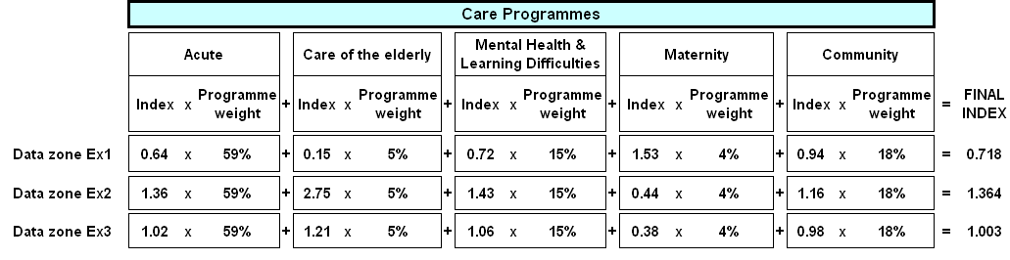

- Flowchart 2 shows that the overall index is calculated by multiplying the final indices for three formula’s components. The formula adjusted population is calculated by multiplying the datazone’s crude population by the overall index. These datazone adjusted populations are then aggregated to Health Board (and Scotland) level to obtain the target share for each Health Board.

Flowchart 2: showing that adjusted population is calculated by multiplying the final indices for three formula’s components by crude population.
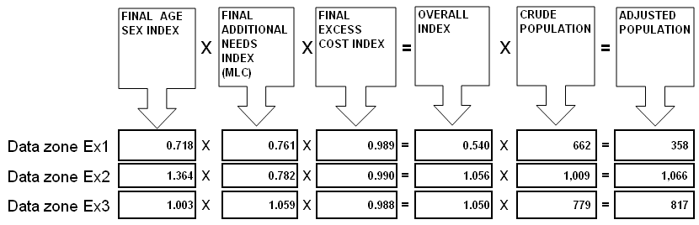

- The national care programme expenditure weights are calculated each year by Scottish Government Finance based on Scottish Health Services Costs (Costs Book) i.e. they are based on historical data.. Chart 1 below shows acute, care of the elderly, mental health and learning difficulties, maternity and community expenditure weights for years ended 31st March 2005, 2006 and 2007.
Chart 1: Scotland, Care programme expenditure weights for year ended 31st March 2005, 2006 and 2007
- Nationally while there was a slight increase in expenditure on the acute and community care programmes, expenditure on care of the elderly, mental health and learning difficulties, and maternity has decreased. Chart 2 below shows care programme expenditure weights in 2006 and 2007 relative to year 2005.
Chart 2: Scotland, Care programme expenditure weights (relative to year 2005 = 0)
- Care programme expenditure weights for NHS Highland and NHS Greater Glasgow & Clyde in years 2005 and 2006 are not comparable to 2007 figures because of the dissolution of the NHS Argyll & Clyde board 31st March 2006.
- Chart 3 shows a comparison of acute expenditure weights between 2005, 2006 and 2007 by Health Board and Scotland. NHS Western Isles acute expenditure in 2005 differs significantly from peer Boards and the national weights.
- Acute programme expenditure weights for Scotland and all NHS Health Boards (except Western Isles) are comparable and stable over the three year period.

Chart 3: Acute expenditure weights by Health Board³ and Scotland – comparison between 2005, 2006 and 2007 figures
- Chart 4 below shows a comparison of care of the elderly expenditure weights between 2005, 2006 and 2007 by Health Board and Scotland. NHS Western Isles and Highland expenditure across the three years were significantly low compared to other Boards and Scotland; NHS Shetland, Dumfries & Galloway and Orkney expenditure across the three years were high compared to other Boards and Scotland.
Chart 4: Care of the elderly expenditure weights by Health Board³ and Scotland – comparison between 2005, 2006 and 2007 figures
Chart 5: Mental health and Learning difficulties expenditure weights by Health Board³ and Scotland – comparison between 2005, 2006 and 2007 figures
- Chart 5 shows a comparison of Mental Health and Learning Difficulties expenditure weights between 2005, 2006 and 2007 by Health Board and Scotland. The three Islands Boards’ expenditure across the three years was very low compared to other Boards and the national weights, while NHS Shetland expenditure represents an extreme outlier.
Chart 6: Maternity expenditure weights by Health Board³ and Scotland – comparison between 2005, 2006 and 2007 figures
- Chart 6 above shows a comparison of Maternity expenditure weights between 2005, 2006 and 2007 by Health Board and Scotland. NHS Shetland maternity expenditure is higher than other Boards and Scotland, especially in 2007.
Chart 7: Community expenditure weights by Health Board³ and Scotland – comparison between 2005, 2006 and 2007 figures
- Chart 7 above shows a comparison of community expenditure weights between 2005, 2006 and 2007 by Health Board and Scotland. NHS Western Isles community expenditure is higher than other Boards and Scotland, especially in 2005. Community programme expenditure weights for Scotland and all NHS Health Boards (except Western Isles and to some extent Borders) are reasonably comparable and stable over the three-year period.
- Results above show that there are differences between Island Boards in general and other Boards and Scotland in relation to expenditure on all care programme expenditure weights (except acute programme).

conclusions
- Scotland-level care programme expenditure weights are used to combine different care programme adjustments/indices across all the formula’s main four components (population, age/sex, additional needs and unavoidable excess cost adjustments). The analyses above show that Scotland-level care programme expenditure weights do not necessarily represent the actual expenditure behaviour of Island Boards.
- TAGRA are invited to discuss the issues raised in this paper and agree how to conclude them:
  - Impact of using national care programme weights in the formula on remote and rural Boards.
  - In Northern Ireland and England national expenditure weightings are used to combine different components of weighted capitation formulas, as we do in Scotland. Although NHS Boards in Scotland have different spending patterns across care programmes, there are methodological reasons behind using national expenditure weightings.

Proposed next steps
- To review and consolidate all analysis undertaken on the Remote and Rural issue, including detailed analysis of hospital unavoidable excess costs by SEURC, care programme expenditure and sensitivity analysis.

Health Finance Information Team
Information Services Division (ISD)
July 2009

Source: Scottish Health Service Costs (Costs Book) data – Scottish Financial Returns (SFR 13.0) which represents board expenditure on board residents
NRAC Final report (page 84).
Fair Shares for All Technical Report (Section 1.6), July 1999, Scottish Executive.
All indices shown within the flowchart are comparable to a Scotland index of 1.00
The Northern Ireland Regional Capitation Formula now uses planned national expenditure weights. See A Summary of the Fifth Report from the Capitation Formula Review Group, May 2008 (paragraph 2.23) at www.dhsspsni.gov.uk for further details.
NHS Argyll & Clyde was dissolved on 31st March 2006. With effect from 1st April 2006, the council area of Argyll & Bute is included in a now enlarged NHS Highland area. Meanwhile, the rest of the former NHS Argyll & Clyde area is now under the responsibility of an enlarged NHS Greater Glasgow (now renamed NHS Greater Glasgow & Clyde). This analysis shows information by the old 15 NHS boards in 2005 & 2006 and by the newly configured NHS boards in 2007.

