TAGRA(2009)15
TAGRA WORK PLAN

Introduction
- ASD and ISD have developed a joint work plan for the year April 2009-March 2010. This details the tasks and associated resources for the analytical work required to maintain and run the formula; and to support its ongoing development through TAGRA.

Purpose
- This paper provides instructions on how to use and interpret the work plan to help with the planning of future work.

work plan
- The work plan is held in an Excel spreadsheet. The main part of the plan is the tasks table which shows for each individual task the estimated resources needed, by week, for the period April 2009 – March 2010.
- The tasks are grouped according to type, described in the table below:
Task Area/Group | Tasks/Work
Formula | All work needed to run and maintain the formula that calculates the Health Board target allocation shares for each financial year. This includes rebasing populations, match costs to activity, dealing with information requests, etc and related output such as the Directors of Finance tables.
Publication | Tasks associated with publishing the annual formula results on the ISD website.
Documentation | Technical documentation describing how to run the statistical programs needed to update the formula and a more general guide to how the formula works.
TAGRA | All work recommended by TAGRA e.g. remote and rural analyses, Health Board workshops, etc as well as attendance and administrative support for the TAGRA meetings.
Other | Other resource allocation tasks e.g. using the formula target shares to inform other funding allocations, parliamentary questions, briefings, integrated resource framework project, etc.
- Various features of the work plan are shown in Exhibit 1 below:

Exhibit 1 - Sample extract from work plan
Tasks table - Time shown here for each task in WTE days.
Click on the + symbol here to see the Formula group of tasks individually

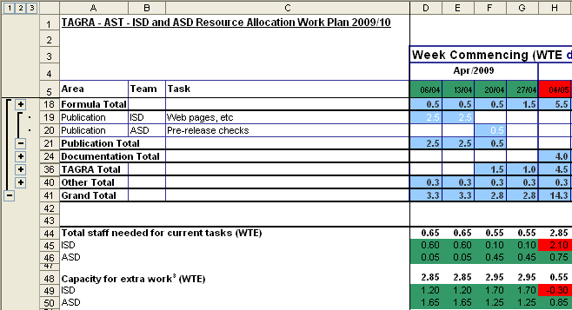
Staff resource needed for all tasks, capacity, staff availability, etc totals found underneath the tasks table (expressed in terms of staff WTE and split by team).
Click on the - symbol to group up individual tasks (Here rows 19 and 20 would be hidden and the user would see only the Publication tasks sub-total)
Conditional formatting is used in the team totals and in the calendar headings. This allows the user to quickly identify weeks where one or both teams are over-resourced/ have spare capacity. The calendar heading is red for w/b 04/05 showing that ISD and/or ASD has a resource issue (here it can be seen from the team totals that it is ISD that is affected).

- The work plan can be summarised at task group level or broken down into individual tasks by using the plus/minus buttons at the left-hand side.
- The tasks are also split by team (i.e. ISD or ASD) and underneath the tasks table various totals are calculated e.g. staff needed, capacity, etc.
- The plan also contains conditional formatting to highlight if resources are scarce in particular weeks and/or months. The logic for the formatting is described underneath the tasks table.

risks
- The work plan also highlights any known risks e.g. staff shortages, other projects, etc that may impact resource allocation work.
- NRAC recommended that at least every three years certain, significant, components of the formula be updated e.g. variables used in the additional needs indices, community travel excess costs model assumptions, etc. If all these changes were carried out in the same year there would be a significant impact on resources; a staggered approach would be more manageable.

Proposed next steps
- TAGRA to use the work plan to help plan future development work and to advise on the timetable for the forthcoming three-year formula updates.

Health Analytical Services Division
Health Directorates
June 2009

