TAGRA(2010)04
NRAC formula workshops – cluster analysis

BackgrounD
- Cluster analysis is an exploratory statistical technique that attempts to identify relatively similar groups in data according to selected characteristics.
- Historically, as part of the original NRAC project, cluster analysis was investigated as a way of simplifying the output of the formula.
- Hospital and Community Health Services (HCHS) formula data was grouped into different clusters according to the care programme age-sex, MLC and Excess costs indices. The resulting clusters were given broad, descriptive names according to the average age-sex and/or deprivation profile of the data zones in each cluster and the predominant geographical type of location.
- As part of this exercise, data zones were also ranked according to their overall HCHS index and grouped into deciles.
- GIS maps, showing the distributions of the clusters and HCHS deciles throughout Scotland, were drafted by ISD to illustrate the results. Pie charts were also produced showing NHS Boards’ population by cluster.

updating the analysis
- The cluster analysis above was repeated using the formula’s HCHS data zone results for 2009/10 (obtained from the ISD website).
- The data zone level formula results and cluster were then used as the source for an Excel pivot table. This was to allow easy manipulation of the data and the calculation of age-sex, MLC, Excess costs and HCHS indices at different levels of aggregation e.g. Board, cluster, etc.
- HCHS deciles (and deciles for the component age-sex; MLC and excess costs indices) were also included in the pivot.
- Other non-formula information was also matched into the data/pivot from the Scottish Neighbourhood Statistics (SNS)/SIMD websites e.g. Intermediate data zone (IDZ) and name (as data zones do not have names); SIMD rank; SEURC, etc.
- This extra information was used to help name the clusters and would also help the Boards to understand their component populations better.
- GIS maps have not yet been re-produced; however, the Board population pie charts have been re-created.
- The cluster average HCHS indices have also been used to estimate each NHS Board’s HCHS target share. An example of this can be found below.

draft results and examples of output

Figure 1 Sample screen shot of draft pivot showing cluster average indices

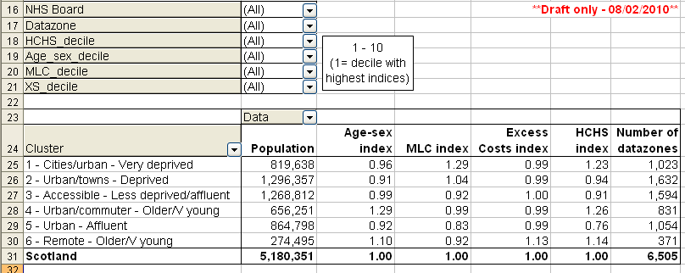

Figure 2 Sample pie chart for NHS Fife
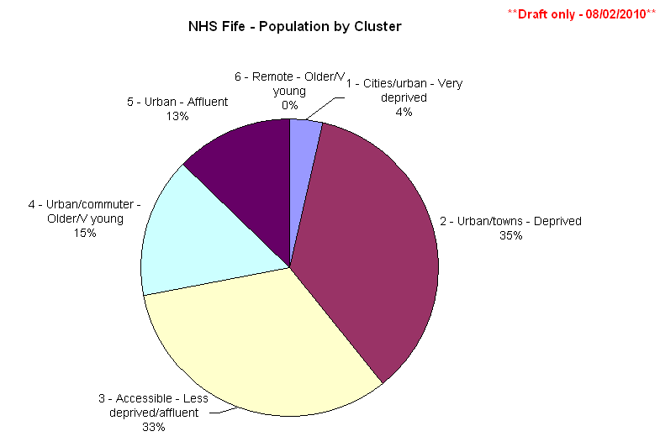

Figure 3 Sample calculation of estimated HCHS target share for NHS Fife

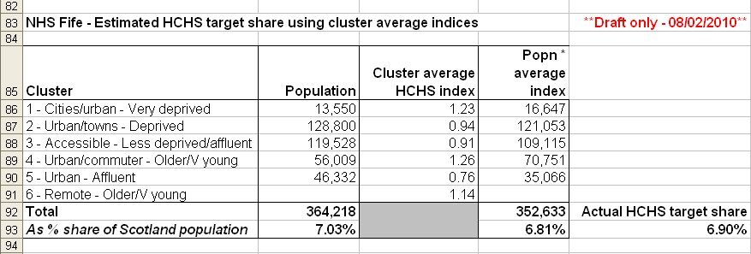

points to note / caveats
- This analysis is completely separate from the formula; it has no bearing on the results and only uses the output from the formula.
- Only the HCHS part of the formula data has been used in the analysis (this is at data zone level).
- The descriptions given to the different clusters are indicative only and are based on the average index profile of the cluster and the predominant type of geographical area in the cluster. Some data zones within a cluster may have differing formula indices to the cluster average and/or appear to not fit exactly with the other areas; however, on average most of the data zones will be similar according to specific measures e.g. they may generally have high age-sex acute indices, low MLC acute indices, etc.
- Cluster analysis can also produce differing numbers of groups: the number can be fixed by the user or automatically determined by the statistical programme. Different clusters may also be produced by re-ordering the data. However, the resulting groups should be broadly homogeneous according to the characteristics chosen.
- The extra, non-formula, SNS data zone information e.g. IDZ name, SIMD rank, etc. is protected by crown copyright. SNS have been contacted to ask if permission is required before using this information at the workshops.
- Because IDZs are aggregates of data zones, one IDZ can be included in more than one cluster. IDZs have been included in the draft pivot as they have names; thereby making it easier for Boards to visualise the different types of area in each cluster and/or HCHS index decile.

Proposed next steps
- TAGRA to decide if this analysis would be useful for the forthcoming formula workshops.
- If so, TAGRA to consider how best to present and/or use the analysis and output.

Health Analytical Services Division
Health Directorates
March 2010

