TAGRA Mental Health MLC: 65+ modelling – Stage 2 results

Summary:
- This note presents the findings from modelling need variables for the 65+ cohort, utilising the short-stay inpatients and outpatients dependant variable. The note reports summary results for 8 variants of need models for Scotland and for Urban-Rural categories.

- The main findings for explanatory power are as follows (see Tables 1, 2 & 3 below):

- there is little variation between the models in terms of explanatory power at the Scotland level (the adj. R² statistic ranges from 22.8% to 24.7%);
- similarly the variation in additional explanatory power is modest (8.1% to 10%);
- the models’ adj. R² for urban areas are similar to that for all Scotland (i.e. urban dominates the overall Scotland result);
- in rural areas the need models’ adj. R² are higher than in all Scotland for the ‘remote small towns’ and ‘remote rural areas’ but lower for ‘accessible rural’;
- however in ‘accessible rural areas’ and ‘remote rural areas’ it appears to be the supply/control variables which are capturing most of the variation in the cost ratio as the additional explanatory power is low or negative;
- all of the need models perform better than the reference model.

- The main findings for the behaviour of the need variable coefficients are as follows (see Table 4 below):

- the coefficient on SMR 65+ was always significant and with the correct sign, except in the ‘remote rural areas’;
- the SIMD coefficient often had the wrong sign and was statistically insignificant across models/rural geographies;
- the other variables’ coefficients were insignificant or insignificant and negative across a number of models/rural geographies.

- The relatively modest variation in model explanatory power at the Scotland level and within urban-rural categories does not provide a clear indication for model choice.

- The poor behaviour of the SIMD coefficient across geographies suggests that models containing SIMD should not be preferred. Of the remaining models the SMR 65+ model (8) provides a reasonable fit across urban rural areas and has the benefit of being parsimonious.

- The group are invited to take a decision on the needs variable/model which should be taken forward to Stage 3 of the programme of work.

1. Introduction:
- This note builds on the sub-group’s discussion, at the meeting on the 10th September, of the initial needs modelling for the 65+ cohort (reported in paper TMLC 16). It reports further work which has been undertaken and constitutes the analysis for Stage 2 of the programme of work (the exploration of alternative indicators of need).

- The following paragraphs set out the estimated explanatory power of the alternative needs models at the overall Scotland level and across urban-rural categories (defined in Annex 3). They also provide a summary of the behaviour of individual needs coefficients across urban-rural categories.

- The analysis utilises the new dependant variable which is comprised of short-stay inpatient and outpatient mental health episodes. The specification used in the modelling reported below is the average of the actual costs, relative to the expected costs, for the years 2007 to 2009. The initial results which were presented in paper TMLC 16 are included in Annex 2 for ease of reference. Note that the ‘alcohol admissions’ variable has been updated to the years 2006/07 to 2009/10 since that analysis.

- Eight different combinations of needs variables were tested, focussing on the request of the group to consider the Attendance Allowance, SIMD, Alcohol Admissions and SMR 65+ variables. Section 2 sets out the adj. R² summary statistic for these eight models alongside the ‘reference’ model and the incremental effect on the adj. R² compared with the supply/control variables alone (i.e. the additional explanatory power).

Section 3 provides information on needs variables which had statistically insignificant coefficients or perverse signs across models at the Scotland level and across urban-rural areas. Residual plots for two typical models are included in Annex 1.

2. Explanatory power for Scotland and Urban/Rural Categories:

2.1 Findings at the Scotland Level (Table 1 below):

Table 1: Needs Variables Regressions - Scotland Level, Adjusted R²
Model | Adjusted R² | Additional explanatory power
Reference | 20.6% | 5.9%
Model 1 (SIMD, Alc, AA, SMR) | 24.7% | 10.0%
Model 2 (SIMD, Alc, SMR) | 24.4% | 9.8%
Model 3 (SIMD, AA, SMR) | 23.8% | 9.1%
Model 4 (Alc, AA, SMR) | 24.7% | 10.0%
Model 5 (SMR, Alc) | 24.4% | 9.7%
Model 6 (AA, SMR) | 23.3% | 8.6%
Model 7 (SIMD, SMR) | 23.4% | 8.7%
Model 8 (SMR) | 22.8% | 8.1%
Number of observations | 1,235

- the reference model explains around 21% of the variation in the cost ratio, implying that the needs variables contribute an incremental 6% to the model;
- the other models adj. R² ranges from just under 23% to 24.7% and the additional explanatory power ranges from around 8% to over 10%;
- there is a trade-off between the number of variables and the explanatory power - the highest adj. R² (24.7%) is a three or four variable model, the lowest adj. R² (22.8%) is for the single variable model.

2.2 Findings for Urban and Rural areas (Table 2 below):

- in the case of the urban classification the adj. R² is similar to that obtained for all Scotland;
- for urban the additional explanatory power (the excess of the adj. R² versus that of the supply model) is higher by up to 1% depending on the model;
- in the case of the rural classification the adj. R² is slightly higher than all Scotland (except models 4 & 5) but there is a substantial reduction in additional explanatory power.

Table 2: Needs Variables Regressions - Urban and Rural, Adjusted R²
 | Urban  (HURC4 = 1) |  | Rural  (HURC4 = 2,3,4)
Model | Adjusted R² | Additional explanatory power | Adjusted R² | Additional explanatory power
Reference | 19.7% | 5.8% | 22.7% | 1.5%
Model 1 (SIMD, Alc, AA, SMR) | 24.6% | 10.7% | 24.7% | 3.5%
Model 2 (SIMD, Alc, SMR) | 24.4% | 10.5% | 24.9% | 3.7%
Model 3 (SIMD, AA, SMR) | 23.9% | 9.9% | 24.3% | 3.1%
Model 4 (Alc, AA, SMR) | 24.6% | 10.7% | 23.8% | 2.6%
Model 5 (SMR, Alc) | 24.4% | 10.5% | 24.1% | 2.9%
Model 6 (AA, SMR) | 23.2% | 9.3% | 24.0% | 2.8%
Model 7 (SIMD, SMR) | 23.6% | 9.7% | 24.5% | 3.3%
Model 8 (SMR) | 22.8% | 8.9% | 24.3% | 3.1%
Number of observations | 958 |  | 277

2.3 Findings for disaggregated Rural areas (Table 3 below):

- the overall adj. R² are much lower for the ‘accessible rural’ category but much higher for the ‘Remote Small Towns’ and ‘Remote Rural Areas’ categories;
- the additional explanatory power is lower for ‘accessible rural’, generally higher for ‘Remote Small Towns’ and much lower for ‘Remote Rural Areas’;
- the results suggest that for remote areas the within-board variation in the needs variables is relatively limited and that the regression is dominated by the control variables.

Table 3: Needs Variables Regressions – Rural categories, Adjusted R²
 | Accessible rural  (HURC4 = 2) |  | Remote small towns (HURC4 = 3) |  | Remote rural areas  (HURC4 = 4)
Model | Adjusted R² | Additional explanatory power | Adjusted R² | Additional explanatory power | Adjusted R² | Additional explanatory power
Reference | 4.9% | -0.4% | 26.6% | -1.8% | 33.6% | -0.4%
Model 1 (SIMD, Alc, AA, SMR) | 7.8% | 2.5% | 40.9% | 12.6% | 32.5% | -1.6%
Model 2 (SIMD, Alc, SMR) | 6.8% | 1.5% | 42.5% | 14.2% | 33.4% | -0.7%
Model 3 (SIMD, AA, SMR) | 8.0% | 2.6% | 40.9% | 12.5% | 32.0% | -2.0%
Model 4 (Alc, AA, SMR) | 7.9% | 2.5% | 40.0% | 11.6% | 31.7% | -2.4%
Model 5 (SMR, Alc) | 6.6% | 1.3% | 41.5% | 13.1% | 32.4% | -1.6%
Model 6 (AA, SMR) | 8.5% | 3.2% | 36.9% | 8.5% | 32.2% | -1.8%
Model 7 (SIMD, SMR) | 7.1% | 1.8% | 42.5% | 14.1% | 33.0% | -1.1%
Model 8 (SMR) | 7.3% | 2.0% | 38.6% | 10.2% | 33.1% | -1.0%
Number of observations | 145 |  | 50 |  | 82

- The (fairly representative) residuals’ plots from models 1 and 8 are presented in Annex 3 for all four urban-rural categories. These do not suggest any further problems with outliers.

3. Needs variable coefficients:
- The following table summarises the behaviour of the coefficients of the needs variables across models and urban-rural categories. Note that the numbers of observations in the disaggregated rural areas are much smaller than the other categories which restricts the degrees of freedom. For example the category ‘remote rural areas’ has 82 intermediate geographies spanning 11 health boards.

- Unless otherwise stated the coefficients were statistically significant and with the expected sign.

Table 4: Needs coefficients – negative signs and insignificance.
Indicator | Model | Scotland | Urban | Rural | Accessible rural  (HURC4 = 2) | Remote small towns (HURC4 = 3) | Remote rural areas  (HURC4 = 4)
SIMD | 1 | ng/ns | ng/ns | ng/ns | ng/ns | ng/ns | ns
SIMD | 2 | ng/ns | ng/ns | ng/ns | ng/ns | ng/ns | ng/ns
SIMD | 3 |  |  | ng/ns | ng/ns | ng/ns | ng/ns
SIMD | 7 |  |  | ng/ns | ng/ns | ns | ng/ns
SIMD - health | 7hs |  |  | ns | ng/ns | ng | na
Alc | 1 |  |  | ns | ns |  | ns
Alc | 2 |  |  |  |  |  | ns
Alc | 4 |  |  | ns | ns | ng/ns | ns
Alc | 5 |  |  | ns | ns | ng/ns | ns
AA | 1 |  |  | ns |  |  | ns
AA | 3 |  |  | ns | ng/ns | ng/ns | ng/ns
AA | 4 |  |  | ns | ng/ns | ns | ng/ns
AA | 6 |  |  | ns | ng/ns | ng/ns | ng/ns
SMR | 1 |  |  |  |  |  | ns
SMR | 2 |  |  |  |  |  | ns
SMR | 3 |  |  |  |  |  | ns
SMR | 4 |  |  |  |  |  | ng/ns
SMR | 5 |  |  |  |  |  | ng/ns
SMR | 6 |  |  |  |  |  | ns
SMR | 7 |  |  |  |  |  | ns
SMR | 7hs |  |  |  |  |  | ng/ns
SMR | 8 |  |  |  |  |  | ng/ns
Note: ng = negative coefficient; ns = not statistically significant; model 7hs is model 7 with Health-SIMD in place of overall SIMD.

- The main findings are that:
- The SIMD coefficient was generally found to have the wrong sign and to be statistically insignificant across models/rural geographies (even at the Scotland level in two models);
- The coefficient on Attendance Allowance had similar problems in rural areas in most models;
- The coefficient on Alcohol Admissions was insignificant across rural areas in most models;
- The coefficient on SMR 65+ was always significant and with the correct sign except in the ‘remote rural areas’.

Analytical Support Team
October 2012
Annex 1: Residual charts for selected models (1 & 8)
Figure 1: Residuals – Model 1, Urban (HURC1)
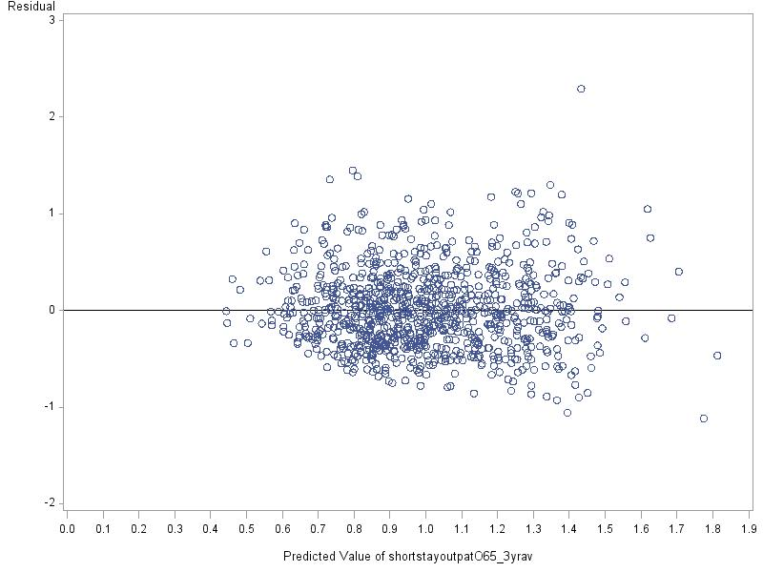

Figure 2: Residuals – Model 1, Accessible rural (HURC2)
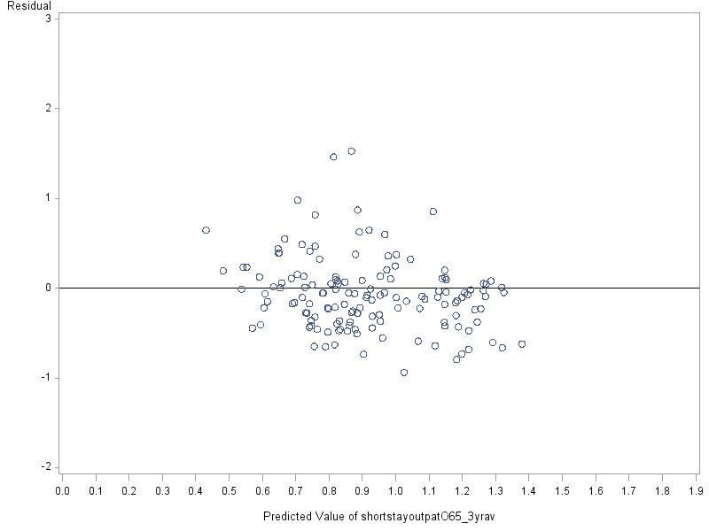

Figure 3: Residuals – Model 1, Remote small towns (HURC3)
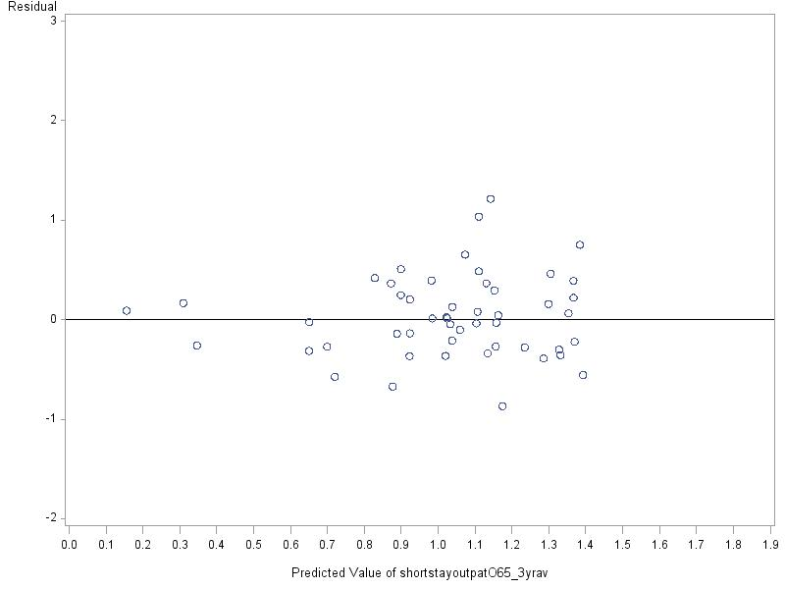

Figure 4: Residuals – Model 1, Remote rural areas (HURC4)
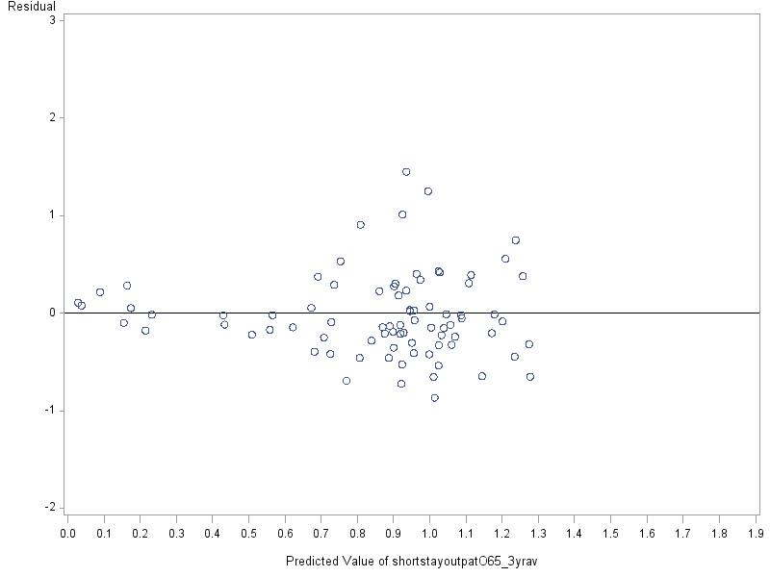

Figure 5: Residuals – Model 8, Urban (HURC1)
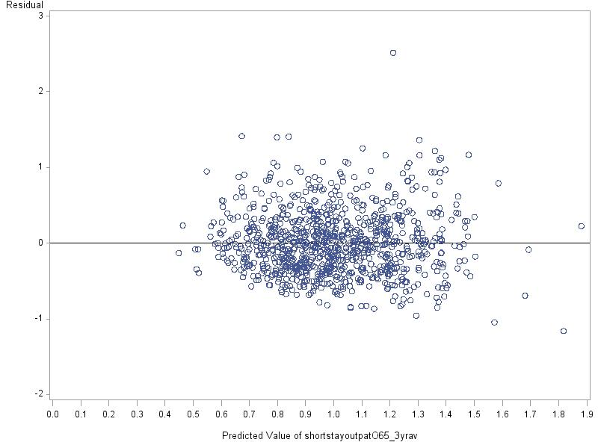

Figure 6: Residuals – Model 8, Accessible rural (HURC2)
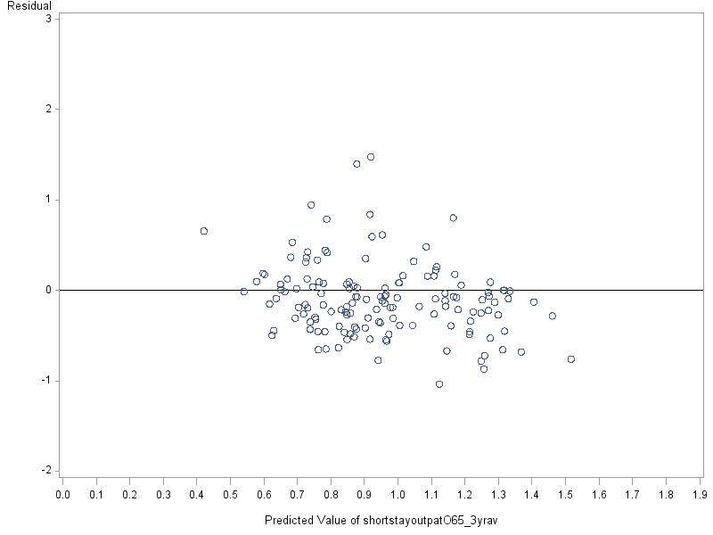

Figure 7: Residuals – Model 8, Remote small towns (HURC3)
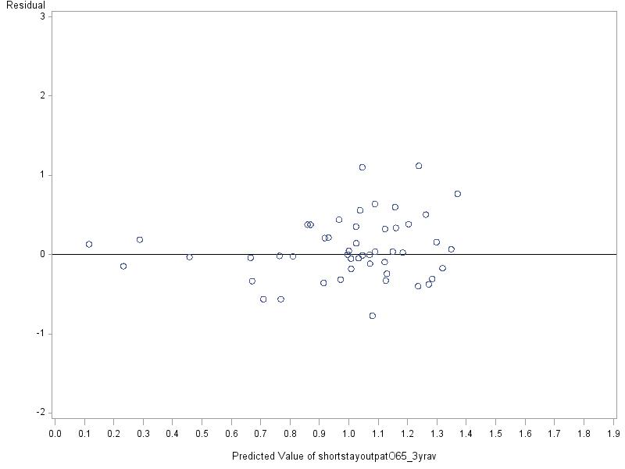

Figure 8: Residuals – Model 8, Remote rural areas (HURC4)
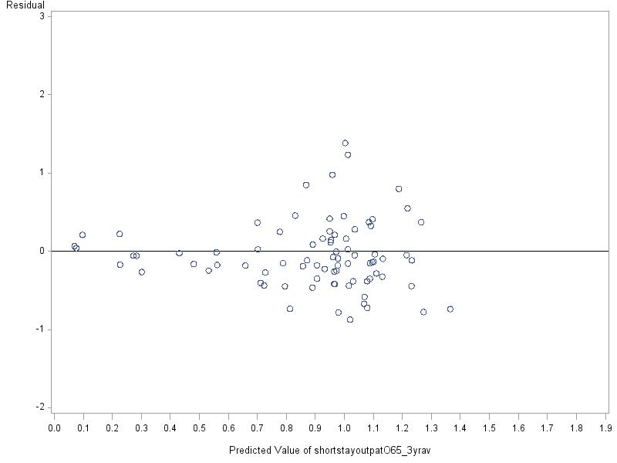

Annex 2: Results reported in paper TMLC 16

This table represents the results previously reported to the meeting on 10th September 2012.

Table 1: Needs Variables Regressions - adjusted R²
Model: | Included Variables: | Adj R² | Implied 'needs' contribution | Comments
Supply model | Supply variables | 14.7% | na | assesses the contribution of the non-needs variables
Supply model | Health board variables | 14.7% | na | assesses the contribution of the non-needs variables
Reference model | Social rented housing | 20.6% | 5.9% | reference model intended to reflect the current adjustment with up-to-date data
Reference model | Single adult discount | 20.6% | 5.9%
Reference model | Benefits claimed | 20.6% | 5.9%
Aggregate deprivation model | Overall SIMD | 19.0% | 4.3%
Unconstrained deprivation model | Separate SIMD components (access, crime, employment, health, income, GP drive-time, education, housing) | 23.4% | 8.7% | education has perverse sign; only access, health and education significant at the 5% level
Health deprivation model | SIMD health | 21.3% | 6.6%
Attendance Allowance Model | Attendance Allowance low/high/combined rates | 17.4% | 2.7% | alternative combinations of low, high and total AA give similar results
Pensioner poverty model | Guaranteed pension credit | 21.0% | 6.3%
Mortality model | SMR 65+ | 22.8% | 8.1%
Alcohol model | Alcohol admissions | 20.8% | 6.1%
Alcohol and drugs model | Alcohol admissions | 20.9% | 6.2% | drugs not significant and with a perverse sign
Alcohol and drugs model | Drugs admissions | 20.9% | 6.2% | drugs not significant and with a perverse sign
Mortality and alcohol model | Alcohol admissions | 24.6% | 9.9%
Mortality and alcohol model | SMR 65+ | 24.6% | 9.9%
Combination model: 1 | SIMD; | 24.3% | 9.6% | pension credit and SIMD not significant
Combination model: 1 | Attendance Allowance; | 24.3% | 9.6% | pension credit and SIMD not significant
Combination model: 1 | Guaranteed pension credit; | 24.3% | 9.6% | pension credit and SIMD not significant
Combination model: 1 | SMR 65+ | 24.3% | 9.6% | pension credit and SIMD not significant
Combination model: 2 | SIMD health; | 24.3% | 9.6% | pension credit and SIMD health not significant
Combination model: 2 | Attendance Allowance; | 24.3% | 9.6% | pension credit and SIMD health not significant
Combination model: 2 | Guaranteed pension credit; | 24.3% | 9.6% | pension credit and SIMD health not significant
Combination model: 2 | SMR 65+ | 24.3% | 9.6% | pension credit and SIMD health not significant
Combination model: 3 | Attendance Allowance | 24.3% | 9.6%
Combination model: 3 | SIMD health; | 24.3% | 9.6%
Combination model: 3 | SMR 65+ | 24.3% | 9.6%
Combination model: 4 | SIMD health; | 24.1% | 9.4%
Combination model: 4 | SMR 65+ | 24.1% | 9.4%

Annex 3: Highland Urban-Rural Classification

Table 1: Highland urban rural classification scheme
Highland Urban-Rural category 1 | Urban | Settlements of over 3,000 people and, if under 10,000 people, within 30 minutes drive of a settlement of 10,000 or more
Highland Urban-Rural category 2 | Accessible rural | Areas with a population of less than 3,000 people, and within a 30 minute drive time of a settlement of 10,000 or more
Highland Urban-Rural category 3 | Remote small towns | Settlements of between 3,000 and 10,000 people and with a drive time of over 30 minutes to a settlement of 10,000 or more
Highland Urban-Rural category 4 | Remote rural areas | Areas with a population of less than 3,000 people, and with a drive time of over 30 minutes to a settlement of 10,000 or more

