TAGRA REMOTE AND RURAL SUBGROUP

Paper TRR16 – GP out of hours

Background

Funding of GP out of hours services has been raised as an issue in several areas. It has been debated in Parliament, considered by the Health and Sport Committee, and reviewed by Audit Scotland. It has also been raised as an issue by TAGRA, in its report into the impact of the NRAC formula on remote and rural areas of Scotland. The Cabinet Secretary has asked TAGRA to review this area, and the subgroup identified it as a priority at its first meeting when setting its work plan.

Current data on GP out of hours

Data on GP out of hours service costs are published in the Costs Book, where they have been separately identified in their own line within the Community section since the 2008/09 edition. The data suggest that spend on GP out of hours service varies significantly between the NHS Boards. This is illustrated in the graph below.

Although there is a tendency for costs to be higher in rural areas, this is not always the case, with costs in Shetland relatively similar to the Scottish national average.

There is not a formal data collection on GP out of hours activity. However, Health Finance Analytical Services have collected data on primary care out of hours services as part of work on unscheduled care. This suggests that the variation in cost cannot simply be explained by different levels of activity between the boards. The graph below shows that the general overall pattern of activity amongst the boards, and the variation is far smaller than that in overall cost.

Despite the fact that spending and activity is higher in Highland and the island boards, these boards actually have a greater level of out of hours provision provided by GP practices through the GP contract.

Table 1 – Out of hours provision in the NHS Boards
NHS Board | Proportion of population with GP practices providing out of hours services (2010)
Ayrshire & Arran | 2%
Borders | 0%
Dumfries & Galloway | 0%
Fife | 0%
Forth Valley | 0%
Grampian | 0%
Greater Glasgow & Clyde | 0%
Highland | 15%
Lanarkshire | 0%
Lothian | 0%
Orkney | 15%
Shetland | 36%
Tayside | 0%
Western Isles | 12%
Scotland | 1%

The variation between the NHS Boards in this area is far greater than explained by the current NRAC formula. The graph below compares the spend per head by NHS Board to the current NRAC overall index and the NRAC community care index. For Highland, Orkney, and Western Isles in particular, but also for Borders and Dumfries & Galloway, there are large differences.

Policy context

Representatives from analytical services have met with Julie McIlroy in from the Scottish Government Primary Care Directorate to discuss the policy around GP out of hours funding. The policy aspiration in this area is to achieve greater integration of unscheduled care across all primary care services, rather than just GP out of hours. There is therefore no preference for ring-fenced GP out of hours funding, and this may be considered impractical, primarily because it is difficult to separate GP out of hours expenditure from expenditure on wider unscheduled care. GP out of hours services will typically share some resources, such as facilities, reception, and potentially nursing staff.

This problem is illustrated in the current Costs Book returns on GP out of hours from the boards. Boards have very variable assessments of the fixed costs of running GP out of hours services, as shown in the graph below. Although they have high overall costs, the island boards report no or very low allocated costs. This may well represent different styles of delivering services. For example, in Greater Glasgow & Clyde, where allocated costs are quite high, services are delivered from A&E premises. It may be that in the island boards, services are delivered through contracts direct with GPs, who are expected to provide their own facilities, and therefore all costs appear as staff related.

NHS Health Improvement Scotland is in the process of developing quality indicators for GP out of hours services. These are currently being piloted in Greater Glasgow & Clyde and Highland. The choice of these pilot sites was influenced by the different delivery styles in the two boards: GG&C’s out of hours services are delivered as an extension of its A&E services, whilst Highland’s are devolved to CHPs. The current draft indicators relating to service provision are based around home visit times. For example:
- Percentage of clinically appropriate NHS 24 1, 2 and 4-hour home visit referrals; and
- Percentage of NHS 24 1, 2 and 4-hour home visit referrals reached within the timescale.

These sort of indicators could potentially be used in conjunction with drive time indicators, such as are used in the Scottish Government urban rural classification, to develop a cost model. Some similar work was undertaken for the Remote and Rural Implementation Group, which looked at the proportion of the population within different drive times of GP practices (see Annex B). However, as data on the quality indicators is not available currently, this could only form part of a future work stream. The pilot project is due to conclude in June 2012, with the final indicators published in July 2012.

Potential approaches to GP out of hours funding

Three possible approaches are discussed here:
- A population based approach;
- An activity based approach; and
- A facilities based approach.

Population based approach

The population based approach would be similar to that adopted by NRAC. The final adjustment is likely to be far simpler than that adopted within the NRAC formula, however, due to lack of data.

The starting point for any adjustment would be a board’s population, where out of hours services are not currently covered by a GP practice. However, with current data, it is not clear how this would in practice differ from the current NRAC formula. With no age-sex data, it is not possible to derive out-of-hours specific age-sex or morbidity and life circumstances adjustments. An attempt has been made to derive out of hours specific cost adjustments at the NHS Board level, by looking at the relationship between population density and cost or activity. Full details are reported in Annex A; however, they are largely unsuccessful, and imply redistributive patterns smaller than the current community adjustment.

Activity based approach

Another approach could be to use activity as the basis for funding. In particular, an adjustment can be made to account for differing proportions of services being delivered as home visits in rural areas.

The methodology used here is to ‘cost weight’ different types of out of hours services. Due to lack of data, however, approximations again have to be used. The NRAC community clinic-based unavoidable excess cost adjustment has been used to cost weight out of hours services provided on site, and the community travel-based unavoidable excess cost adjustment for home visits.

Combining the variations in types of activity with the NRAC variations in cost produces the following distribution between boards. This is shown in the graph below compared to the current distribution of spend.

In order for this to be used in resource allocation, the amount of funding to be allocated on this distribution would have to be determined. This could be, for example, based on the amount reported in the Costs Book for GP out of hours services, either through top-slicing, or creating a specific weighted adjustment within the NRAC formula.

Facilities based approach

The third approach considered here is to look directly at the number of GPs who have opted out of providing out of hours services, and use this as a proxy for the level of services that NHS Boards themselves have to provide.

As discussed above, the proportion of GP practices that have opted out of providing out of hours services varies by board. The graph below shows how many GP practices have opted out, against the population that is not covered.

If it were to be assumed that the number and distribution of GP practices reflects the requirements of an efficient and safe service, this distribution could be interpreted as the age-sex and morbidity and life circumstances adjusted requirement for GP out of hours services. A further adjustment would therefore be required to reflect variations in costs. Again, due to data limitations the NRAC community unavoidable excess costs indices have been applied. The results are shown in the table below, compared to the current spend per head levels.

Again, for this distribution to be used, an NRAC weight or specific top-sliced budget would need to be applied to it.

Areas for discussion

The subgroup is asked for its view on the following points:
- Whether it considers the approaches outline in this paper appropriate;
- Whether it has any comments on or preferences for the approaches;
- How it would like the analysis to proceed; and
- Views on the degree to which GP out of hours spend by boards should be treated as a target ‘need’ for funding.

Iain Pearce
Health Analytical Services
November 2011
ANNEX A – Relationship between cost, activity, and density

Analysis has been carried out on the 2009/10 Costs Book GP out of hours expenditure and the activity data collected by Health ASD, in an attempt to establish a relationship between variation in these data and population sparsity. This is similar to the approach used in the Arbuthnott formula, although less detailed, as the Arbuthnott formula conducted its analysis at Local Authority level to increase the number of observations. Here, analysis is conducted at NHS Board level, which reduces the explanatory power of the analysis. A possible option for improvement would be to conduct a panel and expand the analysis over several years.

To assess the relationship described above, cost per head, activity per head, and cost-weighted activity per head have been regressed on the population density of each NHS Board. The results are shown in the tables below.

In general, population density appears to be a poor explanatory variable for variation in both cost and activity, and very little difference between the NHS Boards is predicted. The main impact is a negative effect upon the very dense boards, Greater Glasgow & Clyde and Lothian, rather than a positive impact upon the very rural boards. The results may change once a panel is constructed, although due to poor historical reporting of GP out of hours services costs, it is unlikely to be possible to construct a panel which covers more than three years.

ANNEX B – Drive times to nearest GP practice

The map below shows the drive time across Scotland to the nearest GP provision. This was produced for the Remote and Rural Implementation Group by Scottish Government Geographical Information Systems.
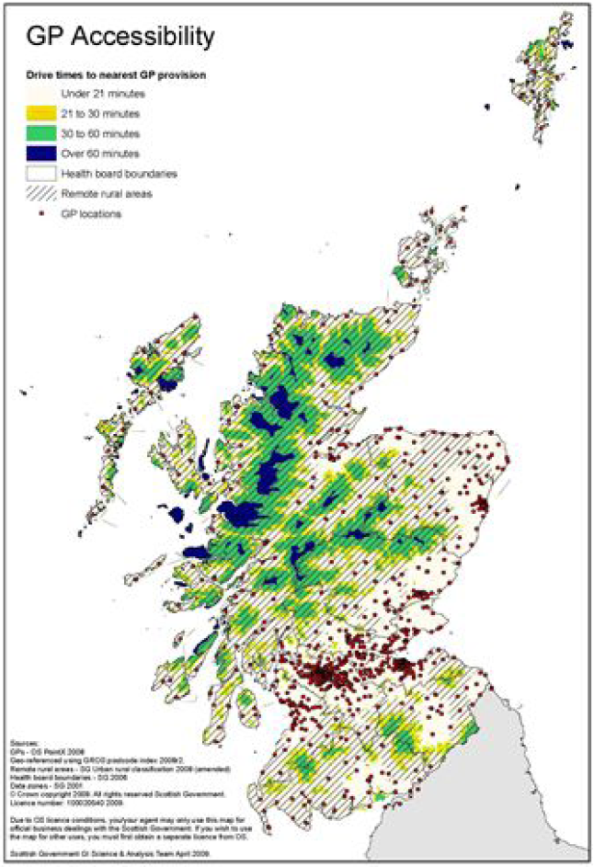

Allocated costs, within the Costs Book, refers to all costs other than direct staff costs and direct supplies costs.

